PPC-3180SW

18.5" Fanless Widescreen Panel PC with Intel® Pentium® N4200 Quad-Core Processor

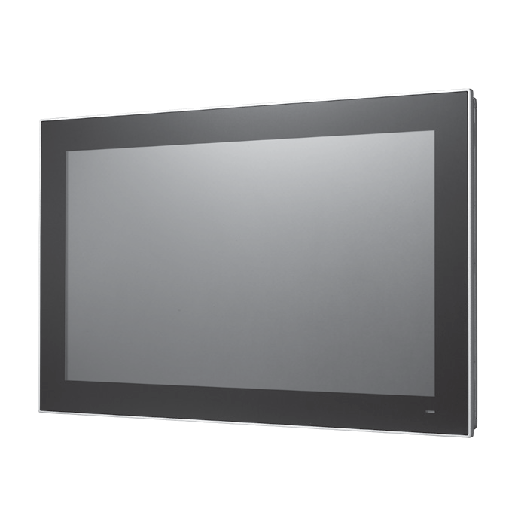
Features
- 18.5" true-flat TFT LCD with projected capacitive touch control
- Fanless design with low power consumption
- Supports 1 x internal 2.5" SATA HDD and 1 x mSATA
- Configurable RS-232/422/485 ports via BIOS
- Automatic data flow control over RS-485
- Wide range DC support (12 ~ 24 VDC)
- Supports dual displays
- IP65-rated front panel
Introduction
The PPC-3180SW is a high-value, ultra-slim panel PC equipped with a 18.5" WXGA TFT LCD, and low-power Intel® Pentium® N4200 quad-core, 1.1 GHz, processor to provide high-performance computing in a compact and fanless system. For high durability and functionality, the PPC-3180SW features an IP65-rated front panel, multi-touch projected capacitive touchscreen, die cast aluminum alloy enclosure, two serial ports, four USB ports, and two GbE LAN ports, making it suitable for diverse industrial applications.

Specifications

System | CPU | Intel Pentium® N4200 quad Core
 | Frequency | 1.1GHz, turbo boot to 2.5GHz.
 | L2 Cache | 3 MB
 | Memory | 1 x SODIMM, DDR3L 1600/1866, max. 8 GB
 | Storage | 1 x 2.5" SATA bay 1 x mSATA bay
 | Network (LAN) | 2 x 10/100/1000 Mbps Ethernet (Intel I211-AT)
 | I/O | 2 x Serial ports: 1 x RS-232, 1 x RS-232/422/485 2 x USB 3.0, 2 x USB 2.0  1 x Line-out  1 x HDMI
 | Expansion | 1 x Mini PCIe
 | Watchdog Timer | 255 timer levels, set up by software
 | Speaker | 2 x 1W
Physical Characteristics | Dimensions | 488 x 309 x 58.45 mm (19.21 x 12.16 x 2.3 in)
 | Weight | 5.4 kg (11.90 lb)
OS Support | OS Support | Microsoft® Windows 10 (64-bit), Linux, Android
Power Comsumption | Input Voltage | 12 ~ 24 VDC
 | Power Consumption | 35 W
LCD | Display Type | 18.5" TFT LCD (LED backlight)
 | Max. Resolution | 1366 x 768
 | Viewing Angle | 85 (Left), 85 (Right), 80 (Up), 80 (Down)
 | Luminance (cd/m2) | 450
 | Contrast Ratio | 1000
 | Backlight Lifetime | 50,000 hr (min.)
Touchscreen | Touch Type | Multi-touch projected capacitive
 | Light Transmission | 90% ± 2%
 | Controller | USB Interface
Environment | Operating Temperature | 0 ~ 50 °C (32 ~ 122 °F) with SSD  0 ~ 40 °C (32 ~ 104 °F) with HDD
 | Storage Temperature | -20 ~ 60 °C (-4 ~ 140 °F)
 | Relative Humidity | 10 ~ 95% @ 40 °C (Non-Condensing)
 | Shock | Operating 10 G Peak Acceleration (11 ms Duration), Follows IEC 60068-2-27
 | Vibration | Operating Random Vibration Test 5~500Hz, 1Grms @with HDD; 2Grms @with SSD, Follows IEC 60068-2-64
 | EMC | CE, FCC Class B, BSMI
 | Safety | CE, UL, CCC, BSMI
 | Front Panel Protection | IP65 compliant
General Panel PCs
All product specifications are subject to change without notice. Last updated: 1-Apr-2019

PPC-3180SW

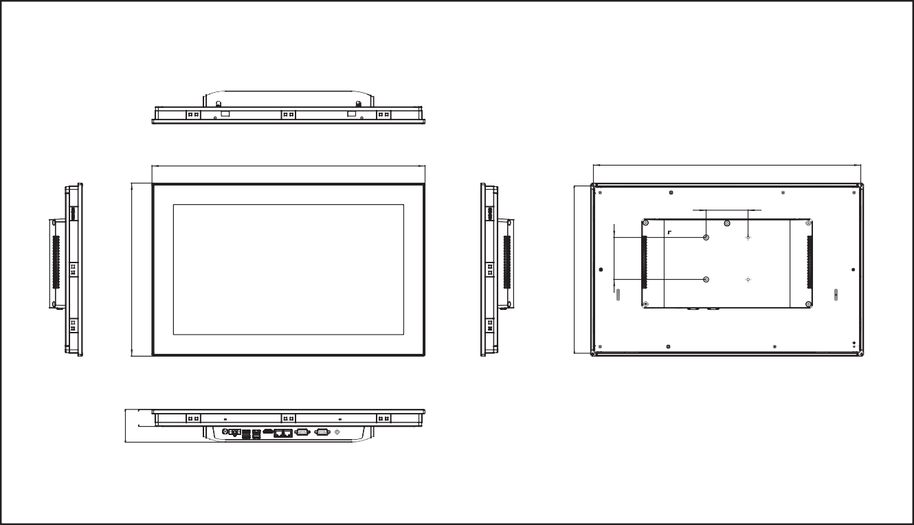Ordering Information
Panel Cutout Dimensions: 479.3 x 300.3 mm (18.87 x 11.82 in)
477.72

75.00
488.00
Unit: mm
Dimensions
58.45
30.45

Part Number | Description
PPC-3180SW-PN4A | 18.5" Wide screen PPC with PCT Multi-touch, Intel Pentium® N4200 Quad-Core
96PSA-A90W19OT-1 | Adapter AC100-240V 90W 19V
1700001524 | POWER Cord 3P UL 10A 125V 180cm
170203183C | POWER Code 3P Europe (WS-010+083)183 cm
1700008921 | POWER CORD 3P/3P POWER SUPPLY 1.8 M PSE
96CB-POWER-B-1.8M | Power code 3P CCC(China) 1.8M
PPC-174T-WL-MTE | Wall mount kit for PPC series
PPC-STAND-A1E | Stand for PPC series
PPC-ARM-A03 | ARM VESA Standard (A-CLEVER) for PPC series
PPC-WLAN-C1E | Supports 802.11 a/b/g/n/ac and BT4.1 (2T2R)
PPC-HDD-N4200 | HDD Bracket module for PPC-3150SW and PPC-3180SW
I/O View

- 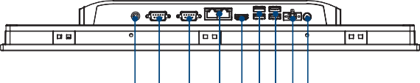Line out

A B C D E F G H I
- COM1: RS-232
C. COM2: RS-232/422/485
- 2 x LAN
- HDMI

- 2 x USB 3.0
- 2 x USB 2.0
- DC-In
- Power Button

309.00
298.72
75.00

Online Download www.advantech.com/products

