PPC-3100

10.4" Fanless Panel PC with Intel® Atom™ E3940 Processor

Features
- 10.4" SVGA TFT LCD with resistive touchscreen
- Intel® Atom™ E3940, 1.6 GHz, processor
- Up to 8 GB DDR3L 1600/1866 SDRAM
- Supports 1 x internal 2.5" SATA HDD and 1 x mSATA
- Fanless design with low power consumption
- Wide range DC support (9 ~ 32 VDC)
- 1 x isolated RS-422/485 with automatic flow control and dual Intel GbE
- Optional GPIO (8 channels, TTL level)

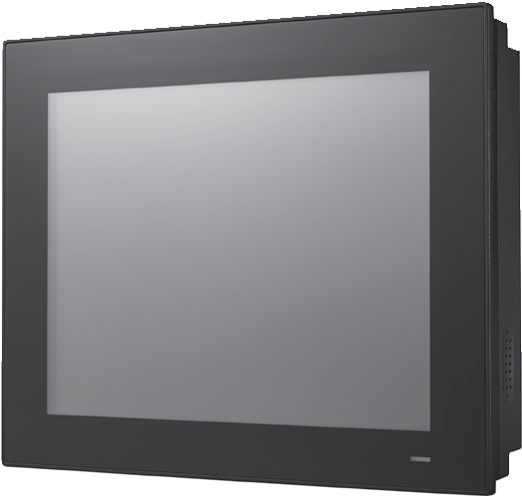Introduction
The PPC-3100 is a 10.4" fanless panel PC equipped with a high-performance Intel® Atom™ E3940 quad-core processor that supports wide power input range (9 ~ 32 VDC). The provision of multiple I/O, including 4 x COM, 4 x USB 3.0, 1 x isolated RS-422/485, and dual Intel® Gigabit Ethernet, ensures easy integration and connectivity.

Specifications

System | CPU | Intel® Atom™ E3940 quad core
 | Frequency | 1.6 GHz
 | L2 Cache | 2 MB
 | Memory | 1 x SODIMM DDR3L 1600/1866 MHz (max. 8 GB)
 | Storage | 1 x 2.5" SATA bay 1 x mSATA bay
 | Network (LAN) | 2 x 10/100/1000 Mbps Ethernet (Intel i210)
 | I/O | 5 x Serial ports: 4 x RS-232, 1 x isolated RS-422/485 (Adjustable through BIOS) 4 x USB 3.0  1 x Line-out, 1 x Mic-in  1 x VGA  1 x HDMI  1 x GPIO (8 channels, TTL level, internal)
 | Expansion | 1 x Mini PCIe
 | Watchdog Timer | 255 timer levels, set up by software
 | Speaker | 2 x 1W
Physical Characteristics | Dimensions | 271.8 x 216.8 x 57.5 mm (10.7 x 8.53 x 2.26 in)
 | Weight | 2.8 kg (6.17 lb)
OS Support | OS Support | Microsoft® Windows 10 IoT Enterprise, Linux, Android 6.0 Marshmallow
Power Consumption | Input Voltage | 9 ~ 32 VDC
 | Power Consumption | 30W (Burn-in test 8.0 in Windows 10 64bit)
LCD | Display Type | 10.4" TFT LED Panel (LED backlight)
 | Max. Resolution | 800 x 600
 | Viewing Angle | 80 (left), 80 (right), 70 (up), 70 (down)
 | Luminance (cd/m2) | 400
 | Contrast Ratio | 700
 | Backlight Lifetime | 30,000 hr (typical)
Touchscreen | Touch Type | 5-wire resistive touch
 | Light Transmission | 80±5% at 550nm wavelength
 | Controller | USB interface
 | Durability (Touches) | Greater than 35 million touches in one location without failure
Environment | Operating Temperature | 0 ~ 50 °C (32 ~ 122 °F)
 | Storage Temperature | -30 ~ 60 °C (-22 ~ 140 °F)
 | Relative Humidity | 10 ~ 95% @ 40 °C (non-condensing)
 | Shock | Operating 10 G peak acceleration (11 ms duration), follow IEC 60068-2-27
 | Vibration | Operating Random Vibration Test 5~500Hz, 1Grms @with HDD; 2Grms @with SSD, follow IEC 60068-2-64
 | EMC | CE, FCC Class B, BSMI
 | Safety | CB, CCC, BSMI, UL
 | Front Panel Protection | IP65 compliant

General Panel PCs
All product specifications are subject to change without notice. Last updated: 26-Mar-2019

PPC-3100

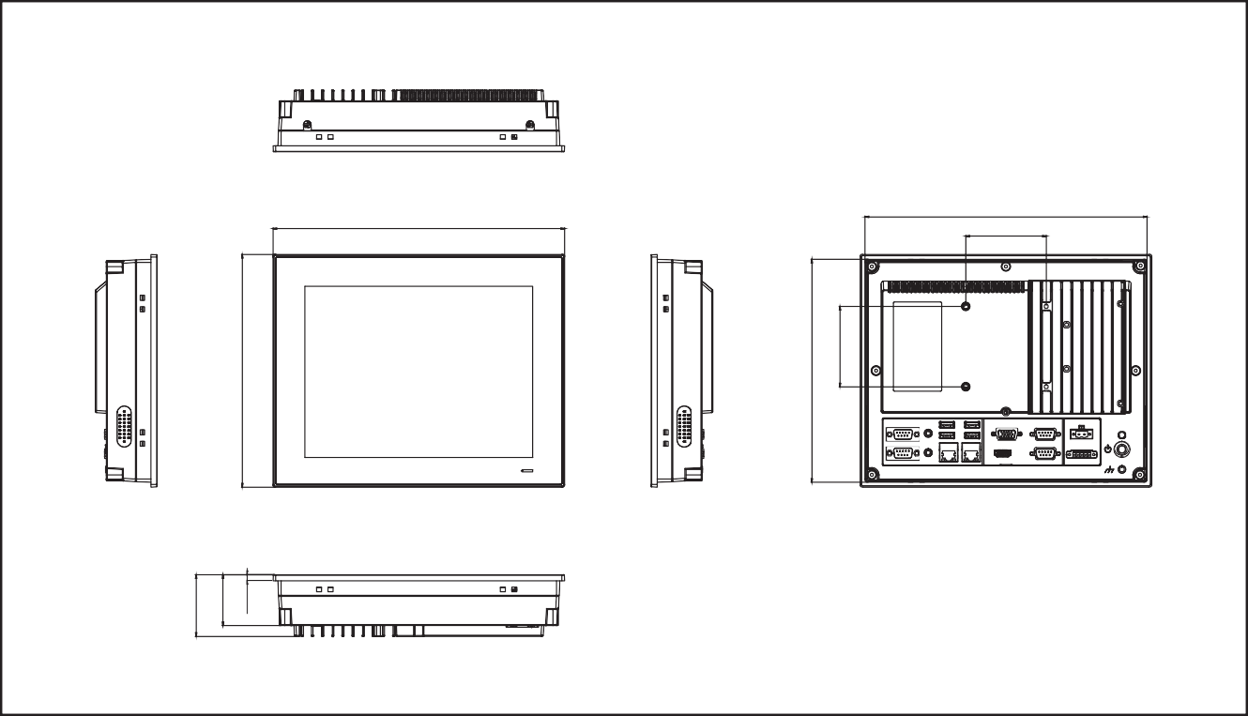Ordering Information
Panel Cutout Dimensions: 265 x 210 mm (10.43 x 8.26 in)
262.80
75
271.80
Unit: mm
Dimensions
57.50
47.50
5.70

Part Number | Description
PPC-3100-RE9A | Atom E3940 Fanless Panel PC with 10.4" SVGA LED backlight, resistive touch
96PSA-A90W19OT-1 | ADP A/D 100-240V 90W 19V W/PFC
1700001524 | Power cord 3P UL 10A 125V 1.8m
170203183C | Power cord 3P Europe (WS-010+083)183cm
1700008921 | Power cord 3P/3P Power supply 1.8M PSE
PPC-174T-WL-MTE | Wall mount kit for PPC series
PPC-ARM-A03 | PPC ARM VESA Standard
96CB-POWER-B-1.8M | Power cable 3P CCC(China) 1.8M
PPC-STAND-A1E | Stand For PPC Series
PPC-WLAN-C1E | Wi-Fi Module with Antenna Cable 40cm for PPC
I/O View

- 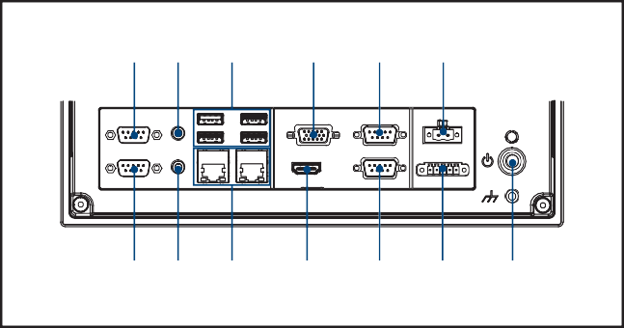COM4: RS-232
M
L
J
H
B D F
K
I
G
A C E
- COM5: RS-232
- Line Out
- Mic In
- 4 x USB 3.0
- 2 x LAN
- VGA

- HDMI
- COM1: RS-232
- COM2: RS-232
- DC Inlet and AT/ATX switch
- COM3: Isolated RS-422/485
- Power Button

216.80
207.80
75

Online Download www.advantech.com/products

