IPPC-6152A IPPC-6172A IPPC-6192A

15" XGA/17" SXGA/19"SXGA TFT LCD
LED Backlight Core™ i7/i5/i3 Industrial Panel PC

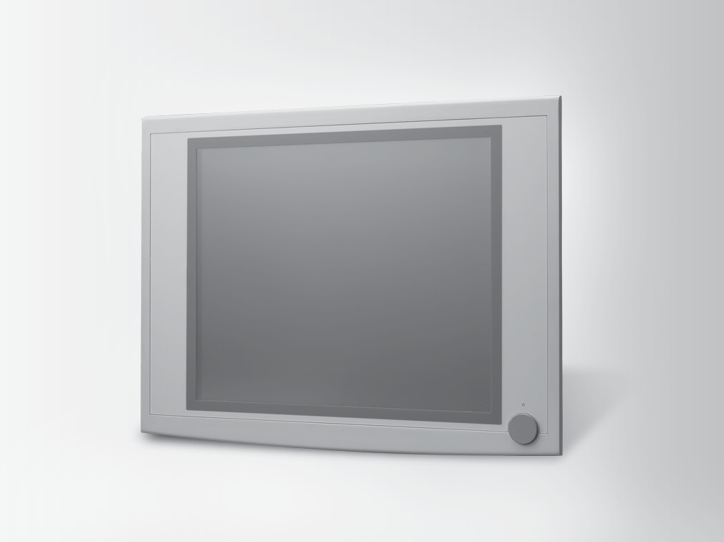
Features
- 15" XGA/17" SXGA/19" SXGA TFT LCD with touchscreen
- Supports Intel® Core™ i7/i5/i3 processor with Q87 chipset (up to 3.1GHz )
- System supports four DIMM sockets support up to 32 GB DDR3 1333/1600 MHz SDRAM
- Offers multiple expansion slots including two PCI (default), one PCI + one PCIe x4 (optional), two PCIe x1 (in the accessory box)
- SATA 2.0 or SATA 3.0 HDDs and RAID 0,1 compatibility
- Front USB access and system reset function
- Front panel is IP65 compliant
- Supports Intel AMT 9.0 and Intel vPro competent
- Supports Microsoft® Windows 7,Windows 8.1 and Windows 10
- Supports SUSIAccess and Embedded Software APIs
- Optional Functionality –CFast ,PCI/ PCIe expansion,DVD-ROM
Introduction
The IPPC-6000A Series is an Industrial Panel PC with front USB access, supports the powerful 4th Gen Intel Core™ i7/i5/i3, high speed DDR3 memory, up to 32 GB, two expansion slots. The processor and chipset combination form the foundation of vPro, Intel’s next generation digital office platform, offering remote out-of-band manageability, improved security, and energy efficient performance. Two SATA hard driver interface with RAID 0,1 support provides data security. Multi function optional –CFast ,PCI/ PCIe expansion,DVD-ROM which offers great flexibility for application specific requirements. Rugged Metal &IP65 Flat-Sealed Front provide excellent durability in harsh environment. With optional mounting accessories, from panels to racks,it can be mounted anywhere.

Specifications

General
- BIOS AMI 64 MB Flash BIOS
- Certification UL, CE, FCC, CCC, BSMI
- Enclosure Die-cast flat-sealed front with SGCC Housing
 Dimensions (W x H x D) IPPC-6152A :449.92 x 315.63 x 126.4 mm
(17.71" x 12.43" x 4.98")
IPPC-6172A: 481.93 x 355.87 x 132.5 mm
(18.97" x 14.01" x 5.22")
IPPC-6192A: 481.93 x 384.6 x 135.5 mm
(18.97" x 15.14" x 5.33")
- Mounting Panel, Rack (optional)
- OS Support Microsoft® WES7 32bit&64bit/Windows 7 32bit&64bit/ Windows 8.1 32bit&64bit/ Windows 10 32bit&64bit
 Power Input 100 ~ 240 VAC @ 60 ~ 50 Hz, 7 ~ 3.5 A
- Power Supply 350 W

System Hardware
- CPU Supports Intel® Core™ i7/i5/i3 processor (up to 3.1GHz )
- Chipset Intel Q87
- Memory System supports four DIMM sockets support up to 32 GB DDR3 1333/1600 MHz SDRAM
- LAN 10/100/1000 Base-T Ethernet x 2
- Expansion Two half-length PCI (default)
Two PCIe x1 (in the accessory box) One PCI + One PCIe x4 (Optional)
- Storage Supports 2 x 2.5“ SATA 2.0 or SATA 3.0 HDDs and
RAID 0,1 compatibility
- Optical Driver 1 x Slim Type DVD-RW (optional)
CFast (optional)

- I/Os 4 (3 x RS-232, 1 x RS-232/422/485 to support auto flow control)
  - x GPIO
  - x Reservation ports
5 x USB Host( USB 2.0 front, 4 USB 3.0) 2 x GbE LAN VGA x1; DVI x1; DP x1
2 (1 x keyboard and 1 x mouse)
2 (Mic-in, Line-out)

LCD Display
- Backlight Life 50,000 hrs
- Contrast Ratio IPPC-6152A: 700:1 IPPC-6172A:1000:1 IPPC-6192A:1000:1
- Display Size 15", 17", 19"
- Display Type IPPC-6152A: XGA TFT LCD LED Backlight
IPPC-6172A:SXGA TFT LCD LED Backlight IPPC-6192A: SXGA TFT LCD LED Backlight
- Luminance IPPC-6152A: 400 cd/m2 IPPC-6172A: 350 cd/m2 IPPC-6192A : 350 cd/m2
- Max. Colors IPPC-6152A:16.2M/262K
IPPC-6172A: 16.7M (RGB 6-bit + Hi-FRC data)
IPPC-6192A:16.7M (RGB 6-bit + Hi-FRC
data)
- Max. Resolution IPPC-6152A: 1024 x 768
IPPC-6172A: 1280 x 1024
IPPC-6192A: 1280 x 1024
- Viewing Angle (H/V°) IPPC-6152A:160/140
IPPC-6172A: 170/160
IPPC-6192A: 170/160

Industrial Panel Computers & Panel PC
All product specifications are subject to change without notice Last updated : 18-Apr-2017

IPPC-6172A: 481.93 [18.97]
IPPC-6192A: 481.93 [18.97]
 |  | IPPC-6152A: 315.63 [12.43] | IPPC-6172A: 355.87 [14.01]

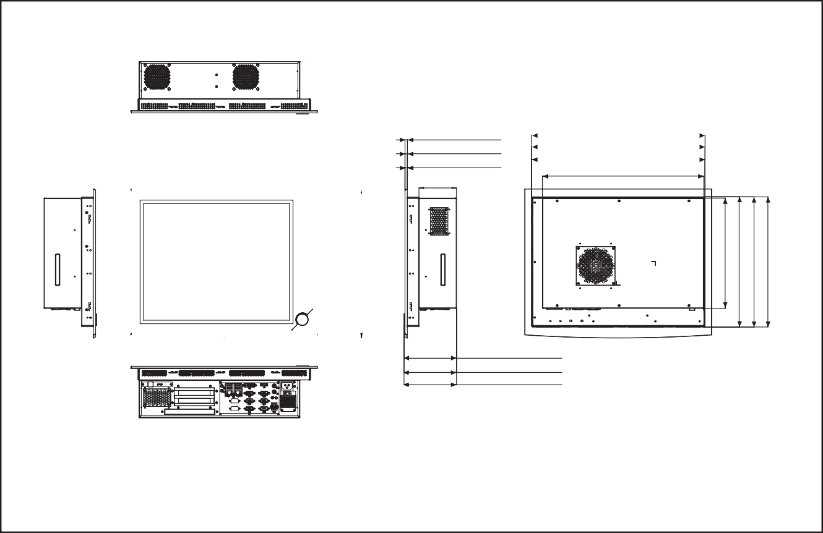Touchscreen
Dimensions
Unit: mm [inches]
IPPC-6152A: 449.92 [17.71]
IPPC-6152A: 6 [0.24]
IPPC-6172A: 6 [0.24]
IPPC-6192A: 7 [0.28]
97 [3.82]
IPPC-6152A: 422 [16.61]
IPPC-6152A:126.40 [4.98]
IPPC-6172A: 132.50 [5.22]
IPPC-6192A: 135.50 [5.33]
Panel Cut-out Dimensions:
IPPC-6152A:424x293mm(16.69"x11.54") IPPC-6172A:454x338mm(17.87"x13.31") IPPC-6192A:454x338mm(17.87"x13.31")
416 [16.38]
IPPC-6192A: 445.92 [17.76]
IPPC-6172A: 450.97 [17.75]
 Lifespan 36 million with a silicone rubber of R8 finger, writing rate is by 250g at 2 times/s

I/O View

COM Ports

LAN Ports

DVD ROM

- Light Transmission > 80%
- Type Analog resistive 5-wire

Environment
- Humidity 5 ~ 85% @ 40°C (non-condensing)
- Ingress Protection Front panel: IP65
- Operating Temperature 0 ~ 50°C (32 ~ 122°F)
- Storage Temperature -20 ~ 60°C (-4 ~ 140°F)
- Vibration Protection 5 ~ 500 Hz, 1 Grms random vibration
Power Switch

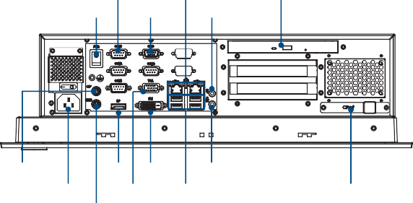
Mouse Port DP
GPIO

DVI Port
Line Out

Mic In

Ordering Information
AC In
VGA
USB 3.0 Ports CFast

- IPPC-6152A-R2AE 15" XGA LED IPPC-61X2-R2 2PCIs w/ TS
IPPC-6192A: 384.60 [15.14]
285 [11.22]
IPPC-6152A: 291 [11.46]
IPPC-6172A: 335.97 [13.23]
IPPC-6192A: 334.52 [13.17]
- IPPC-6172A-R2AE 17" SXGA LED IPPC-61X2-R2 2PCIs w/ TS
- IPPC-6192A-R2AE 19" SXGA LED IPPC-61X2-R2 2PCIs w/ TS

Accessories
- 98R3615210E IPPC-6152A Rack mount Kit
- 98R3617200E IPPC-6172A Rack mount Kit
- 98R3619200E IPPC-6192A Rack mount Kit
- 989KPH1701E CFast module for IPPC-61X2-R2 Series
- 1702002600 Power Cable US Plug 1.8 M
- 1702002605 Power Cable EU Plug 1.8 M
- 1702031801 Power Cable UK Plug 1.8 M
- 1702031836 Power Cable China/Australia Plug 1.8 M
- 96CB-POWER-B-1.8M1 POWER CORD for China 1.8M
- 989KPH3800E PCIE to PCI + PCIE x4
Keyboard Port

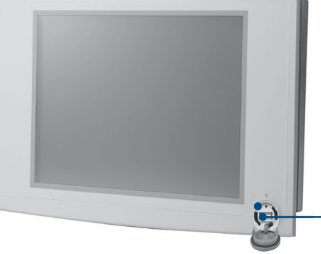
Front Accessible USB Port

Reset Button USB

CPU List

CPU Type List & Description
Model Number | Advantech Part Number | Description
I7-4770S | 96MPI7-3.1-8M10T | CORE 3.1G 8M 1150P 4 CORE I7-4770S
I7-4770TE | 96MPI7-2.3-8M10T | CORE 2.3G 8M 1150P 4 CORE I7-4770TE
I7-4790S | 96MPI7-3.2-8M10T | CORE 3.2G 8M 1150P 4CORE i7-4790S
I5-4670S | -- | CORE 3.8G 6M 4 CORE I5-4670S
I5-4590S | 96MPI5-3.0-6M10T | CORE 3.0G 6M 1150P 4CORE i5-4590S
I5-4570S | 96MPI5-2.9-6M10T | CORE 2.9G 6M 1150P 4 CORE I5-4570S
I5-4570TE | 96MPI5-2.7-4M10T | CORE 2.7G 4M 1150P 2 CORE I5-4570TE
I5-4590T | 96MPI5-2.0-6M10T | CORE 2.0G 6M 1150P 4CORE I5-4590T
I3-4360 | 96MPI3-3.7-4M10T | CORE 3.7G 4M 1150P 2CORE I3-4360
I3-4330 | 96MPI3-3.5-4M10T | CORE 3.5G 4M 1150P 2CORE I3-4330
I3-4350T | 96MPI3-3.1-4M10T | CORE 3.1G 4M 1150P 2CORE I3-4350T
I3-4340TE | 96MPI3-2.6-4M10T | CORE 2.6G 4M 1150P 2CORE I3-4340TE
I3-4330TE | 96MPI3-2.4-4M10T | CORE 2.4G 4M 1150P 2CORE I3-4330TE
G3320TE | 96MPP-2.3-3M10T | PENTIUM 2.3F 3M 1150P TRAY G3320TE
G3420T | -- | Intel® Pentium ® Processor G3420T

Memory List

Memory Type List & Description
Model Number | Advantech Part Number | Description
Transcend TS2KNU28100-3S | 96D3-1G1333NN-TR1 | 1G DDR3-1333 240PIN 128X8 SAM(G)
Apacer 78.A1GC6.421 | 96D3-2G1333NN-AP | 2G DDR3-1333 240PIN 128X8 ELP(G)
Transcend TS5KNU28300-3S | 96D3-2G1333NN-TR2 | 2G DDR3-1333 240PIN 128X8 SAM(G)
Apacer 78.B1GDE.AF1 | 96D3-4G1333NN-AP | 4G DDR3-1333 240PIN 256X8 HYX(G)
Apacer 78.B1GE3.AFF0C | 96D3-4G1600NN-APL | 4G DDR3-1600 240PIN 256X8 VLP HYX(G)
Transcend TS9KNH28300-6M | 96D3-8G1600NN-TR | 8G DDR3-1600 240PIN 512X8 MIC(G)
Apacer 78.C1GET.ATF0C | 96D3-8G1600NN-APL | 8G DDR3-1600 240PIN 512X8 VLP MIC(G)

