IPPC-4001D
Features
5.7”VGA TFT LCD带LED背光
4U 19寸机架式机箱，带14个扩展槽整合式键盘抽屉

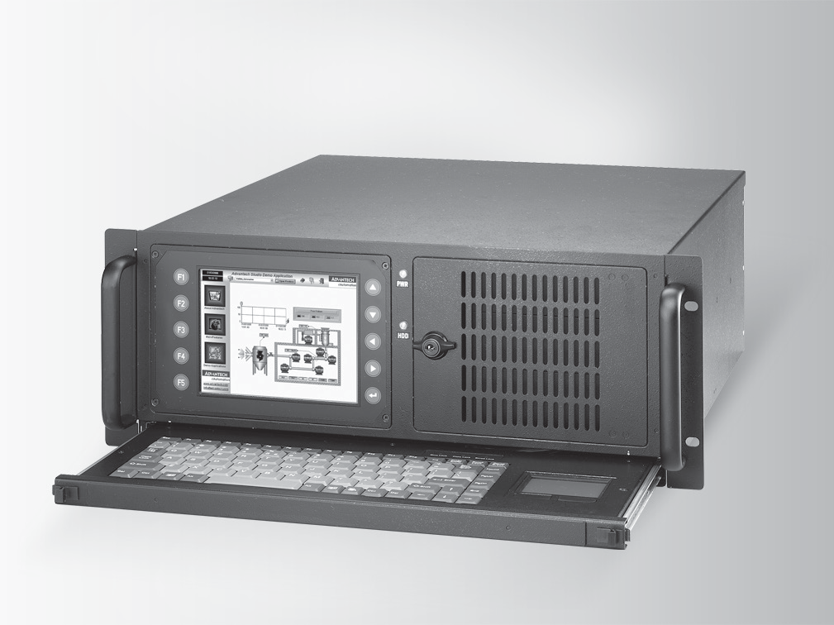
新
主要特点
- 4U 19"机架式机箱，5.7" VGA LED背光显示屏
- 可固定的抽屉式超薄键盘&鼠标
- 支持高性能Intel ® Core™2双核处理器(及以上)
- 提供14个PCI扩展槽
- 可锁固的前面板，利于系统安全
- 带有防水功能薄膜的功能键(F1—F5)，便于各种应用
- 易于操作的屏幕功能，便于进行工业自动化监控
- 前端USB端口便于安插多种USB设备
- 集成的IPC系统，节省了安装LCD/键盘的成本和空间
- 电信/电力站的门户和平台测试和测量设备
- 适用于各种自动化测试设备及生产线测试

产品介绍
IPPC-4001D是一款4U 19寸机架式工业等级强固型平板电脑，带有5.7" VGA TFT LCD背光显示屏，支持多达14个PCI扩展槽。为满足广大传统IPC用户需求，有效节约生产成本，IPPC-4001D采用一体化设计，其带有85键超薄键盘和触摸板抽屉，方便输入，确保输入无故障，5.7" TFT LCD屏幕可完美呈现图表和趋势图等，并可进行简单编程、控制面板操作和现场监测记录等工作。此外，多种研华IPC系列外围设备可与之相连，从而满足不同扩展需求，适合多样工业环境。

产品规格

常规
- 按钮控制 5个覆盖防水薄膜功能键（F1 to F5），5个
光标控制键（上，下，左，右，进入）
- 认证 CE,FCC,CCC
 尺寸（W x H x D） 482 x 174.9 x 486.7 mm (18.97" x 6.88" x 19.16")
- 键盘抽屉 集成88个按键的超薄键盘/触摸板
- 安装 19”机架式
- 电源输入 100 ~ 240 VAC @ 50~ 60 Hz full range 10A
- 电源供电 Watt: 300 W, MTBF: 100,000 hrs
- 重量 20kg

系统硬件
- 存储 3 x 5.25" Disk drive bay
LCD显示
- 背光寿命 50,000 hrs (LED 背光)
 对 比度 800 : 1
- 显示尺寸 5.7"
- 显示类型 VGA TFT LCD
- 流明 700 cd/m2
- 最大色深 262 K (RGB 6-bit)
- 最大分辨率 640 x 480
- OSD控制 开/关，亮度增加/减小
 视 角(H/V°) 160/140

环境
 湿度 5 ~ 85% RH @ 40°C (无凝固)
- 入口保护 前面板IP65
 操作温度 0 ~ 50°C (32 ~ 122°F)
 存储温度 -20 ~ 60°C (-4 ~ 140°F)
- 振动防护 5 ~ 500 Hz, 1 GRMS 随机振动 (操作)

订货信息
- IPPC-4001D-G2AE IPPC-4001D-B0AE无背板

背板建议

 | 料号 | 描述
PICMG 1.0  Full-Size SBC Backplanes | PCA-6114P10-0B2E | 14 slot PICMG BP,2ISA,10PCI,2PICMG RoHS
 | PCA-6114P4 | 14 slot PICMG BP,8ISA,4PCI, 2PICMG RoHS
 | PCA-6113DP4 | 13slot Dual Seg BP,2ISA7PCI 3PICMG 1PICMG/ PCI
PICMG 1.3  Full-Size SHB Backplanes | PCE-5B13-08A1E | 13 Slots PICMG 1.3 BP, 4 PICe,8 PCI, RoHS
 | PCE-5B12-64B1E | 12Slots PICMG1.3BP,1PICe,6PCIX,4PCI RoHS
CPU卡建议

 | 料号 | CPU等级 | 描述
PICMG 1.0 Single Board Computers (SBC) | PCA-6194G2-00A1E | Intel Core 2 Duo (1066/800/533 MHz FSB) | LGA775 Core 2 Duo/ Pentium D/Pentium 4/ Celeron D Processor Card with IPMI/ VGA/ Dual GbE LAN (FSB 1066/800 MHz)
 | PCA-6190VG-00A2E | Intel Pentium 4 (533/800 MHz FSB) | LGA775 Pentium 4/ Celeron Processor Card with VGA/LAN/
 | PCA-6008VG-06A1E | Intel Pentium M/ Celeron M  (533 MHz FSB) | Socket 479 Pentium M/ Celeron M Processor Card with VGA/ DVI/ Dual GbE LAN
PICMG 1.3 System Host Boards | PCE-5125QG2- 00A1E | Intel Core I7 | LGA1156 Q57 FSHB  with DDR3/Core i7/ VGA/DVI/2GbE
 | PCE-5126QG2- 00A1E | Intel Core I7 | LGA1155 Q67 FSHB  with DDR3/Core i7/ VGA/2GbE
 | PCE-5127G2-00A1E | Intel Core I7 | LGA1155 Q77 FSHB  DDR3/Core i7/VGA/ USB3/2GbE

Industrial Panel PCs

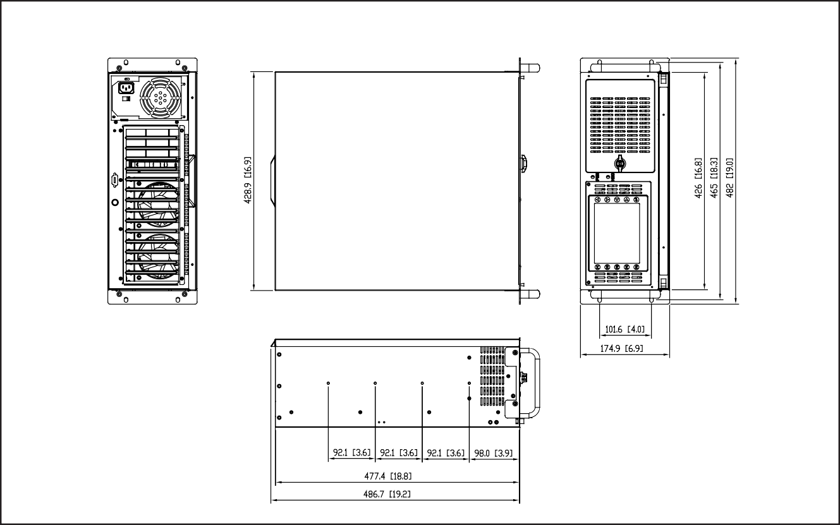IPPC-4001D
单位：mm
尺寸
Dimensions
Unit: mm

附件
- 1702002600 Power Cable US Plug 1.8 M
- 1702002605 Power Cable EU Plug 1.8 M
- 1702031801 Power Cable UK Plug 1.8 M
- 1702031836 Power Cable China/Australia Plug 1.8 M

后视图

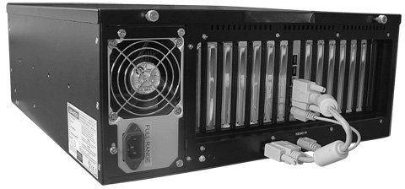
系统视图

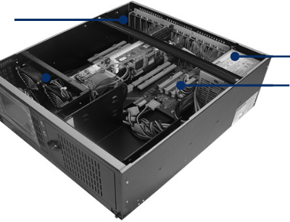
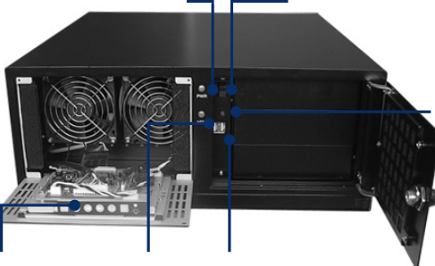PCI Card Holder (with Clamp)
PWR LED
Power On/Off
OSD Controls
HDD LED 2 x USB
System Fan

Reset

PSU
Passive Backplane

Online Download
www.advantech.com/products

