EKI-9728G-4X8CI

Industrial Rackmount L3 Managed Switch with AC/DC

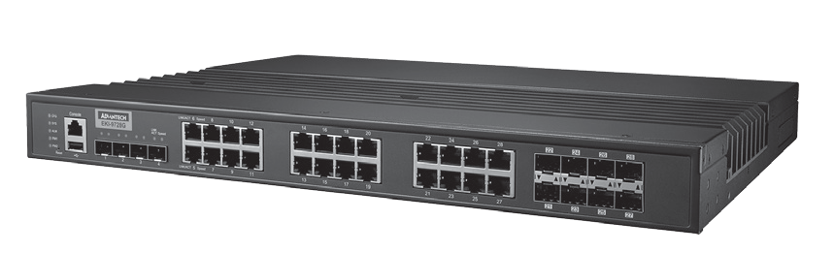
RoHS
COMPLIANT
2002/95/EC
Features
- 16 x Gigabit RJ-45 ports + 4 x 10GbE SFP ports + 8 x Gigabit combo ports
- L3 function: static route, RIP v1/v2, OSPF v2, VRRP
- SFP socket for easy and flexible fiber expansion
- Management: SNMP v1/v2c/v3, WEB, Telnet, standard MIB
- Security: 802.1x HTTPS, SSH, and SNMPv3
- Dual power input and 2 x relay output
- Wide operating temperature range of -40 ~ 85˚C
Introduction
The EKI-9728G is an L3 management switch that supports RIP v1/v2, OSPF v2, and VRRP. Its wide operating temperature of -40 ~ 85°C means that it can operate reliably in harsh environments. Designed with 16 Gigabit ports, 4 10GbE SFP ports, and 8 Gigabit ports, this unit provides abundant and flexible connection options. Finally, the EKI-9728G series feature dual power inputs to ensure system stability, and 2 relay outputs for greater user flexibility.

Specifications

Communications
 Standard IEEE 802.3, 802.3u, 802.3x, 802.3z, 802.1D, 802.1w, 802.1p, 802.1Q, 802.1X, 802.3ad, 802.3ab
- LAN 10/100/1000BASE-TX, optional 100BASE-FX, 1000BASE-SX/LX/LHX/XD/ZX/EZX
- Transmission Distance Ethernet: Up to 100 m (4- wire Cat.5e, Cat.6 RJ45
cable suggested for Gigabit port) SFP: Up to 110 km (depends on SFP)
- Transmission Speed Ethernet: 10/100 Mbps Auto-Negotiation
Gigabit Copper: 10/100/1000 Mbps, Auto-Negotiation Gigabit Fiber: Up to 1000 Mbps

Interface
- Connectors 16 x RJ45 (Ethernet)
8 x RJ45/SFP (mini-GBIC) combo ports 4 x SFP Ports
3-pin removable screw terminal (Power) 4-pin removable screw terminal (Relay)
- LED Indicators 10/100T (X): Link/Activity, Duplex/Collision
Gigabit Copper: Link/Activity, Speed (1000 Mbps) SFP: Link/Activity
- Console RS-232 (RJ45)

Mechanism
- Enclosure IP30, metal shell with solid mounting kits
 Dimensions (W x H x D) 442 x 44 x 352 mm (17.4" x 1.73" x 13.85")
- Mounting 1U 19" Rack mount

Power
- Power Consumption 19.24 W @ 110VAC
- Power Input 90 ~ 264AC/88 ~ 370VDC
- Fault Output 2 Relay Outputs

Protection
- Power Reverse Present
- Overload Current Present

Environment
- Operating Temperature -40 ~ 85°C (-40 ~ 185°F)
- Storage Temperature -40 ~ 85°C (-40 ~ 185°F)
- Operating Humidity 10 ~ 95% (non-condensing)
- Storage Humidity 10 ~ 95% (non-condensing)

Certification
- EMI CE FCC EN55022 Class A
 EMS EN 61000-4-2
EN 61000-4-3
EN 61000-4-4
EN 61000-4-5
EN 61000-4-6
EN 61000-4-8
 Shock IEC 60068-2-27
- Freefall IEC 60068-2-32
- Vibration IEC 60068-2-6

Industrial Ethernet Solutions
All product specifications are subject to change without notice. Last updated: 27-Jun-2018

EKI-9728G-4X8CI

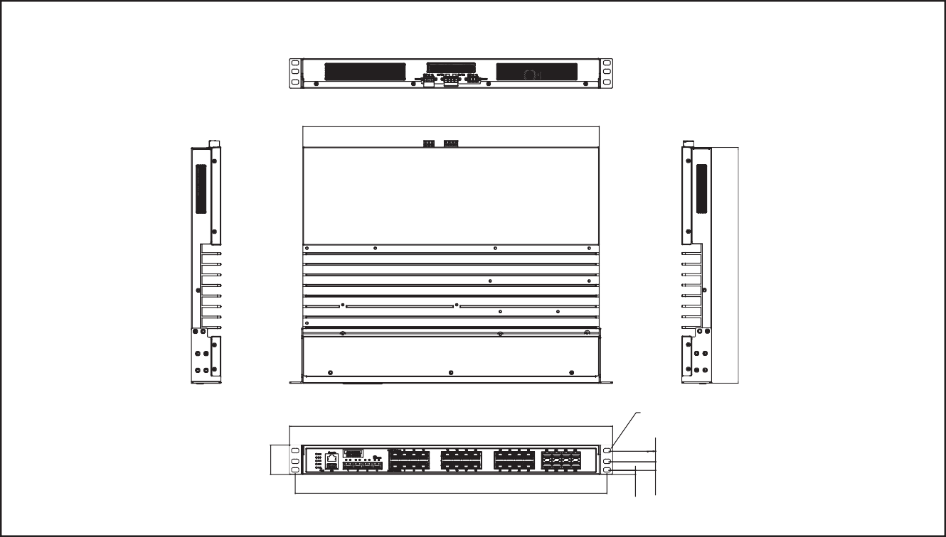L2 Features
465
Ø6.8x10.3 OB Hole
482
442
Unit: mm
Dimensions
44
6.20
12.70 5.90

L2 MAC Address 16K
- Jumbo Frame 12KB
- VLAN Group 4093 (VLAN ID 1~4093)
- VLAN Mac based VLAN, Protocol based VLAN,
IP subnet based VLAN, Port based VLAN, GVRP
- Port Mirroring Per port, Multi-source port
- IP Multicast IGMP Snooping v1/v2/v3, MLD Snooping,
IGMP Immediate leave
- Storm Control Broadcast, Multicast, Unknown unicast
- Spanning Tree IEEE 802.1D-STP, IEEE 802.1s-MSTP,
IEEE 802.1w-RSTP
- Unicast Routing Static Routing, RIPV1/V2, OSPF

QoS
- Priority Queue WRR (Weighted Round Robin), SP (Strict Priority)

Scheduling
- Class of Service IEEE 802.1p based CoS, IP TOS, DSCP based CoS
- Rate Limiting Egress Rate limit, Ingress Rate limit
- Link Aggregation IEEE 802.3ad Dynamic Port Trunking, Static Port
Trunking

Ordering Information
- EKI-9728G-4X8CI-AE Ind. Rackmount L3 Managed Switch with AC/DC

Security
352
- Port Security Static, Dynamic
- Authentication 802.1x (Port-Based), RADIUS, TACACS+
- Advanced Security IP Source Guard

Management
- DHCP Client, Server
- Access SNMP v1/v2c/v3, WEB, Telnet, RMON, Standard MIB, Private MIB
- Security Access SSH 2.0, SSL
- Software Upgrade TFTP, HTTP, Dual Image
- NTP SNTP client

Routing Redunance VRRP

Online Download www.advantech.com/products

