EKI-9628G-4CI

24G+4G Combo Ports Industrial L3 Managed Switch

Features
- Rackmount 24G+4G combo port L3 managed switch
- L3 function: static route, NAT
- SFP socket for easy and flexible fiber expansion
- Management: SNMP v1/v2c/v3, WEB, Telnet, standard MIB
- Security: 802.1x ,HTTPS, SSH, and SNMPv3
- Redundancy: Gigabit X-Ring Pro (ultra-high-speed recovery time, <20 ms), RSTP/STP (802.1w/1D), MSTP
- Wide operating temperature range of -40 ~ 70°C

RoHS
COMPLIANT
2002/95/EC

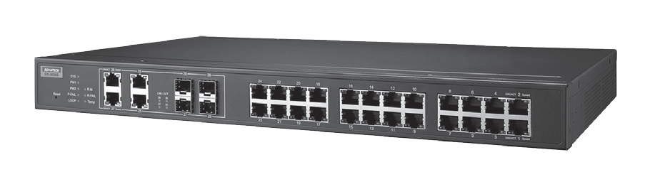Introduction
The EKI-9628G is an industrial-class L3 managed switch that supports static route and NAT. Embedded with 24 Gigabit ports and 4 Gigabit combo ports, it is designed for rackmount installation and can be deployed in demanding industrial environments. It is suitable for edge-to-core industrial networks and supports operating temperatures of -40 ~ 70°C. It is also embedded with Advantech IXM, which benefits users with fast deployment, which can dramatically save on engineering time and cost.

Specifications

Communications
 Standard IEEE 802.3, 802.3u, 802.3x, 802.3z, 802.1D, 802.1w, 802.1p, 802.1Q, 802.1X, 802.3ad, 802.3ab
- LAN 10/100/1000BASE-TX, optional 100BASE-FX, 1000BASE-SX/LX/LHX/XD/ZX/EZX
- Transmission Distance Ethernet: Up to 100 m (4- wire Cat.5e, Cat.6 RJ45
cable suggested for Gigabit port) SFP: Up to 110 km (depends on SFP)
- Transmission Speed Gigabit Copper: 10/100/1000 Mbps, Auto-Negotiation
Gigabit Fiber: Up to 1000 Mbps

Interface
- Connectors 24 x RJ45 (Ethernet)
4 x RJ45/SFP (mini-GBIC) combo ports 4-pin removable screw terminal (Power) 3-pin removable screw terminal (Relay)
- LED Indicators 10/100T (X): Link/Activity, Duplex/Collision
Gigabit Copper: Link/Activity, Speed (1000 Mbps) SFP: Link/Activity
- Console RS-232 (RJ45)

Management
- Configuration Web browser, Telnet, Serial console, TFTP, SNMPv1/
v2c/v3, Port Speed/Duplex Configuration, IPv6
- VLAN IEEE 802.1Q, GVRP
- Redundancy Advantech X-Ring, 802.1w/D RSTP/STP
- Security IP Access security, port security, DHCP client, 802.1X Port Access Control,
- Traffic Control IGMP Snooping/Query for multicast group
management, Port Trunking, Static/802.3ad LACP, Rate limit and storm control, IEEE 802.1p QoS CoS/TOS/ DSCP priority queuing, IEEE 802.3x flow control
- Diagnostics Port Mirroring, Real-time traffic statistic, MAC Address
Table, SNTP, Syslog, E-Mail Alert, SNMP Trap, RMON
- Unicast Routing NAT,Static routing

Mechanism
- Enclosure IP30, metal shell with solid mounting kits
 Dimensions (W x H x D) 438 x 43.6 x 259.20 mm (17.24" x 1.72" x 10.2")
- Mounting 1U 19" Rack mount

Power
- Power Consumption 20W @ 24V
- Power Input 12-48 VDC
- Fault Output 2 Relay Outputs

Protection
- Power Reverse Present
- Overload Current Present
- Environment
- Operating Temperature -40 ~ 70°C (-40 ~ 158°F)
- Storage Temperature -40 ~ 85°C (-40 ~ 185°F)
- Operating Humidity 10 ~ 95% (non-condensing)
- Storage Humidity 10 ~ 95% (non-condensing)
- MTBF 787,940 hours

Certification

Industrial Ethernet Solutions
All product specifications are subject to change without notice. Last updated: 27-Jun-2018

EKI-9628G-4CI
12 [0.47]

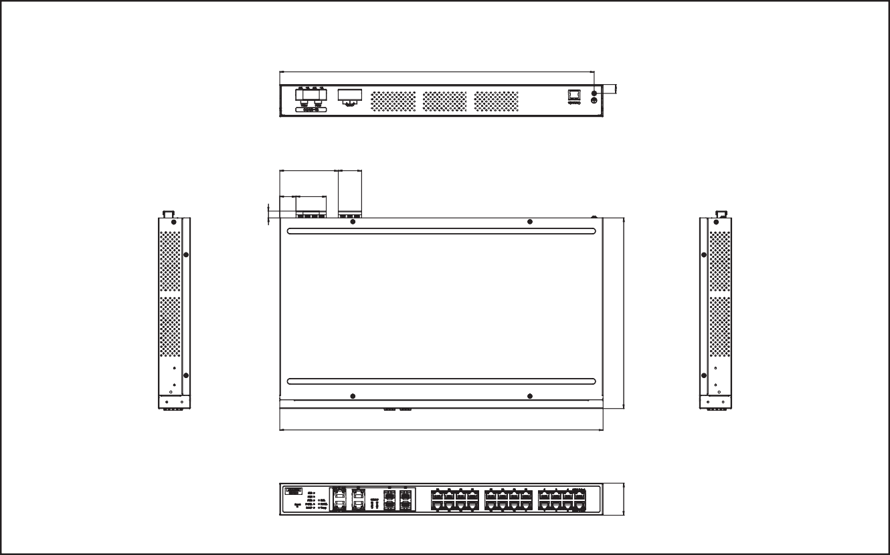 Safety UL 61010-2-201
438 [17.24]
79.30 31.50
[3.12] [1.24]
22 41
[0.87] [1.61]
426 [16.77]
Unit: mm [inch]
Dimensions
43.60
[1.72]
 EMI CE FCC EN55022 Class A
 EMS EN 61000-4-2
EN 61000-4-3
EN 61000-4-4
EN 61000-4-5
EN 61000-4-6
EN 61000-4-8
 Shock IEC 60068-2-27
- Freefall IEC 60068-2-32
- Vibration IEC 60068-2-6
- Railway Track Side EN 50121-4
- Patent http://www.advantech.com/legal/patent

Ordering Information
- EKI-9628G-4CI-AE 24GE +4G Combo Port L3 rackmount Managed
Ethernet Switch w/ Wide Temp

9.20
[0.36]
259.20 [10.20]

Online Download www.advantech.com/products

