EKI-7712G-4FMPI

6G PoE + 2G Mega PoE + 4G SFP Port Gigabit Managed Redundant Industrial Mega PoE Switch

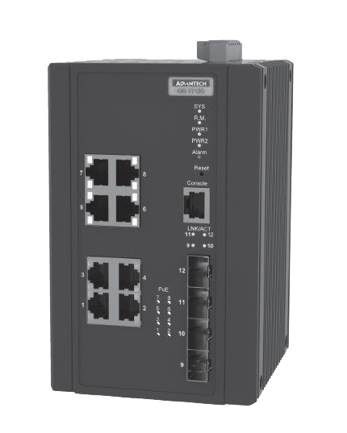
Preliminary
Features
- Support IEEE 802.3bt Class 8 90W Mega PoE, 6 x IEEE 802.3 af/at PoE Gigabit ports + 2 x IEEE 802.3 bt PoE Gigabit ports + 4 SFP ports
- SFP socket for easy and flexible fiber expansion
- Redundancy: X-Ring Pro (ultra-high-speed recovery time, <20 ms), RSTP/STP (802.1w/1D)
- IXM function enables fast deployment
- Security: 802.1x (port-based, MD5/TLS/TTLS/PEAP encryption), RADIUS
- Management: SNMP v1/v2c/v3, WEB, Telnet, standard MIB, private MIB
- NEMA TS2 for traffic control
- EN50121-4 approval for railway trackside deployment
- -40 ~ 70°C wide-range operating temperature
- Dual 48 VDC power input and 1 x relay output

RoHS
COMPLIANT
2011/65/EU

Introduction
The EKI-7712G-4FMPI is a next generation PoE switch which supports IEEE 802.3bt Class 8 90W PoE for high-powered application. Combined with 6 x 802.3 af/at PoE Gigabit ports, 2 x 802.3 bt PoE Gigabit ports, and 4 x SFP ports, EKI-7712G-4FMPI provides multiple usage for different scenario. The EKI-7712G-4FMPI is embedded with Advantech’s IXM function, which can benefit users with fast deployment and can save considerably engineering time and costs. It also supports NMS to help IT managers with networking maintenance and failure prevention. The series are also equipped with X-Ring Pro, which can achieve ultra-high-speed recovery times of <20 ms to ensure network stability.

Specifications

Interface
 I/O Port 8 x 10/100/1000BASE-T/TX RJ-45
4 x SFP (mini-GBIC) port
- Console port RS-232 (RJ45)
- Power Connector 6-pin screw Terminal Block (including relay)

Physical
- Enclosure Metal Shell
- Protection Class IP 30
- Installation DIN-Rail
 Dimensions (W x H x D) 97 x 152 x 105 mm (3.819" x 5.984" x 4.134")

LED Display
- System LED PWR1, PWR2, SYS, Alarm and R.M.
- Port LED Link / Speed / Activity

Environment
- Operating Temperature -40 ~ 70°C (-40 ~ 158°F)
- Storage Temperature -40 ~ 85°C
- Ambient Relative Humidity 10 ~ 95% (non-condensing)
- Humidity 10 ~ 95% (non-condensing)

Power
- Power Consumption 20W @ 48VDC (System)
- Power Input 48 VDC (46 to 57 VDC),
53 -57 VDC is recommended for 802.3at and 802.3bt, redundant dual power input
- Power Budget 370W
- Fault Output 1 Relay Output

Certification
- Safety UL 61010
- EMI CE, FCC Class A
 EMS EN 61000-4-2
EN 61000-4-3
EN 61000-4-4
EN 61000-4-5
EN 61000-4-6
EN 61000-4-8
 Shock IEC 60068-2-27
- Freefall IEC 60068-2-32
- Vibration IEC 60068-2-6
- Traffic control NEMA TS2
- Railway Track Side EN 50121-4
- Patent http://www.advantech.com/legal/patent

L2 Features
- L2 MAC Address 8K
- Jumbo Frame 9216 Bytes
- VLAN Group 256 (VLAN ID 1 ~ 4094)
- VLAN Arrange Port based VLAN, Q-in-Q (VLAN Stacking), GVRP
- Port Mirroring Per port, Multi-source port,
- IP Multicast IGMP Snooping v1/v2/v3, MLD Snooping, IGMP Immediate leave
- Storm Control Broadcast, Multicast, Unknown unicast
- Redundancy IEEE 802.1D-STP, IEEE 802.1s-MSTP, IEEE
802.1w-RSTP, X-Ring Pro, with ultra high-speed recovery time less than 20ms

Industrial Ethernet Solutions
All product specifications are subject to change without notice. Last updated: 5-Sep-2018

EKI-7712G-4FMPI
71.450 [2.813]
15 60.250
[0.591] [2.372]
71.100 [2.799]

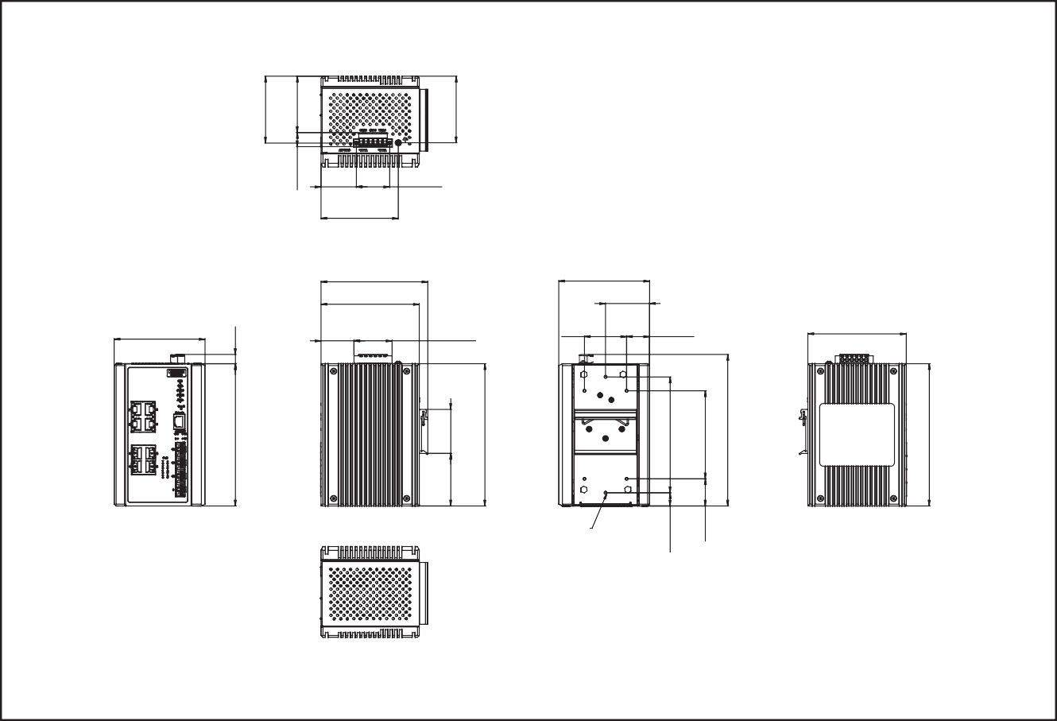QoS
Panel Cut-out Dimensions: 105 x 152 x 97 (4.134" x 5.98" x 3.819")
6-M3xP0.5 Draw Hole
105 [4.134]
97 [3.819]
47 [1.850]
45 24.500
[1.772] [0.965]
40.640
[1.600]
35.180
[1.385]
97 [3.819]
37.720 35.560
[1.485] [1.400]
84 [3.287]

114 [4.488]
105 [4.134]
Unit: mm [inch]
Dimensions
14.100 123.800
[0.555] [5.984]
29 [1.142] 94 [3.701]
161.900 [6.374]
- Priority Queue WRR (Weighted Round Robin), SP (Strict Scheduling
Scheduling Priority) Hybrid Priority
- Class of Service IEEE 802.1p Based CoS, IP TOS, DSCP based CoS
- Rate Limiting Ingress Rate limit, Egress Rate limit
- Link Aggregation IEEE 802.3ad Dynamic Port Trunking, Static Port
Trunking

Ordering Information
- EKI-7712G-4FMPI-AE 6G PoE + 2G Mega PoE + 4G SFP PoE Ethernet Switch
w/Wide Temp

Security
152 [5.984]
9.900 [0.390]
56.181 47 [2.212] [1.850]
152 [5.984]
152 [5.984]
- Port Security Static, Dynamic IP Source Guard, ARP Spoofing
Prevention, Access Control List, DHCP Snooping,
- Authentication 802.1x (Port-Based, MD5/TLS/TTLS/PEAP
Encryption), TACACS+

Management
- DHCP Client, Server, Option66/67/82
- Access SNMP v1/v2c/v3, WEB, Telnet, RMON, Standard MIB, Private MIB
- Security access SSH2.0, SSL
- Software upgrade TFTP, HTTP, Dual Image
- NTP SNTP client

Online Download www.advantech.com/products

