**EKI-7428G-4CI EKI-7428G-4CPI**

# 24G+4G Combo port L2 Managed Switch

**24G+4G Combo port L2 Managed PoE Switch**

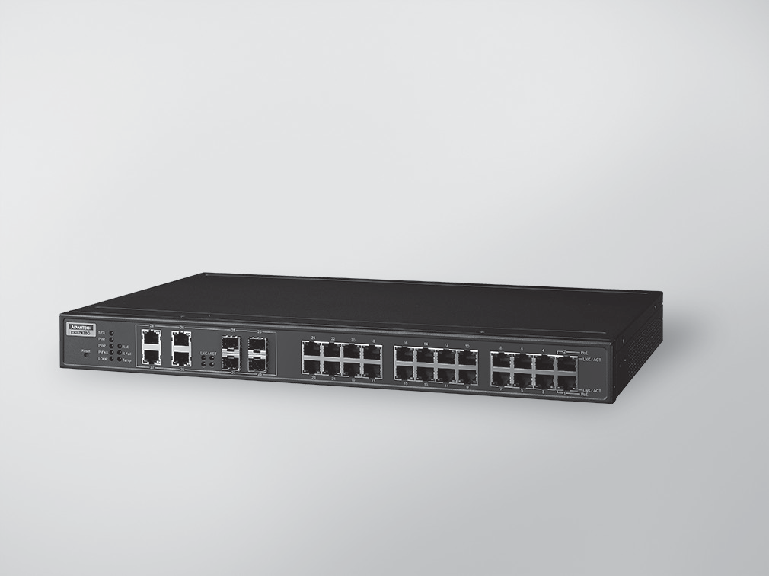

RoHS

**COMPLIANT**

2002/95/EC

**Features**

* 24 x IEEE 802.3 af/at PoE Gigabit ports + 4 x Gigabit Copper/SFP combo ports, provide up to 30Watts per port
* SFP socket for Easy and Flexible Fiber Expansion
* Management: SNMP v1/v2c/v3, WEB, Telnet, Standard MIB
* IXM function enables fast deployment
* Security:802.1x (Port-Based, MD5/TLS/TTLS/PEAP Encryption),HTTPS,SSH and SNMPv3
* Redundancy: Gigabit X-Ring Pro (ultra high-speed recovery time < 20 ms), RSTP/STP (802.1w/1D),MSTP
* 48VDC power input (46-57 VDC for POE af , 53 -57 VDC is recommended for at) and 2 relay output
* -40 ~ 70°C wide-range operating temperature
* Support Security Pack to against internal and external cyber threats

**Introduction**

The EKI-7428G is an industrial-class layer 2 full managed switch including 24 Gigabit ports and 4 Gigabit combo ports. It is designed for rack-mount installation, and can be deployed in demanding industrial environments. It is suitable for edge to core industrial networks. It integrates Layer 2 switching software, which is optimized for scale and performance, delivering wire speed across all ports up to 56 Gbps for layer 2 traffic forwarding. In addition, the PoE design provides up to 30 watts per port to fulfill high power consumption device, moreover, it supports high reliability with -40 ~ 70°C operating temperatures, and dual 48 VDC input power design ensure vital network capabilities with minimum downtime. It is also embedded with Advantech IXM, which benefits users by giving them fast deployment and can dramatically save engineer's time and costs.

# Specifications

## Communications

 **Standard** IEEE 802.3, 802.3u, 802.3x, 802.3z, 802.1D, 802.1w, 802.1p, 802.1Q, 802.1X, 802.3ad, 802.3ab

* **LAN** 10/100/1000Base-T (X), Optional 100Base-FX, 1000Base-SX/LX/LHX/XD/ZX/EZX
* **Transmission Distance** Ethernet: Up to 100 m (4- wire Cat.5e, Cat.6 RJ45

cable suggested for Gigabit port) SFP: Up to 110 km (depends on SFP)

* **Transmission Speed** Gigabit Copper: 10/100/1000 Mbps, Auto-Negotiation

Gigabit Fiber: Up to 1000 Mbps

## Interface

* **Connectors** 24 x RJ45 (Ethernet)

4 x RJ45/SFP (mini-GBIC) combo ports 4-pin removable screw terminal (Power) 3-pin removable screw terminal (Relay)

* **LED Indicators** 10/100T (X): Link/Activity, Duplex/Collision

Gigabit Copper: Link/Activity, Speed (1000 Mbps) SFP: Link/Activity

* **Console** RS-232 (RJ45)

## Network Management

* **Configuration** Web browser, Telnet, Serial console, TFTP, SNMPv1/

v2c/v3, Port Speed/Duplex Configuration, IPv6

* **VLAN** IEEE 802.1Q, GVRP, Port-based VLAN
* **Redundancy** Advantech X-Ring, 802.1w/1D/1s RSTP/STP/MSTP
* **Security** IP Security, SSH, SSL, SNMPV3, HTTPS, IP Source Guard, DHCP Snooping, ARP Spoofing Prevention, 802.1X, TACACS+, Access Control List
* **Traffic Control** IGMP Snooping/Query for multicast group

management, Port Trunking, Static/802.3ad, LACP Rate limit and storm control, IEEE 802.1p QoS CoS/TOS/ DSCP priority queuing, IEEE 802.3x flow control

* **Diagnostics** Port Mirroring, Real-time traffic statistic, MAC Address

Table, SNTP, Syslog, E-Mail Alert, SNMP Trap, RMON

## Mechanism

* **Enclosure** IP30, metal shell with solid mounting kits

 **Dimensions (W x H x D)** 438 x 43.6 x 259.20 mm (17.24" x 1.72" x 10.2")

* **Mounting** 1U 19" Rack mount

## Power

* **Power Consumption** 20W @ 24V (EKI-7428G-4CI)

20W @ 48V (EKI-7428G-4CPI)

* **Power Budget** 685W (EKI-7428G-4CPI)
* **Power Input** EKI-7428G-4CI 12-48 VDC

EKI-7428G-4CPI 48 VDC (46 to 57 VDC),

53 -57 VDC is recommended for 802.3at

* **Fault Output** 2 Relay Outputs

## Protection

* **Power Reverse** Present
* **Overload Current** Present

**Industrial Ethernet Soultions**

All product specifications are subject to change without notice. Last updated: 22-Jun-2018

# EKI-7428-4CI EKI-7428-4CPI

12 [0.47]

## Environment

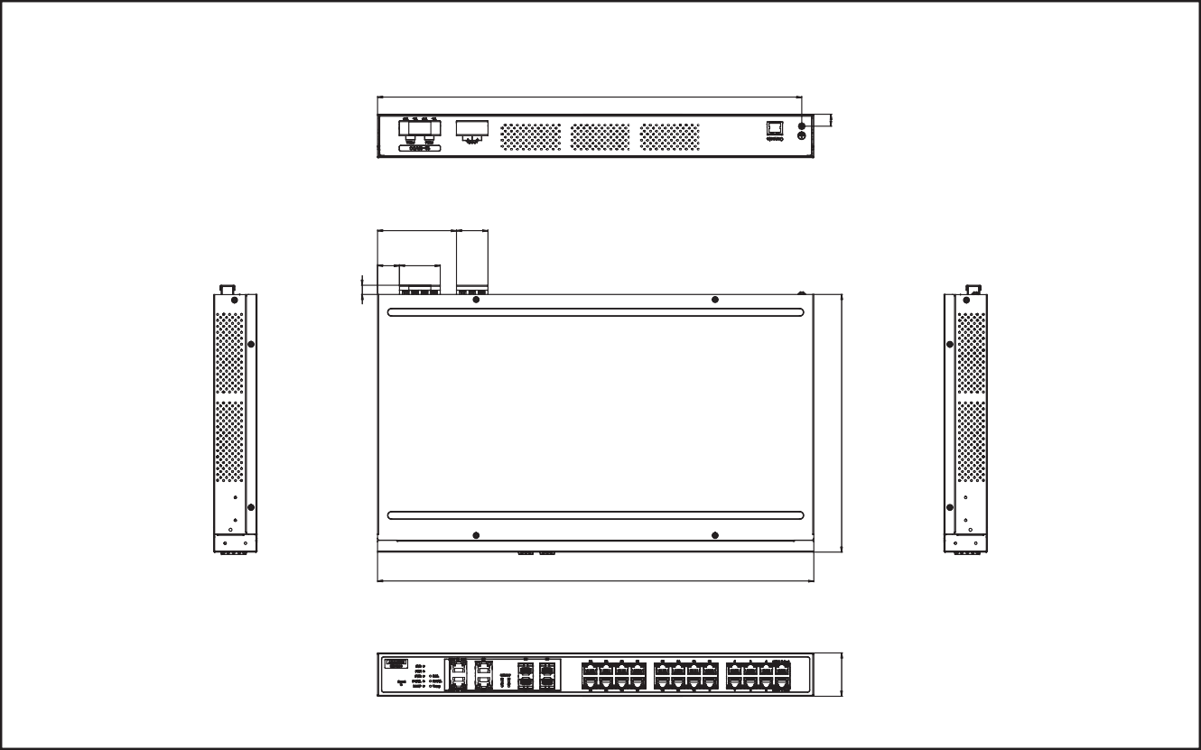

438 [17.24]

79.30 31.50

[3.12] [1.24]

22 41

[0.87] [1.61]

426 [16.77]

Unit: mm [inch]

**Dimensions**

43.60

[1.72]

* **Operating Temperature** -40 ~ 70°C (-40 ~ 158°F)
* **Storage Temperature** -40 ~ 85°C (-40 ~ 185°F)
* **Operating Humidity** 10 ~ 95% (non-condensing)
* **Storage Humidity** 10 ~ 95% (non-condensing)

 **MTBF** EKI-7428-4CI: 787,940 hours EKI-7428G-4CPI: 424,517 hours

# Ordering Information

* **EKI-7428G-4CI-AE** 24GE+4G Combo Port Managed Ethernet Switch w/ Wide Temp
* **EKI-7428G-4CPI-AE** 24G+4G Combo Port POE Managed Ethernet Switch

w/ Wide Temp

## Certification

9.20

[0.36]

259.20 [10.20]

 **Safety** UL 61010-2-201

* **EMI** CE FCC EN55022 Class A

 **EMS** EN 61000-4-2

EN 61000-4-3

EN 61000-4-4

EN 61000-4-5

EN 61000-4-6

EN 61000-4-8

 **Shock** IEC 60068-2-27

* **Freefall** IEC 60068-2-32
* **Vibration** IEC 60068-2-6
* **Railway Track Side** EN 50121-4
* **Patent** <http://www.advantech.com/legal/patent>

**Online Download** [www.advantech.com/products](http://www.advantech.com/products)