# 5-port Gigabit Unmanaged Industrial Ethernet Switch

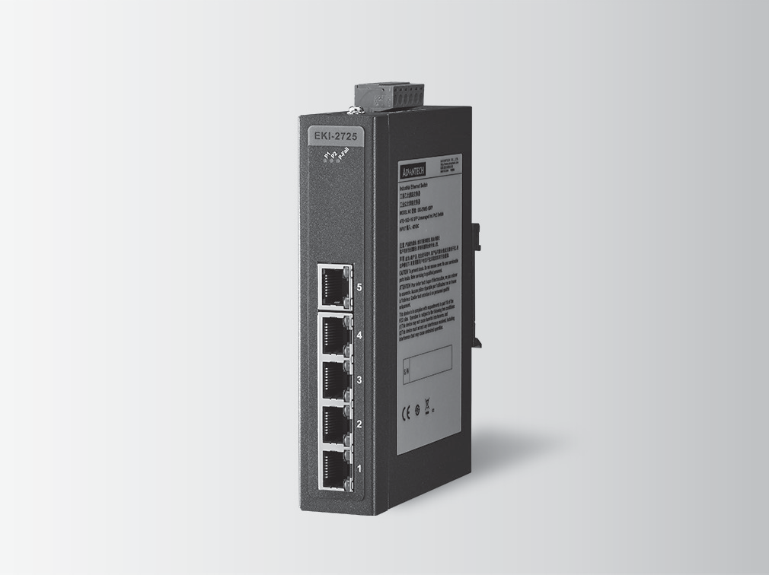

**Features**

* Provides 5 Gigabit Ethernet ports with Auto MDI/MDI-X
* Supports 10/100/1000 Mbps Auto Negotiation
* Supports jumbo frame transmission up to 9kbytes
* Provides Slim size, DIN-rail with IP30 metal mechanism
* Supports Redundant 12 ~ 48 VDC power input and P-Fail Relay

**EKI-2725/I**

**Introduction**

The EKI-2725 supports Gigabit Ethernet. The power is a +12 ~ 48 VDC redundant input design, and is secured with a double protection mechanism: Power Polarity Reverse Protect and an Overload Current Fuse. The former tolerates reverse power wiring while the later secures the system from overload currents. Each port of EKI-2725 has 2 LED’s to show the link status transmission speed and collision status. It also provides a relay output for an event alarm. In the event of a power failure, the built-in LED will activate the alarm to notify administrators. Engineers can simply verify the hardware status by checking the LED, and have troubleshooting easy and quick. EKI-2725 comes with compact metal housing that rates IP30 to help against from dusty industrial environments.



RoHS

**COMPLIANT**

2011/65/EU

# Specifications

## Communications

 **Standard** IEEE 802.3, 802.3u, 802.3x, 802.3ab

 **LAN** 10/100/1000Base-T(X)

* **Transmission Distance** Up to 100 m (4-wire Cat.5e, Cat.6 RJ45 cable)
* **Transmission Speed** Up to 1000 Mbps

## Interface

* **Connectors** 5 x RJ45

6-pin removable screw terminal (power & relay)

* **LED Indicators** P1, P2, P-Fail

10/100/1000T (X): Link/Activity, Duplex/Collision

## Power

* **Power Consumption** 2.5W
* **Power Input** 12 ~ 48 VDC, redundant dual inputs
* **Fault Output** 1 Relay Output

## Mechanism

 **Dimensions (W x H x D)** 30 x 140 x 95 mm (1.18" x 5.51" x 3.74")

* **Enclosure** IP30, Metal shell with solid mounting kits
* **Mounting** DIN-rail, Wall

## Protection

* **Power Reverse** Present
* **Overload current** Present

## Environment

* **Operating Temperature** -10 ~ 60°C (14 ~ 140°F)

-40 ~ 75°C (-40 ~ 167°F) / (I model)

* **Storage Temperature** -40 ~ 85°C (-40 ~ 185°F)
* **Operating Humidity** 10 ~ 95% (non-condensing)
* **Storage Humidity** 10 ~ 95% (non-condensing)
* **MTBF** 2,296,909 hours

## Certifications

* **Safety** UL 60950
* **EMI** CE, FCC Class A

 **EMS** EN 61000-4-2

EN 61000-4-3

EN 61000-4-4

EN 61000-4-5

EN 61000-4-6

EN 61000-4-8

 **Shock** IEC 60068-2-27

* **Freefall** IEC 60068-2-32
* **Vibration** IEC 60068-2-6

**Industrial Communication**

All product specifications are subject to change without notice. Last updated: 12-Feb-2018

# EKI-2725/I

140 [5.5]

15 [0.59]

13.75 [0.54]

150.20 [5.9]

**Ordering Information**

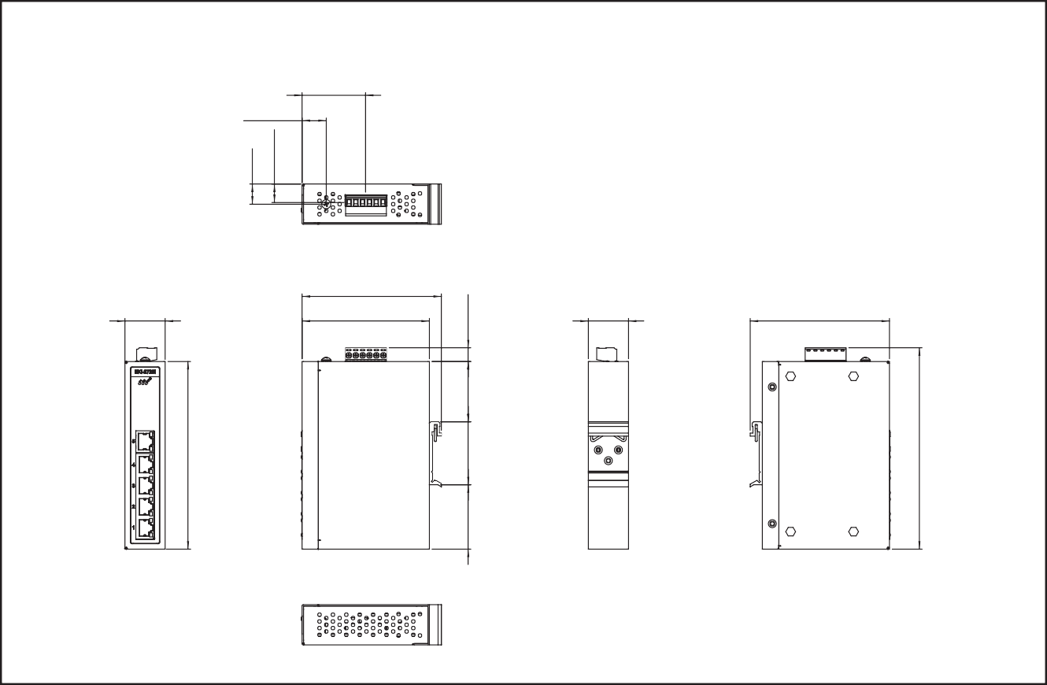

104 [4.09]

30 [1.18]

104 [4.09]

95 [3.74]

30 [1.18]

18 [0.71]

47.30 [1.86]

Unit: [mm]

**Dimensions**

48 [1.89] 47 [1.85] 45 [1.77] 10.20 [0.40]

* **EKI-2725-CE** 5-port Gigabit Unmanaged Switch
* **EKI-2725I-CE** 5-port Gigabit Unmanaged Switch w/wide temp

**Online Download** [www.advantech.com/products](http://www.advantech.com/products)