**EKI-2525PA EKI-2528PAI**

# 5-Port Industrial PoE Switch with 24/48 VDC Power Input

**8-Port Industrial PoE Switch with 24/48 VDC Power Input and Wide Temperature**

**Features**

* 5/8 x fast Ethernet ports with 4 x PoE ports with injector function
* Supports 10/100 Mbps auto negotiation
* Provides broadcast storm protection
* Ethernet ESD protection
* Power line EFT protection
* Slim size, DIN rail/wall mount options
* IP30-rated enclosure
* Redundant 24/48 VDC power input and P-Fail relay
* Operating temperatures of -10 to 60°C (EKI-2525PA) and -40 ~ 75°C (EKI-2528PAI)

   



RoHS

**COMPLIANT**

2002/95/EC

# Introduction

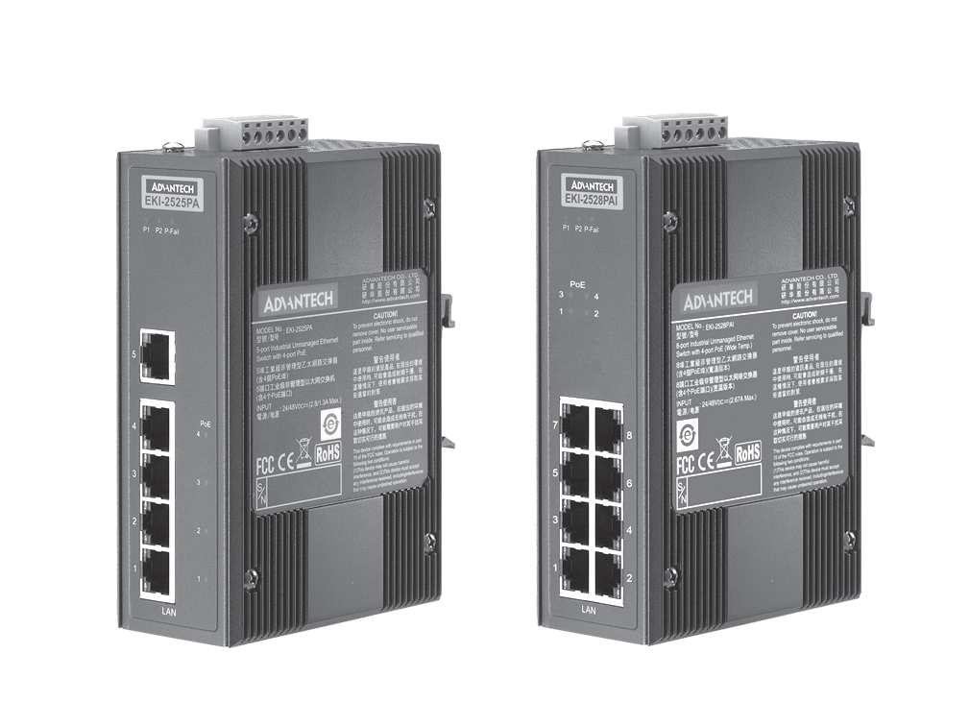

**EKI-2525PA**

**EKI-2528PAI**

The EKI-2525PA and EKI-2528PAI are 5/8-port unmanaged PoE industrial Ethernet switches with 4 PoE ports classified as power source equipment. These PoE switches realize a centralized power supply, providing up to 15.4 W of power per port. Advantech EKI PoE switches can be implemented to power IEEE 802.3af-compliant powered devices via Ethernet cable, thus eliminating the need for additional wiring. Advantech EKI PoE switches come equipped with all the standard features of the EKI family. Furthermore, they offer a 24/48 VDC redundant power input design and are secured with a double protection mechanism: power polarity reverse protect and an overload current resettable fuse. Advantech EKI PoE devices come with an IP30-rated compact metal housing to protect against dust in industrial environments.

# Specifications

## Communications

 **Standard** IEEE 802.3, 802.3u, 802.3x, 802.3af

* **LAN** 10/100BASE-TX
* **Transmission Distance** Up to 100 m
* **Transmission Speed** Up to 100 Mbps

## Interface

* **Connectors** PoE Ports: 4 (Ports 1 ~ 4)

Ethernet ports: 1 (Port 5 ~ Port 8), EKI-2525PA

Ethernet ports: 4 (Port 5 ~ Port 8), EKI-2528PAI 6-pin removable screw terminal (power & relay)

* **LED Indicators** P1, P2, P-Fail

10/100TX: Link/Activity, Duplex/Collision

## Power

* **Power Consumption** EKI-2525PA: 62.5 W (Full load PoE)

EKI-2528PAI: 65 W (Full load PoE)

* **Power Input** 24/48 VDC, redundant dual inputs
* **Power Output** 15.4 W at 48 V (per PoE port)
* **Fault Output** 1 Relay Output

## Mechanism

 **Dimensions (W x H x D)** 48.6 x 140 x 95 mm (1.91" x 5.51" x 3.74")

* **Enclosure** IP30, Metal shell with solid mounting kits
* **Mounting** DIN-rail, Wall

## Protection

* **Reverse Polarity** Present
* **Overload current** Present

## Environment

* **Operating Temperature** -10 ~ 60°C (14 ~ 140°F) (EKI-2525PA) Wide temp. model -40 ~ 75°C (-40 ~ 167°F) (EKI-2528PAI)
* **Storage Temperature** -40 ~ 85°C (-40 ~ 185°F)
* **Operating Humidity** 5 ~ 95% (non-condensing)
* **Storage Humidity** 0 ~ 95% (non-condensing)
* **MTBF** EKI-2525PA: 196,813 hours EKI-2528PAI: 241,413 hours



## Certification

* **Safety** UL508
* **EMI** FCC Part 15 Subpart B Class A, EN 55022 Class A

 **EMS** EN 61000-4-2

EN 61000-4-3

EN 61000-4-4

EN 61000-4-5

EN 61000-4-6

EN 61000-4-8

 **Shock** IEC 60068-2-27

* **Freefall** IEC 60068-2-32
* **Vibration** IEC 60068-2-6
* **Patent** <http://www.advantech.com/legal/patent>

**Industrial Ethernet Solutions**

All product specifications are subject to change without notice. Last updated: 29-Oct-2018

# EKI-2525PA EKI-2528PAI

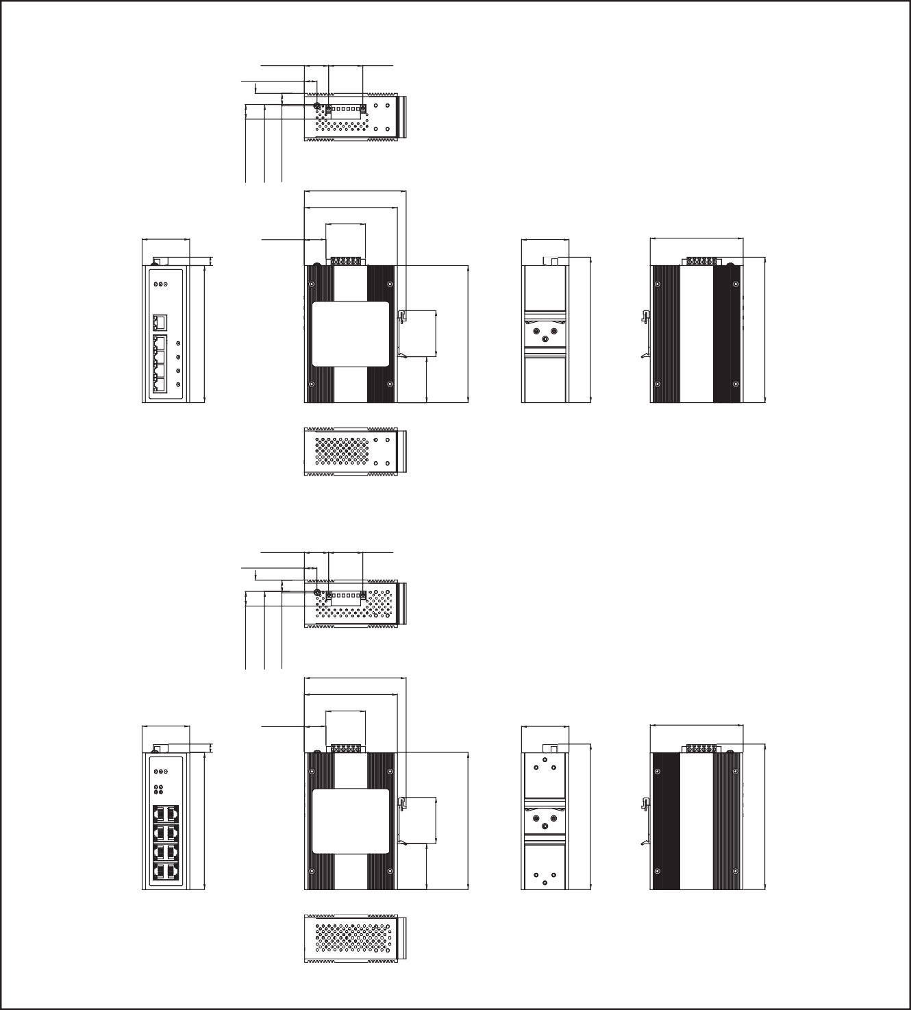**Dimensions**

## EKI-2525PA

24.80 [0.98] 35.00 [1.38]

13.00 [0.51]

Unit: mm [inch]

48.60 [1.91]

148.50 [5.85]

148.50 [5.85]

104.00 [4.10]

95.00 [3.74]

15.00 [0.59]

11.40 [0.45]

12.80 [0.50]

40.00 [1.58]

22.30 [0.88]

140.00 [5.52]

8.50

[0.33]

48.60 [1.91]

46.95

[1.85]

47.05

[1.85]

140.00 [5.52]

95.00 [3.74]

## EKI-2528PAI

**Panel Cut-out Dimensions: 104 x 140 x 48.6 mm (4.1" x 5.52" x 1.91")**

24.80 [0.98] 35.00 [1.38]

13.00 [0.51]

48.60 [1.91]

148.50 [5.85]

148.50 [5.85]

104.00 [4.10]

95.00 [3.74]

15.00 [0.59]

11.40 [0.45]

12.80 [0.50]

40.00 [1.58]

22.30 [0.88] 48.60 [1.91]

140.00 [5.52]

8.50

[0.33]

47.05

[1.85]

140.00 [5.52]

95.00 [3.74]

## Panel Cut-out Dimensions: 104 x 140 x 48.6 mm (4.1" x 5.52" x 1.91")

46.95

[1.85]

**Ordering Information**

* **EKI-2525PA** 5-port Switch with 4 port-PoE and 24/48 VDC Power

Input

* **EKI-2528PAI** 8-port Switch with 4 port-PoE and 24/48 VDC Power Input (Wide Temp)

**Online Download** [www.advantech.com/products](http://www.advantech.com/products)