AIMB-705
LGA1151 6th/7th Generation Intel® Core™ i7/i5/i3/Pentium®/Celeron® ATX with DVI/ VGA, DDR4, SATA III, USB 3.0 & 6 COMs

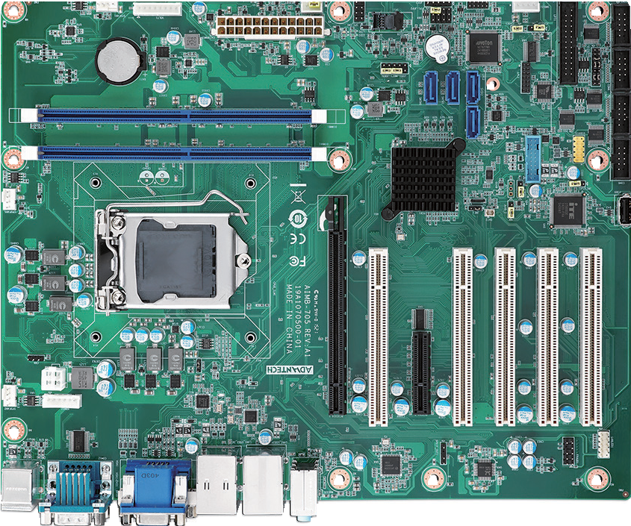
USB3.0
4 SATA III LPT
RS-232/422/485
DDR4 2133 MHz
RS-232
2 USB2.0

USB Type A
PCIe x16
5 PCI
PCIe x4
KBMS1
VGA + DVI
AUDIO1
RS-232 Dual GbE with
2 USB3.0 & 2 USB2.0
Features
- Intel® 6th/7th generation Core™ i7/i5/i3/Pentium®/Celeron® processor
- Dual channel (Non-ECC) DDR4 1866/2133 up to 32GB
- Supports VGA and DVI display
- Supports SATA3.0, USB3.0, dual GbEs
- Supports 5 RS-232 and 1 RS-232/422/485 serial ports
- 1 PCIe x16 (Gen3) and 1 PCIe x4 (Gen2), and 5 PCI expansion slots Note: Intel 7th generation processors only support Windows 10 (64-bit).

Speciﬁcations

Processor System | CPU | i7-7700 | i7-7700T | i7-6700 | i7-6700TE | i5-7500 | i5-7500T | i5-6500 | i5-6500TE | i3-7101E | i3-7101TE | i3-6100 | i3-6100TE | G4400 | G4400TE | G3900 | G3900TE
 | Speed | 3.6GHz | 2.9GHz | 3.4 GHz | 2.4 GHz | 3.4GHz | 2.7GHz | 3.2 GHz | 2.3 GHz | 3.9GHz | 3.4GHz | 3.7 GHz | 2.7 GHz | 3.3 GHz | 2.9 GHz | 2.8 GHz | 2.6 GHz
 | Cache | 8MB | 8MB | 8 MB | 8 MB | 6MB | 6MB | 6 MB | 6 MB | 3MB | 3MB | 4 MB | 4 MB | 3 MB | 3 MB | 2 MB | 2 MB
 | Socket | LGA 1151
 | Chipset | Intel H110
 | BIOS | AMI 128Mbit SPI Flash
Expansion Slot | PCI | 32-bit/33 MHz, 5 slots
 | PCIe x4 (Gen2) | 2 GB/s per direction, 1 slot
 | PCIe x16 (Gen3) | 16 GB/s per direction, 1 slot
Memory | Technology | Dual Channel(Non-ECC) DDR4 1866/2133 MHz
 | Max Capacity | 32 GB (16 GB per DIMM)
 | Sockets | DDR4 288-pin DIMM x2
Graphics | Controller | Chipset integrated Intel HD Graphics
 | VRAM | Shared system memory is subject to OS
Ethernet | Interface | 10/100/1000 Mbps
 | Controller | GbE LAN1: Intel I219-V, GbE LAN2: Intel I211-AT
 | Connector | RJ-45 x2
SATA | Max Data Transfer Rate | 600 MB/s
 | Channel | 4
Rear I/O | VGA | 1 (Resolution up to 1920 x 1200 @ 60Hz)
 | DVI | 1 for G2 version (Resolution up to 1920 x 1200 @ 60Hz)
 | Ethernet | 2 for G2 version; 1 for VG version
 | USB | 4 (USB3.0 x2, USB2.0 x2)
 | Audio | Line-out, Mic-in
 | Serial | 2
 | PS/2 | 2 (1 x keyboard and 1 x mouse)
Internal Connectors | USB | 1 (Type A); 2 (USB2.0, Pin-header); 2 (USB3.0, Box-header)
 | Serial | 4 for G2 version (3 x RS-232, box-header; 1 x RS-232/422/485 with auto-flow control, box-header)
 | Parallel | 1
 | GPIO | 8 bits
Watchdog Timer | Output | System reset
 | Interval | Programmable 1 - 255 sec
Power Requirement | Test Environment | Intel Core i7-6700 3.4GHz; DDR4 2133 8GB x 2
 | Voltage | 3.3V |  |  | 5V |  |  | 12V |  |  | 5Vsb |  |  | -5V |  |  | -12V
 | Current | 0.49A |  |  | 3.13A |  |  | 7.88A |  |  | 0.08A |  |  | 0.07A |  |  | 0.07A
Environment |  | Operating |  |  |  |  |  |  |  |  | Non-Operating
 | Temperature | 0 ~ 60 °C (32 ~ 140 °F), depends on CPU speed and cooler solution |  |  |  |  |  |  |  |  | -40 ~ 85 °C (-40 ~ 185 °F)
 | Humidity | 40 °C @ 95% RH Non-condensing |  |  |  |  |  |  |  |  | 60 °C @ 95% RH Non-condensing
Physical Characteristics | Dimensions (L x H) | 304.8 x 244 mm (12" x 9.6")

Industrial Motherboards
All product specifications are subject to change without notice. Last updated: 27-Jun-2018

AIMB-705

DDR4 1866/2133MHz
DDR4 1866/2133MHz
PCIe x16 Slot

Super I/O NCT6776D
2 x RS-232 |  |  | Case Open
PS/2 KB, MS |  |  | Parallel Port
H/W Monitor |  |  | 8-bit GPIO
Watch Dog Timer

Ordering Information
Block Diagram
DDI
Channel A

Channel B
VGA
eDP
PCIe x 16 Gen 3.0
PCIe x 1
HD Audio
PCIe x 4 (Gen 2.0)
600MB/sec
PCIe x 1
33MHz PCI
USB 3.0
PCIe x 1
3 x RS-232
USB 2.0
G2 Only
SPI Bus
LPC Bus
1 x RS-232/422/485
2nd Super I/O F81216AD
LPC Conn.
128Mb SPI BIOS
2 x USB 2.0 (Rear I/O)
2 x USB 2.0 (Pin Header)
1 x USB 2.0 (Internal Type A)
Intel I211-AT NIC
(G2 only)
2 x USB 3.0 (Rear I/O)
2 x USB 3.0 (Pin Header)
5 x PCI Slots
ITE8896
PCIe to PCI Bridge
4 x SATA 3.0
PCIe x4 Slots
ALC 892 Intel HD Audio Codec
Intel I219-V PHY

Intel H110 PCH
VGA Conn.
Chrontel CH7517A-BF

LGA1151 6th/7th Gen Intel Core Processors
DVI Conn. (G2 Only)

Part Number | Chipset | Memory | Display | USB 3.0 | USB 2.0 | COM | GbE LAN | AMT | SATA | SW RAID | Intelligent System Module Support
AIMB-705G2-00A1E | H110 | Non-ECC | VGA + DVI | 4 | 5 | 6 | 2 | No | 4 | No | No
AIMB-705VG-00A1E | H110 | Non-ECC | VGA | 4 | 5 | 2 | 1 | No | 4 | No | No

Packing List

Part Number | Description | Quantity
1700003194 | SATA HDD cable | x2
1700022749-11 | SATA power cable | x1
1960050472T000 | I/O port bracket | x1
2001070511 | Startup manual | x1
2061070501 | Driver CD | x1
I/O View
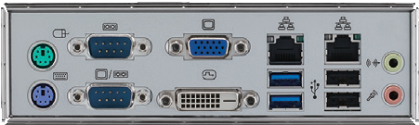
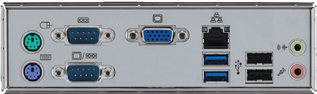
AIMB-705G2-00A1E AIMB-705VG-00A1E

Optional Accessories

Part Number | Description
1701090401 | Single COM port cable(40 cm)
1701092300 | Dual COM port cable(28.5 cm)
1700020294-01 | Printer port cable kit(42 cm)
1700028292-01 | 2-port USB 3.0 cable w/ BKT(30 cm)
1700002204 | 2-port USB 2.0 cable w/ BKT(27 cm)
1960052651N021 | CPU cooler for 2U, 4U, and wallmount chassis
1960049408N001 | CPU cooler for 1U chassis
1960055954T000 | IO bracket for 1U chassis
PCA-COM232-00A1E | 4-port RS-232 LPC module
PCA-TPM-00A1E | TPM module (for BIOS V1.XX)
PCA-TPM-00B1E | TPM2.0 module (for BIOS V2.XX)
Note: Purchasing AIMB-705's proprietary CPU cooler from Advantech is a must. Other brands' CPU coolers are NOT compatible with AIMB-705.

Riser Card

DMI
Part Number | Description
AIMB-RP10P-01A1E | 1U riser card providing 1 PCI slot
AIMB-RP30P-03A1E | 2U riser card providing 3 PCI slots
AIMB-RP3PF-21A1E | 2U riser card providing 1 PCIe x 16 and 2 PCI slots

Online Download www.advantech.com/products

