AIMB-286
Intel® Core™ i7/i5/i3 LGA 1151 Mini-ITX with DP++/HDMI/LVDS(eDP), 6 COM,
Dual LAN, PCIe x4, M.2, DDR4, DC Input

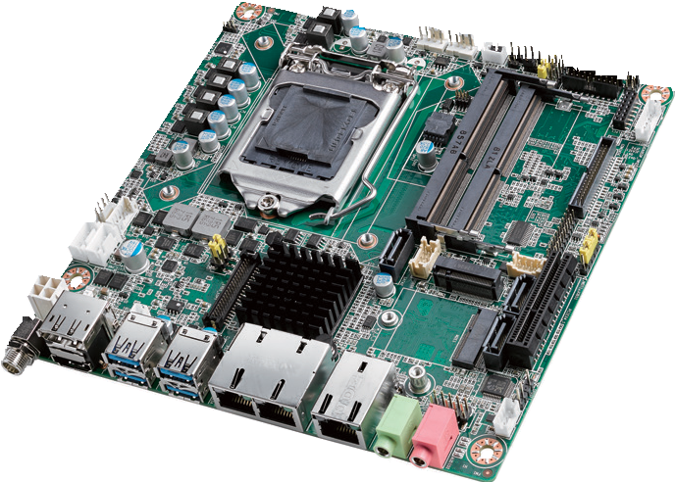
NEW
RoHS
COMPLIANT 2002/95/EC
Features
- Supports Intel® 8th Gen Core™ i processor (LGA1151) with Intel H310 chipset
- Two 260-pin SO-DIMM up to 32GB DDR4 2666 MHz SDRAM
- Supports dual display of DP++/HDMI/LVDs (or eDP)
- Supports PCIe x4 (Gen 3), 1 M.2 B key & 1 M.2 E key, 4 USB 3.0 & 4 USB 2.0 and 3 SATA III
- Supports 12V DC Input and low profile height
- Supports TPM 1.2 / 2.0 (optional)
- Supports WISE-PaaS/RMM and Embedded Software APIs

Software APIs:
SMBus H/W Monitor Watchdog GPIO

Utilities:
BIOS flash Monitoring
Specifications

Processor System | CPU | i7-8700/i7-8700T i5-8500/i5-8500T i3-8100/i3-8100T Pentium G5400/G5400T Celeron G4900/G4900T
 | Core Number | 6/6 6/6 4/4 2/2 2/2
 | Max Speed | 3.2/2.4 GHz 3.0/2.1 GHz 3.6/3.1 GHz 3.7/3.1 GHz 3.1/2.9 GHz
 | SmartCache | 12/12 MB 9/9 MB 6/6 MB 4/4 MB 2/2 MB
 | TDP | 65/35 W 65/35 W 65/35 W 54/35 W 54/35 W
 | Chipset | H310
 | BIOS | AMI EFI 128 Mbit SPI
Expansion Slot | M.2 2, 1 x B key for SSD and 3G/4G (Type: 2242, 3042mm); with SIM card holder  1 x E key for wireless (Type: 2230mm)
 | PCIe x4 (Gen3) | 4 GB/s per direction, 1 slot
Memory | Technology | Dual Channel DDR4 2666 MHz SDRAM
 | Max. Capacity | 32GB (up to 16GB per SO-DIMM)
 | Socket | 2 x 260 PIN DDR4 SO-DIMM (Non-ECC)
Graphics | Controller | Intel HD Graphics
 | LVDS | Supports dual channel 24-bit up to 1920 x 1200 (colay with eDP)
 | HDMI 1.4 | Yes, supports max. resolution 4096 x 2160 @ 24 Hz
 | eDP | Yes, with internal pin header, supports max. resolution 4096 x 2304 @ 60 Hz (BOM optional)
 | Display Port 1.2 | Yes, supports 1 x DP++ with max resolution 4096 x 2304 @ 60 Hz
 | Dual Display | DP+HDMI, DP+LVDS (or eDP), HDMI + LVDS (or eDP)
Ethernet | Interface | 10/100/1000 Mbps
 | Controller | GbE LAN1/2: Realtek 8111G GbE LAN3: Intel i211AT
 | Connector | RJ-45 x 3
SATA | Max Data Transfer Rate | 600 MB/s (SATA 3.0)
 | Channel | 3 (SATA III)
Rear I/O | HDMI | 1 (HDMI 1.4)
 | Display Port 1.2 | 1
 | Ethernet | 3
 | USB | 4 USB 3.0 (USB04 colay with M.2 B key for USB 3.0)
 | Audio | 2 (Mic-in, Line-out)
 | DC Jack | 1
Internal Connector | USB | 4 (USB 2.0)
 | LVDS/inverter | 1
 | Serial | 6 x RS-232 (COM1: RS-232, supports 5V/12V by jumper selection; COM2/3: RS-232/422/485 w/auto flow control, supports RS- 232 by default, RS-422/485 supports by BOM option; COM4/5/6: RS-232)
 | SATA | 3 (SATA 3.0)
M.2 2, 1 x B key for SSD and 3G/4G (M.2 B key USB 3.0 colay with USB04), Type: 2242, 3042mm;
1 x E key for wireless, Type: 2230mm
 | IrDA | -
 | GPIO | 16-bit
Watchdog Timer | Output | System reset
 | Interval | Programmable 1 ~ 255 sec/min
Power Requirements | Input power | 12V DC Input
 | Intel Core i7-8700 3.2GHz, 2pcs 16GB DDR4 2666MHz SDRAM, +12V @ 11.095A
Environment | Operating Non-Operating
 | Temperature | 0 ~ 60° C (32 ~ 140° F), depends on CPU speed and cooler solution -40 ~ 85° C (-40 ~ 185° F)
Physical Characteristics | Dimensions | 170 mm x 170 mm (6.69" x 6.69")

Industrial Motherboards & Systems
All product specifications are subject to change without notice. Last updated: 9-Jan-2019

AIMB-286

Ordering Information
LPC BUS
USB 2.0
SATA/ PCIex2

USB 3.0/2.0
HD Audio
PCIex1
USB 2.0
PCIe x1
USB 3.0
PCIe x1
SATA 3
PCIe x1
Display port
Channel B
Channel A
Display port
PCIe x 4
Display port
Block Diagram
3 x RS-232, 1 x RS-232/422/485
(RS-422/485 support by BOM optional)
1 RS-232, 1 x RS-232/422/485, PS/2, WDT, 16-bit GPIO
Inﬁneon
TPM 1.2/2.0 (Option)

NCT5114D
Super I/O Nuvuton NCT6776

BIOS
M.2 (B key, USB 3.0 colay with USB04)
Audio Codec Realtek ALC892
M.2 (E key)
4 USB 2.0 ports
GbE LAN3: Intel I211AT
4 USB 3.0 ports (USB04 3.0 colay with
M.2 B key)
GbE LAN2: Realtek 8111G

H310
3 SATA III Ports
GbE LAN1: Realtek 8111G
HDMI 1.4
DDR4 2666 MHz SO-DIMM
eDP (optional)
DDR4 2666 MHz SO-DIMM
LVDS 24/48 bits
PCIe x 4 (Gen 3)
Display Port 1.2

Intel 8th Gen Core i7/i5/i3/Pentium/
Celeron processor

P/N | Chipset | DP | LVDS/eDP | HDMI 1.4 | GbE LAN | COM | SATAIII | USB3.0/2.0 | M.2 B key | M.2 E key | PCIex4 | TPM | AMP
AIMB-286F-00A1E | H310 | 1 | 1 / (1) | 1 | 3 | 6 | 3 | 4/4 | 1 | 1 | 1 | (1) | (1)
AIMB-286G2-00A1E | H310 | 1 | 1 / (1) | 1 | 2 | 2 | 3 | 4/4 | 1 | 1 | 1 | (1) | (1)
AIMB-286L-00A1E | H310 | 1 | 0 | 1 | 1 | 2 | 2 | 4/0 | 1 | 1 | 0 | 0 | 0

*() BOM options available on MP version.
Packing List

Part Number | Description | Quantity
1700003194 | SATA HDD cable | 1
1700018785 | SATA power cable (1 port, 25cm) | 1
1701200220 | 1-to-2 serial port cable, 22cm | 1
1960090424T001 | I/O port bracket | 1
1700029538-01 | 1-to-4 serial port cable, 35cm | 1
2046028600 | Startup manual | 1
1700023082-11 | ATX 2*10P to 1*3P-2.0 25cm cable | 1
Optional Chassis

Part Number | Description
AIMB-B2000-15ZE | Mini-ITX chassis with 150W ATX power supply
AIMB-B2000-00YE | Mini-ITX chassis (Optional external AC-DC 60W/84W Adaptor)
I/O View

Optional Accessories

Part Number | Description
1700029428-01 | M cable USB-A 4P(F)*2/2*4P-2.0 25cm
1960053207N001 | LGA1150 CPU cooler for CPU TDP 65W, 92.9 (W) x 92.9 (L) x 46 (H) mm
1960060732N001 | LGA1150 CPU cooler for CPU TDP 45W, 80 (W) x 80 (L) x 32.2 (H) mm
96PSA-A120W12V1 | ADP A/D 100-240V 120W 12V C14 DC Plug 180ŁX
Embedded OS/API

OS/API | Part No. | 968 P/N | Description
Windows 10

SPI
DMI x 4
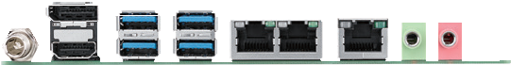

Online Download www.advantech.com/products

