AIMB-276
Intel® Core™ i7/i5/i3 LGA 1151 Mini-ITX with dual DP++/HDMI/LVDS(eDP), 2 COM, Dual LAN, PCIe x16, M.2, DDR4, DC Input

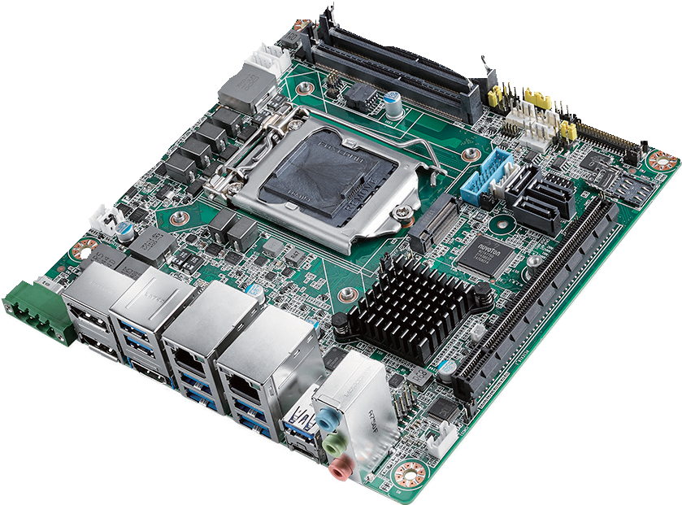
RoHS
COMPLIANT 2002/95/EC
Features
- Supports Intel® 8th Gen Core™ i processor (LGA1151) with Intel Q370 chipset
- Two 260-pin SO-DIMM up to 32GB DDR4 2666 MHz SDRAM
- Supports triple display of DP++/DP++/HDMI/LVDS(eDP)
- Supports PCIe x16 (Gen 3), 1 M.2 B key & 1 M.2 E key, 6 USB 3.1 & 4 USB
3.0 and 3 SATA III
- Support wide range 12V~24V DC Input
- Supports Intel vPro, AMT 12.0, Software RAID 0,1,5,10, TPM 1.2 / 2.0 (optional)
- Supports WISE-PaaS/RMM and Embedded Software APIs

Software APIs:
SMBus H/W Monitor Watchdog GPIO

Utilities:
BIOS flash Monitoring
Specifications

Processor System | CPU | i7-8700/i7-8700T i5-8500/i5-8500T i3-8100/i3-8100T Pentium G5400/G5400T | Celeron G4900/G4900T
 | Core Number | 6/6 6/6 4/4 2/2 | 2/2
 | Max Speed | 3.2/2.4 GHz 3.0/2.1 GHz 3.6/3.1 GHz 3.7/3.1 GHz | 3.1/2.9 GHz
 | SmartCache | 12/12 MB 9/9 MB 6/6 MB 4/4 MB | 2/2 MB
 | TDP | 65/35 W 65/35 W 65/35 W 54/35 W | 54/35 W
 | Chipset | Q370
 | BIOS | AMI EFI 256 Mbit SPI
Expansion Slot | M.2 2, 1 x B key for SSD and 3G/4G (Type: 2242, 3042mm) & 1 x E key for wireless (Type: 2230mm);  B key supports SATA/PCIe lanes by default, USB2.0 support by BOM change
 | PCIe x16 (Gen3) | 16 GB/s per direction, 1 slot
Memory | Technology | Dual Channel DDR4 2666 MHz SDRAM
 | Max. Capacity | 32GB (up to 16GB per SO-DIMM)
 | Socket | 2 x 260 PIN DDR4 SO-DIMM (Non-ECC)
Graphics | Controller | Intel® UHD Graphics 630 / Intel® HD Graphics 615
 | LVDS | Supports dual channel 24-bit up to 1920 x 1200
 | HDMI | Yes, supports max. resolution 4096 x 2160 @60 Hz (HDMI 2.0a)
 | eDP | Yes, with internal pin header, supports max. resolution 4096 x 2304 @ 60 Hz (BOM optional)
 | Display Port 1.2 | Yes, supports 2 x DP++ with max resolution 4096 x 2304 @ 60 Hz
 | Triple Display | DP+DP+HDMI, DP+HDMI+LVDS (or eDP), LVDS(or eDP)+DP+DP
Ethernet | Interface | 10/100/1000 Mbps
 | Controller | GbE LAN1: Intel i219LM; LAN2: Intel I211AT
 | Connector | RJ-45 x 2
SATA | Max Data Transfer Rate | 600 MB/s (SATA 3.0)
 | Channel | 3 (SATA III)
Rear I/O | HDMI | 1 (HDMI 2.0a)
 | Display Port 1.2 | 2
 | Ethernet | 2
 | USB | 6 USB 3.1 + 2 USB USB 3.0 (USB06 is USB 3.1 type C, supports 5V/3A, BOM optional)
 | Audio | 3 (Mic-in, Line-out, Line-in)
 | Phoenix Connector | 1
Internal Connector | USB | 2 (USB 3.0)
 | LVDS/inverter | 1
 | Serial | 2 (1 x RS-232/422/485, 1 x RS-232, supports 5V/12V)
 | SATA | 3 (SATA 3.0)
M.2 2, 1 x B key for SSD and 3G/4G (Type: 2242, 3042mm);
1 x E key for wireless (Type: 2230mm)
 | IrDA | -
 | GPIO | 8-bit
Watchdog Timer | Output | System reset
 | Interval | Programmable 1 ~ 255 sec/min
Power Requirements | Input power | 12 ~ 24V DC Input
 | TBD
Environment | Operating Non-Operating
 | Temperature | 0 ~ 60° C (32 ~ 140° F), depends on CPU speed -40 ~ 85° C (-40 ~ 185° F)  and cooler solution
Physical Characteristics | Dimensions | 170 mm x 170 mm (6.69" x 6.69")

Industrial Motherboards & Systems
All product specifications are subject to change without notice. Last updated: 25-Feb-2019

AIMB-276

Ordering Information
USB 2.0
SATA/ PCIex2
USB 3.0
PCIex1

USB 2.0
USB 3.1
PCIe x1

PCIe x1
SATA 3
Display port
Channel B
Display port
Channel A
Display port
PCIe x 16
Display port
Block Diagram
1 x RS-232 & 1 x RS-232/422/485, PS/2, WDT, 8-bit GPIO
Infineon TPM 1.2/2.0 (Optional)

BIOS
Audio Codec Realtek ALC888S
Super IO Nuvuton 6776D
M.2_B key (USB2.0 support by
BOM change)
4 USB 3.0 ports
M.2_E key
6 USB 3.1 ports, USB06 is optional (type C)
GbE LAN2: Intel I211AT
3 SATA III Ports
GbE LAN1: Intel I219LM

Q370
HDMI 2.0a
DDR4 2666 MHz SO-DIMM
eDP (optional)
LVDS 24/48 bits
DDR4 2666 MHz SO-DIMM
Display Port 1.2
PCIe x 16 (Gen 3)

Intel 8th Gen Core i7/i5/i3/Pentium/
Celeron processor
Display Port 1.2
HD Audio
SPI
LPC

P/N | Chipset | DP | LVDS/eDP | HDMI | GbE LAN | COM | M.2 B key | M.2 E key | SATA III | USB 3.1/3.0 | TPM | AMP | PCIex16 | Power
AIMB-276G2-00A1E | Q370 | 2 | 1/(1) | 1 | 2 | 2 | 1, Type: 2242 & 3042 | 1, Type: 2230 | 3 | 5+(1)/4 | (1) | (1) | 1 | 12~24V (via phoenix connector)
AIMB-276G2-01A1E | Q370 | 2 | 1/(1) | 1 | 2 | 2 | 1, Type: 2242 & 3042 | 1, Type: 2230 | 3 | 5+(1)/4 | (1) | (1) | 1 | 12V (via ATX12V1)

*() BOM options available on MP version.
Packing List

Part Number | Description | Quantity
1700003194 | SATA HDD cable | 1
1700018785 | SATA power cable (1 port, 25cm) | 1
1700022363-01 | 1-to-1 serial port cable 17CM | 2
TBD | I/O port bracket | 1
TBD | Startup manual | 1
1700023082-11 | ATX 2*10P to 1*3P-2.0 25cm cable | 1
Optional Chassis

Part Number | Description
AIMB-B2000-15ZE | Mini-ITX chassis with 150W ATX power supply
AIMB-B2000-00YE | Mini-ITX chassis (Optional external AC-DC 60W/84W Adaptor)
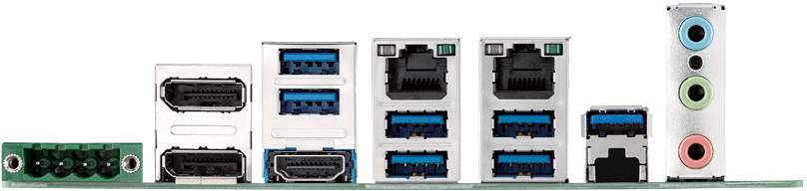
I/O View

Optional Accessories

Part Number | Description
1700020277-01 | Dual port USB 3.0 cable 30cm with IO bracket
1703060191 | KB/MS cable 1*6P-2.0/M-DIN 6P(F)*2, 19cm
1700023768-01 | 1x4P Phoenix to DC Jack 15cm cable
1960053207N001 | LGA1150 CPU cooler for CPU TDP 65W, 92.9 (W) x 92.9 (L) x 46 (H)  mm
1960060732N001 | LGA1150 CPU cooler for CPU TDP 45W, 80 (W) x 80 (L) x 32.2 (H) mm
96PSA-A120W12P4 | ADP A/D 100-240V 120W 12V C14 TERMINAL BLOCK 4P
Embedded OS/API Riser Card
OS/API | Part No. | 968 P/N | Description
Windows 10

Part Number | Description
AIMB-RF10F-01A1E | 1U riser card with 1 PCIex16 expansion
AIMB-RF20F-02A1E | 2U riser card for 1xPCIex16 to 2 PCIex16 (both Lane are PCIEX8 only)

** compliant with AIMB-276G2 (Q370) sku only

DMI x 4

Online Download www.advantech.com/products

