AIMB-227
AMD Merlin Falcon Quad Core Mini-ITX with DP/DVI-D/HDMI, 6COM, and
Dual LAN

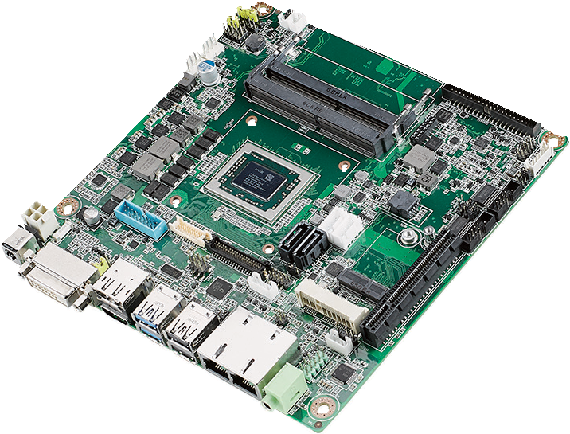
NEW
RoHS
COMPLIANT 2002/95/EC
Features
- Supports AMD Merlin Falcon / Brown Falcon / Prairie Falcon processor
- Two 260-pin SO-DIMM up to 16GB DDR4 2400 SDRAM
- Supports triple display with DP/eDP/LVDS + DVI-D + HDMI
- Supports 1 PCIe x8 and 1 Mini-PCIe expansion slots
 6 COM, 4 USB 2.0, 4 USB 3.0
- Supports WISE-PaaS/RMM and Embedded Software APIs

Software APIs:
SMBus H/W Monitor Brightness Watchdog GPIO

Utilities:
BIOS flash Monitoring
Specifications

Processor System | SOC (28nm) | AMD Quad RX-421BD RX-216GD GX-224IJ
 | Max. Speed | 2.1GHZ (Quad Core 35W) 1.6GHz (Dual Core 15W) 2.4GHz (Dual Core 15W)
 | L2 Cache | 2 Mb 1 Mb 1Mb
 | BIOS | AMI 16 Mbit SPI AMI 16 Mbit SPI AMI 16Mbit SPI
Expansion Slot | M.2 | 1, E key (2230)
 | Mini-PCIe | 1, F/S x 1 support mSATA with SIM card holder
 | PCIe | 1, PCIe x8 (BF and PF support 1 PCIe x4)
Memory | Technology | Dual Channel DDR4 2400MHz SDRAM
 | Max. Capacity | 16 GB/8 GB per SO-DIMM
 | Socket | 2 x 260-pin DDR4 SO-SIMM with ECC Support (PF supports 1 DDR4 SO DIMM slot and no ECC function)
Graphics | Controller | AMD Radeon 3rd Generation GCN (Up to 8 CUs)
 | DVI-D | 1, supports up to SXGA 1920 x 1200
 | eDP Version 1.4 | 1, 2560 x 1600 @ 60Hz Max (Optional)
 | LVDS | 1, supports dual channel 48-bit up to 1920 x colay DP 1.2 port (Optional)
 | Display Port 1.2 | 1, Supports DP++, resolution up to 4096 x 2160 @ 24Hz
 | HDMI V2.0 | 1, 4096 x 2160 @ 60Hz Max (60Hz requires re-timer)
 | Multi Display | Merlin Falcon: DP/eDP/LVDS + DVI-D +HDMI  Brown Falcon & Prairie Falcon: DP/eDP/LVDS + DVI-D
Ethernet | Interface | 10/100/1000 Mbps
 | Controller | GbE LAN1: Realtek 8111G GbE LAN2: Realtek 8111G
 | Connector | RJ-45 x 2
SATA | Max Data Transfer Rate | 600 MB/s
 | Channel | 2, SATA 2 colay mSATA (optional); SATA 1 support SATA-DOM device
Rear I/O | DVI-D (Default) | 1
 | DP1.2 (Default) | 1
 | HDMI (Default) | 1 (Brown Falcon / Prairie Falcon no support)
 | Ethernet | 2
 | USB | 2 x USB 2.0/2 x USB 3.0
 | Audio | 1 (Line out)
 | DC jack | 1 (2.5 mm)
Internal Connector | LVDS & Inverter (Optional) | 1/1
 | eDP (Optional) | 1
 | USB | 2 x USB3.0, 2 x USB2.0
 | Serial | 6 (5 x RS232,1 x RS232/422/485; COM 3 support RS232/422/485 auto flow control; COM6 support 5v/12V by jumper selection; 1 COM support CCtalk ; 1 COM support TTL)
 | SATA | 2
 | SATA PWR Connector | 2
 | PS/2 KB & MS | 1
 | Intrusion Protection | 1
 | GPIO | 8-bit
Watchdog Timer | Output | System reset
 | Interval | Programmable 1 ~ 255 sec/min
Power | Power Type | Single voltage 12V DC input; 1 x External DC jack; 1 x Internal 4-pin (2x2) power connector; Supports AT/ATX mode
 | Typical Power Consumption | TBD
Environment | Operating Non-Operating
 | Temperature | 0 ~ 60° C (32 ~ 140° F) -40 ~ 85° C (-40 ~ 185° F)
Physical Characteristics | Dimensions | 170 mm x 170 mm (6.69" x 6.69")
Industrial Motherboards
All product specifications are subject to change without notice. Last updated: 26-Apr-2018

AIMB-227
LPC
SPI
1 PCIe x 1 / 1 USB 2.0
HD Audio
1 PCIe x 1
USB 3.0
1 PCIe x 1
USB 2.0
1 PCIe x 1
SATA III
PCIe x 8
BF & PF only support PCIe x 4
DDI 3
DDR4 2133 MHz SODIMM
Channel
PF only support 1 SODIMM
DDI 2
DDR4 2133 MHz SODIMM
DDI 1
Colay eDP/LVDS
Block Diagram
PS2 KB/MS, WDT, 8bit GPIO,
Smart Fan, HW.M, 6COM ports

NCT6106D
Infineon TPM 2.0 (optional)
BIOS
M.2 E key (2230)
Realtek Audio codec ALC892
1 F/S mPCIe colay mSATA /SIM card holder
4 USB 3.0
GbE LAN2:
Realtek RTL8111G
4 USB 2.0
GbE LAN1:
Realtek RTL8111G
2 SATAIII ports
1 PCIex8 Slot
HDMI (BF/PF no support)
DVI-D

AMD Merlin Falcon / Brown Falcon / Prairie Falcon Platform
DP++

Ordering Information

Part Number | CPU | Display | TPM | eDP/LVDS | PCIe Slot | USB 3.0/2.0 | GbE | SATA | COM | Thermal Solution
AIMB-227MG2-00A1E | RX-421BD | DP/eDP/LVDS, DVI-D, HDMI | (1) | (1) | x8 | 4/4 | 2 | 2 | 6 | Active
AIMB-227MG2-01A1E | RX-216GD | DP/eDP/LVDS, DVI-D, HDMI | (1) | (1) | x8 | 4/4 | 2 | 2 | 6 | Passive
AIMB-227PG2-02A1E | GX-224IJ | DP/eDP/LVDS, DVI-D | (1) | (1) | x4 | 4/4 | 2 | 2 | 6 | Passive

Note: Passive = fanless; Active = with fan
*() BOM options available on MP version.
Packing List

Part Number | Description | Quantity
1700003194 | SATA HDD cable | 1
1700018785 | SATA power cable | 1
1700008876 | 1-to-4 serial ports cable kit, 35 cm | 1
1700100250 | 1-to-1 serial ports cable kit, 25 cm | 2
1960078398T000 | I/O port bracket | 1
1960054541N031 | CPU Cooler (CPU TDP 35W); RX-421BD | 1
1960083981N001 | CPU Heatsink (CPU TDP<= 15W); RX-216GD, GX-224IJ | 1
2006022700 | Startup manual | 1
Optional Chassis

Part Number | Description
AIMB-B22270G-00YE | EPC-B2227 W/ RX-421BD Barebone system
AIMB-T1227A-00YE | EPC-T1227 W/ RX-216GD Barebone system
I/O View

Optional Accessories

Part Number | Description
1700020277-01 | Dual port USB 3.0 cable 30cm with IO bracket
1700026162-01 | USB 2.0 cable with two ports, 30 cm with bracket
1700023474-01 | 2 port USB cable, F10p/2.0, lock 10-pin(right-up), 345 mm
1700025573-01 | USB 3.0 Cable A CABLE USB 3.0 A/M*2/2*10P 2.0 90D 20CM
1700023082-11 | A cable 2*10P-4.2/1*3P-2.0 15cm
96PSA-A84W12V1 | ADAPTER AC100~240V 84W +12V/7A (FSP)
96PSA-A60W12V1-1 | ADAPTER AC100~240V 60W +12V/5A (FSP)
1702002600 | Power cable 3-pin 180 cm,USA type
1702002605 | Power cable 3-pin 180 cm, Europe type
1702031801 | Power cable 3-pin 180 cm, UK type
1700000237 | Power cable 3-pin PSE Mark 183 cm
1700000596-11 | Power cable 3-pin 180 cm, China type
Embedded OS
Part Number | Description
20706WX6VS0002 | img W10 16VL AIMB-227 64b 1709 ENU  (Merlin Falcon)
20706WX6ES0003 | img W10 16EL AIMB-227 64b 1709 ENU  (Brown Falcon, Prairie Falcon)

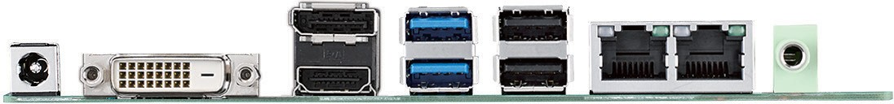

Online Download www.advantech.com/products

