AIMB-216 A2
Intel Pentium & Celeron, Quad Core & Dual core, N3710/N3160/N3010, and Atom Quad Core x5-E8000 Mini-ITX with DVI-D/DP/HDMI, 6 COM, and Dual LAN

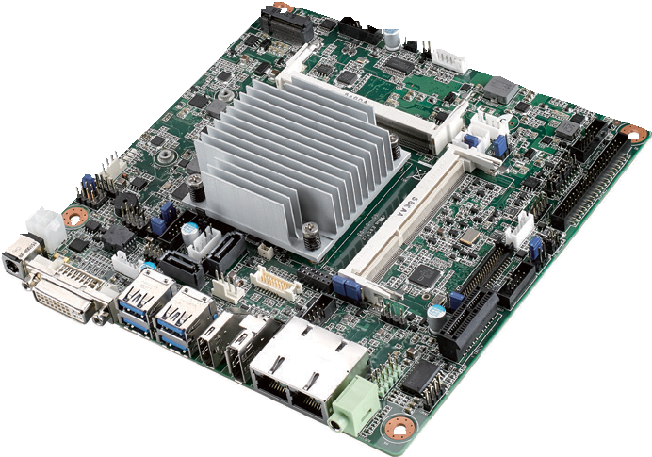
NEW
Features
- Supports Intel Pentium, Celeron Quad Core & Dual Core N3710/N3160 & N3010, and Atom Quad Core x5-E8000 processor
- Two 204-pin SO-DIMM up to 8 GB DDR3L 1600 MHz SDRAM
- Supports DVI-D/DP1.1a/HDMI 1.4b
- Supports 1 PCIE x1 and 1 M.2 (B key) + 1 MiniPCIe, 6 COMs, 4 USB 3.0 and 6 USB 2.0 (USB7/8/9/10 is BOM optional)
- Lower total cost of ownership with DC12V support and onboard TPM1.2/2.0 (optional)
- Supports WISE-PaaS/RMM and Embedded Software APIs
Software APIs:
H/W Monitor Brightness Watchdog GPIO

Utilities:
BIOS flash Monitoring
Specifications

Processor System | CPU (14nm) | Intel N3710 Intel N3160 Intel N3010 Intel x5-E8000
 | Max. Speed | 1.6 GHz (Quad core) 1.6 GHz (Quad core) 1.04 GHz (Dual core) 1.04 GHz (Quad core)
 | L2 Cache | 2 MB 2 MB 2 MB 2 MB
 | BIOS | AMI 64 Mbit SPI
Expansion Slot | M.2 B key for SSD and 3G supported (Type: 2242, 2280)
 | Mini-PCIe | 1 (F/S)
 | PCIe | PCI Express x1 (Gen2), colay MiniPCIe
Memory | Technology | Dual channel DDR3L 1600 MHz SDRAM
 | Max. Capacity | 8 GB/8 GB per SO-DIMM
 | Socket | 2 x 204-pin SO-DIMM (Non-ECC)
Graphics | Controller | Intel Gen 8 Graphics Engines and media encode/decode engine; GPU Frequency: 400 MHz for N3710; 320 MHz for N3160 & N3010
 | DVI-D | Supports up to 3840 x 2160 @ 30Hz
 | HDMI/LVDS | HDMI co-lay with LVDS, HDMI supports up to 3840 x 2160 @ 30Hz; LVDS supports up to 1920 x 1200
 | DP1.1a | 1, Supports up to 3840 x 2160 @ 30Hz; colay eDP supports up to 2560 x 1440 @ 60Hz
 | Triple display | DVI-D+DP+LVDS, DVI-D+DP+HDMI, DVI-D+EDP+LVDS, DVI-D+EDP+HDMI
Ethernet | Interface | 10/100/1000 Mbps
 | Controller | GbE LAN1: Realtek 8111G GbE LAN2: Realtek 8111G
 | Connector | RJ-45 x 2
SATA | Max Data Transfer Rate | 600 MB/s (SATA 3.0)
 | Channel | 2, SATA 2 colay M.2; SATA 1 support SATA-DOM device
Rear I/O | DVI-D | 1
 | DP 1.1a | 1
 | HDMI 1.4b | 1
 | Ethernet | 2
 | USB | 4 (USB 3.0)
 | Audio | 1 (supports Line out, converts to Mic in or Line in)
 | DC jack | 1 (2.5 mm)
Internal Connector | LVDS & Inverter | 1/1
 | eDP | 1 (optional)
 | USB | 6 (USB2.0), USB7/8/9/10 is BOM optional
 | Serial | 6 (5 x RS-232, 1 x RS-232/422/485; COM 3 support RS-232/422/485 auto flow control; COM 6 support 5V/12V by jumper selection)
 | IDE | None
 | SATA | 2
 | SATA PWR Connector | 2
 | Parallel | None
 | Mini-PCIe | 1 (F/S)
 | M.2 1 (B Key for SSD and 3G supported)
 | GPIO | 8-bit
 | PS/2 KB & MS | 1
Watchdog Timer | Output | System reset
 | Interval | Programmable 1 ~ 255 sec/min
Power | Power Type | Single voltage 12V DC input; 1 x External DC jack; 1 x Internal 4-pin (2x2) power connector; Supports AT/ATX mode
 | Typical Power Consumption | Windows Idle mode: 12.6W (Intel N3710 1.6GHz processor/DDR3L 1600MHz 4GB x 2pcs)
Environment | Operating Non-Operating
 | Temperature | 0 ~ 60° C (32 ~ 140° F) with 0.7m/s air flow -40 ~ 85° C (-40 ~ 185° F)
Physical Characteristics | Dimensions | 170 x 170 mm (6.69" x 6.69")

Industrial Motherboards & Systems
All product specifications are subject to change without notice. Last updated: 20-Dec-2017

AIMB-216 A2
SPI
LPC
HD Audio
(PCIex1/USB signal)
PCIe x1
Realtek Audio Codec ALC892
USB 2.0
6 USB 2.0 ports (USB7/8/9/10 is BOM optional)
USB 3.0
PCIe x1
600 MB/s
PCIe x1
48-bit LVDS
Channel A

Channel B
Block Diagram
5 RS-232, 1 RS-232/422/485
8-bit GPIO
Infineon TPM 1.2/2.0 (optional)
Super I/O Nuvoton NCT6106D
BIOS
PCIe x 1 slot
(colay Full-size Mini-PCIe)
Full-size Mini-PCIe (colay PCIex1)
M.2 B key (colay SATA2)
4 USB 3.0 port
2 SATA III Ports (SATA2 colay M.2)
GbE LAN2:
Realtek RTL8111G
DP1.1a
(colay eDP by optional)
GbE LAN1:
Realtek RTL8111G
LVDS (colay HDMI)
DDR3L 1600 MHz SO-DIMM
HDMI 1.4b (colay LVDS)
DDR3L 1600 MHz SO-DIMM

Intel N3710/N3160/ N3010/x5-E8000
DVI-D

Ordering Information

Part Number | CPU | Memory | DP/eDP | DVI-D | HDMI/ LVDS | GbE LAN | COM | SATA III | USB3.0/2.0 | MiniPCIe | M.2 | TPM | AMP | PCIex1 | Thermal Solution | Operating Temp.
AIMB-216D-S6A2E | N3710 | 2 | 1 / (1) | 1 | 1 | 2 | 6 | 2 | 4/2+(4) | 1 | 1 | (1) | (2 x 6W) | 1 | Passive | 0 ~ 60° C
AIMB-216N-S6A2E | N3160 | 2 | 1 / (1) | 1 | 1 | 2 | 6 | 2 | 4/2+(4) | 1 | 1 | (1) | (2 x 6W) | 1 | Passive | 0 ~ 60° C
AIMB-216U-S6A2E | N3010 | 2 | 1 / (1) | 1 | 1 | 2 | 6 | 2 | 4/2+(4) | 1 | 1 | (1) | (2 x 6W) | 1 | Passive | 0 ~ 60° C
AIMB-216L-S6A2E | N3160 | 2 | 0 | 1 | LVDS only | 1 | 2 | 1 (SATA1) | 4/0 | 1 | 0 | (1) | (2 x 6W) | 1 | Passive | 0 ~ 60° C
AIMB-216E-S6A2E | x5-E8000 | 1 | 0 | 1 | HDMI only | 1 | 2 | 1 (SATA1 | 4/0 | 1 | 1 | 0 | 0 | 0 | Passive | 0 ~ 60° C

Note: Passive = fanless
* () BOM options available on MP version

Packing List

Part Number | Description | Quantity
1700003194 | SATA HDD cable | 1
1700018785 | SATA power cable | 1
1700008876 | 1-to-4 serial ports cable kit, 35 cm (only for D/N/U sku) | 1
1700100250 | 1-to-1 serial port cable, 25 cm | 2
19Z0001230T000 | I/O port bracket | 1
2007021610 | Startup manual | 1
1960073060T001 | Fanless heatsink for AIMB-216U/E | 1
1960064228N001 | Fanless heatsink for AIMB-216U | 1
Optional Chassis

Optional Accessories

Part Number | Description
96PSA-A60W12V1-1 | Adapter AC100-240V 60W +12V/5A
96PSA-A84W12V1 | Adaptor AC100-240V 84W, 12V/7A
1703060191 | KBMS cable 1*6P-2.5/DIN-6P(F)*2, 25 cm
1700023474-01 | A Cable USB-A 4P(F)*2/2*5P-2.0 34.5CM F/10
1700024790-01 | A Cable USB-A 4P(F)*2/2*5P-2.0 20CM F/10
Embedded OS/API
OS/API | Part No. | Description
Windows 10 | 2070015014 | img W10 16EL AIMB-216 64bit 1701 ENU (all)
WE8.1 | 2070014774 | img W8.1 IDTP AIMB-216 x64 1609 10MUI
WES7 | 2070014888 | img WES7E AIMB-216 32bit 1609 4MUI
WES7 | 2070014954 | img WES7E AIMB-216 64bit 1701 4MUI

Part Number | Description
AIMB-B2000-00YE | Mini-ITX chassis with optional DC Adaptor

Online Download www.advantech.com/products

