AIMB-205
Intel® Core™ i7/i5/i3 LGA 1151 Mini-ITX with VGA/DP/DVI-D/LVDS(eDP), 8 COM, Dual LAN, PCIe x16, M.2, DDR4

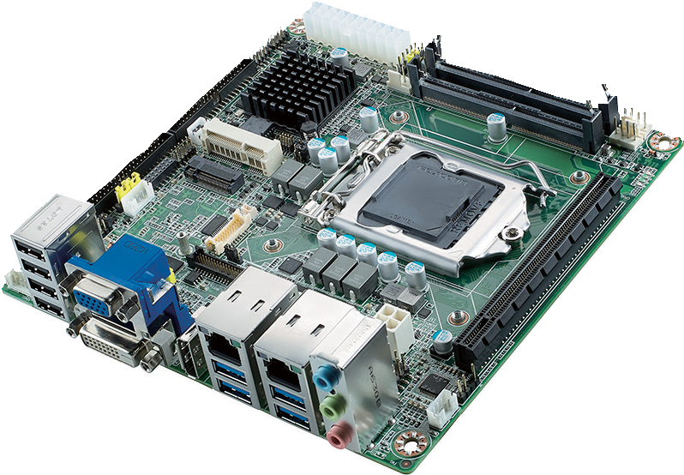
RoHS
COMPLIANT 2002/95/EC
Standard 7
Features
- Supports Intel® 7th Gen Core™ & 6th Gen Core™ i processor /Pentium / Celeron (LGA1151) with Intel H110 chipset
- Two 260-pin SO-DIMM up to 32GB DDR4 2400/2133 MHz SDRAM
- Supports Dual display configuration by multiple interface: DP/DVI-D/VGA/ LVDS(eDP)
- Supports DirectX 12, OpenGL 4.4, OpenCL 2.0 and outstanding 3D graphics performance
- Supports 1 F/S MiniPCIe and 1 M.2 2242 (B key for SSD)

Specifications

Processor System | CPU i7-7700/ i7-6700/ i5-7500/ i5-6500/ i3-7101/ i3-6100/ Pentium Pentium Celeron Celeron  7700T i7-6700TE i5-7500T i5-6500TE i3-7101TE i3-6100TE G4400 G4400TE G3900 G3900TE
 | Core Number 4/4 4/4 4/4 4/4 2/2 2/2 2 2 2 2
Max Speed 3.6GHz/ 3.4GHz/ 3.4GHz/ 3.2GHz/ 3.9GHz/ 3.7GHz/ 3.3G 2.4G 2.8G 2.6G
2.9GHz 2.4GHz 2.7GHz 2.3GHz 3.4GHz 2.7GHz
 | L3 Cache 8M/8M 8M/8M 6M/6M 6M/6M 3M/3M 3M/4M 3M 3M 2M 2M
 | TDP 65W/35W 65W/35W 65W/35W 65W/35W 54W/35W 51W/35W 54W 35W 51W 35W
 | Chipset H110
 | BIOS AMI EFI 128 Mbit SPI
Memory | Technology Dual channel DDR4 2400/2133 MHz non ECC SDRAM (Only supports DDR4 2133 MHz SDRAM for SKL-S CPU)
 | Max. Capacity Up to 32GB (16GB per SO-DIMM)
 | Socket 2 x 260-pin SO-DIMM
Graphics | Controller Integrated Intel® HD Graphics 530
 | VRAM Shared system memory, 2 GB and above, total system memory shared 1 GB maximum video memory
 | VGA Max. resolution 1920 x 1200 @ 60 Hz
 | DVI-D Supports max. resolution 1920 x 1200 @ 60Hz
 | Display Port Max. resolution 4096 x 2160 @ 60Hz
 | LVDS/eDP LVDS: Supports dual channel 24-bit up to 1920 x 1200 / eDP:with internal pin header, supports max. resolution 4096 x 2160 @ 60 Hz
 | Dual Display Yes (DP+VGA, DP+LVDS (or eDP), DP+DVI-D, DVI-D+VGA, DVI-D+LVDS (or eDP), VGA+LVDS (or eDP)
Ethernet | Interface 10/100/1000 Mbps
 | LAN 1 Controller Realtek RTL8111G GbE LAN
 | LAN 2 Controller Realtek RTL8111G GbE LAN
 | Connector 2 x RJ-45
Expansion Slot | M.2 1 M.2 2242 (B key for SSD)
 | Mini PCIe 1 F/S miniPCIe slot support mSATA
 | PCIe x16 (Gen2/3) 1 (16GB/s per direction)
Storage | SATA 3.0 2 (600MB/s per port)
Rear I/O Connector | DVI-D 1
 | VGA 1
 | DisplayPort 1
 | RJ-45 2
 | USB 3.0 4
 | USB 2.0 4
 | Audio 3 (line-in, line-out, mic-in)
Internal Connector | USB 2.0 6 (USB11-14 is BOM optional)
Serial 7 x RS232, 1 x RS232/422/485
COM1: supports 5V/12V by jumper selection, COM2: supports RS-232/422/485 by BIOS selection
 | SATA 3.0 2
 | TPM (optional SLB9660 TPM 1.2/ SLB9665 TPM 2.0)
 | GPIO 1 (8-bit)
Watchdog Timer | Output System reset
 | Interval Programmable 1-255 sec/min
Power Requirements | Input Power ATX  Win Idle 10.43W (Intel core i7-7700 3.6GHz / DDR4 2133MHz 16GB x 2)
Environment | Operation Temperature 0 ~ 60° C (32 ~ 140° F)
 | Non-Operation Temperature -40 ~ 85° C (-40 ~ 185° F)
Physical Characteristics | Dimensions 170 x 170 mm (6.7" x 6.7")

Industrial Motherboards & Systems
All product specifications are subject to change without notice. Last updated: 17-Aug-2017

AIMB-205

Ordering Information
Block Diagram

PCIex 16

Display port
Channel A

eDP

Channel B

DMI x 4

SATA3
PCIe x 1

USB 3.0/2.0
PCIe x 1

USB 2.0

PCIE/USB/SATA

USB 2.0

SATA/PCIEx2/USB
PCIe x 1

HD Audio
NCT6106D
3 x RS-232 &
1 x RS-232/422/485 PS/2 , WDT,
8-bit GPIO
F81216HD
4 x RS232
TPM 1.2/2.0 SLB9660&9665
(optional)
Realtek Audio Codec ALC892
4 USB 2.0 (optional)
1 M.2-B for SSD (2242)
2 USB2.0 (internal)
1 F/S mini PCIe (colay mSATA)
4 USB2.0 ports (rear IO)
GbE LAN2: Realtek 8111G
4 USB3.0 ports (rear IO)
GbE LAN1: Realtek 8111G

Intel H110
2 SATA3 ports
VGA (rear IO)
DDR4 SO-DIMM2
LVDS, colay eDP
DDR4 SO-DIMM1
DP (rear IO)
PCIe x 16 Slot

Intel 7th & 6th Gen Core i / Pentium / Celeron
processor
DVI -D (rear IO)
LPC

P/N | Chipset | DP | DVI-D | VGA | LVDS | GbE LAN | COM | SATA | USB 3.0/2.0 | M.2 | Mini PCIe | TPM | AMP | PCIe x 16
AIMB-205G2-00A1E | H110 | 1 | 1 | 1 | 1 | 2 | 8 | 2 | 4/6 | 1 (1 M.2-B 2242) | 1 F/S | (1) | 1 | 1

*() BOM options available on MP version.

Packing List

Part Number | Description | Quantity
1700003194 | SATA HDD cable | 1
1700008876 | 1-to-4 serial ports, 35 cm | 2
1960082356T000 | I/O port bracket | 1
2006B20500 | Startup manual | 1
Optional Chassis

Part Number | Description
AIMB-B2000-15ZE | Mini-ITX chassis (w/ 150W PSU)
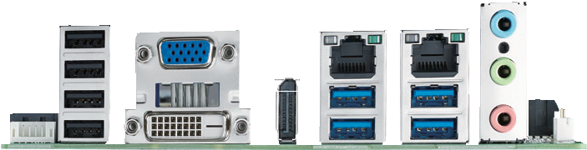
Rear I/O

Optional Accessories

Part Number | Description
1700026162-01 | USB 2.0 cable with two ports, 30 cm with bracket
1960053207N001 | LGA1150 CPU cooler for CPU TDP 65W, 92.9 (W) x 92.9 (L) x 46 (H) mm
1960060732N001 | LGA1150 CPU cooler for CPU TDP 45W, 80 (W) x 80 (L) x 32.2 (H) mm
1703060191 | KB/MS cable 1*6P-2.0/M-DIN 6P(F)*2, 19cm
Embedded OS/API

OS/API | Part No. | Description
Win10 IoT Ent | 2070015197 | img W10 16HL AIMB-205 64b 1701 ENU
Win10 IoT Ent | 2070015198 | img W10 16VL AIMB-205 64b 1701 ENU
WE8.1 | 2070015281 | img W81 IP AIMB-205 64b 1609 ENU
**KBL-S CPU only support windows 10

Online Download www.advantech.com/products

