IPC-510
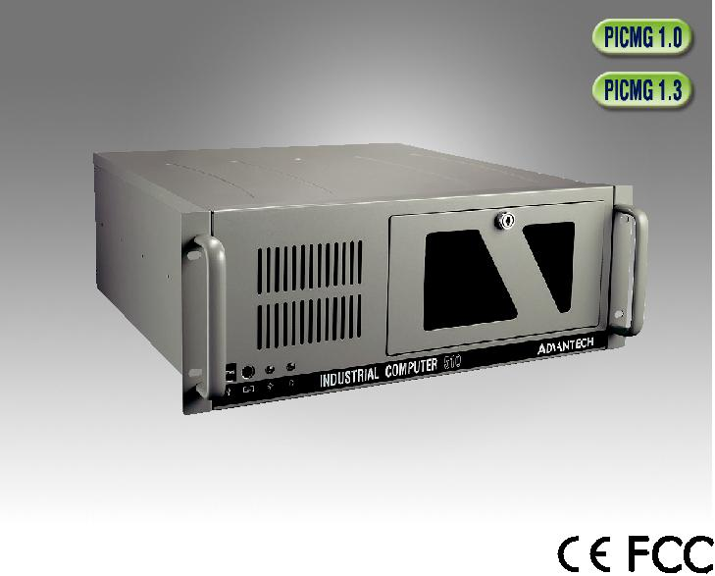

Economical 4U Rackmount Chassis with Front-Accessible USB and PS/2 Interfaces

Features

 Most cost-effective rackmount chassis

 Supports PS/2 single power supply

 Easy-to-install front-accessible drive bays hold 3 x 5.25" and 2 x 3.5" drives (1 x front-accessible and 1 x internal)

 Front-accessible USB and PS/2 interfaces

Specifications
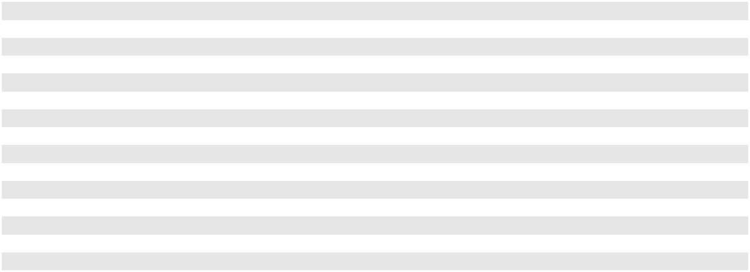

 |  | External | Internal
Drive Bay | 5.25" | 3 | -
 | 3.5" | 1 | 1
Cooling | Fan | 1 (12 cm/77 CFM)
 | Air Filter | Yes
Front I/O | USB | 2
 | PS/2 | 1
Miscellaneous | LED Indicators | Power and HDD activity
 | Rear Panel | Motherboard version: 1 x 9-pin D-Sub and 1 x 68-pin SCSI openings
 |  | Operating | Non-Operating
 | Temperature | 0 ~ 40 °C (32 ~ 104 °F) | -20 ~ 60 °C (-4 ~ 140 °F)
Environment | Humidity | 10 ~ 85% @ 40 °C, non-condensing | 10 ~ 95% @ 40 °C, non-condensing
 | Vibration (5 ~ 500 Hz) | 1 Grms | 2 G
 | Shock | 10 G (with 11 ms duration, half sine wave)
Physical Characteristics | Dimensions (W x H x D) | 481 x 175 x 446 mm (19 x 7 x 17.6")
 | Weight | 10.7 kg (23.5 lb)
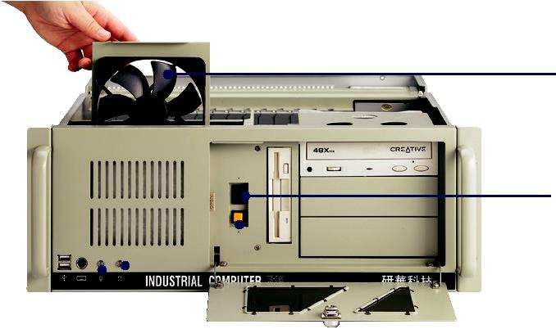
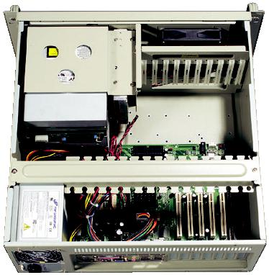

Easy Maintenance
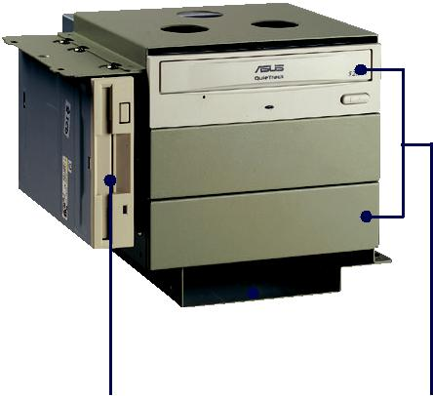
Cooling Fan

Reset
Button

 |  |  |  |  |  |  |  |  |  |  |  | Motherboard
 | HDD |  |  |  |  | LED |  | Power Switch |  | 1 x 3.5" Drive Bay | 3 x 5.25" Drive Bays
 |  |  |  |  |  |  |  |  |  |  |  | (fits 450 mm/17.7" depth)
 |  |  |  |  |  |  |  |  |  | 1 x 3.5" Internal Drive Bay Space
USB and PS/2 Power LED
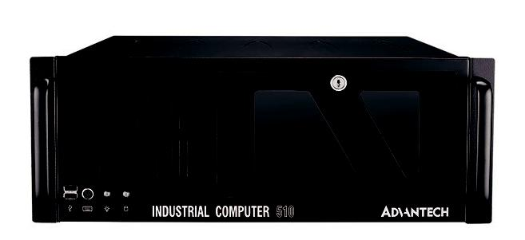

Black Version

Industrial Chassis

All product specifications are subject to change without notice. Last updated: 5-Aug-2019

IPC-510

Dimensions
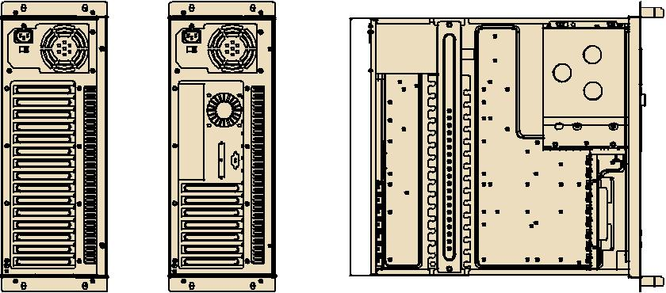

Unit: mm [inch]
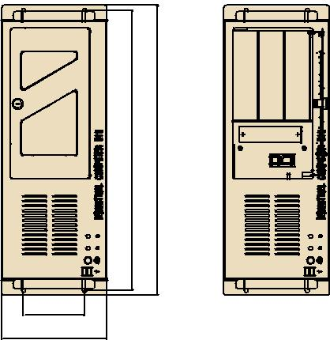

426. [16.79]5 | 464. [18.30]9 | 0481. [18.94]

101.6 [4.00]
485.7 [19.12] _{174.9 [6.89]}
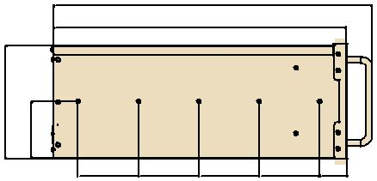
446.2 [17.57]

172. [6.80]7 | 786. [3.42]

92.0 92.0 92.0 92.0 41.9

[3.62] [3.62] [3.62] [3.62] [1.65]

Ordering Information
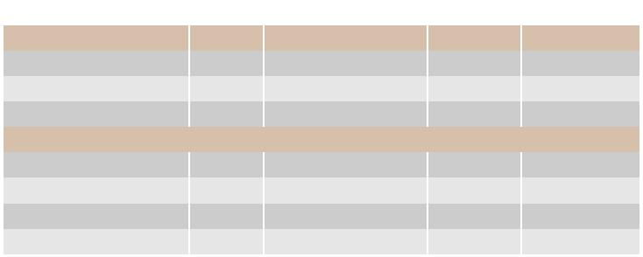

Part Number | Color | Power Supply | Wattage | Switch Type
Backplane Version
IPC-510BP-30CE | Beige | PS8-300ATX-ZBE | 300W | ATX
IPC-510BP-30ZCE | Black | PS8-300ATX-ZBE | 300W | ATX
IPC-510BP-40ZCE | Black | PS8-400ATX-ZE | 400W | ATX
Motherboard Version
IPC-510MB-30CE | Beige | PS8-300ATX-ZBE | 300W | ATX
IPC-510MB-40CE | Beige | PS8-400ATX-ZE | 400W | ATX
IPC-510MB-30ZCE | Black | PS8-300ATX-ZBE | 300W | ATX
IPC-510MB-40ZCE | Black | PS8-400ATX-ZE | 400W | ATX

Optional Accessories

Part Number | Description
IPC-DT-3120E | Mobile rack for converting one 3.5" drive bay into two
 | 2.5" SATA HDD trays
IPC-DT-5230E | Mobile rack for converting two 5.25" drive bays into
 | three 3.5" SATA HDD trays

Spare Parts

Part Number | Description
2130018002T000 | Fan filter 120 x 100 x 15 mm

Online Download www.advantech.com/products

