Machine Vision Solutions

Machine Vision

w w w . i ei w or l d .c om

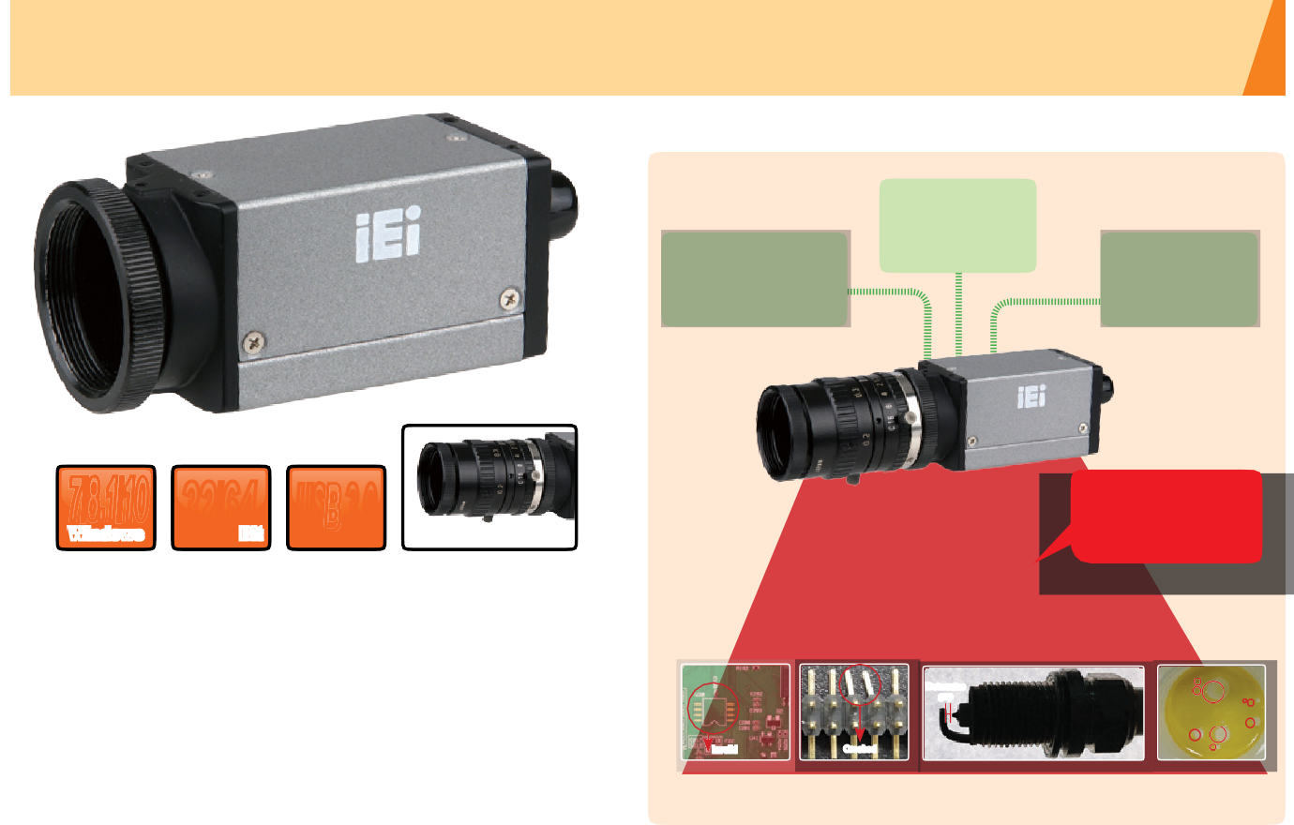
HSC-03M2-O

Lightweight USB 3.0 Camera, Micron MT9V022 CMOS, Global Shutter, 60 FPS at 752x480, without Lens

Demo Codes Provided

)
Open eVision
(Euresys)
Open CV
(Open Source
MIL
(Matrox)

7/8.1/10
Windows

Features
32/64Bit
USB 3.0

HSC-03M2-O
USB 3.0 High Speed C
amera
Capture Card
= +
Camera

- IEI Vision SDK available

Camera Lens (option)
- Compact and lightweight industrial camera with Aptina global shutter CMOS sensor
- Compatible with USB 3.0 SuperSpeed specification
- Resolutions up to 752x480
- Frame rates up to 60 FPS
- Support AMCap and other DirectShow compatible software
- Other commercial vision software supported through DirecShow, ex: Halcon
- IEI Similarity technology can provide image enhancement

Specifications
Camera
Resolution (max.) | 752 x 480
Frame Rate (max.) | 60 FPS
Megapixels | 0.3 MP
Chroma | Mono
Sensor Name | Micron MT9V022
Sensor Type | CMOS
Readout Method | Global shutter
Sensor Format | 1/3-inch
Pixel Size | 6.0 µm
Lens Mount | CS-mount
ADC | 8-bit/10-bit
Auxiliary Output | 3.3 V, 100 mA max
Interface | USB 3.0 interface
Mass | 79g
Compliance | CE, FCC

Invalid

Machine Vision Application Examples

Determine gap

Crooked

Dimensions (Unit: mm)

System Requirement

System | Intel® Core™ i5 or above
Memory | 2GB or more
Software Support

57

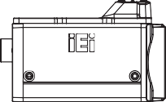

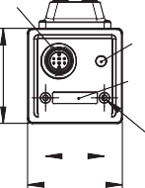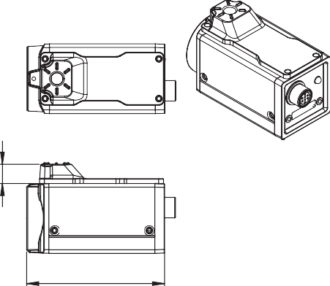Packing List
8

HR25

LED USB 3.0
29
screw M2
29
18

OS Support | Microsoft Windows 7/8.1/10 (32-bit/64-bit)  Operating systems that support UVC
SDK | Windows: Provides SDK and demo program with  sample source code

1 x HSC-03M2-O | 1 x CS to C mount adapter
1 x Mounting bracket | 1 x QIG

Others
Dimensions (mm) | 58.9 mm x 29 mm x 29 mm
Operating Temperature | 0°C ~ 45°C
Storage Temperature | -30°C ~ 60°C
Operating Humidity | 20% ~ 80%
Storage Humidity | 20% ~ 95%
Power Requirements | 5V via external connector or USB 3.0
Power Consumption (max.) | <3.5W

Ordering Information

Part No. | Description
HSC-03M2-O-R10 | Lightweight USB 3.0 camera & opto-isolated, Micron MT9V022 CMOS, global shutter, 60 FPS at 752x480, without Lens
32001-019800-100-RS | USB 3.0 cable, 1800 mm, USB 3.0 A type male and micro USB  3.0 B type male+screw
Note: IEI does not offer Open eVision and MIL software licenses. Please buy the original

HSC-03M2-O-2017-V10
version from their vendors.

