HDC-304E

w w w . i ei w or l d .c om

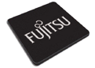PCI Express Video/Audio Capture Card with Four Channel HDMI Inputs and One Channel HDMI Output, 1920x1080@60p, and H.264 Hardware Codec

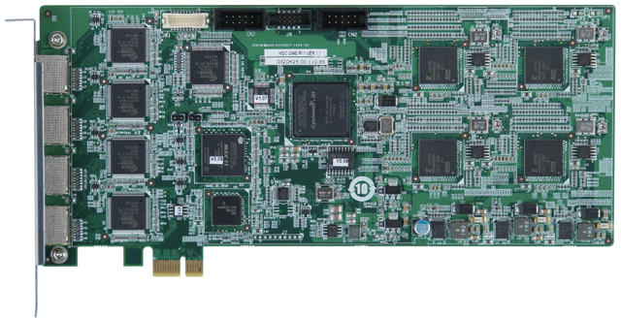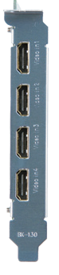1-channel HDMI output
H.264 Hardware Codec

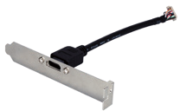
4-channel HDMI input

7/10
32/64
H.264
HDMI output cable

PCIe Bus

Features
Windows
Bit MPEG-4/AVC

- 4-channel HDMI input with H.264 hardware compression and 1-channel HDMI output
- High quality video encoding or decoding up to 1080p60
- HDMI output port supports playback video file captured by HDC-30X
series cards
- Enables the system to support up to 8-channel input by adding multiple video capture cards. The HDC-304E installed in IEI systems and backplanes could support over 8 channel inputs under Linux environment (supported capability may vary depending on customers’ needs).
- Low power consumption
- SDK available for customer to create customized applications
- Windows/Linux OS supported

System Block

Specifications
Interface

Video Input | 4 channels
Video Input type | HDMI
Audio Input | 4 channels
Audio Input Type | HDMI
Video Output | 1 channel
Video Output Type | HDMI output cable kit
Audio Output | 1 channel
Audio Output Type | HDMI output cable kit
Bus Interface | PCIe x1
Loop Through | 1 channel
Video Processing

Video Compression | H.264/AVC High Profile Level 4.2
Input Resolution & Frame Rate | 1920 x 1080 x 60p / 59.94p / 50p 720 x 480 x 60i / 59.94i  1920 x 1080 x 60i / 59.94i / 50i 720 x 576 x 50i  1280 x 720 x 60p / 59.94p / 50p
Record Resolution / Frame Rate / Bit Rate | 1920 x 1080 x 60p / 59.94p / 50p, encoding video -bit rate from 6Mbps to 20Mbps  1920 x 1080 x 60i / 59.94i / 50i, encoding video -bit rate from 6Mbps to 20Mbps  1280 x 720 x 60p / 59.94p / 50p, encoding video -bit rate from 4Mbps to 20Mbps  720 x 480 x 60i / 59.94i, encoding video -bit rate from 2Mbps to 10Mbps  720 x 576 x 50i, encoding video -bit rate from 2Mbps to 10Mbps
Functionality

Audio Processing
HDMI Out

HDMI
In 4

HDMI
In 3

HDMI
In 2

HDMI
In 1
HDMI
Rx
HDMI
Rx

HDMI
Rx
HDMI
Rx
PCIe x1
Bridge

CPLD

FPGA

H.264 H.264 CODEC CODEC

H.264 H.264 CODEC CODEC
HDMI
Tx

Audio Compression | MPEG-1 Audio Layer 2
Bit Rate | 256k
System Requirement

System | x86 PC compatible computer, Intel® Pentium® 4 2.0GHz or above for video record  Recommends using a DXVA or CUDA capable graphics card  for real-time video playback
Memory | 1GB or more
Software Support

OS Support | Microsoft Windows 7/10 (32-bit & 64-bit)  Linux: Ubuntu 16.04 (64-bit) Kernel version: 4.4.0-21 x64
SDK | Windows: Provides SDK and demo program with sample source code  Linux: Provides SDK and demo program with sample source  code
Others

Dimensions | 230 mm x 116 mm
Operating Temperature | 0°C ~ 65°C, non-condensing
Power Consumption | 12.7W (12V@0.61A, 3.3V@1.63A)

Packing List
1 x QIG
1 x HDMI output kit

1 x HDC-304E capture card

Ordering Information
Part No. | Description
HDC-304E-R11 | PCI Express video/audio capture card with four channel HDMI inputs and one channel HDMI output,1920x1080@60p, and  H.264 hardware codec

HDC-304E-2019-V10
Video Capture Solutions
Multiple Card Support | 2 cards, 8 channels

