w w w . i ei w or l d .c om
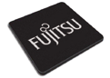
HDC-302E
PCI Express Video/Audio Capture Card with Two Channel HDMI Inputs and Two Channel HDMI Outputs, 1920x1080@60p, and H.264 Hardware Codec

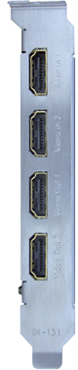
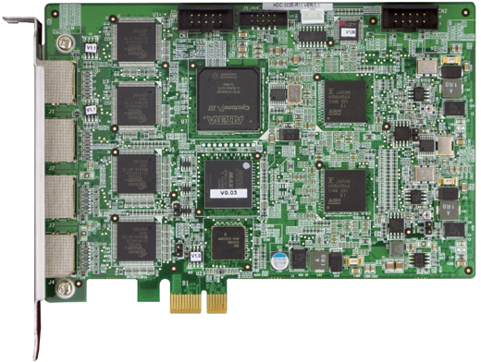2-channel HDMI input
H.264 Hardware Codec
7/10
Windows
32/64Bit
H.264
MPEG-4/AVC
PCIe Bus

2-channel HDMI output

Features
HDC-302E-2018-V11
Video Capture Solutions
- 2-channel HDMI input with H.264 hardware compression and 2-channel HDMI output
- High quality video encoding or decoding up to 1080p60
- HDMI output port supports low-delay video pass through up to 1080p60, so you can check video while recording
- HDMI output port supports playback video file captured by HDC-30X
series cards
- Low power consumption
- SDK available for customer to create customized applications
- Windows/Linux OS supported

Specifications
Interface

Video Input | 2 channels
Video Input Type | HDMI
Audio Input | 2 channels
Audio Input Type | HDMI
Video Output | 2 channels
Video Output Type | HDMI
Audio Output | 2 channels
Audio Output Type | HDMI
Bus Interface | PCIe x1
Loop Through | 2 channels
Video Processing

Video Compression | H.264/AVC High Profile Level 4.2
Input Resolution & Frame Rate | 1920 x 1080 x 60p / 59.94p / 50p 720 x 480 x 60i /59.94i  1920 x 1080 x 60i / 59.94i / 50i 720 x 576 x 50i  1280 x 720 x 60p / 59.94p / 50p
Record Resolution / Frame Rate / Bit Rate | 1920 x 1080 x 60p / 59.94p / 50p, encoding video -bit rate from 6Mbps to 20Mbps  1920 x 1080 x 60i / 59.94i / 50i, encoding video -bit rate from 6Mbps to 20Mbps  1280 x 720 x 60p / 59.94p / 50p, encoding video -bit rate from 4Mbps to 20Mbps  720 x 480 x 60i / 59.94i, encoding video -bit rate from 2Mbps to 10Mbps  720 x 576 x 50i, encoding video -bit rate from 2Mbps to 10Mbps
Functionality Audio Processing
Multiple Card Support | 4 cards, 8 channels

Audio Compression | MPEG-1 Audio Layer 2
Bit Rate | 256k

System Block

HDMI
Out 1
HDMI
Out 2

HDMI
In 2

HDMI
In 1
HDMI
Tx
HDMI
Tx

FPGA
PCIe x1
Bridge
H.264 CODEC
H.264 CODEC

CPLD
HDMI
Rx
HDMI
Rx
System Requirement

System | x86 PC compatible computer, Intel® Pentium® 4 2.0GHz or above for video record  Recommends using a DXVA or CUDA capable graphics card  for real-time video playback
Memory | 1GB or more
Software Support

OS Support | Microsoft Windows 7/10 (32-bit & 64-bit)  Linux: Ubuntu 16.04 (64-bit) (Kernel version: 4.4.0-21 x64)
SDK | Windows: Provides SDK and demo program with sample  source code  Linux: Provides SDK and demo program with sample source code
Others

Dimensions | 155 mm x 98.6 mm
Operating Temperature | 0°C ~ 65°C, non-condensing
Power Consumption | 9.53W (12V@0.46A, 3.3V@1.21A)

Packing List

1 x HDC-302E
1 x QIG

Ordering Information
Part No. | Description
HDC-302E-R11 | PCI Express video/audio capture card with two channel HDMI inputs and two channel HDMI outputs, 1920x1080@60p, and  H.264 hardware codec

