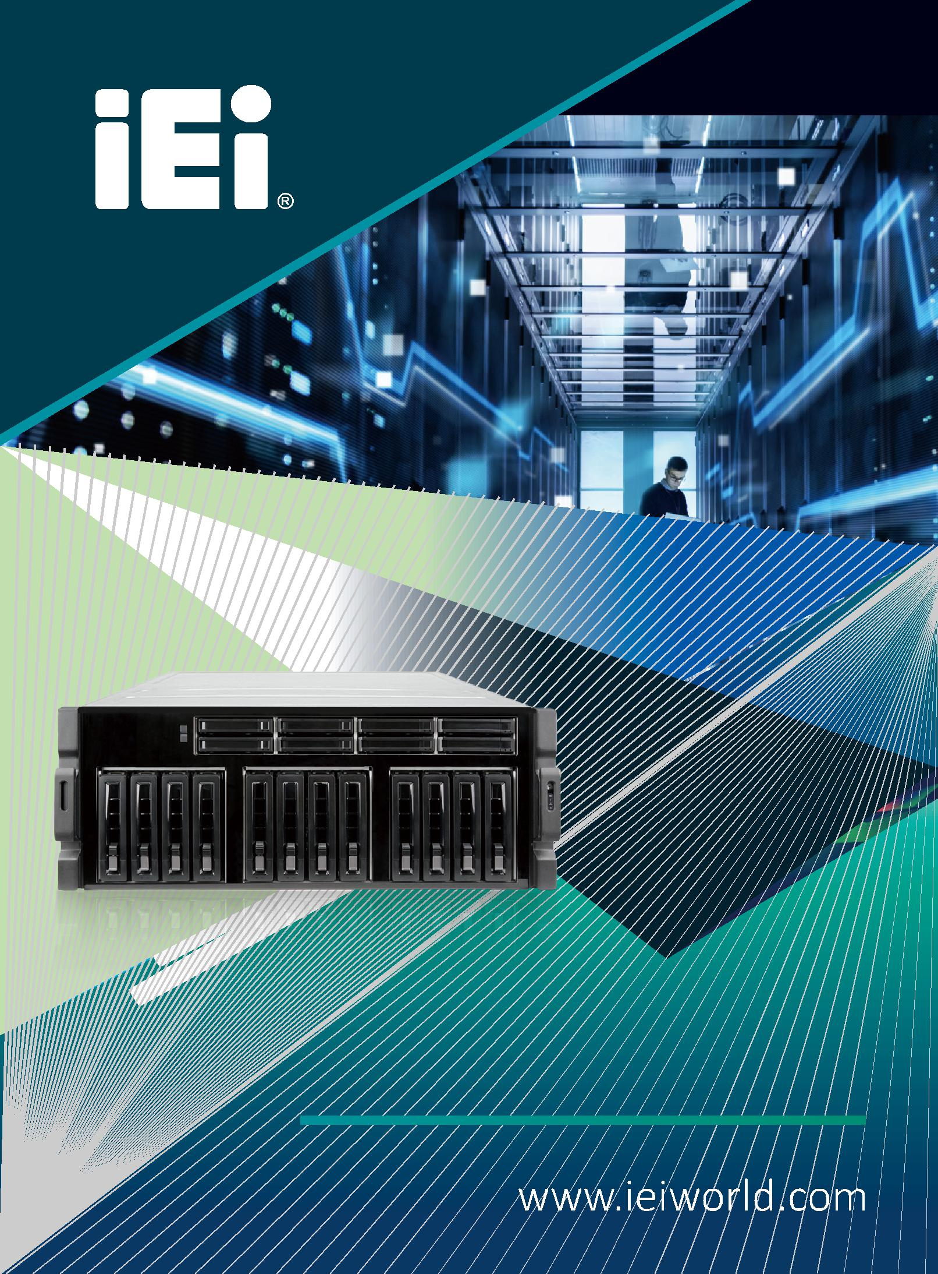

GRAND-C422-20D

AI ready in deep learning solution

GRAND-C422-20D

GRAND AI training server system

The GRAND-C422-20D is an AI training system which has maximum expansion ability to add in AI computing accelerator cards for AI model training or inference.

Intel® Xeon® W family processor supported
6 x PCIe Slot, up to 4 dual width GPU cards

Water cooling system on CPU

Support two U.2 SSD

Support one M.2 SSD M-key slot ( NVMe PCIe 3.0 x4 )

Support 10GbE network

IPMI remote management

Demand for AI computing is booming

The application of AI computing is absolutely not enough through the CPU computing. With the decentralized architecture, the huge data is calculated to obtain the computing result. Therefore, we have developed a water-cooled chassis system with high expansion capability by adding multiple GPUs, FPGA or VPU acceleration cards for AI deep learning and inference.
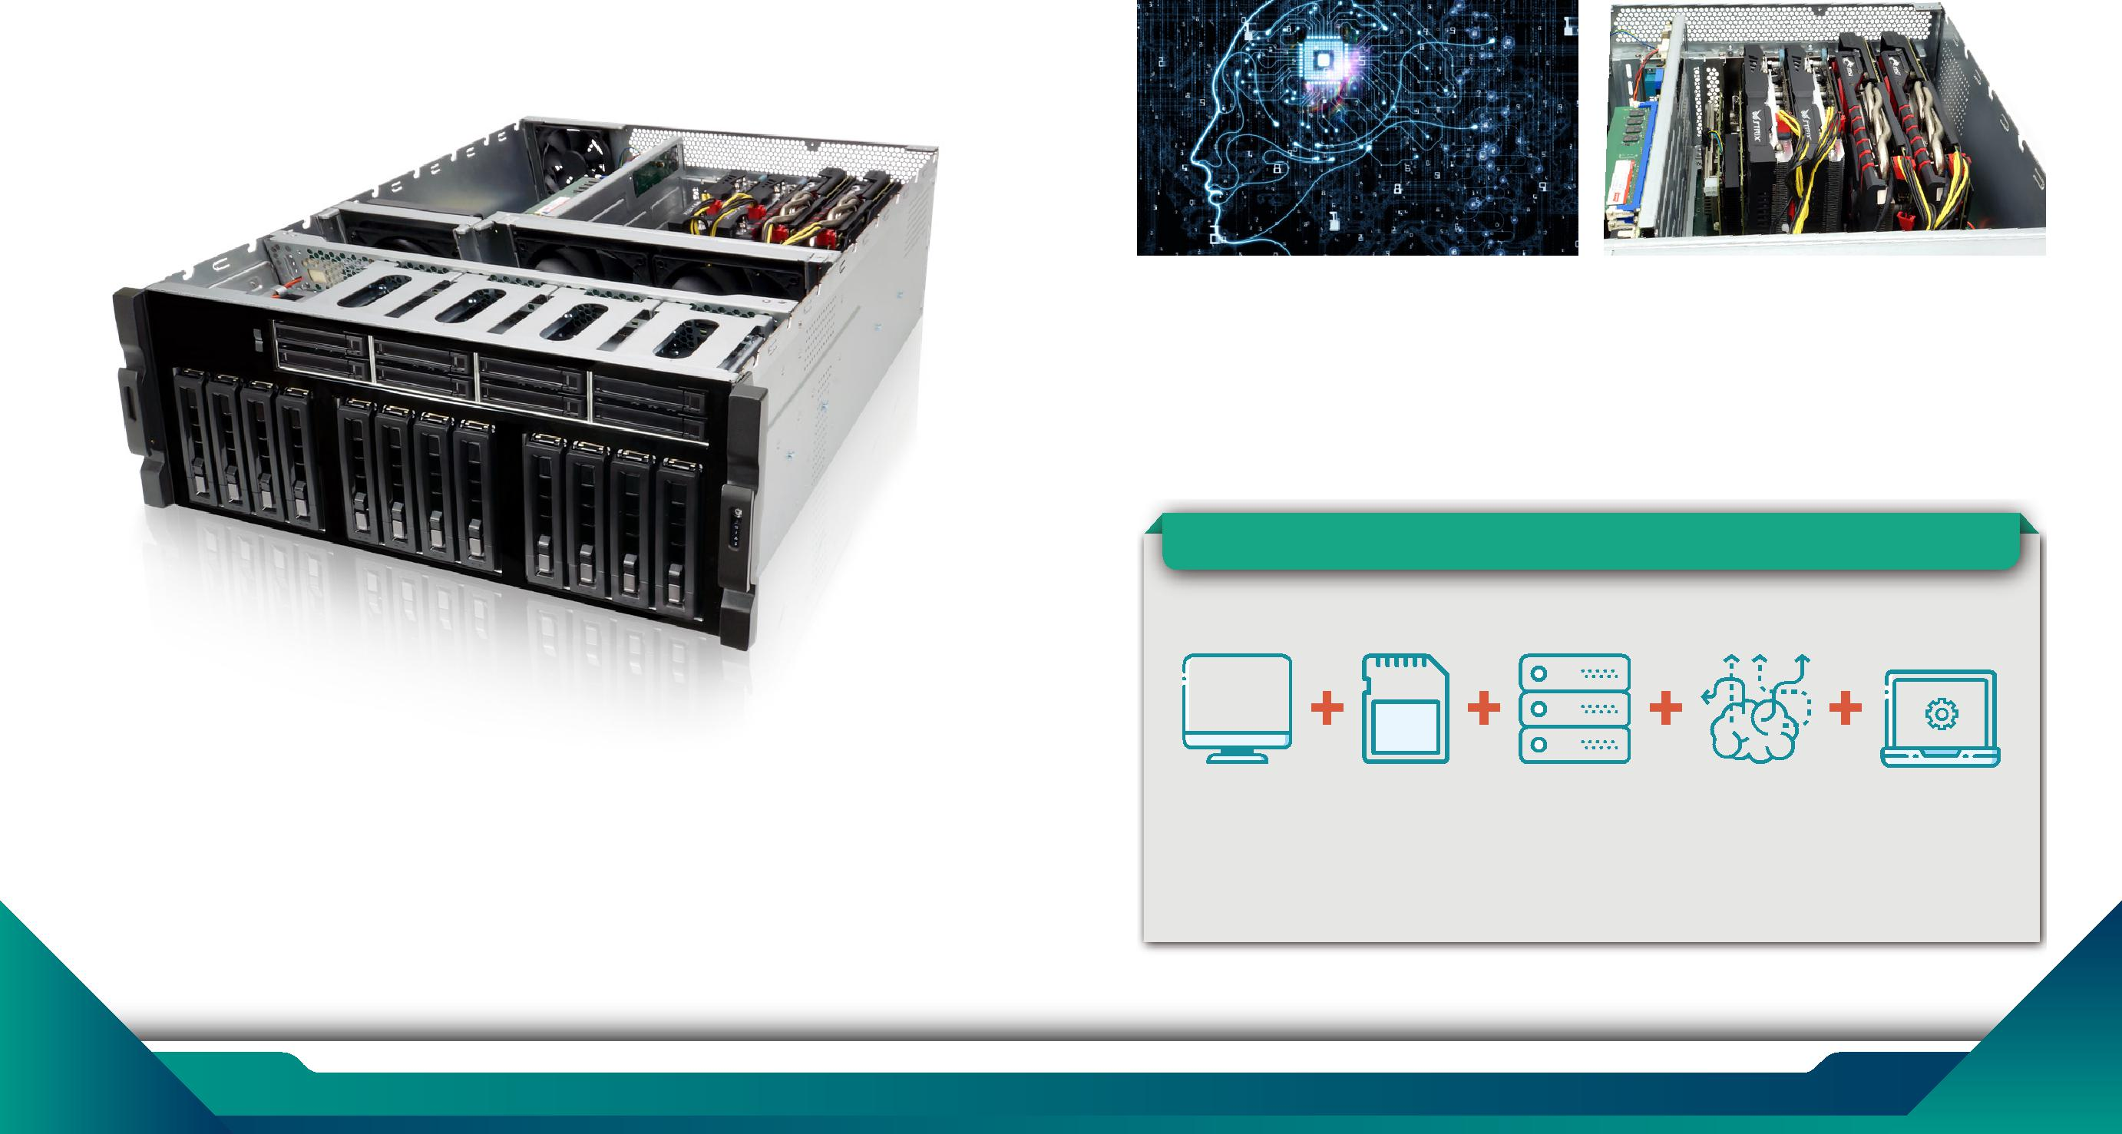

Hyper converged infrastructure

Hyper converged infrastructure (HCI) is scale-out software-defined infrastructure that converges core data services on flash-accelerated, industry-standard servers, delivering flexible and powerful building blocks under unified management.

Efficient, agile, flexible, and integrated, these systems allow for easy scale-out storage, cost-savings, and simplicity to manage your systems. To find out if hyperconverged is the best solution for your Data Center, consider the following.

1 www.ieiworld.com 2

Edge computing server in training
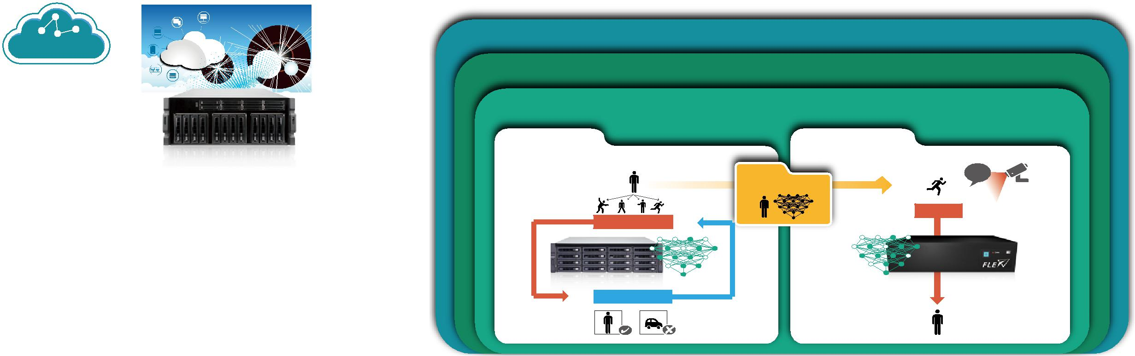

The GRAND-C422-20D is perfectly suited for edge computing server in data training or inference. With edge computing, you can pre-process data generated within your organization or across your devices on-premise, to filter out irrelevant information and only keep valuable insights, and then further utilize them by sending or uploading to cloud platforms. You can save a great deal of cloud platform and bandwidth fees as your data to be analyzed is filtered and only relevant data will be further dealt with.

Public Cloud

Edge to cloud communication
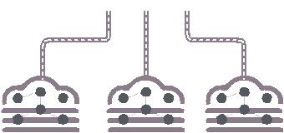

Public Cloud

Platform

ARTIFICIAL INTELLIGENCE

MACHINE LEARNING

DEEP LEARNING

Training | Learning from existing data | Inference | Predict new input data

The advantages of edge computing: Edge computing GRAND-C422-20D

- Reduce data center loading, transmit less data, reduce network traffic bottlenecks.

- Real-time applications, the data is analyzed locally, no need long distant data center.

- Lower costs, no need to implement sever grade machine to achieve non-complex applications.
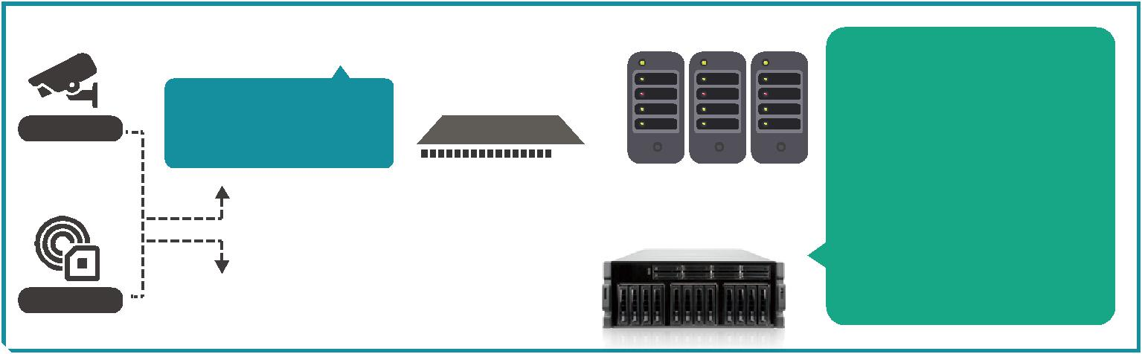

 | Training Dataset | New Data ?
 | Human
 |  | Forward
 | Forward
 | GRAND-C422 | FLEX AI Modular Box PC
 | Backward
“Human” | “Car” | “Human”

• •
•

Deep learning break through

With the introduction of deep learning, the most important issue is the "data blowout", and the fields of voice, image have the breakthrough due to the data-supported algorithms and computing power growed up rapidly. Artificial intelligence has ushered the new opportunities for developing new appliance. This time, it will lead the whole society to change in deeper level, this is the future we can see. The outbreak of artificial intelligence began from the Internet which brought many demands, including search, social, shopping, and so on. These demands are increasing, and it makes huge amount of data go online.
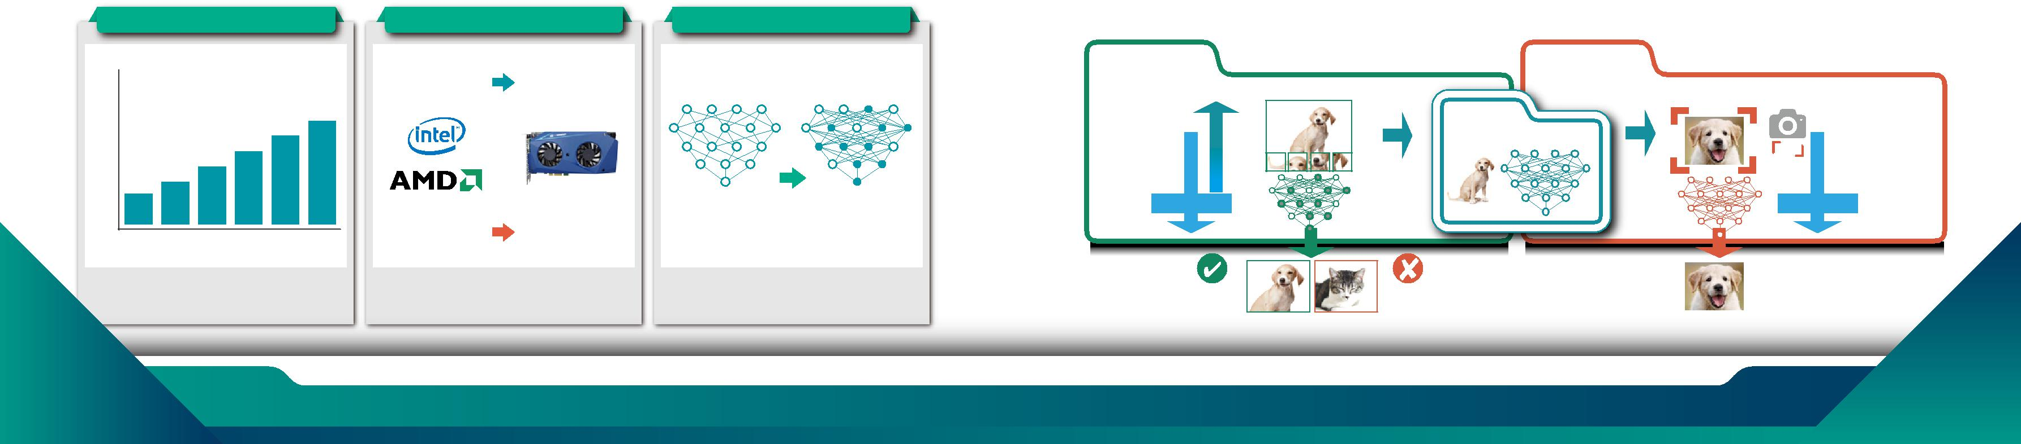

What is deep learning

- Training

In deep learning, each level learns to transform its input data into a slightly more abstract and composite representation. In an image recognition application, the raw input may be a matrix of pixels; the first representational layer may abstract the pixels and encode edges; the second layer may compose and encode arrangements of edges; the third layer may encode a nose and eyes; and the fourth layer may recognize that the image contains a face. Importantly, a deep learning process can learn which features to optimally place in which level on its own.

- Inference

In the field of Artificial Intelligence, inference engine is a component of the system that applies logical rules to the knowledge base to deduce new information. The first inference engines were components of expert systems. The typical expert system consisted of a knowledge base and an inference engine. The knowledge base stored facts about the world. The inference engine applies logical rules to the knowledge base and deduced new knowledge. This process would iterate as each new fact in the knowledge base could trigger additional rules in the inference engine.

 |  | •••• |  | •
 |  |  |  | •

 |  | • • |  | 「 」
 |  |  |  | 「」

3 www.ieiworld.com 4

AI Training System

The AI training system GRAND-C442 is dedicated for these tasks because it offers a wide range of slots for storage expansion, acceleration cards and video capture, Thunderbolt ™ or PoE add-on cards for unlimited data ac-quisition possibilities. In order to develop a useful training model, existing and widely used deep learning training frameworks such as Caffe, Tensor-Flow or Apache MXNet are recommended. These facilitate the definition of the apt architecture and algorithms for a distinct AI application.

Supported Software

• • • •• |  |  |  | • … •- •† •‡• |  | ‚ • ˆ • • |  |  | •
• • | -€• |  |  | ˆ • • |  | •ƒ •- •†• •„
 |  |  |  |  |  |  |  | • -
‚ • • |  |  |  | • • •„
ƒ • •„ |  |  |  |  |  |  |  | €•
 |  |  |  |  |  |  |  | •
• | •• • |  |  | • • •„ |  | • • |  | ‚ƒ „
•• • •„ |  |  |  |  |  | ‰•• • •
 |  |  |  |  |  |  |  | …

• •

••• • •••

AI infernece System

IEI offers three different acceleration cards. Whereby the Mustang-V100-MX8 is based on Intel® Movidius Myriad X and the Mustang-F100-A10 is based on Intel® Arria 10GX 1150 FPGA. Both are designated for inference enhancement. The CPU acceleration card Mustang-200 combined two Intel® Core ULT CPUs and offers additional boost for training systems.

Computing accelerator models

Mustang-200 |  | Mustang-F100-A10 |  | Mustang-V100-MX8
• Two Intel Core ULT |  | • Intel Arria 10 GX 1150 FPGA |  | • Intel Movidius solution
• 4 DDR4 UDIMM |  | • PCIe Gen3 x 8 |  | • 8 x Myriad X VPU
• 2 NVMe, 2 eMMC |  | • Low profile , half size, double slot |  | • PCIe Gen2 x4
• 10GbE based |  |  |  | • Low profile , half size, single slot
• PCIe x4 interface
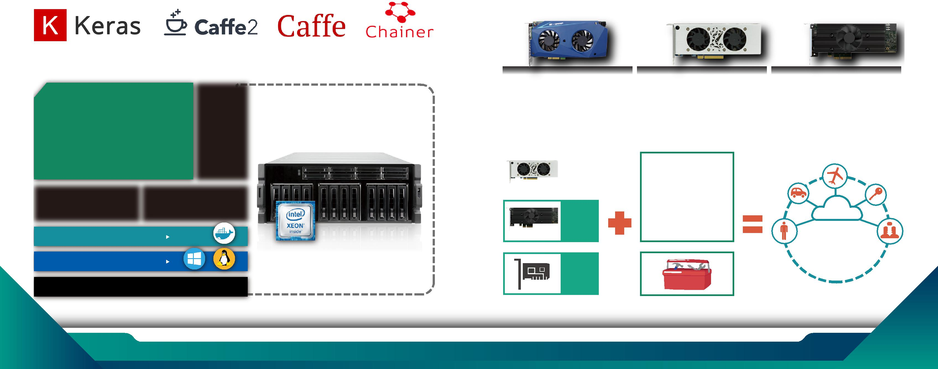

In addition, the performance of both the DL training and optimized inference models can be further enhanced by adding heterogeneous low profile computing acceleration cards such as the Mustang-F100-A10 with Intel® FPGA or Mustang-V100-MX8 with Intel® VPU or GPU card. The combination of GRAND-C422, TANK-870AI, the accelerator cards and a DL toolkit form IEI's AI ready solution.

TENSORRT

5 www.ieiworld.com 6

GRAND-C422-20D |  | ‚- – • “ Œ „ ƒ |  | ƒ ƒƒƒ —† ƒƒ “ † • ˜ƒ —
 |  | ƒ „ ƒ • | … †•
Hardware Architecture |  | ƒ‡ ƒ • - ƒ† |  | – “ Œ | ‹ - – •• – •
 |  | † “ • - “ † ƒ‡ “ ƒ‡ “ “ Œ‡ „ |  |  |  | Œ “ ƒ
 |  | ‹ †- „ ƒ ™ Œ - †- ‡ ‹ “ “ |  |  | „ “ | ‹ƒ
 | € • ‚ €‚‚ | … ƒ•
 | ． Ž ••• “ | …• • ‡
 | ．•• ˆ “ ‹ | ． „ “
 |  | ． Ž •““ … “ “ ” †- „
． |  | ． ƒ „ „ š
．
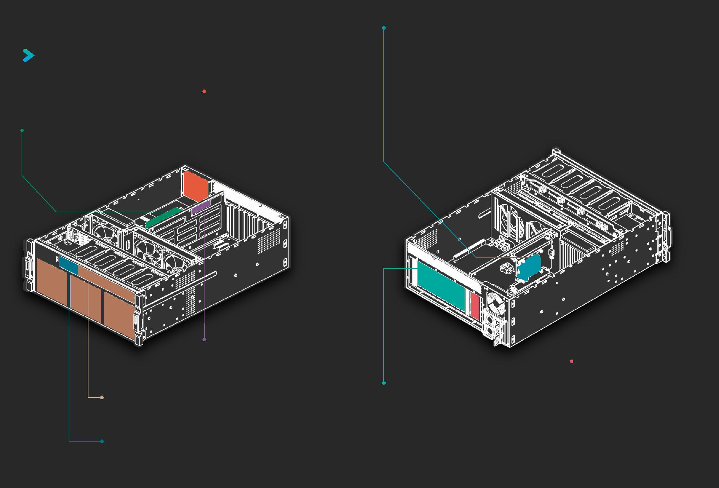

--

． • •• “ †
．” „- ƒ ••• Œ ƒ „

••
． „- • Š ‹ Œƒ

．‚• ‹ •• Š ‹ Œƒ
． ‹ † ‹ Œ

． • ˆ• • ƒ

 |  |  | •• •••
 |  |  | ． ‰ … ƒ Œ
 |  |  | ．Ž• ‘ …’
． ••• • |  |  | ．Ž ‘ …’
• • -€ |  |  | ． ˆ •••
．‚• ••• |  |  | ． ˆ ••
•ƒ „ • -€
． … †† † ƒ‡
ƒ †- ƒ • - ˆ † |  | ‡
… † ‡ ‰ ˆ † ‡ †

7 8

Expandable to suit your needs

- AI computing requires huge computing power, so our system can support up to 4 dual-width expansion slots (PCIe x8) and 2 single-width expansion slots (PCIe x4) for maximum expansion ability to meet computing needs.

- All six of the backplane slots connect directly to the system host board. This is perfect for applications that require minimal latency.

 |  |  |  |  |  |  |  |  |  |  |  |  | •
 | •-
‡ | „… |  |  |  |  |  |  | • ‡ €‚ |  |  |  |  |  | ƒ | „
 |  |  |  |  |  |  |  | ‡ |  | „…
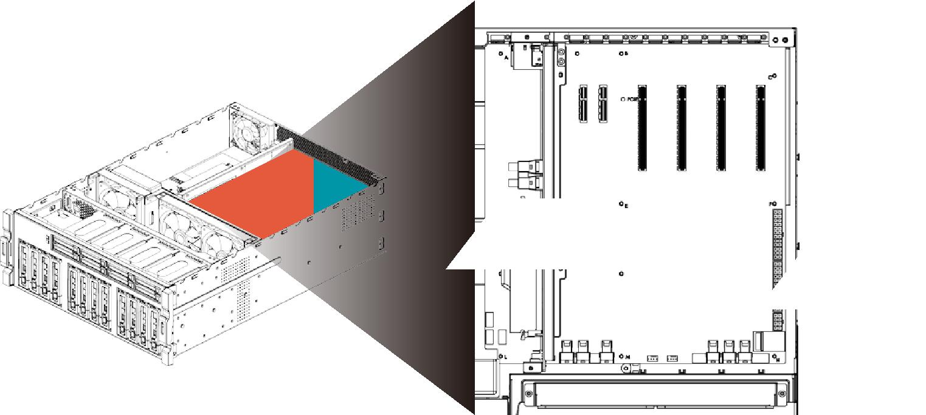

Storage (M.2, U.2, SATA)

The GRAND-C422-20D support M.2 nVMe SSD, U.2 SSD and SATA HDD/SSD. It has a built-in M.2 nVMe port and 20 bays of HDD/SSD slots including two U.2 SDD slots. The GRAND-C422-20D supports M.2 solid-state disk which is the next-generation small-sized form factor introduced by Intel after mSATA. It has better performance than general SATA SSD but it is lighter and more power-saving.
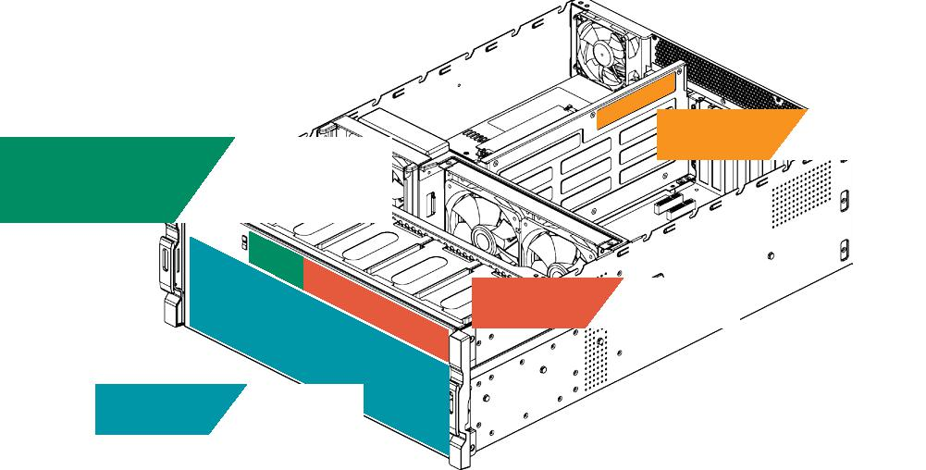

• •• •

U.2 SSD

U.2 uses the same concept as a general hard disk. With a connection cable, a hard disk can be installed in the case without occupying the space of the motherboard. Therefore, M.2 and U.2 interfaces can be coexistence because they have different application environment. M.2 is more suitable for laptops or microcomputers, and U.2 is more suitable on a desktop or server. The U.2 interface features high-speed, low-latency, low-power, NVMe standard protocol, and PCIe 3.0 x4 channel. The theoretical transmission speed is up to 32Gbps, while SATA is only 6Gbps, which is 5 times faster than SATA.

The U.2 interface utilizes the existing physical interface, but the bandwidth is faster. The four-channel design makes the bandwidth upgrade from PCIe x2 to PCIe 3.0 x4, which is several times more than SATA interface. The U.2 interface combines the features of SATA and SAS, and uses the signal pin to fill the connector of the SAS interface. The L-type foolproof design, except the PCIe interface, also compatible with various mainstream hard disc interface such as SATA, SAS and SATA E.

 |  |  | SSD Performance
 |  |  | SATA SSD 550
READ |  |  |  |  |  |  | M.2 | SSD 1800
 |  |  |  |  |  |  |  | U.2 SSD 2100
 |  | SATA SSD 500
WRITE |  |  | M.2 SSD 560
 |  |  | U.2 SSD 800
MB/s
 | 0 |  | 500 |  | 1000 |  | 1500 |  | 2000

Water Cooling System for CPU

- IEI uses the latest 14nm Intel Xeon Processor W family which uses the LGA2066 interface and Skylake-SP architecture with 4, 6, 8, 10, 14 and 18 core versions.

- High performance means higher power consumption, therefore IEI designed water cooling system for CPU with smaller size, higher efficiency cooling system makes CPU cooler and keep the high performance, and it can support up to 250W TDP.
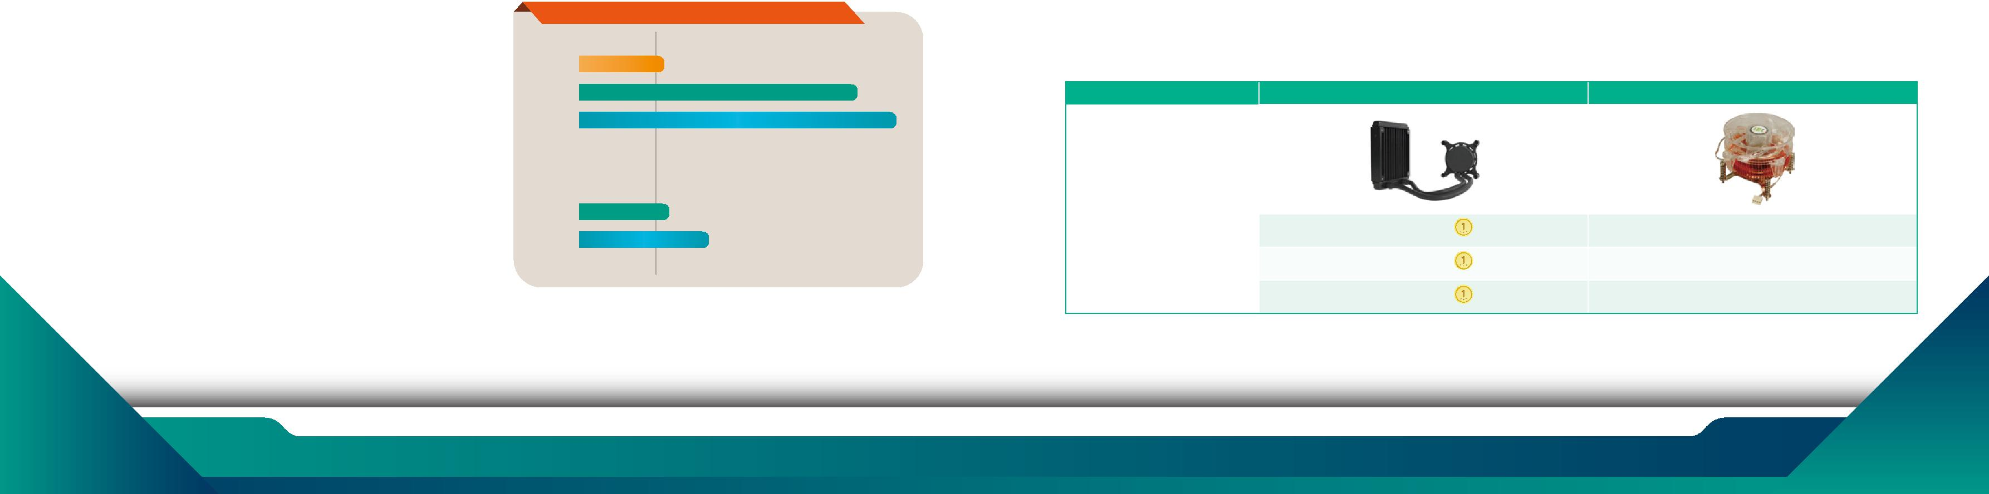

Water Cooling | Air Cooling

Cooler Size | Small | Large
Working Noise | Small | Large
Cooling Efficiency | Better | Worse

9 www.ieiworld.com 10

Selection Guide

 | Model |  | GRAND-C422-20D
 |  | Dimensions (H x W x D) | 176.15 mm x 480.94 mm x 644 mm
Chassis |  | System Fan | 2 x 120 mm, 12V DC
 |  | Chassis Construction | 4U, Rackmount
 |  | System Cooling | 2 x Cooling Fans with Smart Fan
 |  | CPU | Support LGA-2066 Intel® Xeon® W family processor
 |  | Processor Cooling | Water cooling system
Motherboard |  | Chipest | C422
 |  | Memory | Total slot: 4 x DDR4 ECC RDIMM/LRDIMM
 |  |  | Memory expandable up to:256GB (4 x 64GB)
Security |  | TPM | 1 x TPM 2.0 Pin header
IPMI |  | IPMI Solution | IPMI LAN port, IPMI VGA
 |  | Hard Drive | 12 x 2.5" / 3.5" drive bay
 |  |  | 8 x 2.5" drive bay
Storage
 |  | M.2 | 1 x M.2 built in on SBC
 |  | U.2 | 2 x U.2 SSD drive bay compatible to SATA
Networking |  | Ethernat IC | 1 GbE NIC: Intel® i210-AT with NCSI support
 |  |  | 10 GbE NIC: Aquantia AQC107
 |  | USB 3.0 | 4
 |  | USB 2.0 | 2
I/O Interface |  | Ethernet | 1 x 1GbE RJ45 combo LAN ports / IPMI
 |  |  | 1 x 10GbE RJ45 LAN port
 |  | Display | 1 x IPMI VGA display
 |  | Buttons | Power button
 |  | COM port | 2 x RS232 pin header
Internal I/O |  | USB 3.0 | 2 x USB 3.0 pin header
 |  | USB 2.0 | 1 x USB DOM header
Indicator |  | LEDs | 10 GbE, Status, LAN, Storage Expansion Port Status
 |  | LCM | LCM, 2 buttons
Expansion |  | PCIe | 4 x PCIe 3.0 x8
 |  |  | 2 x PCIe 3.0 x4
 |  | Power Input | 110-240 AC,47-63Hz
Power |  | Power Consumption | In Operation: 285W
 |  | Type/Watt | Redundant Power 1600W
 |  | Operating Temperature | 0~40°C
Reliability |  | Relative Humidity | 5 to 95% non-condensing, wet bulb: 27˚C.
 |  | Weight | 23.59 kg
 |  | Certification | CE/FCC
OS |  | support OS | Windows server 2016
 |  |  | Linux

Ordering information

GRAND-C422-20D-S1A1-R10 | 20-bay(3.5" x12, 2.5" x 8) 4U Rackmount, Intel® Xeon® W-2123 with C422 chipset, 32G DDR4 w/ECC, 6 x PCIe expansion slot, and
 | 1600W redundant PSU, RoHS
GRAND-C422-20D-S1B2-R10 | 20-bay(3.5" x12, 2.5" x 8) 4U Rackmount, Intel® Xeon® W-2133 with C422 chipset, 64G DDR4 w/ECC, 6 x PCIe expansion slot, and
 | 1600W redundant PSU, RoHS
GRAND-C422-20D-S1C3-R10 | 20-bay(3.5" x12, 2.5" x 8) 4U Rackmount, Intel® Xeon® W-2145 with C422 chipset, 128G DDR4 w/ECC, 6 x PCIe expansion slot, and
 | 1600W redundant PSU, RoHS
GRAND-C422-20D-S1D3-R10 | 20-bay(3.5" x12, 2.5" x 8) 4U Rackmount, Intel® Xeon® W-2155 with C422 chipset, 128G DDR4 w/ECC, 6 x PCIe expansion slot, and
 | 1600W redundant PSU, RoHS
GRAND-C422-20D-S1E4-R10 | 20-bay(3.5" x12, 2.5" x 8) 4U Rackmount, Intel® Xeon® W-2195 with C422 chipset, 256G DDR4 w/ECC, 6 x PCIe expansion slot, and
 | 1600W redundant PSU, RoHS
Packing list | 2019.01
Flat head screws | Flat head screws | 1 x Cat5e LAN cable | 1 x QIG | 2 x Power cord | 1 x Cat6A LAN cable
(for 2.5” HDD) | (for 3.5” HDD)

2019.01

