AI Solution
w w w. i e i w o r l d . c o m
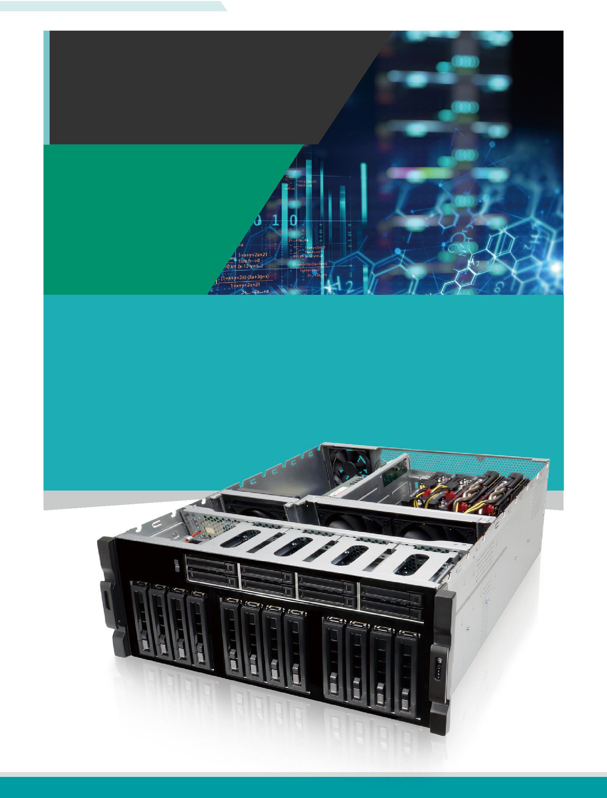

GRAND-C422-20D
GRAND AI training
server system

The GRAND-C422-20D is an AI training system which has maximum expansion ability to add in AI computing accelerator cards for AI model training or inference.

Intel® Xeon® W family processor supported

6 x PCIe Slot, up to 4 dual width GPU cards

Water cooling system on CPU

Support two U.2 SSD

Support one M.2 SSD M-key slot ( NVMe PCIe 3.0 x4 )

Support 10GbE network

IPMI remote management

GRAND-C422-20D-2019-V10

AI Solution
w w w . i e i w o r l d . c o m

Demand for AI computing is booming

The application of AI computing is absolutely not enough through the CPU computing. With the decentralized architecture, the huge data is calculated to obtain the computing result. Therefore, we have developed a water-cooled chassis system with high expansion capability by adding multiple GPUs, FPGA or VPU acceleration cards for AI deep learning and inference.
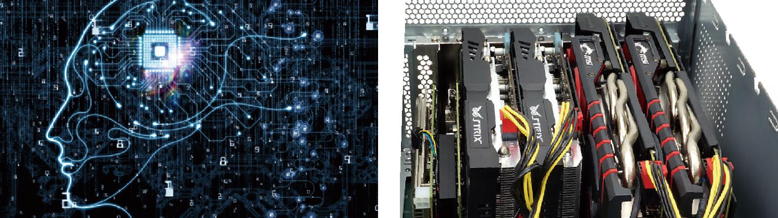

Hyper converged infrastructure

Hyper converged infrastructure (HCI) is scale-out software-defined infrastructure that converges core data services on flash-accelerated, industry-standard servers, delivering flexible and powerful building blocks under unified management.

Efficient, agile, flexible, and integrated, these systems allow for easy scale-out storage, cost-savings, and simplicity to manage your systems. To find out if hyperconverged is the best solution for your Data Center, consider the following.
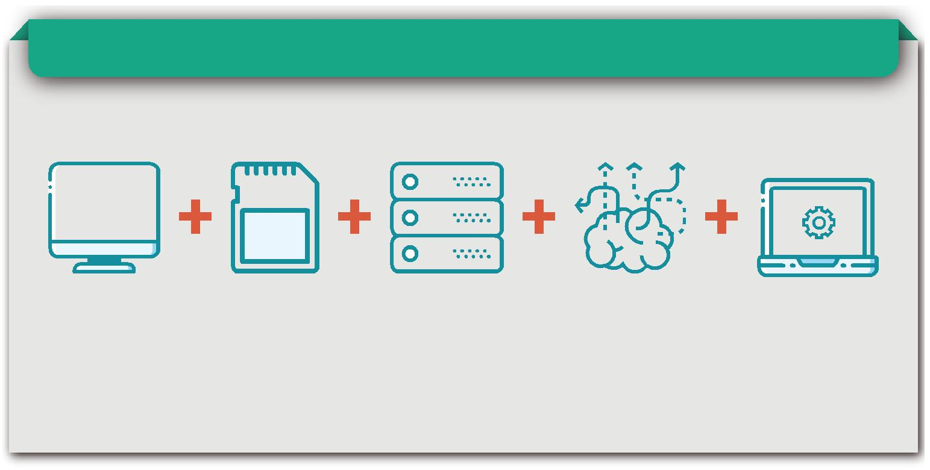

GRAND-C422-20D-2019-V10

AI Solution
w w w. i e i w o r l d . c o m

AI Training System

The AI training system GRAND-C442 is dedicated for these tasks because it offers a wide range of slots for storage expansion, acceleration cards and video capture, Thunderbolt™ or PoE add-on cards for unlimited data ac-quisition possibilities. In order to develop a useful training model, existing and widely used deep learning training frameworks such as Caffe, Tensor-Flow or Apache MXNet are recommended. These facilitate the definition of the apt architecture and algorithms for a distinct AI application.

Supported Software
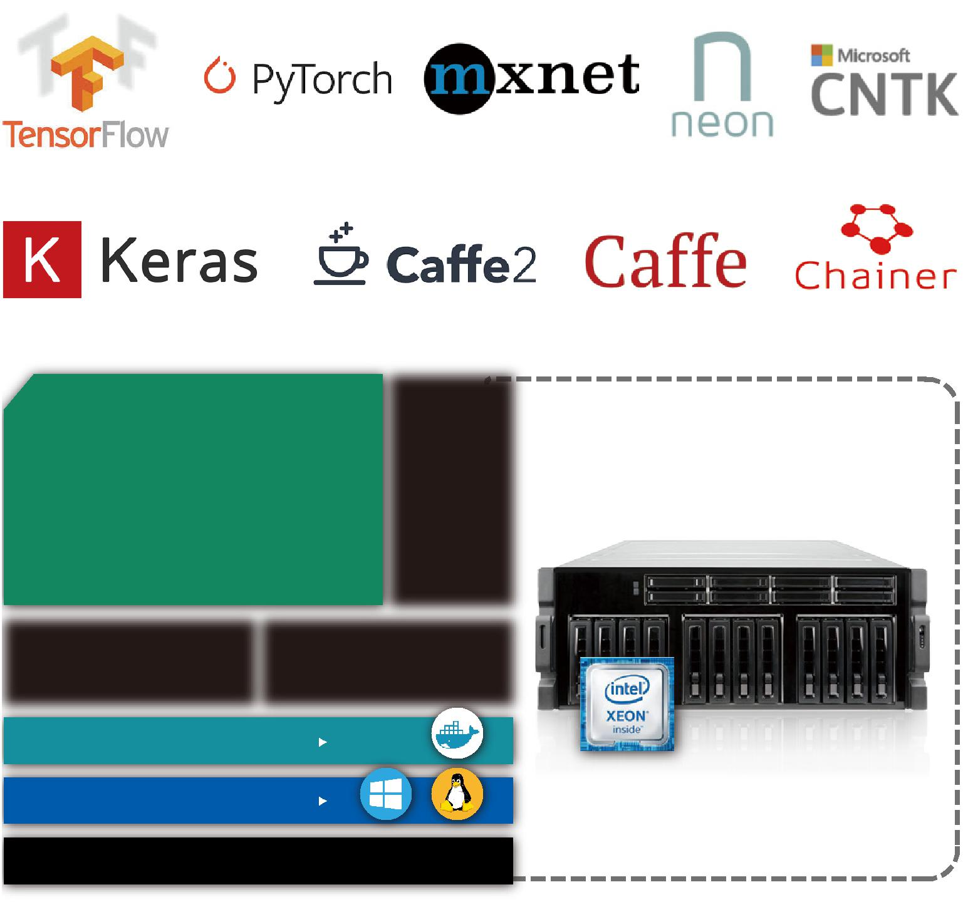

• • • •• |  |  |  | • … •- •† •‡• |  | ‚ • ˆ • • |  |  | •
• • | -€• |  |  | ˆ • • |  | •ƒ •- •†• •„
 |  |  |  |  |  |  |  | • -
‚ • • |  |  |  | • • •„
ƒ • •„ |  |  |  |  |  |  |  | €•
 |  |  |  |  |  |  |  | •
• | •• • |  |  | • • •„ |  | • • |  | ‚ƒ „
•• • •„ |  |  |  |  |  | ‰•• • •
 |  |  |  |  |  |  |  | …

• •

••• • •••

GRAND-C422-20D-2019-V10

AI Solution
w w w . i e i w o r l d . c o m

Expandable to suit your needs

AI computing requires huge computing power, so our system can support up to 4 dual-width expansion slots (PCIe x8) and 2 single-width expansion slots (PCIe x4) for maximum expansion ability to meet computing needs.
All six of the backplane slots connect directly to the system host board. This is perfect for applications that require minimal latency.

 |  |  |  |  |  |  |  |  |  |  |  |  | •
 | •-
‡ | „… |  |  |  |  |  |  | • ‡ €‚ |  |  |  |  |  | ƒ | „
 |  |  |  |  |  |  |  | ‡ |  | „…
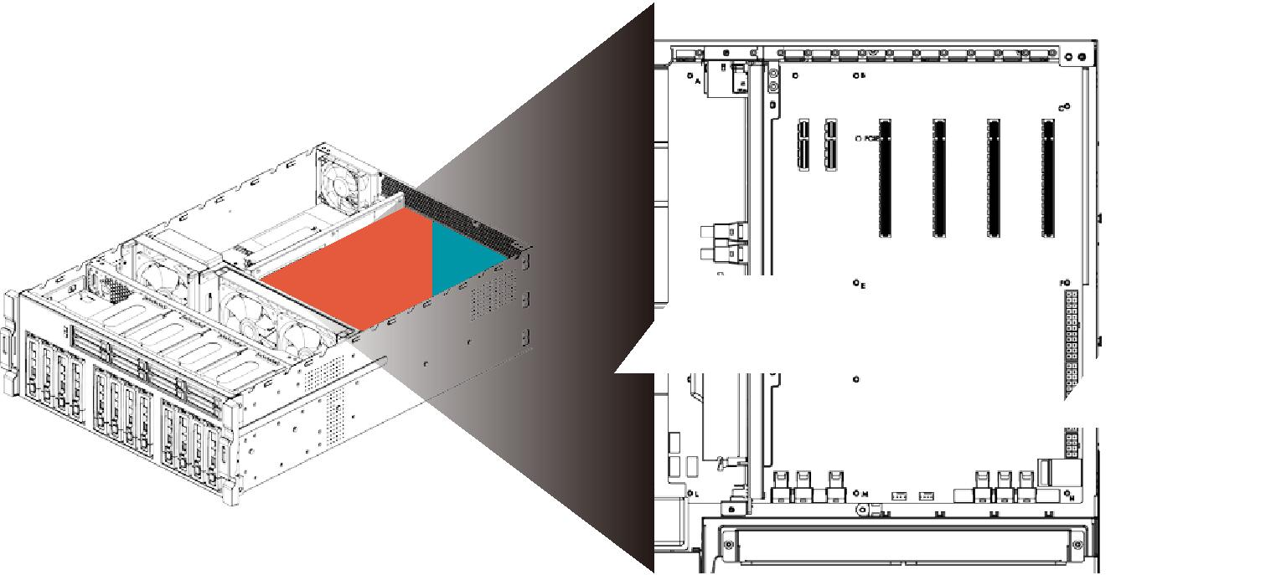

U.2 SSD

U.2 uses the same concept as a general hard disk. With a connection cable, a hard disk can be installed in the case without occupying the space of the motherboard. Therefore, M.2 and U.2 interfaces can be coexistence because they have different application environment. M.2 is more suitable for laptops or microcomputers, and U.2 is more suitable on a desktop or server. The U.2 interface features high-speed, low-latency, low-power, NVMe standard protocol, and PCIe 3.0 x4 channel. The theoretical transmission speed is up to 32Gbps, while SATA is only 6Gbps, which is 5 times faster than SATA. The U.2 interface utilizes the existing physical interface, but the bandwidth is faster. The four-channel design makes the bandwidth upgrade from PCIe x2 to PCIe 3.0 x4, which is several times more than SATA interface. The U.2 interface combines the features of SATA and SAS, and uses the signal pin to fill the connector of the SAS interface. The L-type foolproof design, except the PCIe interface, also compatible with various mainstream hard disc interface such as SATA, SAS and SATA E.

 |  |  | SSD Performance
 |  |  | SATA SSD 550
READ |  |  |  |  |  |  | M.2 | SSD 1800
 |  |  |  |  |  |  |  | U.2 SSD 2100
 |  | SATA SSD 500
WRITE |  |  | M.2 SSD 560
 |  |  | U.2 SSD 800
MB/s
 | 0 |  | 500 |  | 1000 |  | 1500 |  | 2000
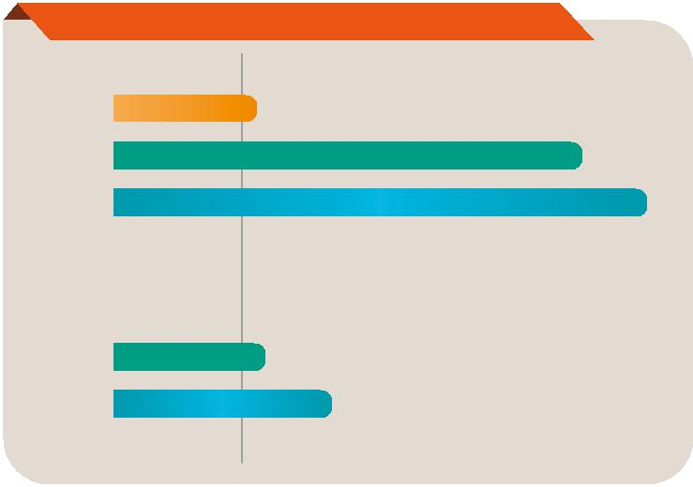

GRAND-C422-20D-2019-V10

AI Solution
w w w. i e i w o r l d . c o m

Storage (M.2, U.2, SATA)

The GRAND-C422-20D support M.2 nVMe SSD, U.2 SSD and SATA HDD/SSD. It has a built-in M.2 nVMe port and 20 bays of HDD/SSD slots including two U.2 SDD slots. The GRAND-C422-20D supports M.2 solid-state disk which is the next-generation small-sized form factor introduced by Intel after mSATA. It has better performance than general SATA SSD but it is lighter and more power-saving.
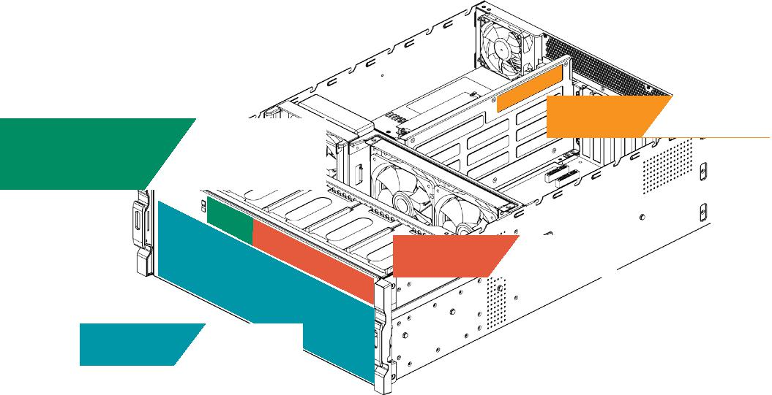

• •• •

Water Cooling System for CPU

IEI uses the latest 14nm Intel Xeon Processor W family which uses the LGA2066 interface and Skylake-SP architecture with 4, 6, 8, 10, 14 and 18 core versions.
High performance means higher power consumption, therefore IEI designed water cooling system for CPU with smaller size, higher efficiency cooling system makes CPU cooler and keep the high performance, and it can support up to 250W TDP.
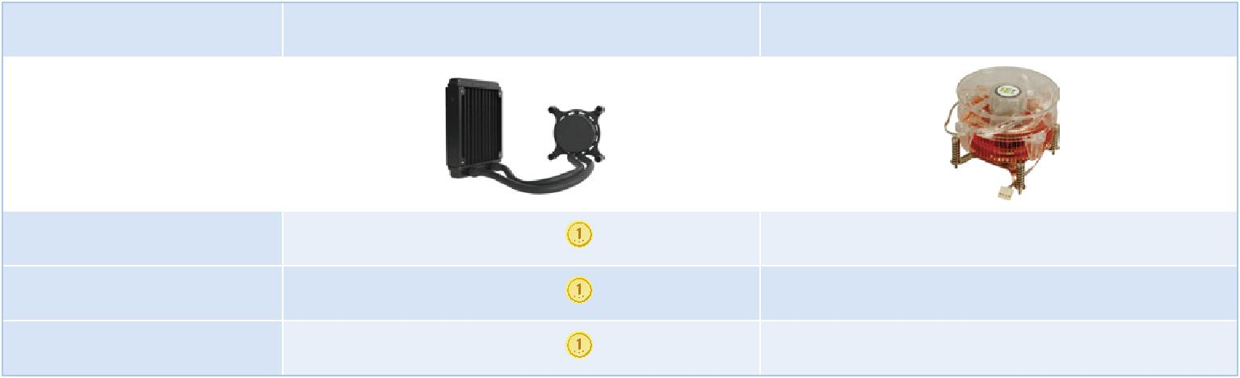

Water Cooling | Air Cooling

Cooler Size | Small | Large
Working Noise | Small | Large
Cooling Efficiency | Better | Worse

GRAND-C422-20D-2019-V10

AI Solution
w w w . i e i w o r l d . c o m

Specifications
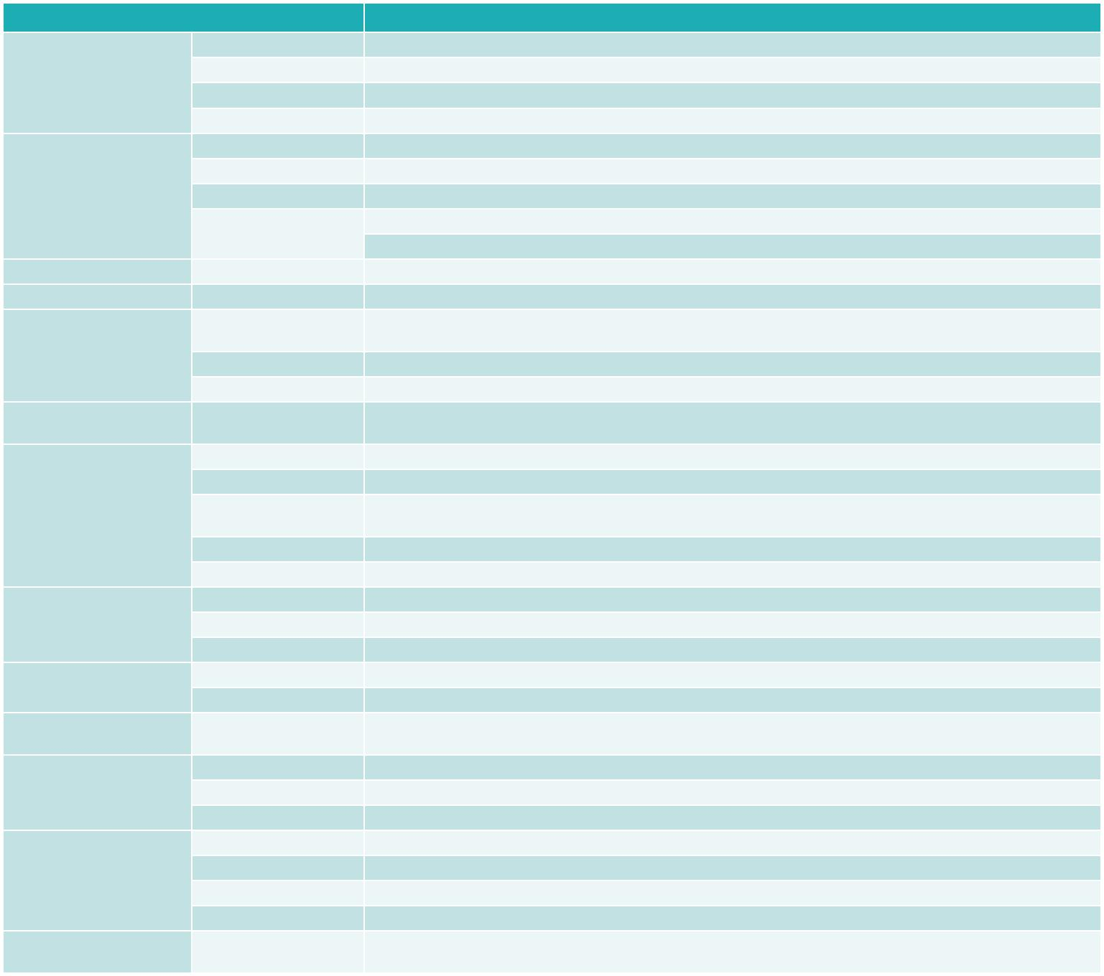

Model |  | GRAND-C422-20D
 | Dimensions (H x W x D) | 176.15 mm x 480.94 mm x 644 mm
Chassis | System Fan | 2 x 120 mm, 12V DC
 | Chassis Construction | 4U, Rackmount
 | System Cooling | 2 x Cooling Fans with Smart Fan
 | CPU | Support LGA-2066 Intel® Xeon® W family processor
 | Processor Cooling | Water cooling system
Motherboard | Chipest | C422
 | Memory | Total slot: 4 x DDR4 ECC RDIMM/LRDIMM
 |  | Memory expandable up to:256GB (4 x 64GB)
Security | TPM | 1 x TPM 2.0 Pin header
IPMI | IPMI Solution | IPMI LAN port, IPMI VGA
 | Hard Drive | 12 x 2.5" / 3.5" drive bay
 |  | 8 x 2.5" drive bay
Storage
 | M.2 | 1 x M.2 built in on SBC
 | U.2 | 2 x U.2 SSD drive bay compatible to SATA
Networking | Ethernat IC | 1 GbE NIC: Intel® i210-AT with NCSI support
 |  | 10 GbE NIC: Aquantia AQC107
 | USB 3.1 Gen 1 | 4
 | USB 2.0 | 2
I/O Interface | Ethernet | 1 x 1GbE RJ45 combo LAN ports / IPMI
 |  | 1 x 10GbE RJ45 LAN port
 | Display | 1 x IPMI VGA display
 | Buttons | Power button
 | COM port | 2 x RS232 pin header
Internal I/O | USB 3.1 Gen 1 | 2 x USB 3.1 Gen 1 (5Gb/s) pin header
 | USB 2.0 | 1 x USB DOM header
Indicator | LEDs | 10 GbE, Status, LAN, Storage Expansion Port Status
 | LCM | LCM, 2 buttons
Expansion | PCIe | 4 x PCIe 3.0 x8
 |  | 2 x PCIe 3.0 x4
 | Power Input | 110-240 AC,47-63Hz
Power | Power Consumption | In Operation: 285W
 | Type/Watt | Redundant Power 1600W
 | Operating Temperature | 0~40°C
Reliability | Relative Humidity | 5 to 95% non-condensing, wet bulb: 27˚C.
 | Weight | 23.59 kg
 | Certification | CE/FCC
OS | support OS | Windows server 2016
 |  | Linux

Ordering Information
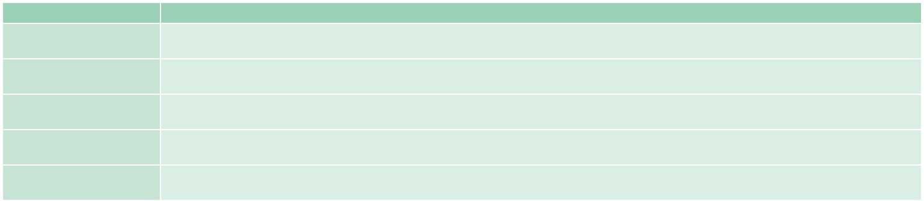

Part No. | Description
GRAND-C422-20D-S1A1-R10 | 20-bay(3.5" x12, 2.5" x 8) 4U Rackmount, Intel® Xeon® W-2123 with C422 chipset, 32G DDR4 w/ECC, 6 x PCIe expansion slot, and 1600W redundant
 | PSU, RoHS
GRAND-C422-20D-S1B2-R10 | 20-bay(3.5" x12, 2.5" x 8) 4U Rackmount, Intel® Xeon® W-2133 with C422 chipset, 64G DDR4 w/ECC, 6 x PCIe expansion slot, and 1600W redundant
 | PSU, RoHS
GRAND-C422-20D-S1C3-R10 | 20-bay(3.5" x12, 2.5" x 8) 4U Rackmount, Intel® Xeon® W-2145 with C422 chipset, 128G DDR4 w/ECC, 6 x PCIe expansion slot, and 1600W redundant
 | PSU, RoHS
GRAND-C422-20D-S1D3-R10 | 20-bay(3.5" x12, 2.5" x 8) 4U Rackmount, Intel® Xeon® W-2155 with C422 chipset, 128G DDR4 w/ECC, 6 x PCIe expansion slot, and 1600W redundant
 | PSU, RoHS
GRAND-C422-20D-S1E4-R10 | 20-bay(3.5" x12, 2.5" x 8) 4U Rackmount, Intel® Xeon® W-2195 with C422 chipset, 256G DDR4 w/ECC, 6 x PCIe expansion slot, and 1600W redundant
 | PSU, RoHS

Options

Item | Part No. | Description
Slide rail | RAIL-A02-90 | Kingslide Rail kit for TS-EC2480U-RP, maximum load 90 kg

Packing List

Flat head screws (for 2.5” HDD) | Flat head screws (for 3.5” HDD)
1 x Cat5e LAN cable | 1 x QIG
2 x Power cord | 1 x Cat6A LAN cable

GRAND-C422-20D-2019-V10

