AI Solution
w w w . i e i w o r l d . c o m

FLEX-BX200 | 2U AI Modular PC with 8th Generation LGA1151
 | Core™ i7/i5/i3 and Pentium® Processor
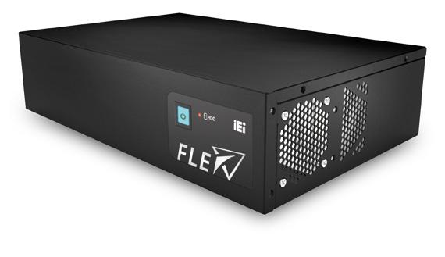

Hardware Feature

● 2U AI Modular PC with 8th Generation LGA 1151 Intel® Core™ i7/i5/i3 and Pentium® processor

● Four hot-swappable and accessible HDD drive bays, support RAID 0/1/5/10

● Two PCIe 3.0 by 4 and two PCIe 3.0 by 8 slots

● Dual M.2 2280 PCIe Gen 3.0 x4 NVMe™ SSD support

● QTS-Gateway support

Specifications

Model |  | FLEX-BX200-Q370
 | CPU | 8th Genertion Intel® Core™ i7/i5/i3 porcessors in the LGA 1151 package
 |  | (Please choose the TDP of the the processor under 65W)
 | Chipset | Intel® 300 Series Chipsets Q370 (Coffee Lake)
System | Memory | 2 x 288-pin 2666/2400 MHz dual-channel DDR4 unbuffered DIMM supporting up to 64GB
 | Graphics Engine | Intel® HD Graphics Gen 9 Engines with Low power 16 execution unit, supports DX2015, OpenGL 5.X and OpenCL2.
 |  | x, ES 2.0
 | Ethernet | Intel® I211 controller
Storage |  | 4 x accessible 2.5" HDD/SSD SATA 6 Gb/s bay (with RAID 0/1/5/10 support) with LED indicator
 |  | 2 x NGFF M.2(2280) M Key socket (support NVMe SSD)
 |  | 1 x HDMI output
 |  | 2 x GbE LAN
 |  | 6 x USB 3.1 Gen 1 (5Gb/s) Type-A
I/O Ports and Switches |  | 2 x RS-232 DB-9 type
 |  | 1 x Mic in1 x Line out
 |  | 1 x AC Inlet
 |  | Power button with power LED (power on=Blue)
 |  | AT/ATX mode switch
 |  | Reset button
Expansion Slots |  | 2 x PCIe 3.0 by 8 (by 16 slot)
 |  | 2 x PCIe 3.0 by 4 (Maximum card size supported: 68 mm x 167 mm)
Thermal Solution |  | System Fan x3, CPU Cooler x1
 |  | AC input ATX power supply
 |  | 1. 250W power supply
 |  | - Input: 115VAC~230VAC, 50/60Hz
Power supply |  | - Output (Max.): 3.3V@12A, 5V@14A, 12V@25A, -12V@0.3A,+5Vsb@3A
 |  | 2. 350W power supply (Build to Order)
 |  | - Input: 115VAC~264VAC, 50/60Hz
 |  | - Output (Max.): 3.3V@14A, 5V@16A, 12V@29A, -12V@0.3A,+5Vsb@3A
 |  | -Efficiency: Full load (100%) 87%, Typical load (50%) 90%, Light load (20%) 87%
Watchdog Timer |  | Software Programmable support 1~255 sec. System reset
 | Chassis Construction | Metal Housing
 | Mounting | Wall and Rack Mount
Construction | Color | Black
 | Dimensions (LxDxH) | 357 x 230 x 88
 | (mm)
 | Weight (kg) Net/Gross | 4/6
 | Operating Temperature | -20°C ~ 50°C (with SSD and TDP 65W processor)
 |  | -20°C ~ 40°C (with HDD or add-on cards without fan)
 | Storage Temperature | -20°C ~ 60°C
Environmental | Operating Humidity | 5% ~95%, non-condensing
 | Vibration | 5~17Hz, 0.1 double amplitude displacement 17~640Hz 1.5G acceleration peak to peak
 | shock | 10G acceleration part to part (11ms)

FLEX-BX200-2019-V10

AI Solution
 |  |  |  | w w w. i e i w o r l d . c o m
Ordering Information
 | Part No. | Description
 | FLEX-BX200-Q370-P/25-R10 | 2U | AI Modular Box PC, Intel® Pentium® Gold G5400T Processor (2-core, 4-thread, 3.10 GHz) TDP 35W,
 |  | two PCIe x4 and two PCIe x8 slots, four HDD bays, 250W PSU, R10
 | FLEX-BX200-Q370-i3/25-R10 | 2U | AI Modular Box PC, Intel® Core™ i3-8100T Processor (4-core, 4-thread, 3.10 GHz) TDP 35W, two
 |  | PCIe x4 and two PCIe x8 slots, four HDD bays, 250W PSU, R10
 | FLEX-BX200-Q370-i5/25-R10* | 2U | AI Modular Box PC, Intel® Core™ i5-8500T Processor (6-core, 6-thread, 2.1 GHz) TDP 35W, two PCIe
 |  | x4 and two PCIe x8 slots, four HDD bays, 250W PSU, R10
 | FLEX-BX200-Q370-i7/25-R10* | 2U | AI Modular Box PC, Intel® Core™ i7-8700T Processor (6-core,12-thread,2.4 GHz) TDP 35W, two PCIe
 |  | x4 and two PCIe x8 slots, four HDD bays, 250W PSU, R10
 | FLEX-BX200-Q370-P/35-R10* | 2U | AI Modular Box PC, Intel® Pentium® Gold G5400T Processor (2-core, 4-thread, 3.10 GHz) TDP 35W,
 |  | two PCIe x4 and two PCIe x8 slots, four HDD bays, 350W PSU, R10
 | FLEX-BX200-Q370-i3/35-R10* | 2U | AI Modular Box PC, Intel® Core™ i3-8100T Processor (4-core, 4-thread, 3.10 GHz) TDP 35W, two
 |  | PCIe x4 and two PCIe x8 slots, four HDD bays, 350W PSU, R10
 | FLEX-BX200-Q370-i5/35-R10* | 2U | AI Modular Box PC, Intel® Core™ i5-8500T Processor (6-core, 6-thread, 2.1 GHz) TDP 35W, two PCIe
 |  | x4 and two PCIe x8 slots, four HDD bays, 350W PSU, R10
 | FLEX-BX200-Q370-i7/35-R10* | 2U | AI Modular Box PC, Intel® Core™ i7-8700T Processor (6-core,12-thread,2.4 GHz) TDP 35W, two PCIe
 |  | x4 and two PCIe x8 slots, four HDD bays, 350W PSU, R10
*Build to order
Packing List
 | Item | Q’ty |  | Remark
 | 32702-000200-100-RS | 1 |  | European power cord, 1830mm
 | 41020-0521C2-00-RS | 2 |  | wall mount kit, black
 | 44035-040062-RS | 4 |  | M4*6 oval head screw for wall mount kit, black
 |  | 1 |  | Key for HDD cover
Options
 | Part No. | Description
 | FLEX-BXRK-R10 | Rack mount kit
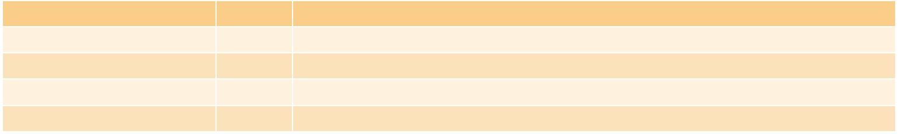

FLEX-BX200-2019-V10

AI Solution
w w w . i e i w o r l d . c o m

I/O Interface
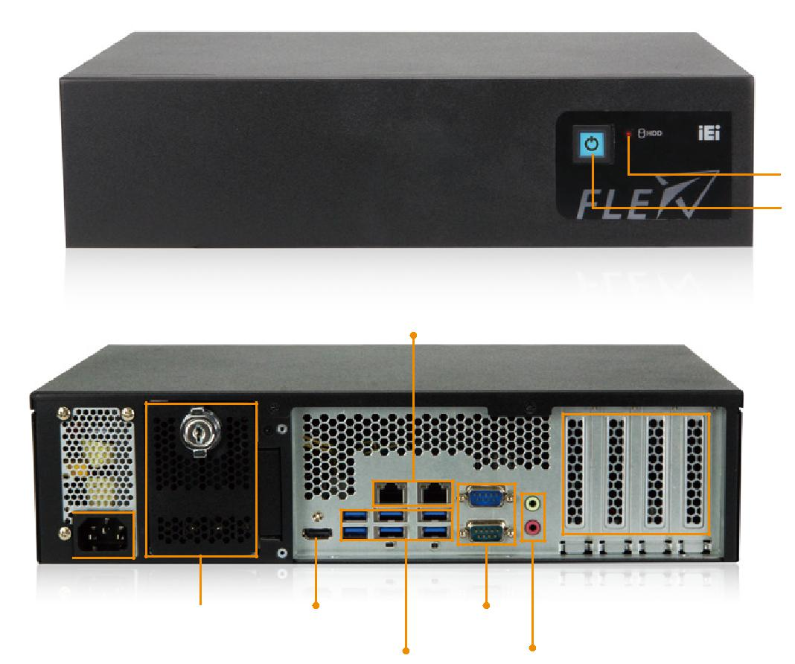

HDD status LED

Power button with
power LED

GbE LAN

2 x PCIe 3.0 x8 (x16 slot)
2 x PCIe 3.0 x4 (x4 slot)

AC Inlet

4 x Hot swappable 2.5”HDD HDMI 2.0 output 2 x | RS-232
6 x USB 3.1 Gen 1 | Audio (Mic-in, Line-out)
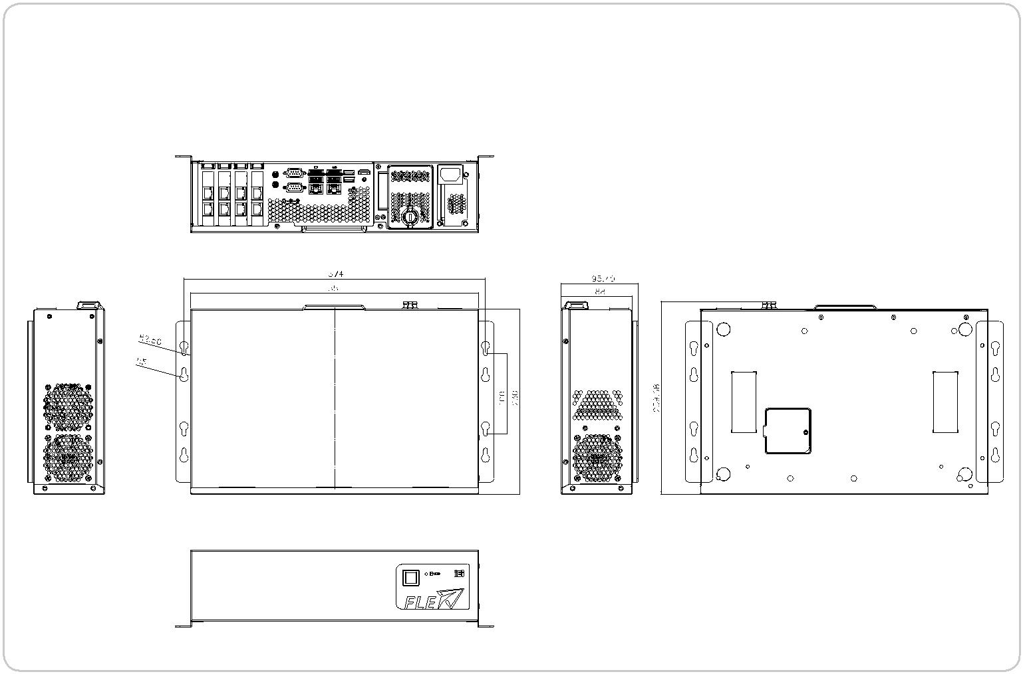

FLEX-BX200

Dimensions (Unit: mm)

FLEX-BX200-2019-V10

AI Solution
w w w. i e i w o r l d . c o m

Configurable Systems

Panel Kit Modules
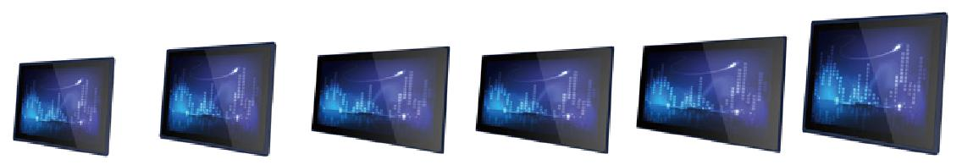

Specifications

Model |  | FLEX-PLKIT-F15 | FLEX-PLKIT-F17 | FLEX-PLKIT- |  | FLEX-PLKIT- | FLEX-PLKIT- | FLEX-PLKIT-
 |  |  |  | FW15 |  | FW19 | FW22 | FW24
 | LCD Size | 15” | 17” | 15.6" |  | 18.5" | 21.5” | 23.8”
 | Max. Resolution | 1024x768 | 1280x1024 | 1366x768 |  | 1366x768 | 1920x1080 | 1920x1080
 | Brightness (cd/m²) | 450 | 350 | 400 |  | 400 | 250 | 250
TFT LCD | Contrast Ratio | 800:1 | 1000:1 | 500:1 |  | 1000:1 | 1000:1 | 3000:1
 | LCD Color | 16.2M | 16.7M | 16.2M |  | 16.7M | 16.7M | 16.7M
 | Viewing Angle (H/V) | 160°/150° | 170°/160° | 170°/160° |  | 170°/160° | 170°/160° | 178°/178°
 | Backlight MTBF | 70,000 | 50,000 | 50,000 |  | 50,000 | 30,000 | 30,000
 | (Hrs)
Touch Screen |  |  | PCAP touch with 10-point multitouch and anti-glare coating
Video Interface |  |  |  | LVDS
IP Rating |  |  |  | IP66-rated front panel
Other |  |  |  | Support FLEX-BX200-Q370 only

Ordering Information

Part No. | Description
FLEX-PLKIT-F15/PC-R10 | 15" 450cd/m² 1024 x768 FLEX modular resistive touch window/LCD kit, R10
FLEX-PLKIT-F17/PC-R10 | 17" 350cd/m² 1280 x 1024 FLEX modular PCAP touch window/LCD kit, R10
FLEX-PLKIT-FW15/PC-R10 | 15.6" 400cd/m² 1366 x 768 FLEX modular PCAP touch window/LCD kit, R10
FLEX-PLKIT-FW19/PC-R10 | 18.5" 400cd/m² 1366 x 768 FLEX modular PCAP touch window/LCD kit, R10
FLEX-PLKIT-FW22/PC-R10 | 21.5" 250cd/m² 1920 x 1080 FLEX modular PCAP touch window/LCD kit, R10
FLEX-PLKIT-FW24/PC-R10 | 23.8" 250cd/m² 1920 x 1080 FLEX modular PCAP touch window/LCD kit, R10

Options

Item | FLEX-PLKIT-F15 | FLEX-PLKIT-FW15 | FLEX-PLKIT-F17 | FLEX-PLKIT-FW19 | FLEX-PLKIT-FW22 | FLEX-PLKIT-FW24
Panel Mount Kit | FPK-12-R10 | FPK-14-R10 | FPK-13-R10 | FPK-13-R10 | FPK-13-R10 | FPK-14-R10
Rack Mount Kit | FRK15C-R10 | FRKW15C-R10 | FRK17C-R10 | FRKW19C-R10 | N.A. | N.A.
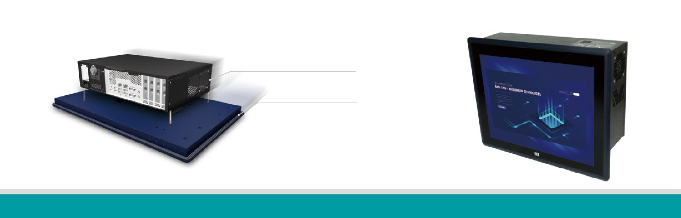

FLEX-BX200 Series
+ | = PPC-FxxC Series
FLEX-PLKIT Series

FLEX-BX200-2019-V10

AI Solution
w w w . i e i w o r l d . c o m

Configurable Systems
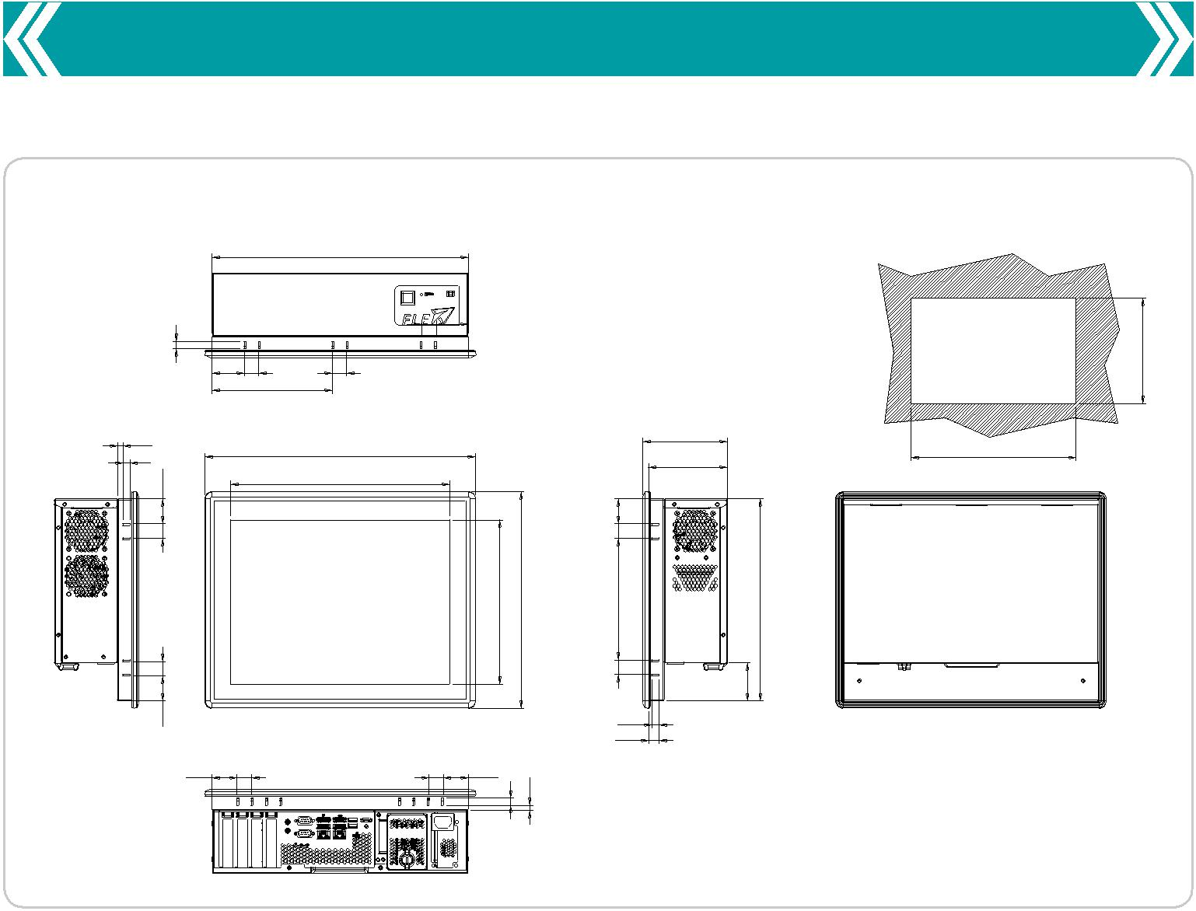

PPC-F15C-Q370 Dimensions (Unit: mm)

 |  | 358.10
10
 | 44.7520 | 20
 | 167.80
7.50 |  | 378.50 |  |  |  |  |  | 117.96 | 361.1
10 |  |  |  |  |  |  |  | 110
7534. |  |  |  |  |  |  |  |  | Suggested cut out size
 |  | 306 |  |  |  |  | 34.75
20 |  |  |  |  |  |  | 20
 |  |  |  | 230 | 303 |  | 170.60 |  | 60282.
20 |  |  |  |  |  |  | 20 |  | 53.60
34.75 |  |  |  |  |  |  | 10
 |  |  |  |  |  |  | 14.50
34.75 | 20 |  | 20 | 34.75 |  | 7.50
 |  |  |  | 10
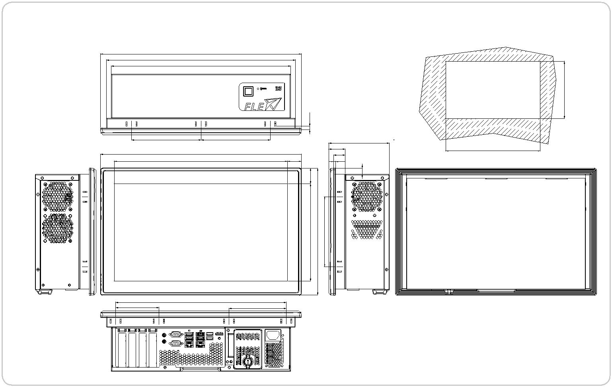

285.6

PPC-FW15C-Q370 Dimensions (Unit: mm)

400.70
376.10
357
 | 7.50
138.05 | 138.05 |  | 121
 |  | 33
400.10
 | 27.34 | 23 | 3.50
345.43
 | 30.71 |  | 12
 | 194.7430253.139.30

Suggested Cut out Size

Scale 1:2

379.1

3232.

86 | 339.90 | 114

FLEX-BX200-2019-V10

AI Solution
w w w. i e i w o r l d . c o m

Configurable Systems
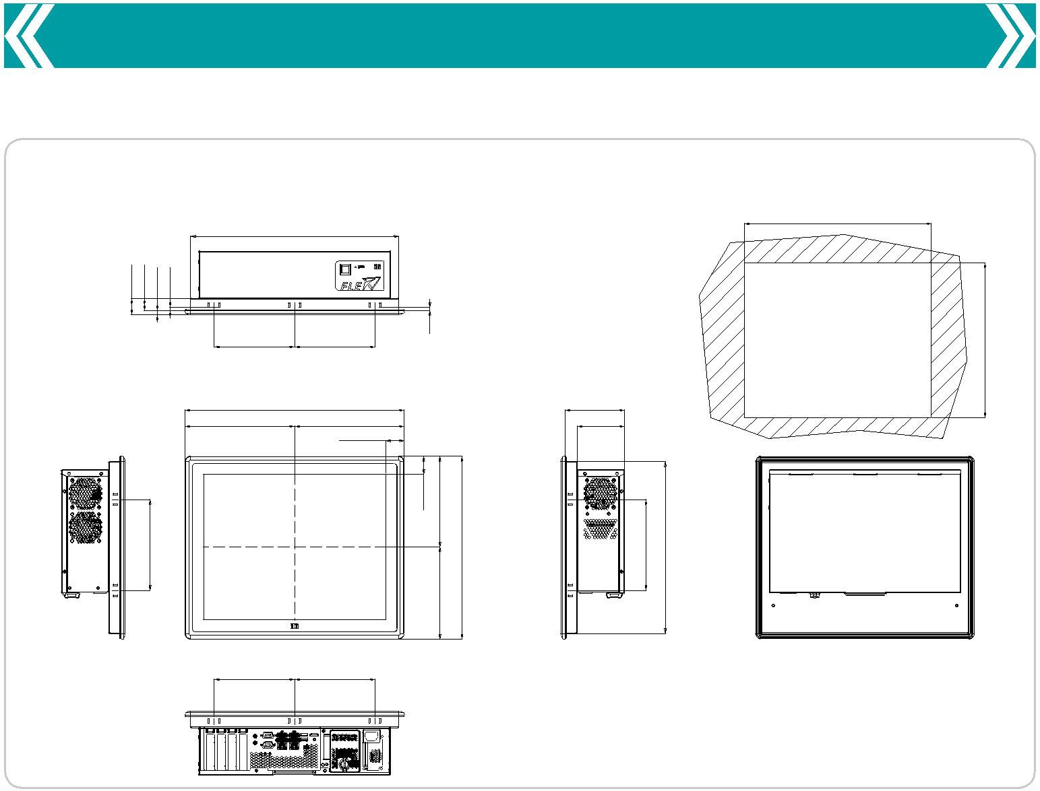

PPC-F17C-Q370 Dimensions (Unit: mm)

 | 388
3123 | 6
8
 | 150 | 150 | 6
 | 408.40 |  |  | 111
 | 204.20 | 204.20 |  | 88
 |  | 34.20
 |  |  | 33.5570169.
170 |  |  | 341.40 | 170 | 321
 |  |  | 70171.

391

Suggested
Cutout Size

324

150 150
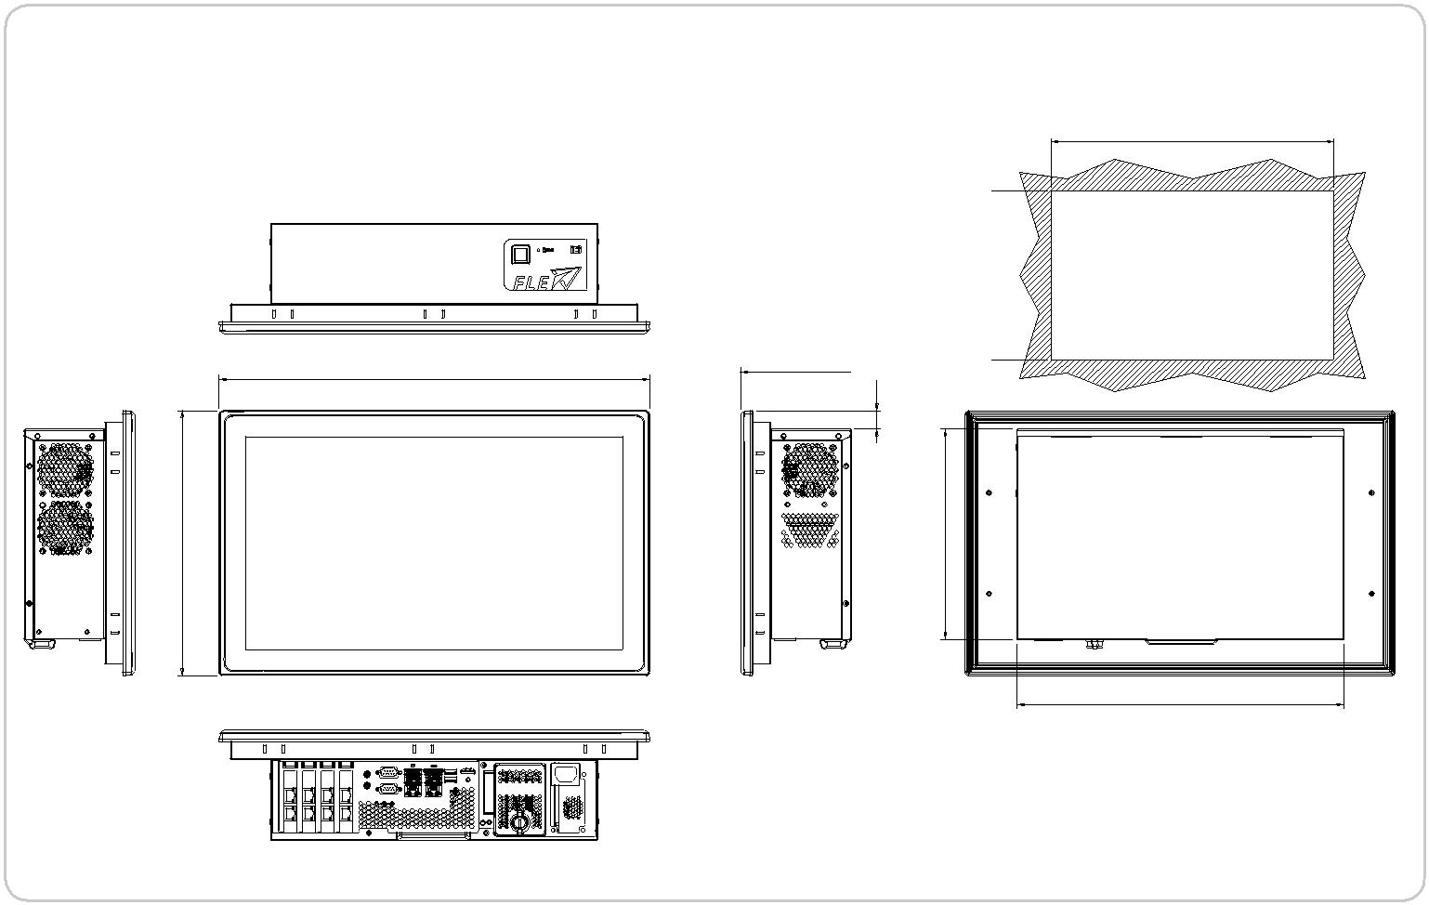

PPC-FW19C-Q370 Dimensions (Unit: mm)

469.80

289.20

120.80

20.10

267.20

230

447.80

Suggested
Cut Out Size

357

FLEX-BX200-2019-V10

AI Solution
w w w . i e i w o r l d . c o m

Configurable Systems
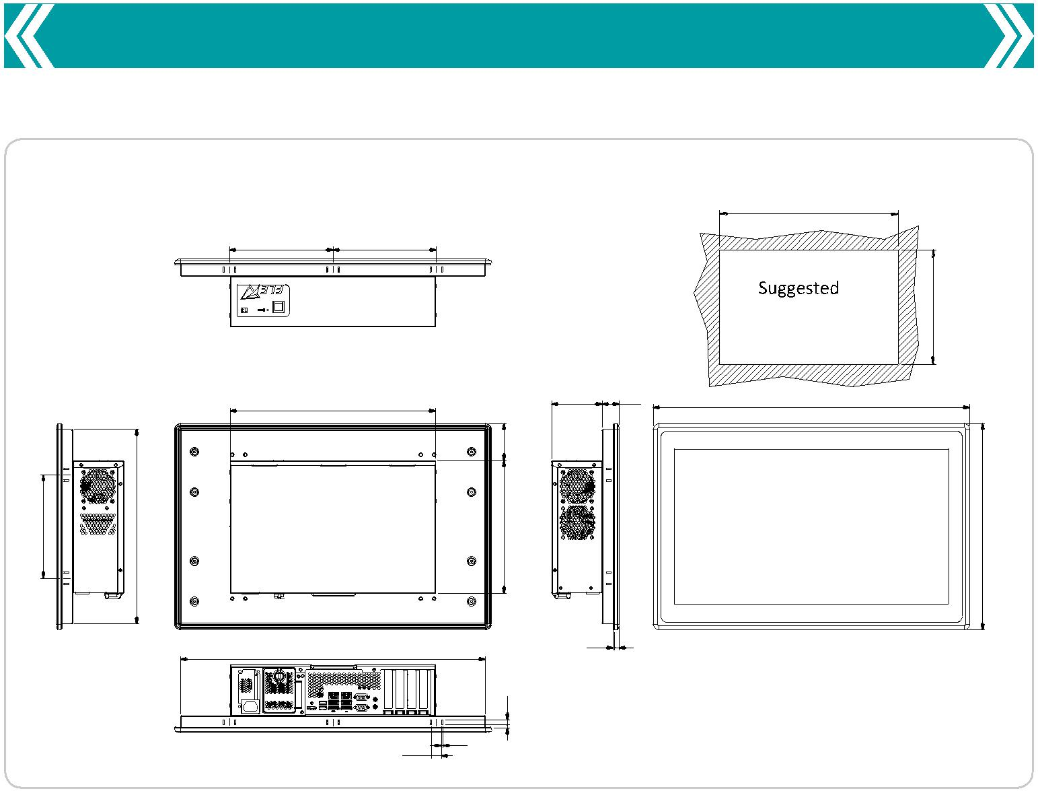

PPC-FW22C-Q370 Dimensions (Unit: mm)

533

180 180

Cut out Size

357 | 88 | 29.80 | 550.40

 |  | 64.70
180 | 338 | 230

2.30 8
530

 |  | 8.50
17.50 | 2.50 | 6
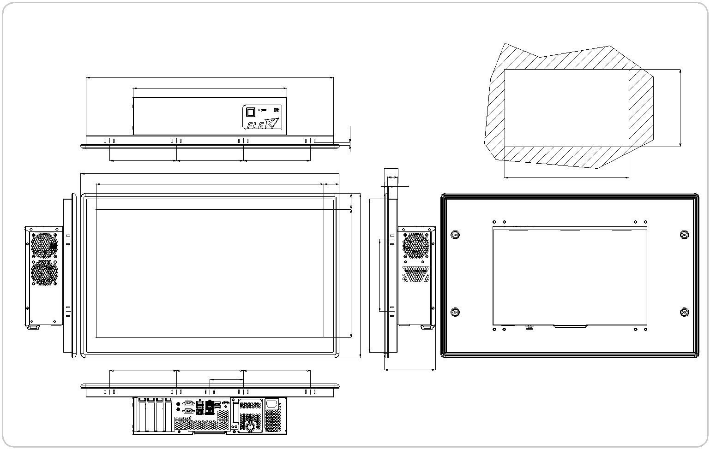

341

40358.

PPC-FW24C-Q370 Dimensions (Unit: mm)

574.6
357

36.

155.2 155.2 155.2
600
528.6 35.7

37

 | Suggested Cut Out Size
 | Scale 1:2
31
²³2.3 | 577.6

359.6

298 | 6356. | 166.6
382

155.2 | 155.2 | 155.2 | 119
 | 77.6

FLEX-BX200-2019-V10

