w w w . i ei w or l d .c om
QTS-Gateway for Fanless Embedded System wtih Intel® Celeron® J1900 Processor
ECW-281B-QGW

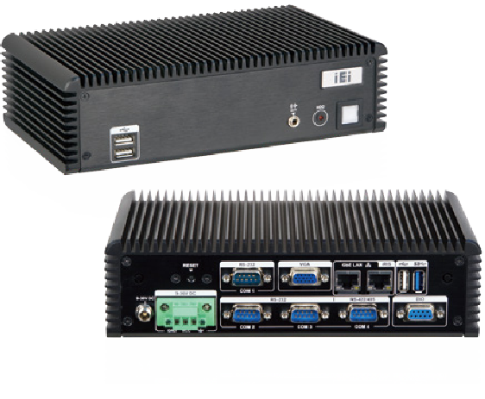
Features
- Fanless system with Intel® Celeron® J1900 Processor
- Supports four COM ports (three RS-232, one RS-422/485)
- 9~36V DC input support
- Wide operating temperature: -20°C ~ 60°C with SSD
- Pre-install QTS-Gateway

Fanless
USB
USB 3.0

Dual GbE

Specifications

Model Name |  | ECW-281B-BT
Chassis | Color | Black
 | Dimensions  (WxHxD) (mm) | 229 x 64 x 132
 | System Fan | Fanless
 | Chassis  Construction | Aluminum alloy with heavy duty metal
Motherboard | Motherboard Model | WAFER-BT-i1
 | SBC Size (mm) | 3.5", 146 x 102
 | CPU | Intel® Celeron® J1900 processor  (2 GHz, quad-core, 2 MB cache, TDP=10W)
 | Chipset | SoC
 | System  Memory | 1 x 204-pin 1066/1333 MHz single-channel DDR3L  SO-DIMM (system max. 8 GB)
IPMI | iRIS Solution | 1 x iRIS-1010-R10 (optional)
Storage | Hard Drive | 1 x 2.5” SATA 3Gb/s HDD bay
I/O Interfaces | USB 3.0 | 1
 | USB 2.0 | 3
 | Ethernet | LAN 1: PCIe GbE by Intel® I210 controller  LAN 2: PCIe GbE by Intel® I211 controller
 | COM Port | 3 x RS-232  1 x RS-422/485
 | Digital I/O | 8-bit digital I/O
 | Display | 1 x VGA
 | Resolution | VGA: Up to 2560x1600@60Hz
 | Audio | 1 x Line out
Expansion | PCIe Mini | 1 x Half-size PCIe Mini card (only for iRIS)
Power | Power Input | 3-pin terminal: 9 V~36 V DC
 | Consumption | 12V@1.45A (with Intel® Celeron® J1900 CPU and one  8 GB 1333 MHz DDR3 memory)
Reliability | Mounting | Wall mount, VESA 100
 | Operating  Temperature | -20°C~60°C with air flow (SSD),  10% ~ 95%, non-condensing
 | Storage  Temperature | -20°C ~ 60°C
 | Operating  Shock | Half sine wave 5G, 11ms 3-axis (non-operational)
 | Operating  Vibration | MIL-STD-810F 514.5C-1 (HDD)
 | Weight  (Net/Gross) | 2.1 kg / 3.9 kg
Ordering Information
Dimensions (Unit: mm)
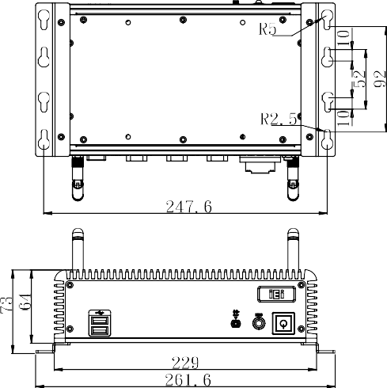

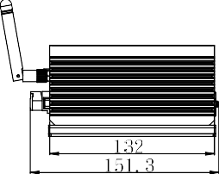

Options

Part No. | Description
iRIS-1010-R10 | IPMI 2.0 adapter card with AST1010 BMC chip (W/O KVM over IP function) for PCIe Mini socket interface
ECW-281B-BTi-WES7E64-R10 | OS Image with Windows® Embedded Standard 7 E 64Bit for ECW-281BTi Series, with DVD-ROM, RoHS, R10

Packing List

1 x Wall mount bracket | 1 x Screw set
1 x One Key Recovery CD | 1 x Utility CD

ECW-281B-QGW-2018-V10
Industrial Computer Chassis
Part No. | Description
ECW-281BWD-BTi-QGW-R10 | Fanless embedded system with WAFER-BTi-R10,with Intel® Celeron J1900 2GHz, 4 serial ports,with 4GB DDR3L pre-installed SO-DIMM memory, with QTS-Gateway, 9~36VDC in, w/o adapter, black, RoHS

