- Intel® Core™ i5/Celeron® CPU
- Triple Video Outputs
ECN-380-QM87

Specifications
Features

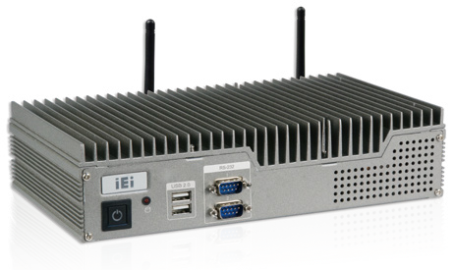Intel® Core™ i5/Celeron® CPU
» Intel® Core™ i5-4400E 2.7 GHz/Celeron® 2000E 2.2 GHz

Triple video outputs
» 2 x HDMI + VGA

Two 2.5'' SATA 6Gb/s HDD/SSD drive bays

Fanless

Dual LAN

Dual HDD
Display
Triple

Model Name |  | ECN-380-QM87
Chassis | Color | Silver
 | Dimensions (WxDxH) (mm) | 265 x 134 x 56.7
 | System Fan | Fanless
 | Chassis Construction | Aluminum alloy with heavy duty metal
Motherboard | Motherboard Model | NANO-QM871-i1
 | SBC Size (mm) | EPIC, 165 x 115
 | CPU | Intel® mobile Core™ i5-4400E with AMT 9.0 support (up to 2.7GHz, dual-core, 3MB cache, TDP=37W) Intel® mobile Celeron® 2000E (up to 2.2GHz, dual-core, 2MB cache, TDP=37W)
 | Chipset | Intel® QM87
 | System Memory | One 204-pin 4GB DDR3 SO-DIMM pre-installed (system max: 8GB)
IPMI | iRIS Solution | 1 x iRIS-1010 (optional)
Storage | Hard Drive | 2 x 2.5'' SATA 6Gb/s HDD/SSD drive bay
I/O Interfaces | USB 3.0 | 2
 | USB 2.0 | 4
 | Ethernet | 2 x RJ-45  LAN1: Intel® I217LM PHY with Intel® AMT 9.0 support LAN2: Intel® I210-AT PCIe controller
 | COM Port | 2 x RS-232
 | Display | 2 x HDMI, 1 x VGA
 | Resolution | VGA: Up to 1920 x 1200@60Hz HDMI: Up to 2500 x 1600@60Hz
 | Audio | 1 x Line-out, 1 x Mic-in
 | Wireless | 1 x 802.11b/g/n (optional)
Expansions | PCIe Mini | 1 x Full-size PCIe Mini (supports mSATA, SATA 6Gb/s signal only)* 1 x Half-size PCIe Mini (only for iRIS-1010)
Power | Power Input | DC jack: 12 V DC  3-pin terminal: 9 V~36 V DC
 | Power Consumption | 12 V@4.6 A  (Intel® mobile Core™ i5-4400E with 4GB 1333MHz DDR3 memory)
Reliability | Mounting | Wall mount, VESA 100
 | Operating Temperature | -20°C ~60°C with air flow (SSD), 10% ~ 95%, non-condensing
 | Storage Temperature | -30°C ~70°C with air flow (SSD), 10% ~ 95%,non-condensing
 | Operating Shock | Half-sine wave shock 5G, 11ms, 3 shocks per axis
 | Operating Vibration | MIL-STD-810F 514.5C-2 (with SSD)
 | Weight (Net/Gross) | 2.4 kg/4.2 kg
* ECN-380-QM87i-WD-QGW without Full-size PCIe Mini Card slot expansion

Removable 2.5’’ SATA HDD/SSD Bay Triple Display Outputs
Display
Triple

The ECN-380 series is equipped with two 2.5" SATA HDD bays.

Dual HDD
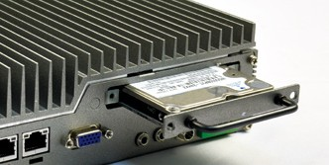One of the HDD bays is removable for easy installation.
The ECN-380-QM87 contains two HDMI and one VGA. All of the display outputs support high resolution video, which can be applied widely in multi-monitor applications.

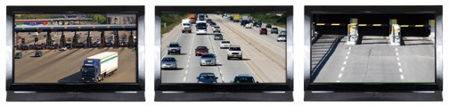

Fully Integrated I/O
●ECN-380-QM87 Front I/O ●ECN-380-QM87 Rear I/O

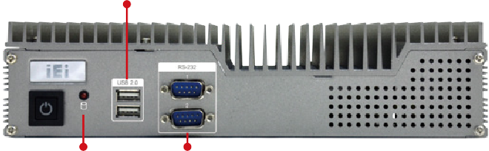
2 x USB 2.0 2 x USB 3.0 2 x LAN Audio

Power 1 (Terminal Block)

HDD LED

2 x RS-232

2 x HDMI
2 x USB 2.0 VGA Power 2
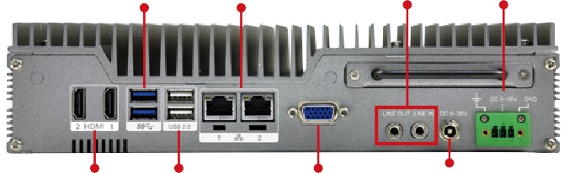
(DC Jack)

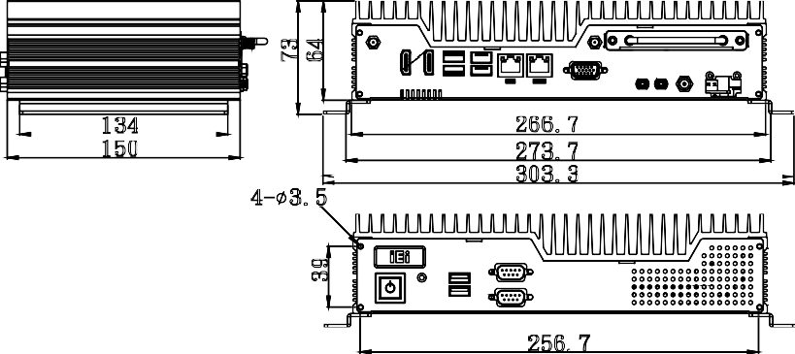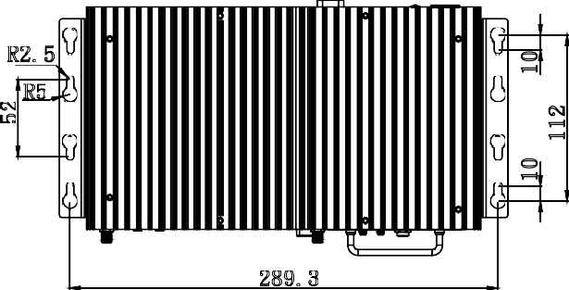Dimensions (Unit: mm)
266.7
273.7
303.3
4- 3.5
256.7
150
134
R2.5
289.3
R5
52
10
10
112

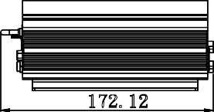
172.12

Ordering Information
73
64
39

Part No. | Description
ECN-380-QM87i-i5/4G-R11 | Fanless embedded system with Intel® Core™ i5-4400E 2.7 GHz CPU, TDP 37W, 2 x HDMI, 1 x VGA, 2 x 2.5'' SATA HDD bay, 4GB memory  pre-installed, iRIS-1010, 12 V DC, RoHS
ECN-380-QM87i-C/4G-R11 | Fanless embedded system with Intel® Celeron® 2000E 2.2 GHz CPU, TDP 37W, 2 x HDMI, 1 x VGA, 2 x 2.5'' SATA HDD bay, 4GB memory  pre-installed, iRIS-1010, 12 V DC, RoHS
ECN-380-QM87i-i5/WD/4G-R11 | Fanless embedded system with Intel® Core™ i5-4400E 2.7 GHz CPU, TDP 37W, 2 x HDMI, 1 x VGA, 2 x 2.5'' SATA HDD bay, 4GB memory  pre-installed, iRIS-1010, 9 V~36V DC, RoHS
ECN-380-QM87i-C/WD/4G-R11 | Fanless embedded system with Intel® Celeron® 2000E 2.2 GHz CPU, TDP 37W, 2 x HDMI, 1 x VGA, 2 x 2.5'' SATA HDD bay, 4GB memory  pre-installed, iRIS-1010, 9 V~36 V DC, RoHS
ECN-380-QM87i-WD-QGW-R10 | Fanless embedded system with Intel® Core™ i5-4400E 2.7 GHz, TDP 37W, 2 x HDMI, 1 x VGA, 2 x 2.5’’ SATA HDD bay, 8GB memory pre-installed, iRIS-1010, with QTS-gateway, 9 V~36V DC, RoHS
Options

Part No. | Description
iRIS-1010-R10 | IPMI 2.0 adapter card with AST1010 BMC chip (W/O KVM over IP function) for PCIe Mini socket interface
ECN380VK-100-R10 | VESA 100 mount kit for ECN-380
ECN-380-QM87i-WES7E-R10 | OS image with Windows Embedded Standard 7 E for ECN-380-QM87i Series, WES7E license label, with DVD ROM
Packing List

1 x Power cord | 1 x Chassis screw set | 1 x Utility CD
1 x Power adapter (with PSE/ErP certified) | 1 x Wall mount bracket | 1 x One Key Recovery CD

