Industrial System
w w w . i ei w or l d .c om
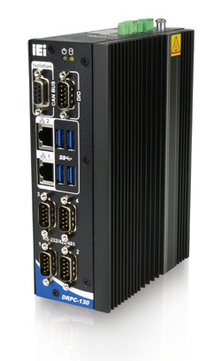
Features
- Intel® Atom™ x5-E3930 1.3GHz (up to 1.8 GHz)
- DDR3L 1.35V SO-DIMM supported
- Serial, CAN bus and digital I/O interface
Fanless
CAN-Bus
Dual LAN
RS-232
/422/485
PCIe Mini Expansion
Specifications
- Fanless DIN-Rail Embedded System
- Intel® Atom™ x5-E3930 1.3GHz (up to 1.8 GHz) Solution
DRPC-130-AL

Model Name |  | DRPC-130-AL
Chassis | Color | Black
 | Dimensions (WxDxH) | 58.75 x 130 x 174
 | System Fan | Fanless
 | Chassis Construction | Extruded aluminum alloy
Motherboard | CPU | Intel® Atom™ x5-E3930 1.3GHz (up to 1.8 GHz, dual core, TDP=6.5W)
 | Chipset | SoC
 | System Memory | 1x 204-pin DDR3L SO-DIMM slot (system max. 8 GB)  (DRPC-130-AL-E1/4GB SKU is pre-installed with 4 GB memory)
Storage | Hard Drive | 1 x 2.5'' SATA 6Gb/s HDD/SSD bay
 | eMMC | 1 x eMMC 5.0 support (up to 32GB, optional)
I/O Interfaces | USB 3.0 | 4
 | USB 2.0 | 1 by pin header
 | Ethernet | 2 x RJ-45  PCIe GbE by Intel® I211 controller
 | COM Port | 4 x RS-232/422/485 (DB-9)
 | Digital I/O | 8-bit digital I/O, 4-bit input/4-bit output (DB-9)
 | CAN Bus | 1 x DB-9 w/ 2.5kV Isolation protection, supporting 2-port CAN-bus
 | Display | 2 x HDMI 1.4b
 | Resolution | Up to 3840 x 2160@30Hz
 | SIM | 1 x Internal on-board SIM slot (optional)
 | Wireless | 1 x 802.11a/b/g/n/ac (optional)
 | TPM | 1 x TPM 2.0 (2x10 pin) (optional)
 | Others | 1 x Power Button 1 x LED for HDD (Yellow)  1 x Reset Button 1 x LED for Power (Green) 1 x AT/ATX Switch
Expansions | PCIe Mini | 1 x Half-size PCIe Mini slot  1 x Full-size PCIe Mini slot (supports mSATA, colay with SATA)
Power | Power Input | 3-pin terminal block: 12 V ~ 24 V DC
 | Remote PWR | PSON 2-pin terminal block
 | Power Consumption | 12V @ 2.88 A (Intel® Atom™ x5-E3930 CPU with 4GB 1600 MHz DDR3L memory)
Reliability | Mounting | DIN-rail / Wall mounting
 | Operating Temperature | -20°C ~ 60°C with air flow (SSD), 10% ~ 95%, non-condensing
 | Storage Temperature | -40°C ~ 85°C with air flow (SSD), 10% ~ 90%, non-condensing
 | Operating Shock | Half-sine wave shock 5G, 11ms, 100 shocks per axis, IEC68-2-27
 | Operation Vibration | MIL-STD-810G 514.6C-1 (SSD)
 | Weight (Net/Gross) | 1.4Kg/2.5Kg
 | Safety / EMC | CE/FCC
 | Watchdog Timer | Programmable 1~255 sec/min
OS | Supported OS | Microsoft® Windows 10 / Linux

w w w . i ei w or l d .c om

Fully Integrated I/O
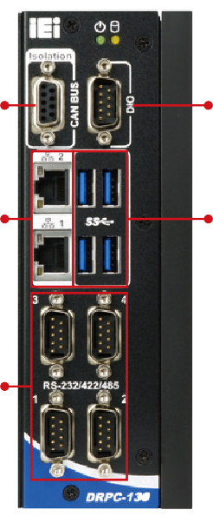
Front View Top View

2 x CAN-bus isolated DIO

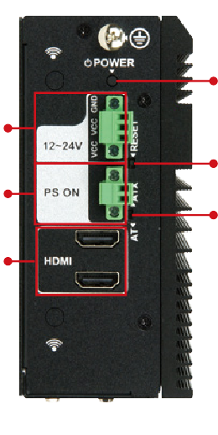
12V~24V DC in

Power switch

2 x GbE LAN

4 x RS-232/422/485

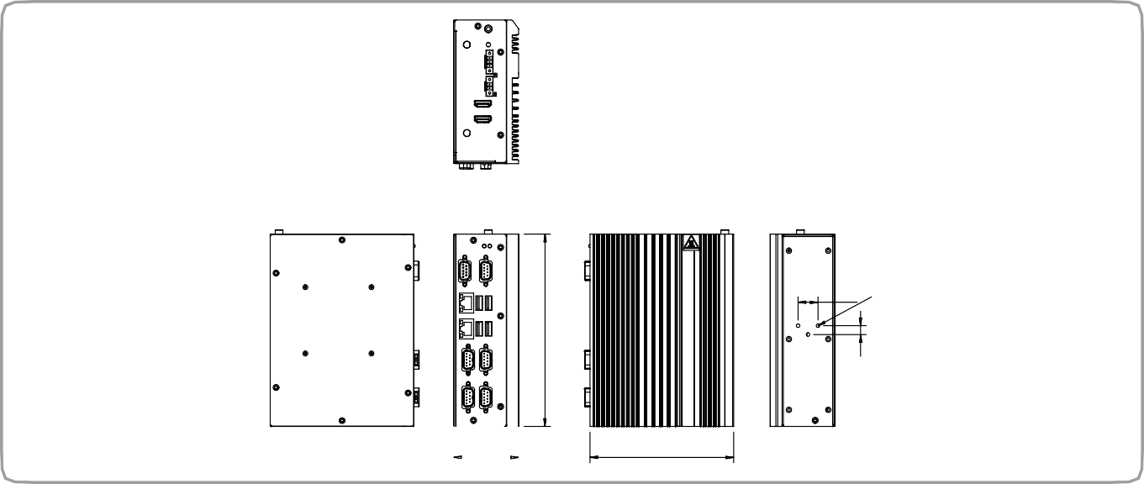Dimensions (Unit: mm)
18
#6-32
a a
a
130
DRPC-130-AL

58.75

4 x USB 3.0

PS On

2 x HDMI

Reset

AT/ATX mode

Industrial System

Ordering Information
174
8
Part No. | Description
DRPC-130-AL-E1-R11 | Fanless embedded system, Intel®Apollo Lake x5-E3930 1.3GHz (up to 1.8GHz, dual core), two HDMI, 8 CH DIO, CAN-Bus, COM, 12~24V DC and RoHS
DRPC-130-AL-E1/4GB-R11 | Fanless embedded system, Intel®Apollo Lake x5-E3930 1.3GHz (up to 1.8GHz, dual core), 4GB DDR3L pre-installed memory, two HDMI, 8 CH DIO, 12V ~ 24V DC and RoHS
Options
Item | Part No. | Description
Adapter | 63040-010036-210-RS | Adapter Power;FSP;FSP036-RHBN3;9NA0362707;;Vin:90~264VAC;36W;Dim:37.8*89.8*27.0mm;Plug=7.5mm;Cable  =1500mm;Erp(NO LOAD 0.075W);Vout:12VDC;Φ2.5/Φ5.5/lock;CCL;RoHS
Power Cable | 32102-026500-100-RS | Power cable 200mm, (A) DC jack to (B) 3-pin terminal block P=3.5
Power Cord | 32702-000200-100-RS | POWER CORD; EUROPEAN CODE(VDE); 2; 1830MM; (A)PLUG:SH-005(16A 250V); (B)CONNECTOR:C13(SH- 006,10A250V); Self-Man; CCL; RoHS
Wireless Kit | EMB-WIFI-KIT01-R20 | 1T1R Wi-Fi module kit for embedded system, IEEE802.11a/b/g/n/ac Wi-Fi with Bluetooth 4.0/3.0+HS, 1 x Wi-Fi module, 2 x 250mm RF cable, 2 x Antenna, RoHS
TPM Module | TPM-IN02-R20 | 20-pin Infineon TPM2.0 module, software mangement tool, firmware v5.5
DIN-Rail Mounting Kit | DK-DRPC-R10 | Rugged DIN-rail mounting kit for DPRC series only
OS:Windows Embedded 10 | DRPC-130-W10E64-E-R10 | OS Image with Windows® 10 IoT Enterprise Entry 64-bit for DRPC-130-AL Series, with DVD-ROM, RoHS
Packing List
1x Din-rail mounting kit
1 x Screw kit

