- Fanless DIN-Rail Embedded System
- Intel® E3845 1.91GHz Solution
DRPC-120-BT

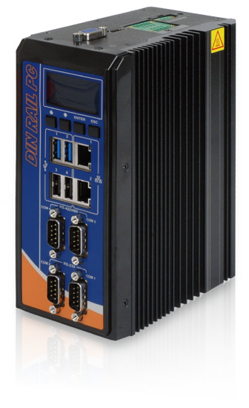
Features
- Intel® Atom™ E3845 1.91GHz
- 1 x 2.5'' SATA HDD/SSD drive bay
- DDR3L 1.35V SO-DIMM support
- Programmable OLED display
- 8-bit digital I/O (4-bit inputs/outputs)
- IEI iRIS-2400 solution

Fanless Expansion
PCIe Mini
Dual LAN RS-232
/422/485

User Friendly Installation
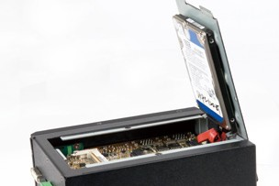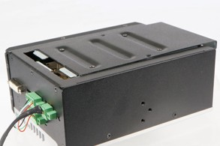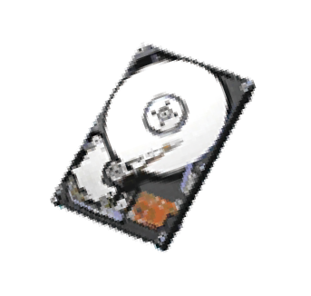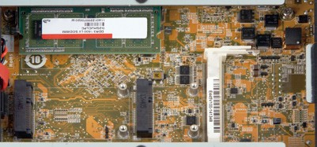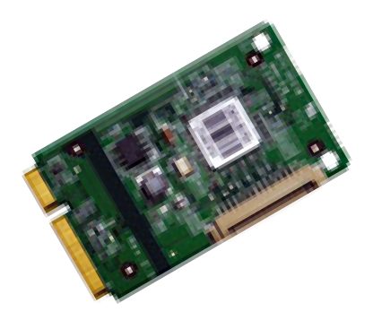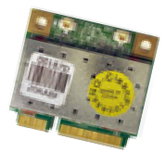The DRPC-120 is designed with an easy removable back cover for users to install SATA HDD, PCIe Mini cards, DDR3 memory modules or iRIS-2400 modules conveniently.

DDR3 SO-DIMM memory

1 x 2.5'' SATA 6Gb/s HDD/SSD Bay

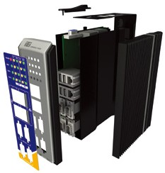8-Channel Digital I/O

Fanless
Full-size PCIe Mini Half-size PCIe Mini

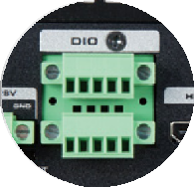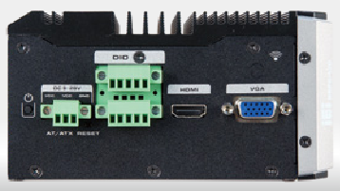The DRPC-120 is outfitted with 8-channel (4-bit input and 4-bit output) digital I/O to provide digital input and output signals for control of industrial devices.
The DRPC-120 series provides the best components for generating less heat, while m aint aining high s y s t em performance. With the fanless design, the DRPC-120 reduces system failure caused by fans and extends the lifetime of the device.

iRIS Solution
By installing the IEI iRIS-2400 module, the DRPC-120 is capable to complete your IoT application through the advanced remote control features, such as power management and control, remote KVM for device status monitoring, sending active
alerts and warning messages by e-mail or SMS.

Communication Gateway
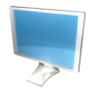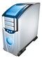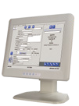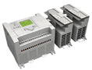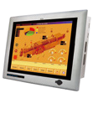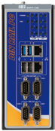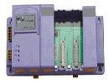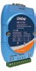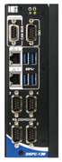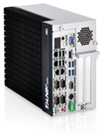For high surge ESD automation environments, the DRPC series provides isolated digital IO, CAN-bus and serial communication ports.

Ethernet
Database

DIN Rail Standard
A DIN rail is a metal rail of a standard type widely used for mounting circuit breakers and industrial control equipment inside equipment racks. These products are typically made from cold rolled carbon steel sheet with a zinc-plated and chromated bright surface finish. The term derives from the original specifications having been published by Deutsches Institut für Normung (DIN) in Germany, which have since been adopted as European (EN) and international (ISO) standards.

VGA

Ethernet

DIO

RS-232
PC/ERP

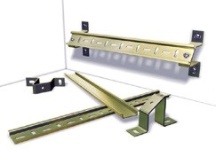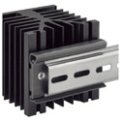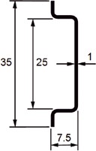HMI

CAN-bus

RS-422/485

Converter

PAC

Devices

PLC

Alarm

OLED Indicator Function

DRPC-120 OLED indicator

- Programmable OLED Display
Users can program their own APIs to show any information by the OLED display.
- Programmable Function Keys
Users can program the four keys to control OLED display.

Terminal Screen & Status Display
It supports both text format and graphic format.

Protocol & Demo Source Code Open
IEI provides the protocol & demo source code for users to program their own usage.

Programmable OLED indicator

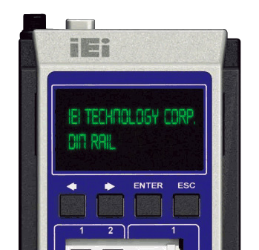Function Keys

Fully Integrated I/O

Front View Top Side View

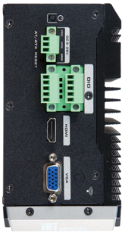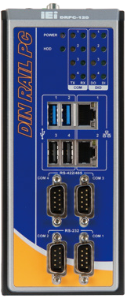9 V~30 V DC-in

LED indicators

Power switch

2 x LAN
2 x USB 3.1
Gen 1

2 x USB 2.0

AT/ATX mode
Reset

8-bit digital I/O

HDMI

2 x RS-422/485
isolated

2 x RS-232
isolated

VGA

Antenna connector

Specifications

Model Name |  | DRPC-120-BT
Chassis | Color | Black
 | Dimensions (WxDxH) (mm) | 74.08 x 140 x 171.5
 | System Fan | Fanless
 | Chassis Construction | Extruded aluminum alloys
Motherboard | CPU | Intel® Atom™ E3845 1.91 GHz
 | Chipset | SoC
 | System Memory | 1 x 204-pin DDR3L SO-DIMM 2 GB pre-installed (system max: 8GB)
IPMI | iRIS Solution | 1 x iRIS-2400 (optional)
Storage | Hard Drive | 1 x 2.5'' SATA 3Gb/s HDD/SSD bay
 | CF card | N/A
I/O Interfaces | USB 3.1 Gen 1  (5Gb/s) | 2
 | USB 2.0 | 2
 | Ethernet | 2 x RJ-45  1 x PCIe GbE by Intel® I210 controller 1 x PCIe GbE by Intel® I211 controller
 | COM Port | 2 x RS-232 (DB-9 w/3KV isolation protection*) 2 x RS-422/485 (DB-9 w/3KV isolation protection*)
 | Digital I/O | 8-bit digital I/O, 4-bit input/4-bit output
 | Display | 1 x VGA, 1 x HDMI
 | Resolution | Up to 1920 x 1200 @ 60Hz
 | Wireless | 1 x 802.11a/b/g/n/ac (optional)
 | Other | 1 x Power Button 1 x Reset Button 1 x AT/ATX Switch
Expansions | PCIe Mini | 1 x Half-size PCIe Mini slot (w/o USB signal) 1 x Full-size PCIe Mini slot (supports mSATA, colay with SATA)**
Power | Power Input | 3-pin terminal block: 9 V ~ 28 V DC
 | Power Consumption | 12 V@ 2.1 A  (Intel® Atom™ E3845 with 2 GB memory )
Reliability | Mounting | DIN-rail
 | Operating Temperature | -20ºC ~ 60ºC with air flow (mSATA), 5% ~ 95%, non-condensing
 | Operating Shock | Half-sine wave shock 5G, 11ms, 3 shocks per axis
 | Operating Vibration | MIL-STD-810F 514.5C-2 (with SSD)
 | Weight (Net/Gross) | 1.4 kg/2.5 kg
 | Safety/EMC | CE/FCC
OS | Supported OS | Microsoft® 8,  Microsoft® Windows® Embedded Standard 7 E
* COM port isolation: 3 kV for 1 sec, 2.5 kV for 1 minute
** DRPC-120-QGW-E5-LED/4G-R10 has only one Half-size PCIe Mini slot

Ordering Information
Part No. | Description
DRPC-120-BTi-E5-OLED/2G-R10 | Fanless embedded system, Intel® Bay-Trail E3845 1.91 GHz, TDP 10W, 2GB DDR3L pre-  installed memory, one VGA, one HDMI, 8 CH DIO,  iRIS-2400 optional, 9 V~28 V DC, OLED  indicators, R10, RoHs
DRPC-120-BTi-E5-LED/2G-R10 | Fanless embedded system, Intel® Bay-Trail E3845 1.91 GHz, TDP 10W, 2GB DDR3L pre-  installed memory, one VGA, one HDMI, 8 CH DIO,  iRIS-2400 optional, 9 V~28 V DC, LED indicators,  R10, RoHs
DRPC-120-QGW-E5-LED/4G-R10 | Fanless embedded system with Intel® Bay-Trail E3845 1.91 GHz, TDP 10W,4 GB DDR3L pre-  installed memory, with QTS-Gateway, 1 x VGA, 1 x HDMI, 8 CH DIO, iRIS-2400 optional,9 V~28  V DC, LED indicators, RoHs

Dimensions (Unit: mm)

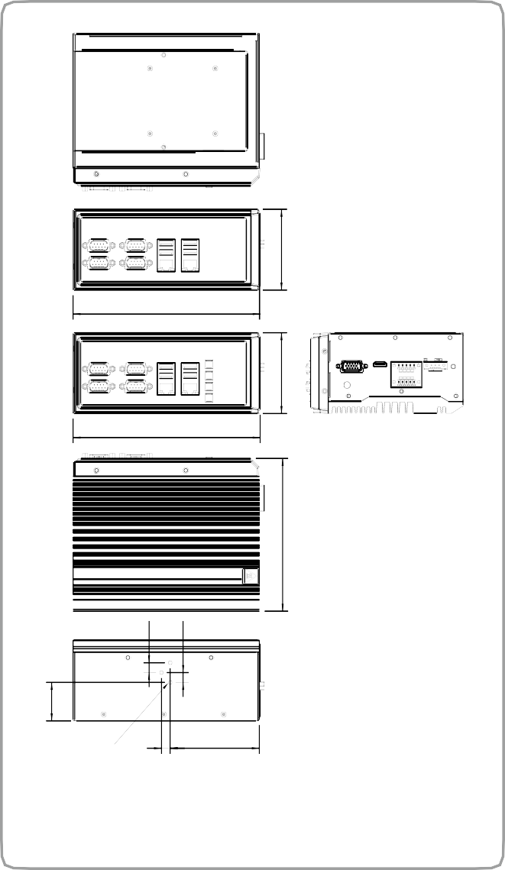Options
171.50
171.50
8
81.70
DRPC-120-BT
74.08
74.08
140
9
9
3-NUT-#6-32
35.27

Item | Part No. | Description
OS: Windows Embedded 7 | DRPC-120- WES7E-R10 (CD-ROM) | OS Image with Windows® Embedded Standard 7 E for DRPC-120 Series, CD- ROM, RoHS
Wireless kit | EMB-WIFI-  KIT01-R20 | 1T1R wifi module kit for embedded system, IEEE802.11a/b/g/n/ac WiFi with Bluetooth 4.0/3.0+HS, 1 x wifi module, 2 x 250mm RF cable, 2 x Antenna, RoHS
Adapter | 63040-010036-210- RS | Adapter Power;FSP;FSP036-RHBN3;9NA 0362707;;Vin:90~264VAC;36W;Dim:37.8*8  9.8*27.0mm;Plug=7.5mm;Cable=1500mm; Erp(NO LOAD 0.075W);Vout:12VDC;Φ2.5/  Φ5.5/lock;CCL;RoHS
Power Cable | 32102-026500-100- RS | Power cable 200mm, (A) DC jack to (B) 3-pin terminal block P=3.5
Power Cord | 32702-000400-200-  RS | European power cord
DIN-Rail mounting kit | DK-DRPC-R10 | Rugged DIN-Rail mounting kit only for DRPC series
Packing List
1 x Mounting bracket
1 x Screw kit

1 x SATA cable & SATA power cable

