Drive Cage Standard 3.5” Device in 5.25” Drive Bay Solutions
Following the traditional industrial system needs for stability, durability and toughness for storage drive operating condition, IEI provides various kinds of standard 3.5" device in 5.25" removable drive bay and modules for different demands.

 | SATA / IDE / SSD Solution |  | SATA Solution
 | 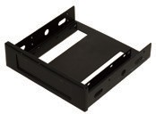 | 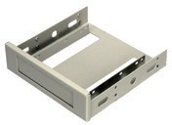 | 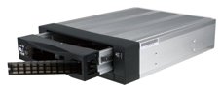 | 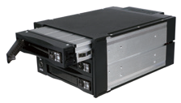
Model Name | XWC-410030507220-RS | XWC-410030507230-RS | RD-03A-R20 | RHD-302SATA-R20
Dimensions  (L x W x H) (mm) | 150 x 146 x 42 | 150 x 146 x 42 | 186 x 146 x 42 | 202 x 146 x 86
Material | Aluminum | Aluminum | Aluminum alloy | Aluminum alloy
Interface | SATA / IDE / SSD | SATA / IDE / SSD | SATA III / SAS 2.0 | SATA III / SAS 2.0
Data Transfer Rate |  |  | SAS 2.0 / SATA III 6Gbps | SAS 2.0 / SATA III 6Gbps
Drive Bay Space | One 5.25” drive bay | One 5.25” drive bay | 1 x 5.25'' Device Bay for 1 x 2.5" or 3.5" Hard Drive | 2 x 5.25'' Device Bay for 3 x 2.5" or 3.5" Hard Drive
HDD Type | Internal 3.5" device bay | Internal 3.5" device bay | 2.5" or 3.5" Hard Drive | 2.5" or 3.5" Hard Drive
Cooling Fan |  |  | 8CM | 8 cm
Hot Swap | No | No | Yes | Yes
Keylock | No | No | No | No
Signal Out | No | No | SATA III 7-Pin | SATA III 7-Pin
Color | Black | White | Black | Black
Gross Weight | 0.2 kg | 0.2 kg | 0.85kg | 1.3kg

 | SATA Solution
 | 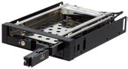 | 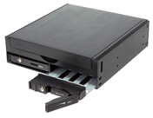 | 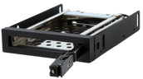 | 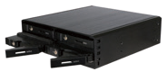 | 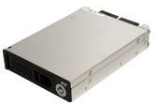
Model Name | RHD-102SATA-R20 | RHD-102DW-R20 | RHD-101SATA-R20 | RHD-104SATA-R20 | RHF-21-SATA-R10
Dimensions  (L x W x H) (mm) | 140 x 101.6 x 25 | 153 x 146 x 42 | 140 x 101.6 x 25 | 149.6 x 146 x 42.1 | 151.5 x 102 x 25.7
Material | Aluminum & SPCC | Aluminum | Aluminum & SPCC | Full Metal | SECC
Interface | SATA 7 + 15 Pin | SATA | SATA 7 + 15 Pin | SATA III | SATA
Data Transfer Rate | up to 6Gb/Sec | up to 6Gb/Sec | Up to 6Gb/Sec | SATA III 6Gbps | No
Drive Bay Space | One 3.5” drive bay | One 5.25” drive bay | One 3.5” drive bay | 1 x 5.25'' Device Bay for 4 x  2.5" Hard Drive | Internal 3.5" drive bay
HDD Type | 2.5” SATA/SAS  2 x HDD/SSD | 2.5” SATA  2 x HDD/SSD | 2.5” SATA/SAS  1 x HDD/SSD | 2.5" Hard Drive | 2.5'' SATA HDD
Cooling Fan | No | Yes | No | 4CM | No
Hot Swap | Yes | Yes | Yes | Yes | Yes
Keylock | Yes | Yes | Yes | Yes | Yes
Signal Out | SATA 7 Pin | SATA 7 Pin | SATA 7 Pin | SATA III 7-Pin | 1 x Female connector  1 x SATA LED signal connector 1 x Power LED connector  1 x Key on/off connector 1 x Power/SATA LED connector  1 x Male connector
Color | Black | Black | Black | Black | Black
Gross Weight | 0.304 Kg | 0.534 Kg | 0.236 Kg | 0.56kg | 0.3 kg

FCD-301

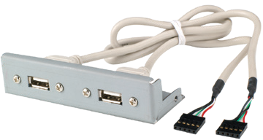
3.5" compact drive bay with USB port
Pin 1 | Pin 2 | Pin 3 | Pin 4
+5V | Data- | Data+ | GND

- The most suitable USB cable for IEI's CPU boards
- Support standard 3.5" drive bay, 4-pin female connector to CPU boards’ pin header, length: 60cm
- RoHS compliant
- Pin definition
Ordering Information
Part No. | Description
FCD-301[C]-RS | 3.5" compact drive bay with USB port, RoHS  Color Code: B=Black, W=White

AS-35A / AS-25A / AS-25C

AS-35A

AS-25A
  - Resistant to shocks and vibrations from all directions
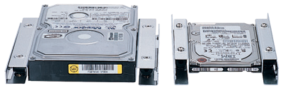
  - Support 2.5" HDD into 3.5" drive bay (AS-25A/ 25C) Support 3.5" HDD into 5.25" drive bay (AS-35A)
  - Meets the following standards:
» MIL-SLD-810F 514.5C-1 standard
» 5-20Hz, 1G peak to peak
» 60-200Hz, 3G peak to peak

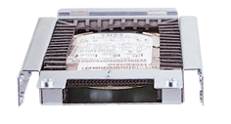Anti-vibration Drive Kit
AS-25C

Industrial Keyboard Series
- RoHS compliant

Ordering Information
Part No. | Description
AS-35A-RS | 3.5" drive anti-vibration kit, RoHS
AS-25A-RS | 2.5" drive anti-vibration kit, RoHS
AS-25C-RS | Enhanced 2.5" drive anti-vibration kit, RoHS

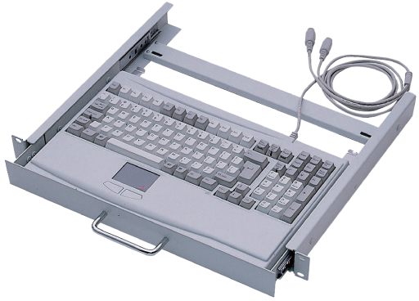
MK-KTP5A

Model Name | MK-KTP5AW-R20
Key Number | 105-key | Color | White
Mouse | Touchpad | Waterproof | NA
Connector | 2 x PS/2 for KB/MS | Dimensions (mm) | 482 (D) x 380 (W) x 44 (H)

Ordering Information
Part No. | Description
MK-KTP5AW-R20 | 1U rackmount keyboard/touchpad drawer, RoHS

