Power Supply / Peripherals

Peripherals

w w w . i ei w or l d .c om

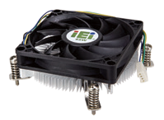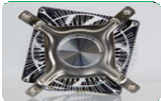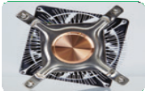
CPU Cooler High performance thermal solutions
Choosing the wrong CPU cooler for a system can lead to serious overheating, resulting in system shutdown and potential damage to CPUs.
For industrial applications, the following CPU coolers fit the needs of various operating environments, where different levels
of cooling are required.

 | IEI Special Desktop Core™ CPU Cooler
 | 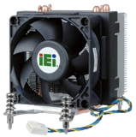 | 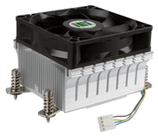 | 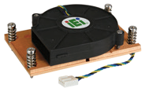 | 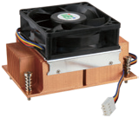 | 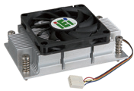
Where Used | For spacial models: SPCIE-C2260, PCIE-Q870, PCIE-H810, WSB-H810, KINO-AQ870
Model Name | CF-1150SA-R10 | CF-1150SB-R11 | CF-1150SC-R20 | CF-1150SE-R11 | CF-1150SF-R10
Description | IEI customized cooler for LGA1150 Intel® CPU, RoHS |  | IEI customized cooler for LGA1150 Intel® CPU, 1U  chassis compatible, RoHS | IEI customized cooler for LGA1150 Intel® CPU, RoHS | IEI customized cooler for LGA1150 Intel® CPU, RoHS
CPU Solution | Intel® Core™ i7/i5 | Intel® Core™ i7/i5 | Intel® Core™ i7/i5 | Intel® Core™ i7/i5 | Intel® Core™ i7/i5
Socket Solution | LGA1150/LGA1151 | LGA1150/LGA1151 | LGA1150/LGA1151 | LGA1150/LGA1151 | LGA1150/LGA1151
Dimensions (mm) | 83 x 83 x 57 | 96 x 82 x 60 | 105 x 80 x 23.7 | 107 x 70 x 60 | 107 x 70 x 35
Material | Al | Al | Cu | Cu | Al
Bearing Type | Ball And sleeve | Two-ball | Two-ball | Two-ball | Two-ball
Capability (Watt) | 95 W | 65 W | 65 W | 95 W | 54 W
Fan Speed (RPM) | 4200 | 3500 | 5500 | 4200 | 4500
Noise Level (dBA) | 40 | 41 | 55 | 36 | 39
Life Expectancy (hrs) | 40,000 | 50,000 | 50,000 | 50,000 | 50,000
Weight | 330 g | 286 g | 406 g | 812 g | 220 g

 | Intel® Standard Desktop Core™ CPU Cooler
 | 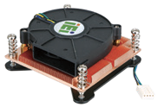 |  |  | 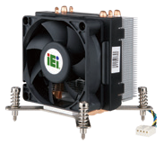 | 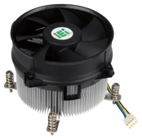
 | LGA115X (LGA1150/LGA1151/LGA1155/LGA1156)
Model Name | CF-115XA-R10 | CF-115XC-R10 | CF-115XD-R10 | CF-115XE-R10 | CF-115XF-R10
Description | High performance LGA1155/ LGA1156 cooler kit, 1U chassis compatible | Low power LGA1155/LGA1156 cooler Kit, RoHS |  | High performance LGA1155/ LGA1156 CPU cooler, RoHS | High performance LGA1155/ LGA1156 CPU cooler, RoHS
CPU Solution | Intel® Core™ i5/i3 | Intel® Core™ i5/i3 | Intel® Core™ i7/i5/i3 | Intel® Xeon®/Core™ i7/i5/i3 | Intel® Xeon®/Core™ i7/i5/i3
Socket Solution | LGA115X (LGA1150/LGA1151/LGA1155/LGA1156)
Dimensions (mm) | 89 x 92.6 x 27.4 | 94.34*94.34*43.4 | 94.34*94.34*43.4 | 91 x 91 x 84 | 90 x 90 x 69.3
Material | Cu | Al | Cu+Al | AI | Al
Bearing Type | Two-ball | Two Ball | Two Ball | Ball and Sleeve | Two Ball
Capability (Watt) | 73 W | 45W | 65W | 95 W | 95 W
Fan Speed (RPM) | 5500 | 3600 | 3600 | 4200 | 4200
Noise Level (dBA) | 51 | 40 | 40 | 40 | 48
Life Expectancy (hrs) | 50,000 | 70000 | 70000 | 40,000 | 50,000
Weight | 422 g | 226g | 260g | 301 g | 432

Power Supply / Peripherals

Peripherals - Industrial Flash Module

w w w . i ei w or l d .c om

CPU Cooler High performance thermal solutions
Choosing the wrong CPU cooler for a system can lead to serious overheating, resulting in system shutdown and potential damage to CPUs.
For industrial applications, the following CPU coolers fit the needs of various operating environments, where different levels
of cooling are required.

 | Desktop CPU Cooler
 | 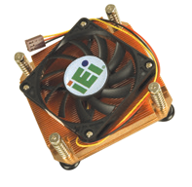 | 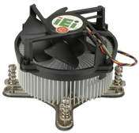
 | LGA775 Cooler
Model Name | CF-775B-RS-R11 | CF-520-RS-R11
Description | High performance 1U LGA 775 CPU cooler, with 7010 fan, RoHS | High performance LGA 775 CPU cooler, RoHS
CPU Solution | Intel® Core™2 Duo | Intel® Core™2 Duo
Socket Solution | LGA 775 | LGA 775
Dimensions (mm) | 80.5 x 81 x 28.2 | 115 x 115 x 67
Material | Cu | Aluminum alloy
Bearing Type | Two-ball | Two-ball
Capability (Watt) | 90 W | 115 W
Fan Speed (RPM) | 4250 | 4500
Noise Level (dBA) | 40 | 47.5~51.5
Life Expectancy (hrs) | 50,000 | 70,000
Weight | 600 g | 635 g

 | CPU Cooler | Mobile Core™ i7 CPU Cooler
 | 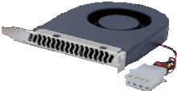 | 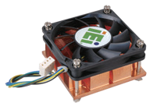 | 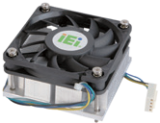
 | Blower | PGA989
Model Name | BF-02-RS | CF-989A-RS-R12 | CF-989B-RS-R11
Description | Bracket cooling fan, RoHS | High performance Socket-G (PGA989) smart fan CPU cooler, RoHS | High performance Socket-G (PGA989) CPU cooler, aluminum, RoHS
CPU Solution | Breaket cooling fan | Intel® Core™ i7/i5/i3 | Intel® Core™ i7/i5/i3
Socket Solution |  | PGA989 | PGA989
Dimensions (mm) | 112 x 90 x 21 | 60 x 60 x 27.5 | 60 x 60 x 27.5
Material | Plastic | Cu | Al
Bearing Type | One-ball | Two-ball | Two-ball
Capability (Watt) |  | 55 W | 50 W
Fan Speed (RPM) | 2800 | 4800 | 4800
Noise Level (dBA) | 28 | 40 | 40
Life Expectancy (hrs) | 45,000 | 50,000 | 50,000
Weight | 107.5 g | 255 g | 26 g

