Display System
w w w . i ei w or l d .c om
19” SXGA AFOLUX Panel PC

Intel® Core™ i7/i5/i3/Celeron® Processor
AFL-19i-HM55

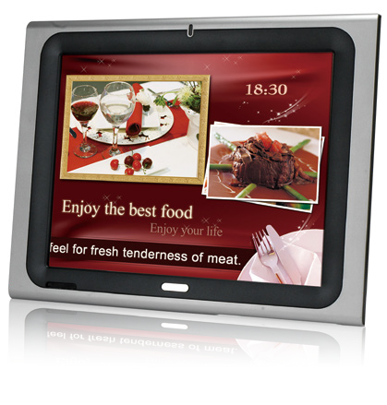
New HM55 Platform Features:
- Powered by high performance 2.66 GHz Intel® Core™ i7-620M CPU with Intel® HM55 chipset
- 1066MHz DDR3 system memory up to 4GB
- HDMI port delivers high image quality on the second display
- IEI One Key Recovery solution allows you to create rapid OS backup and recovery (over 4GB storage capacity is suggested)

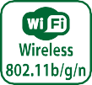
Specifications

Model | AFL-19i-HM55
LCD Size | 19”
Max Resolution | 1280 x 1024
Brightness (cd/m²) | 350
Contrast Ratio | 1000 : 1
LCD Color | 16.7M
Pixel Pitch (mm) | 0.294 (H) x 0.294 (V)
Viewing Angle (H-V) | 170º / 160º
Backlight MTBF | 50000 hrs (LED backlighting)
SBC Model | AFLMB2-HM55-R10
CPU | Intel® Core™ i7/i5/i3/Celeron® Processor
Chipset | Intel® HM55
RAM | Two 204-pin 800/1066MHz DDR3 dual-channel SO-DIMMs supported (Max. 8GB)
I/O Ports | - x RS-232 COM Port  1 x RS-232/422/485 COM Port  - x RJ-45 for Giga LAN 4 x USB 2.0  1 x Power Switch 1 x Reset Button  1 x Audio Port (Line-out) 1 x VGA  1 x Power Jack 1 x HDMI Port
Storage | 1 x 2.5” SATA HDD bay
Watchdog Timer | Software programmable supports 1~255 sec. system reset
Audio | AMP 3W + 3W (internal speakers)
Wireless Connection | 1 x Wireless LAN 802.11b/g/n Module (internal PCIe Mini card interface) Telec certified
Construction Front Panel | ABS + PC Plastic front frame
Membrane Keypad | OSD Keypad below the Front Panel (5 keys)
LED Function | 1 x Power on/off LED on front panel
Mounting | Panel, Wall, Stand and Arm VESA 100mm x 100mm
Front Panel Color | Sliver (877U) & Gray (ABSA2037)
Dimensions (WxHxD) (mm) | 470 x 383 x 72
Operation Temperature (°C) | 0°C~50°C
Storage Temperature (°C) | -20°C ~60°C
N/G Weight | 6.2Kg
IP Level | Front Frame IP64
Touch Screen | Resistive Type 5-Wire (Touch controller IC is on board)
Power Adapter | P/N: 63040-010096-100-RS  96W Power Adapter (Meet PSE) Input: 90VAC~264VAC, 50 / 60 Hz  Output: 12VDC
Power Requirement | 12VDC
Power Consumption | 88W (Intel® T7500, 2GB memory, 80G HDD)

w w w . i ei w or l d .c om

Ordering Information
Part Number | Description
AFL-19i-HM55-P45/R/1G-R21 | 19" 350cd/m² SXGA LED backlighting panel PC with Intel® Celeron® P4500 1.86G CPU, 1GB DDR3 RAM, 802.11b/g/n wireless module, touch screen, R21
AFL-19i-HM55i3-35/R/2G-R21 | 19" 350cd/m² SXGA LED backlighting panel PC with Intel® Core™ i3-350M 2.26G CPU, 2GB DDR3 RAM, 802.11b/g/n wireless module, touch screen, R21
AFL-19i-HM55i5-52/R/2G-R21 | 19" 350cd/m² SXGA LED backlighting panel PC with Intel® Core™ i5-520M 2.4G CPU, 2GB DDR3 RAM, 802.11b/g/n wireless module, touch screen, R21
AFL-19i-HM55i7-62/R/2G-R21 | 19" 350cd/m² SXGA LED backlighting panel PC with Intel® Core™ i7-620M 2.66G CPU, 2GB DDR3 RAM, 802.11b/g/n wireless module, touch screen, R21
ISMM Supported Functions
 | Voltage | Fan | Smart Fan | Temperature | WDT | Cash Drawer
AFL-19i-HM55 | V | V | V | V | V

Packing List
Item | Part Number | Q’ty | Specification
Screw Pack | 44013-030041-RS | 4 | M3;5mm
Power Adpater | 63040-010096-100-RS | 1 | 90~264V AC; 12V DC; 96W (Meet PSE)
Power Cord | 32000-000002-RS | 1 | 1750mm; European Standard
Utility CD | 7B000-000087-RS | 1
Touch Pen | 43125-0002C0-00-RS | 1
One Key Recovery CD |  | 1
Options
Model | AFL-19i-HM55
Panel Mounting Kit | AFLPK-19B
Wall Mounting Kit | AFLWK-19B
Arm | ARM-11-RS / ARM-31-RS
Stand | STAND-A19-RS / STAND-A21-R10 / STAND-210-R11
OS: Win XPE | AFLSD-15-HM55-2G-XPE-R21 (without storage)
OS: Win 7 Embedded | AFL-15i-HM55-WES7E-R21
Magnetic Stripe Reader | AFLP-19MSR-U
DC 12V Input UPS | AUPS-B10-R10 (VESA 100, DC 12V input, 12V output 100W UPS module with 3800mAH)
DC 9~36V Input UPS | AUPS-B20-R10 (VESA 100, DC 9~36V input, 12V output 100W UPS module with 3800mAH)

Fully Integrated I/O

Membrane Keypad
- LCD on/off • Brightness up
VESA 100 x 100
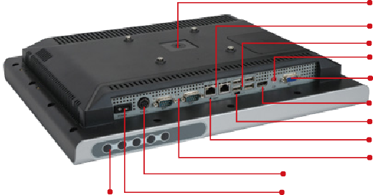
2 x RJ-45 Giga LAN
4 x USB 2.0
1 x Line-out
1 x VGA
1 x HDMI
AT/ATX switch
Reset Button 1 x RS-232
12 V DC Input 1 x RS-232/422/485
Power Switch

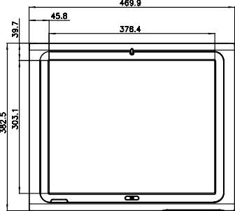
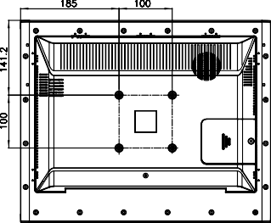
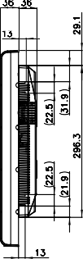
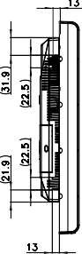
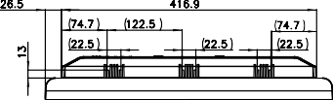
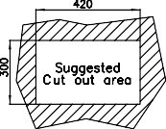
- Volume up • Brightness down • Volume down
Dimensions (Unit: mm)
Display System

