Display System
w w w . i ei w or l d .c om
17” SXGA AFOLUX Panel PC

Intel® Core™ i7/i5/i3/Celeron® Processor
AFL-17i-HM55

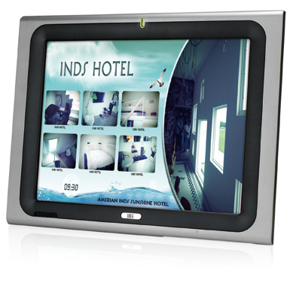
New HM55 Platform Features:
- Powered by high performance 2.66 GHz Intel® Core i7-620M CPU with Intel®
HM55 chipset
- DDR3 800/1066MHz system memory up to 8GB
- HDMI port delivers high image quality on the second display
- IEI One Key Recovery solution allows you to create rapid OS backup and recovery (over 4GB storage capacity is suggested)

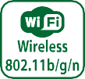
Specifications
Model | AFL-17i-HM55
LCD Size | 17"
Max Resolution | 1280 x 1024
Brightness (cd/m²) | 350
Contrast Ratio | 800 : 1
LCD Color | 16.7M
Pixel Pitch (mm) | 0.264 (H) x 0.264 (V)
Viewing Angle (H-V) | 170º / 160º
Backlight MTBF | 50000 hrs
SBC Model | AFLMB2-HM55-R10
CPU | Intel® Core™ i7/i5/i3/Celeron® Processor
Chipset | Intel® HM55
RAM | Two 204-pin 800/1066MHz DDR3 dual-channel SO-DIMMs supported (Max. 8GB)
I/O Ports | - x RS-232 COM Port  1 x RS-232/422/485 COM Port  - x RJ-45 for Giga LAN 4 x USB 2.0  1 x Power Switch 1 x Reset Button  1 x Audio Port (Line-Out) 1 x VGA  1 x Power Jack 1 x HDMI Port
Storage | 1 x 2.5” SATA HDD bay
Watchdog Timer | Software programmable supports 1~255 sec. system reset
Audio | AMP 3W + 3W (internal speakers)
Wireless Connection | 1 x Wireless LAN 802.11b/g/n Module (internal PCIe Mini card interface)
Construction Front Panel | ABS + PC Plastic front frame
Membrane Keypad | LCD On/Off, Brightness Up/Down, Volume Up/Down (5 keys)
LED Function | 1 x Power on/off LED on front panel
Mounting | Panel, Wall, Rack, Stand and Arm VESA 100mm x 100mm
Front Panel Color | Sliver (877U) & Gray (ABSA2037)
Dimensions (WxHxD) (mm) | 428 x 350 x 71
Operation Temperature (°C) | 0ºC ~ 50ºC
Storage Temperature (°C) | -20°C ~60°C
N/G Weight | 6.0 Kg
IP Level | IP 64 compliant front panel
Touch Screen | 5-wire resistive type (touch controller IC is on board)
Power Adapter | P/N: 63040-010096-100-RS  96W Power Adapter (Meet PSE) Input: 90VAC~264VAC, 50/60Hz  Output: 12VDC
Power Requirement | 12VDC
Power Consumption | 85W

Display System
w w w . i ei w or l d .c om

Ordering Information
Part Number | Description
AFL-17i-HM55-P45/R/1G-R20 | 17" 350cd/m² SXGA panel PC with Intel® Celeron® P4500 1.86G CPU, 1GB DDR3 RAM, 802.11b/g/n wireless module, touch screen, R20
AFL-17i-HM55i3-35/R/2G-R20 | 17" 350cd/m² SXGA panel PC with Intel® Core™ i3-350M 2.26G CPU, 2GB DDR3 RAM, 802.11b/g/n wireless module, touch screen, R20
AFL-17i-HM55i5-52/R/2G-R20 | 17" 350cd/m² SXGA panel PC with Intel® Core™ i5-520M 2.4G CPU, 2GB DDR3 RAM, 802.11b/g/n wireless module, touch screen, R20
AFL-17i-HM55i7-62/R/2G-R20 | 17" 350cd/m² SXGA panel PC with Intel® Core™ i7-620M 2.66G CPU, 2GB DDR3 RAM, 802.11b/g/n wireless module, touch screen, R20

ISMM Supported Functions
 | Voltage | Fan | Smart Fan | Temperature | WDT
AFL-17i-HM55 | V | V | V | V | V
Packing List
Item | Part Number | Q'ty | Specification
Screw Pack | 44013-030041-RS | 4 | M3; 5mm
Power Adpater | 63040-010096-100-RS | 1 | 90~264V AC; 12V DC; 96W (Meet PSE)
Power Cord | 32000-000002-RS | 1 | 1750mm; European Standard
Utility CD | 7B000-000087-RS | 1
Touch Pen | 43125-0002C0-00-RS | 1
One Key Recovery CD |  | 1

Options
Model | AFL-17i-HM55
Panel Mounting Kit | AFLPK-17B
Wall Mounting Kit | AFLWK-19B
Rack Mounting Kit | AFLRK-17i-R10
Arm | ARM-11-RS / ARM-31-RS
Stand | STAND-A19-RS / STAND-A21-R10 / STAND-210-R11
OS: Win XPE | AFLSD-15-HM55-2G-XPE-R21 (without storage)
OS: Win 7 Embedded | AFL-15i-HM55-WES7E-R21
Magnetic Stripe Reader | AFLP-17BMSR-U
DC 12V Input UPS | AUPS-B10-R10 (VESA 100, DC 12V input, 12V output 100W UPS module with 3800mAH)
DC 9~36V Input UPS | AUPS-B20-R10 (VESA 100, DC 9~36V input, 12V output 100W UPS module with 3800mAH)
Note: Win CE application without digital microphone function

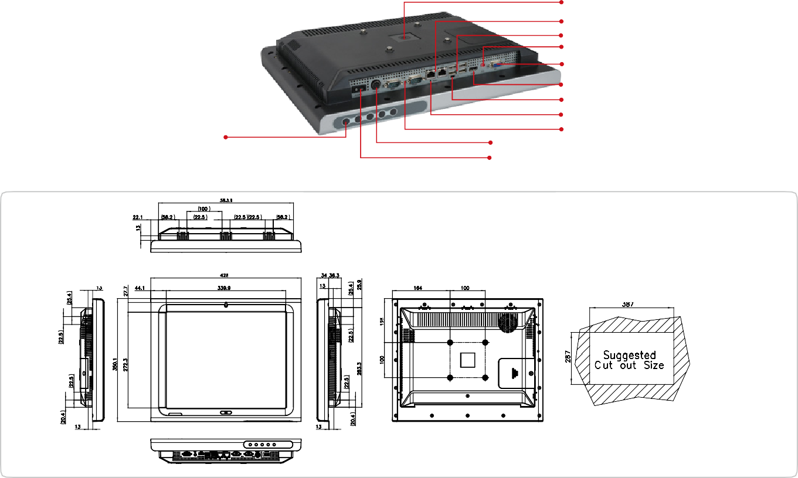
VESA 100 x 100
Fully Integrated I/O
2 x RJ-45 Giga LAN
4 x USB 2.0
1 x Line-out
1 x VGA

1 x HDMI
AT/ATX Switch
Reset Button
Membrane Keypad
- LCD on/off • Brightness up
- Volume up • Brightness down • Volume down
1 x RS-232
12 V DC Input 1 x RS-232/422/485
Power Switch
Dimensions (Unit: mm)

