w w w . i ei w or l d .c om
15" XGA AFOLUX Panel PC

Intel® Core™ i7/i5/i3/Celeron® Processor
AFL-15i-HM55

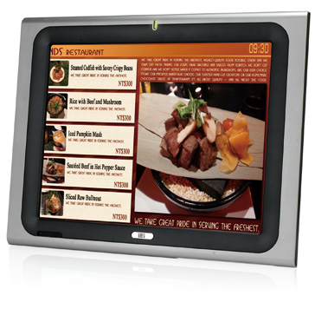
Specifications
Features
- Intel® Core i7-620M CPU with Intel® HM55 chipset
- DDR3 1066MHz system memory up to 4GB
- HDMI/VGA port delivers high quality image on the second display
- IEI One Key Recovery solution allows you to create rapid OS backup and recovery (over 4GB storage capacity is suggested)

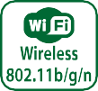

Display System
Model | AFL-15i-HM55
LCD Size | 15”
Max Resolution | 1024 x 768
Brightness (cd/m²) | 450
Contrast Ratio | 700:1
LCD Color | 16.7M
Pixel Pitch (mm) | 0.297(H) x 0.297(V)
Viewing Angle (H-V) | 160º/150º
Backlight MTBF | 50000 hrs (LED backlighting)
SBC Model | AFLMB2-HM55-R10
CPU | Intel® Core™ i7/i5/i3/Celeron® Processor
Chipset | Intel® HM55
RAM | Two 204-pin 800/1066MHz DDR3 dual-channel SO-DIMMs supported (Max. 8GB)
I/O Ports | - x RS-232 COM Port  1 x RS-232/422/485 COM Port  - x RJ-45 for Giga LAN 4 x USB 2.0  1 x Power Switch 1 x Reset Button  1 x Audio Port (Line-out) 1 x VGA  1 x Power Jack 1 x HDMI Port
Storage | 1 x 2.5” SATA HDD bay
Watchdog Timer | Software programmable supports 1~255 sec. system reset
Audio | AMP 3W + 3W (internal speakers)
Wireless Connection | 1 x Wireless LAN 802.11b/g/n Module (internal PCIe Mini card interface)
Construction Front Panel | ABS + PC Plastic front frame
Membrane Keypad | LCD on/off, Brightness up/down, Volume up/down (5 keys)
LED Function | 1 x Power on/off LED on front panel
Mounting | Panel, Wall, Rack, Stand and Arm VESA 100mm x 100mm
Front Panel Color | Sliver (877U) & Gray (ABSA2037)
Dimensions (WxHxD) (mm) | 394 x 309 x 66
Operation Temperature (°C) | 0°C~50°C
Storage Temperayure (°C) | -20°C ~ 60°C
N/G Weight | 5.8 Kg
IP Level | Front Frame IP64
Touch Screen | Resistive Type 5-Wire
Power Adapter | P/N: 63040-010096-100-RS  96W Power Adapter (Meet PSE) Input: 90VAC~264VAC, 50/60Hz  Output: 12VDC
Power Requirement | 12VDC
Power Consumption | 80W

w w w . i ei w or l d .c om
Ordering Information
Part Number | Description
AFL-15i-HM55-P45/R/1G-R30 | 15" 450cd/m² XGA LED backlighting panel PC with Intel® Celeron P4500 1.86G CPU, 1GB DDR3 RAM, 802.11b/g/n wireless module, touch screen, R30
AFL-15i-HM55i3-35/R/2G-R30 | 15" 450cd/m² XGA LED backlighting panel PC with Intel® Core™ i3-350M 2.26G CPU, 2GB DDR3 RAM, 802.11b/g/n wireless module, touch screen, R30
AFL-15i-HM55i5-52/R/2G-R30 | 15" 450cd/m² XGA LED backlighting panel PC with Intel® Core™ i5-520M 2.4G CPU, 2GB DDR3 RAM, 802.11b/g/n wireless module, touch screen, R30
AFL-15i-HM55i7-62/R/2G-R30 | 15" 450cd/m² XGA LED backlighting panel PC with Intel® Core™ i7-620M 2.66G CPU, 2GB DDR3 RAM, 802.11b/g/n wireless module, touch screen, R30
ISMM Supported Functions
 | Voltage | Fan | Smart Fan | Temperature | WDT | Cash Drawer
AFL-15i-HM55 | V | V | V | V | V

Packing List
Item | Part Number | Q’ty | Specification
Screw Pack | 44013-030041-RS | 4 | M3;5mm
Power Adpater | 63040-010060-110-RS | 1 | 90~264V AC; 12V DC; 96W (Meet PSE)
Power Cord | 32000-000002-RS | 1 | 1750mm; European Standard
Utility CD | 7B000-000087-RS | 1
Touch Pen | 43125-0002C0-00-RS | 1
One Key Recovery CD |  | 1
Options
Model | AFL-15i-HM55
Panel Mounting Kit | AFLPK-15B
Wall Mounting Kit | AFLWK-19B
Rack Mounting Kit | AFLRK-15i-R10
Arm | ARM-11-RS / ARM-31-RS
Stand | STAND-A19-RS / STAND-A21-R10-R10 / STAND-210-R11
OS: Win XPE | AFLSD-15-HM55-2G-XPE-R21 (w/o storage)
OS: Win 7 Embedded | AFL-15i-HM55-WES7E-R21
Hybrid Card Reader | AFLP-17AMSI-U
Magnetic Stripe Reader | AFLP-17AMSR-U
DC 12V Input UPS | AUPS-B10-R10 (14.8V 3800mAH)
DC 9~36V Input UPS | AUPS-B20-R10 (14.8V 3800mAH)

Fully Integrated I/O

Membrane Keypad
  - LCD on/off • Brightness up

12 V DC Input
VESA 100 x 100
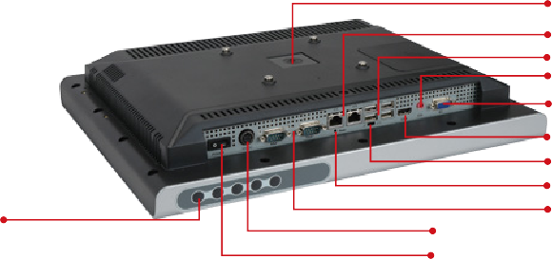
2 x RJ-45 Giga LAN
4 x USB 2.0
1 x Line-out
1 x VGA

1 x HDMI
AT/ATX Switch
Reset Button 1 x RS-232
1 x RS-232/422/485

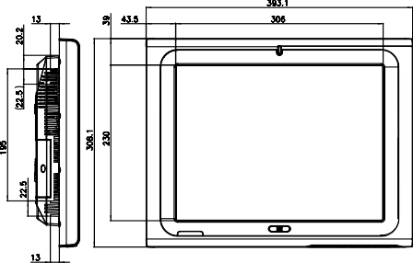
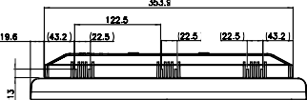
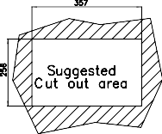
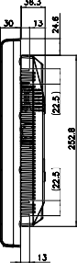
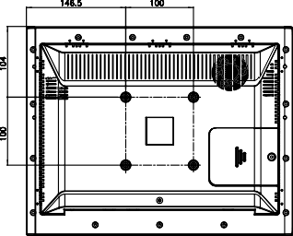
- Volume up • Brightness down • Volume down Power Switch
Display System
AFL-15i
Dimensions (Unit: mm)

