7" Wide Screen WVGA AFOLUX PPC
AMD Geode™ LX 800 500 MHz Processor
Intel® Atom™ N270 1.6GHz Processor
Intel® Atom™ N2600 1.6GHz Processor
AFL-W07A-N26
AFL-07A-N270
AFL-07A-LX

9V ~ 28V Wide DC Power Input
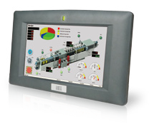The compact fanless AFL-W07A-N26 model with widescreen high- brightness panel is ideal for setup in a place where space and light is limited. This makes it an ideal choice for mobile and transportation PC applications.
16:9
Wide Screen

Features
- 7” widescreen WVGA LED backlight TFT LCD with resistive touch screen
- 9V~28V wide range DC power input (for Intel® N2600 platform)
- Compact design with plastic housing
- Fanless cooling system
- Selectable AT/ATX power mode
- System memory up to 2 GB SDRAM
- Built-in 802.11b/g/n Wireless LAN
- Built-in speakers
- One compactFlash® slot
- IP 64 compliant front panel
- IEI One Key Recovery solution allows you to create rapid OS backup and recovery (suggest with over 4GB storage capacity)

Specifications

Speakers

Wireless 802.11b/g/n

mSATA

Dual Display
IP64
Model | AFL-07A-LX | AFL-07A-N270 | AFL-W07A-N26
LCD Size | 7”
Max Resolution | 800 x 480
Brightness (cd/m²) | 500
Contrast Ratio | 400:1
LCD Color | 262K
Pixel Pitch (mm) | 0.0635 (H) x 0.1905 (V)
Viewing Angle (H-V) | 140º / 110º
Backlight MTBF | 50000 hrs (LED Backlight)
SBC Model | AFLMB-LX-800 | AFLMB-945GSE-N270-R10 | AFLMB-CV-N2600-R10
CPU | AMD Geode™ LX 800 (500Mhz) | Intel® Atom™ N270 1.6GHz CPU | Intel® Atom™ N2600 dual core 1.6 GHz CPU
Chipset | AMD LX800 + AMD CS5536 | Intel® 945GSE + ICH7M | Intel® NM10
RAM | Supports one 333MHz or 400MHz DDR SO-DIMM (1GB Max.) | Supports one 400MHz or 533MHz DDR2 SO-DIMM (2GB Max.) | One 800 MHz 204-pin DDR3 SO-DIMM slot (max. 2G) pre-installed wiith 2GB
I/O Ports | - x RS-232 COM Port  1 x RS-232/422/485 COM Port  - x RJ-45 for 10/100Mbps LAN 2 x USB 2.0  1 x Power Switch 1 x Reset Button 1 x Power Jack  1 x Audio Jack (Line-out) | - x RS-232 COM Port  1 x RS-232/422/485 COM Port  - x RJ-45 for GbE 2 x USB 2.0  1 x Power Switch 1 x Reset Button 1 x Power Jack  1 x External SATA  1 x Audio Jack (Line-out) | 1 x 9-28V Lockable DC Jack 1 x RJ45 for RS-232  1 x RS-232/422/485  - x VGA  - x GbE LAN  2 x USB 2.0  1 x Power switch 1 x Reset button 1 x AT/ATX switch 1 x Line out
Storage | CF Type II |  | mSATA
Watchdog Timer | Software programmable supports 1~255 sec. system reset
Audio | AMP 1.5W + 1.5W (internal speaker) |  | AMP 2W + 2W (internal speaker)
Wireless Connection | 1 x Wireless LAN 802.11 b/g Module (internal Mini PCI interface) | 1 x Wireless LAN 802.11b/g/n Module (internal PCIe Mini card interface) Telec certified | 1 x Wireless LAN 802.11b/g/n 2T2R Module (internal PCIe Mini card interface) Telec certified
Construction Front Panel | ABS + PC Plastic front frame
LED Function | 1 x LED on front panel for power on/off
Mounting | Panel, Wall, Rack, Stand or Arm mounting VESA 75mm x 75mm
Front Panel Color | Gray 7539U
Dimensions (WxHxD) (mm) | 226 x 140 x 41
Operation Temperature (°C) | 0~50°C | -10°C ~50°C | -10°C~50°C
Storage Temperayure (°C) | -20°C ~ 60°C
N/G Weight | 0.6 Kg
IP Level | Front Frame IP64
Safety & EMC | CE / FCC
Touch Screen | 4-wire Resistive Type (touch controller IC is on board)
Power Adapter | P/N: 63040-010036-111-RS  36W Power Adapter (Meet PSE) Input: 90VAC~264VAC, 50/60Hz  Output: 12VDC | P/N: 63040-010036-111-RS  36W Power Adapter (Meet PSE) Input: 90VAC~264VAC, 50/60Hz  Output: 12VDC | P/N: 63040-010036-121-RS  36W Power Adapter (Meet PSE) Input: 90VAC~264VAC, 50/60Hz  Output: 12VDC
Power Requirement | 12VDC | 12VDC | 9-28V DC
Power Consumption | 20W | 23W | 23W

Display System
w w w . i ei w or l d .c om

Ordering Information
Part Number | Description
AFL-07A-LX/R/512-R23 | 7” 500 cd/m², WVGA fanless panel PC with AMD LX-800 CPU, AT/ATX mode, 802.11b/g Wireless Module, Touch screen and 512MB DDR RAM, R23
AFL-07A-N270/R/1G-R24 | 7” 500 cd/m² WVGA fanless panel PC with Intel® Atom™ N270 1.6GHz, 802.11b/g/n wireless module, touch screen ,1GB DDR2 533, R24
AFL-W07A-N26/R/2G-R11 | 7” 500cd/m², WVGA fanless panel PC with Intel® Atom™ cedarview N2600 dual core 1.6GHz, 802.11b/g/n wireless module, touch screen, 2GB DDR3, R11

ISMM Support Functions

 | Voltage | Fan | Smart Fan | Temperature | WDT | Cash Drawer
AFL-07A-LX | V |  |  | V | V
AFL-07A-N270 | V |  |  | V | V
AFL-W07A-N26 | V |  |  | V | V

Packing List

Item | Part Number | Q’ty | Specification
Screw Pack | 44013-030041-RS | 4 | M3;5mm
Power Adpater | 63040-010036-111-RS (for AFL-07A-N270/AFL-07A-LX)  63040-010036-121-RS (for AFL-07A-N26) | 1 | 90~264V AC; 12V DC; 36W (Meet PSE)
Power Cord | 32000-000002-RS | 1 | 1750mm; European Standard  (EU or US, depending on the shipment country)
Utility CD | 7B000-000087-RS | 1
Touch Pen | 43125-0002C0-00-RS | 1
One Key Recovery CD |  | 1
RJ45 to RS-232 Transfer Cable | 32005-000200-200-RS | 1 | 300MM; RJ45 to D-SUB 9P transfer cable

Options
Model | AFL-07A-LX | AFL-07A-N270 | AFL-W07A-N26
Panel Mounting Kit | AFLPK-12
Wall Mounting Kit | AFLWK-12
Rack Mounting Kit | AFLRK-07
Arm | ARM-11-RS / ARM-31-RS
Stand | STAND-100-RS
VSTAND | VSTAND-A07-R11
9~30VDC to 12VDC Converter Module | IDD-930160-KIT
OS: Win CE 5.0 (128 MB CF card) | AFLCF-07-LX-CE-R21 | -- | --
OS: Win CE 6.0 (128 MB CF card) | AFLCF-07-LX-CE060-R21 | -- | --
OS: Win XPE (1 GB CF card) | AFLCF-07-LX-XPE-R21 | AFLCF-07-N270-XPE-R24 | AFL-W07-N26-XPE-R11*
OS: Win 7 Embedded  (4 GB CF card or CD-ROM) | -- | AFLCF-07-N270-WES7E-R24 | AFL-W07-N26-WES7E-R11*
Magnetic Stripe Reader | AFLP-08AMSR-U
DC 12V Input UPS | AUPS-A10-R10 (7.4V 3800mAH)
DC 9~36V Input UPS | AUPS-A20-R10 (7.4V 3800mAH)
*OS image with CD-ROM

AFL-07A-LX
Fully Integrated I/O
Standard VESA mounting

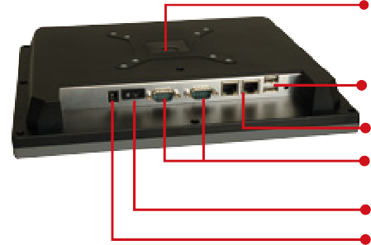
2 x USB

2 x LAN
1 x RS-232
1 x RS-232/422/485 selectable COM port 12VDC Power Jack or 18~30VDC Input
Power Switch

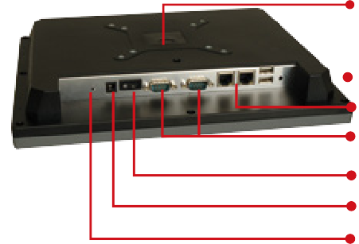Standard VESA mounting

AFL-07A-N270
Fully Integrated I/O

AFL-W07A-N26
Fully Integrated I/O

2 x USB
2 x LAN
1 x RS-232
1 x RS-232/422/485 selectable COM port Power Switch
12VDC Power Jack Audio (Line-out)

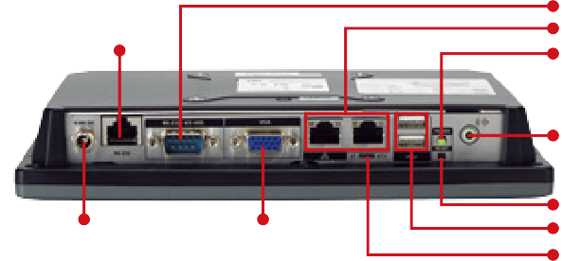RS-232/422/485
RS-232
Lockable DC Jack
VGA
2 x LAN Port Power Switch

Line Out

Reset Button 2 x USB 2.0
AT/ATX Switch
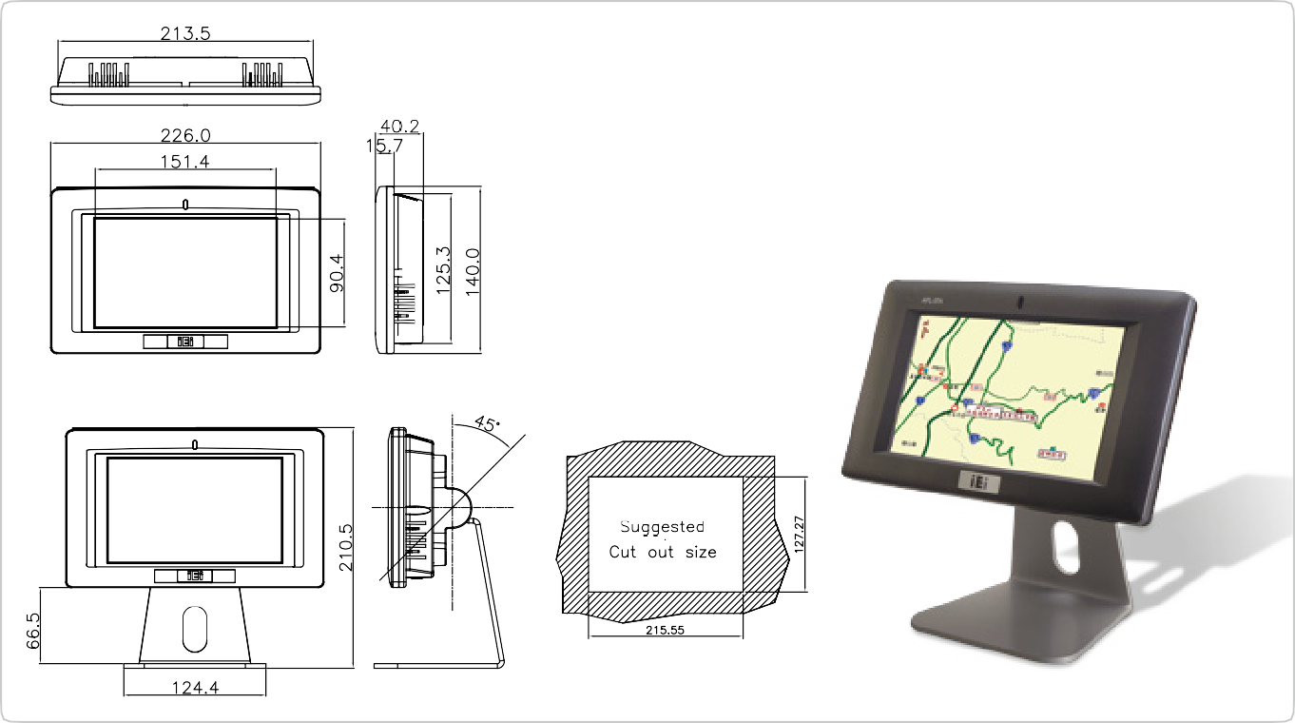
Dimensions (Unit: mm)

(Optional Stand Kit)

