Display System
w w w . i ei w or l d .c om
Intel® Core™ i5 and Celeron® ULT Processor
AFL3-W22C-ULT3

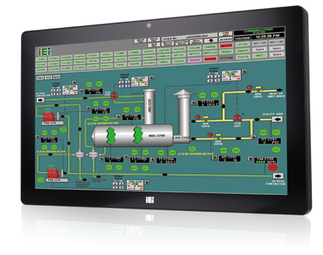Features
- W21.5 light industrial interactive panel PC
- 9 V ~ 30 V wide range DC power input
- Selectable AT/ATX power mode
- Built-in speakers
- One mSATA slot
- IP64 compliant front panel
- IEI One Key Recovery solution alllows you to create rapid OS backup and recovery (suggested with over 4GB storage capacity)

Specifications

Model |  | AFL3-W22C-ULT3
LCD | Size | 21.5”
 | Resolution | 1920 x 1080
 | Brightness (cd/m²) | 250
 | Contrast Ratio | 1000:1
 | LCD Color | 16.7M
 | Pixel Pitch (mm) | 248.25 (H) × 248.25 (V)
 | Viewing Angle (H-V) | 170º/160º
 | Backlight MTBF(hrs) | 30,000 (LED backlight panel)
Touch | Touch Screen | Projected capacitive with USB interface (nti-UV / anti-glare coating)
 | Touch Controller | EETI EXC3180
Motherboard | CPU | Intel® Core™ i5 and Celeron® ULT Processor
 | RAM | Two 260-pin 2133/1867 MHz dual-channel DDR4 SO-DIMMs (system max. 32 GB)
 | Ethernet | 2 x Intel® I211-AT PCIe GbE controller
 | Audio Codec | ALC892
Storage |  | 1 x mSATA (E-Window)  1 x 2.5” SATA 3Gb/s HDD bay  1 x M.2 M key PCIe (2280 or 22110)
I/O Ports & Switch |  | 1 x RS-232 by DB-9 (RI/5V/12V)  1 x RS-232/422/485 by DB-9 (RI/5V/12V)  2 x GbE LAN  4 x USB 3.1 Gen 1 (5Gb/s) 1 x HDMI output  1 x Power switch 1 x Reset button 1 x AT/ATX switch  1 x 9-30V lockable power jack
E-Window Expansion |  | Yes, optional (full-size mini-PCIe slot with PCIe/SATA/USB)
Audio |  | AMP 3W + 3W (internal speaker)
Camera and Microphone |  | 2-megapixel with low light function, digital microphone
Wireless & Bluetooth |  | IEEE 802.11 a/b/g/n/ac, Bluetooth V4.1 M.2 slot A+E key 2230 slot (PCIe/USB signal)
OSD Function |  | Software OSD
Physical | Front Panel Construction | PC + ABS Plastic
 | Mounting | Panel, Wall, Stand and Arm VESA 75mm x 75mm / 100mm x 100mm
 | Color | Black C
 | Dimensions (W x H x D) (mm) | 528 x 336 x 68
 | Cut-out Dimensions (W x H) (mm) | 502 x 303
 | Net/Gross Weight (kgs) | 8.27/11.27
Environment | Operating Temperature (Ambient with air flow) | -20ºC ~ 50ºC
 | Storage Temperature | -20ºC ~ 60ºC
 | Humidity | 10% to 95% (non-condensing)
 | IP Level | IP 64 compliant front panel
 | Safety & EMC | CE / FCC
 | Thermal Solution | Fanless
Power | Power Requirement | 9 V ~ 30 VDC
 | Power Consumption | 12V@6A (Intel® Core™ i5-6300U CPU with 4GB DDR42133 MHz DDR4 memory)

w w w . i ei w or l d .c om

Ordering Information

Part No. | Description
AFL3-W22C-ULT3-C/PC/4G-R13 | Wide 22” 250 cd/m² 1920x1080 Panel PC with withIntel® 14nm 6th Generation Mobile Celeron®3955U (15W) on-board Processor (ULT), 1*4GB DDR4 RAM, 802.11a/b/g/n/ac WiFi module, PCAP touch, 2M camera, microphone,with AG, R13
AFL3-W22C-ULT3-i5/PC/4G-R13 | Wide 22” 250 cd/m² 1920x1080 Panel PC with Intel® 14nm 6th Generation Mobile Core™ i5-6300U (15W) on-board Processor (ULT), 1*4GB DDR4 RAM, 802.11a/b/g/n/ac WiFi module, PCAP touch, 2M camera, microphone , with AG, R13
Packing List

Item | Part No. | Q’ty | Remark
Round head machine screw | 44403-040061-RS | 4 | M2*4 round head machine screw
Pan head machine screw | 44003-030052-RS | 4 | M4*6 pan head machine screw
Power adapter | 63040-010096-100-RS | 1 | 96W; Vin: 90V~264V AC; Vout: 12VDC

Options

Item | AFL3-W22C-ULT3
Panel Mounting Kit | AFL3PK-W19C-R10
Wall Mounting Kit | AFLWK-19B
Arm | ARM-11-RS/ARM-31-RS
Stand | STAND-A21-R10/ STAND-210-R11/STAND-A19-RS/STAND-C19-R10
Magnetic Card Reader | AFL3P-W10MSR-U-R10
Barcode Scanner | AFL3-2D-R11
RFID Reader (13.56 MHz Mifare Type) (For ATO assembly) | AFL3-MF-RFID-KIT02-R10
*OS: Win 7 Embedded (64-bit) | AFL3-W15C-ULT3-WES7P64-R10
*OS: Win 10 IOT Enterprise (64-bit) | AFL3-W15C-ULT3-W10E64-V-R10
*OS image with CD-ROM without storage

E-Window (for ATO assembly)
Part No. | Description
E-MPCIE-LAN02-R10 | PCIe Mini card supports 1-port GbE with Realtek RTL8111E controller, with PMS 194C I/O bracket and 340 mm cable, R10
E-MPCIE-CClink02-R10 | PCIe Mini card supports CC-Link Slave interface according to V2.0 and V1.1, with PMS black C I/O bracket and 300mm cable, R10
E-MPCIE-PROFIBUS02-R10 | PCIe Mini card supports universal PROFI BUS DP card for Master or Slave, with PMS black C I/O bracket and 300mm cable, R10
E-MPCIE-EtherCAT-R10 | PCIe Mini card supports universal for all Real-Time Ethernet protocols, with PMS black C I/O bracket and 280mm cable, R10
E-MPCIE-3G-R10 | PCIe Mini card supports 3G WWAN , with PMS 130C I/O bracket, RF antenna 300mm cable and GSM antenna cable, R10

Speaker
4 x USB 3.1 Gen 1 (5Gb/s)
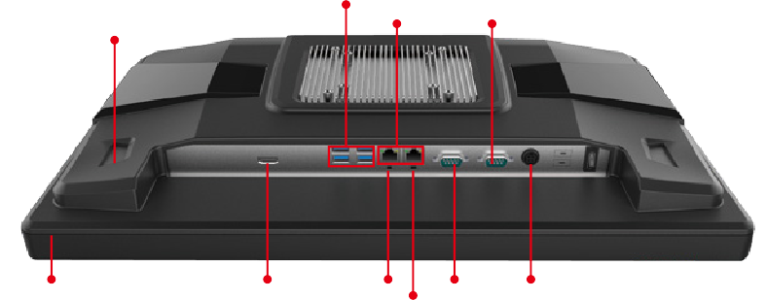
2 x GbE LAN RS-232/422/485

AFL3-W22C-ULT3
Fully Integrated I/O

Digital Microphone HDMI output

Reset

RS-232 9 V ~ 30 V DC Jack

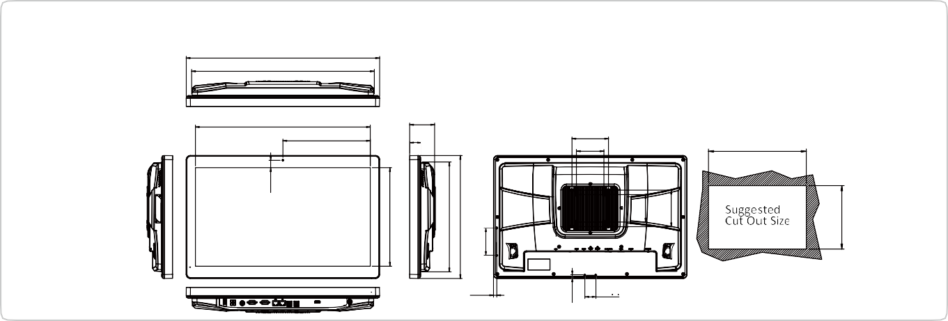AT/ATX Switch
Display System
30
8.82
501.5
100
75
68
30
238.50
477
AFL3-W22C-ULT3 Dimensions (Unit: mm)
527.69
498.50
20.50
269
299.69
335.69
75
8.99
75
100
302.69

