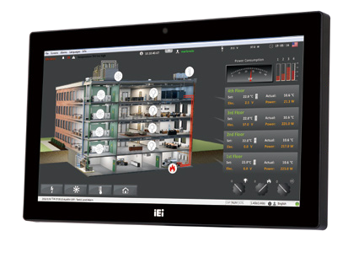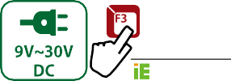
Intel® Celeron® J1900 (Quad Core, 2.0 GHz)
Intel® Core™ i7/i5/i3, Pentium® and Celeron®
Intel® Core™ i5 and Celeron® ULT Processor
Features
- W15” light industrial interactive panel PC
- 9 V ~ 30 V wide range DC power input
- Selectable AT/ATX power mode
- Built-in speakers
- One mSATA slot
- IP64 compliant front panel
- IEI One Key Recovery solution alllows you to create rapid OS backup and recovery (suggested with over 4GB storage capacity)
Specifications
AFL3-W15C-ULT3
AFL3-W15B-H81
AFL3-W15A-BT

Model |  | AFL3-W15A-BT | AFL3-W15B-H81 | AFL3-W15C-ULT3
LCD | Size | 15.6”
 | Resolution | 1366 x 768 (16:9)
 | Brightness (cd/m²) | 400
 | Contrast Ratio | 500:1
 | LCD Color | 16.2M
 | Pixel Pitch (mm) | 0.240 (H) x 0.240 (V)
 | Viewing Angle (H-V) | 170º / 160º
 | Backlight MTBF(hrs) | 50000 (LED backlight)
Touch | Touch Screen | 5-wire resistive with RS-232 interface (anti-glare coating), Projected capacitive with USB interface (anti-UV / anti-glare coating)
 | Touch Controller | PenMount DMC9000 / EETI EXC3188 | PenMount DMC9000 / EETI EXC7200 | PenMount DMC9000 / EETI EXC3188
Motherboard | CPU | Intel® Celeron® J1900 (quad core, 2 GHz) | Intel® Core™ i7/i5/i3, Pentium®, Celeron® processor (TDP 35W) | 6th Generation Intel® Core™ i5 and Celeron® on-board processor
 | Chipset |  | Intel® H81
 | RAM | One 204-pin 1333 MHz single-channel DDR3L SO- DIMM, 2GB pre-installed (system max. 8GB) | Two 204-pin 1333 MHz single-channel DDR3 SO-DIMM, 4GB pre-installed (system max. 16GB) | Two 260-pin 2133/1867 MHz dual-channel DDR4 SO-DIMMs (system max. 32 GB)
 | Ethernet | 2 x PCIe GbE by RTL8111E controller |  | 2 x Intel® I211 PCIe GbE controller
 | Audio Codec | ALC892
Storage |  | 1 x mSATA (E-Window)  1 x 2.5” SATA 3Gb/s HDD bay |  | 1 x mSATA (E-Window)  1 x 2.5” SATA 3Gb/s HDD bay  1 x M.2 M key PCIe (2280 or 22110)
I/O Ports & Switch |  | - x RS-232 COM port (RJ-45 connector) 1 x RS-232/422/485 COM port  (DB-9 connector) (RI/5V/12V) 2 x USB 2.0  - x USB 3.1 Gen 1 (5Gb/s)  2 x GbE LAN  1 x Power switch 1 x Reset button 1 x AT/ATX switch  1 x Audio port (line-out)  1 x 9-30V lockable power jack | 1 x RS-232 COM port (DB-9 connector) 1 x RS-232/422/485 COM port  (DB-9 connector) (RI/5V/12V) 2 x GbE LAN  4 x USB 2.0  2 x USB 3.1 Gen 1 (5Gb/s) 1 x HDMI output  1 x Power switch 1 x Reset button 1 x AT/ATX switch  1 x Audio port (line-out)  1 x 9-30V lockable power jack | 1 x RS-232 by DB-9 (RI/5V/12V)  1 x RS-232/422/485 by DB-9 (RI/5V/12V)  2 x GbE LAN  4 x USB 3.1 Gen 1 (5Gb/s) 1 x HDMI output  1 x Power switch 1 x Reset button 1 x AT/ATX switch  1 x 9-30V lockable power jack
E-Window Expansion |  | Yes, optional  (full-size mini-PCIe slot with PCIe/SATA/USB) | N/A | Yes, optional  (full-size mini-PCIe slot with PCIe/SATA/USB)
Audio |  | AMP 3W + 3W (internal speakers)
Camera and Microphone |  | 2-megapixel with low light function, digital microphone
Wireless & Bluetooth |  | IEEE 802.11a/b/g/n/ac  half-size mini-PCIe slot (PCIe signal) | IEEE 802.11 a/b/g/n/ac, Bluetooth V4.0 half-size mini-PCIe slot (PCIe/USB signal) | IEEE 802.11 a/b/g/n/ac, Bluetooth V4.1  M.2 slot A+E key 2230 slot (PCIe/USB signal)
OSD Function |  | Software OSD
Physical | Front Panel Construction | PC + ABS Plastic
 | Mounting | Panel, Wall, Rack, Stand and Arm VESA 75mm x 75mm / 100mm x 100mm
 | Color | Black C
 | Dimensions (WxHxD)  (mm) | 396 x 250 x 53 | 396 x 250 x 59 | 396 x 250 x 64
 | Cut-out Dimensions (WxH)  (mm) | 273 x 226 | 369 x 226 | 369 x 226
 | Net/Gross Weight (kgs) | 3.3/5.6 | 3.74/5.74 | 4.5/6.5
Environment | Operating Temperature (°C) (Ambient with air flow) | -20°C~50°C | 0°C~50°C | -20°C~50°C
 | Storage Temperature (°C) | -20°C~60°C
 | Humidity | 10% to 95% (non-condensing)
 | IP Level | IP 64 compliant front panel
 | Safety & EMC | CE / FCC
 | Thermal Solution | Fanless | Smart Fan | Fanless
Power | Power Requirement | 9 V ~ 30 V
 | Power Consumption | 12V@4.16A (Intel® J1900 CPU with 2GB 1333  MHz DDR3 memory) | 12V@6.33A (Intel® Pentium® G3320TE CPU with 4GB 1333 MHz DDR3L memory) | 12V@.6A (Intel® Core™ i5-6300U CPU with 4GB DDR4 2133 MHz DDR4 memory)

Ordering Information
- Intel® Celeron® Platform
Part No. | Description
AFL3-W15A-BT-J1/PC/2G-R13 | Wide 15.6” 400 cd/m² 1366 x 768 fanless panel PC with Intel® Celeron® J1900 quad core 2 GHz, 802.11a/b/g/n/ac, projected capacitive touch screen, 2GB DDR3L RAM, 2-megapixel camera, microphone, R13
AFL3-W15A-BT-J1/R/2G-R13 | Wide 15.6” 400 cd/m² 1366 x 768 fanless panel PC with Intel® Celeron® J1900 quad core 2 GHz, 802.11a/b/g/n/ac, resistive touch window, 2GB DDR3L RAM, 2-megapixel camera, microphone, R13
- Intel® H81 Platform
Part No. | Description
AFL3-W15B-H81-P/R/4G-R13 | Wide 15.6” 400 cd/m² 1366 x 768 panel PC with Intel® H81 chipset, Intel® Pentium® G3320TE dual-core processor (2.3 GHz), TDP 35W, two 2GB DDR3 RAM, 802.11a/b/g/n/ac, resistive touch screen, 2-megapixel camera, microphone, R13
AFL3-W15B-H81-i3/R/4G-R13 | Wide 15.6” 400 cd/m² 1366 x 768 panel PC with Intel® H81 chipset, Intel® Core™ i3-4330T dual-core processor (3.0 GHz), TDP 35W, two 2GB DDR3 RAM, 802.11a/b/g/n/ac, resistive touch screen, 2-megapixel camera, microphone, R13
AFL3-W15B-H81-i5/R/4G-R13 | Wide 15.6” 400 cd/m² 1366 x 768 panel PC with Intel® H81 chipset, Intel® Core™ i5-4570TE dual-core processor (2.7 GHz), TDP 35W, two 2GB DDR3 RAM, 802.11a/b/g/n/ac, resistive touch screen, 2-megapixel camera, microphone, R13
AFL3-W15B-H81-P/PC/4G-R13 | Wide 15.6” 400 cd/m² 1366 x 768 panel PC with Intel® H81 chipset, Intel® Pentium® G3320TE dual-core processor (2.3 GHz), TDP 35W, two 2GB DDR3 RAM, 802.11a/b/g/n/ac, PCAP touch screen, 2-megapixel camera, microphone, R13
AFL3-W15B-H81-i3/PC/4G-R13 | Wide 15.6” 400 cd/m² 1366 x 768 panel PC with Intel® H81 chipset, Intel® Core™ i3-4330T dual-core processor (3.0 GHz), TDP 35W, two 2GB DDR3 RAM, 802.11a/b/g/n/ac, PCAP touch screen, 2-megapixel camera, microphone, R13
AFL3-W15B-H81-i5/PC/4G-R13 | Wide 15.6” 400 cd/m² 1366 x 768 panel PC with Intel® H81 chipset, Intel® Core™ i5-4570TE dual-core processor (2.7 GHz), TDP 35W, two 2GB DDR3 RAM, 802.11a/b/g/n/ac, PCAP touch screen, 2-megapixel camera, microphone, R13

- Intel® Skylake ULT3 Platform
Part No. | Description
AFL3-W15C-ULT3-C/PC/4G-R13 | Wide 15.6” 400 cd/m² 1366 x 768 Panel PC with Intel® 14nm 6th Generation Mobile Celeron®3955U (15W) on-board Processor (ULT), 1*4GB DDR4 RAM, 802.11a/b/g/n/ac WiFi module, PCAP touch, 2M camera, microphone,with AG,R13
AFL3-W15C-ULT3-C/R/4G-R13 | Wide 15.6” 400 cd/m² 1366 x 768 Panel PC with Intel® 14nm 6th Generation Mobile Celeron®3955U (15W) on-board Processor (ULT), 1*4GB DDR4 RAM, 802.11a/b/g/n/ac WiFi module, resistive touch, 2M camera, microphone,with AG,R13
AFL3-W15C-ULT3-i5/PC/4G-R13 | Wide 15.6” 400 cd/m² 1366 x 768 Panel PC with Intel® 14nm 6th Generation Mobile Core™ i5-6300U (15W) on-board Processor (ULT), 1*4GB DDR4 RAM, 802.11a/b/g/n/ac WiFi module, PCAP touch, 2M camera, microphone , with AG, R13
AFL3-W15C-ULT3-i5/R/4G-R13 | Wide 15.6” 400 cd/m² 1366 x 768 Panel PC with Intel® 14nm 6th Generation Mobile Core™ i5-6300U (15W) on-board Processor (ULT), 1*4GB DDR4 RAM, 802.11a/b/g/n/ac WiFi module, resistive touch, 2M camera, microphone , with AG, R13

Options

Item | AFL3-W15A-BT | AFL3-W15B-H81 | AFL3-W15C-ULT3
Panel Mounting Kit | AFL3PK-W15A-R10 | AFL3PK-W15A-R10 | AFL3PK-W15A-R10
Wall Mounting Kit | AFLWK-19B
Rack Mounting Kit | AFL3RK-W15A-R11 | AFL3RK-W15B-R10 | AFL3RK-W15B-R10
Arm | ARM-11-RS/ARM-31-RS
Stand | STAND-A21-R10/ STAND-210-R11/STAND-A19-RS/STAND-C19-R10
Magnetic Card Reader | AFL3P-W10MSR-U-R10
Barcode Scanner | AFL3-2D-R11
RFID Reader (13.56 MHz Mifare Type) (for ATO assembly) | AFL3-MF-RFID-KIT02-R10** | AFL3-MF-RFID-KIT02-R10 | AFL3-MF-RFID-KIT02-R10
*OS: Win 7 Embedded (64-bit) | AFL3-W07A-BT-WES7P64-R11 (for PCAP touch)  AFL3-W07A-BT-WES7E64-R11 (for resistive touch) | AFL3-W15B-H81-WES7P64-R10  (for PCAP touch)  AFL3-W15B-H81-WES7E64-R10  (for resistive touch) | AFL3-W15C-ULT3-WES7P64-R10  (for PCAP touch)  AFL3-W15C-ULT3-WES7E64-R10  (for resistive touch)
*OS: Win 8 Embedded (64-bit) | AFL3-W07A-BT-WE8S64-R10 | N/A | N/A
*OS: Win 10 IoT Enterprise (64-bit) | AFL3-W07A-BT-W10E64-E-R10 | AFL3-W15B-H81-W10E64-V-R10 | AFL3-W15C-ULT3-W10E64-V-R10
**RFID is supported after AFL3-xxA-BT R11 version
*OS image with CD-ROM without storage

E-Window (for ATO assembly)
Part No. | Description | Supported Model
E-MPCIE-LAN-R10 | PCIe Mini card supports 1-port GbE with Realtek RTL8111E controller, with PMS 194C I/O bracket and 250mm cable, | AFL3-W15A-BT-J1/PC/2G-R12*
 | R10 | AFL3-W15A-BT-J1/R/2G-R12*
 |  | AFL3-W15C-ULT3-C/R/4G-R10
E-MPCIE-DLAN-R10 | PCIe Mini card supports 2-port GbE with Intel I211 controller, with PMS 194C I/O bracket and 250mm cable, R10
 |  | AFL3-W15C-ULT3-i5/R/4G-R10
E-MPCIE-3G-R10 | PCIe Mini card supports 3G WWAN module , with PMS 130C I/O bracket, RF antenna 300mm cable and GSM antenna cable, R10 | AFL3-W15C-ULT3-C/PC/4G-R10  AFL3-W15C-ULT3-i5/PC/4G-R10
E-MPCIE-CClink-R10 | PCIe Mini card supports CC-Link Slave interface according to V2.0 and V1.1, with PMS black C I/O bracket and
 | 250mm cable, R10 | AFL3-W15C-ULT3-C/R/4G-R10
E-MPCIE-PROFIBUS-R10
 | PCIe Mini card supports universal PROFIBUS DP card for Master or Slave, with PMS black C I/O bracket and | AFL3-W15C-ULT3-i5/R/4G-R10
 | 250mm cable, R10 | AFL3-W15C-ULT3-C/PC/4G-R10
 |  | AFL3-W15C-ULT3-i5/PC/4G-R10
E-MPCIE-EtherCAT-R10 | PCIe Mini card supports universal Real-Time Ethernet protocols, with PMS black C I/O bracket and 280mm cable,
 | R10
*Installation E-MPCIE-LAN-R10 & E-MPCIE-DLAN-R10 after remove AFL3-USBHUB-R10

Packing List

Item | Part No. | Q’ty | Remark
Round head machine screw | 44003-020041-RS (W15A-BT/15B-H81) | 4 | M2*4 round head machine screw
Pan head machine screw | 44403-040061-RS | 4 | M4*6 pan head machine screw
Fix holder | 46003-009500-RS | 2
Power adapter | 63040-010060-120-RS (W15A-BT) | 1 | 60W; Vin: 90V~264V AC; Vout: 12VDC
 | 63040-010096-100-RS | 1 | 96W; Vin: 90V~264V AC; Vout: 12VDC
RJ-45 to DB-9 COM port transfer cable | 32005-004600-100-RS(W15A-BT) | 1 | 300mm, 26AWG, (A) D-SUB 9 male, (B) RJ-45

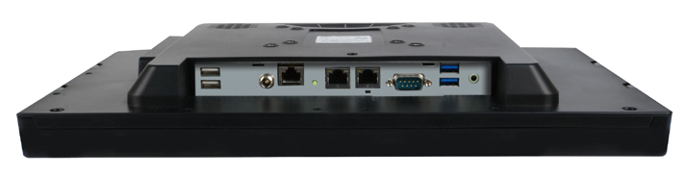RS-232 2 x GbE LAN 2 x USB 3.1 Gen 1 (5Gb/s)
2 x USB 2.0 9 V ~ 30 V DC
RS-232/422/485 Line-out
Digital Microphone
Jack
Power Button

AFL3-W15A-BT
Fully Integrated I/O
AT/ATX Switch

2 x GbE LAN

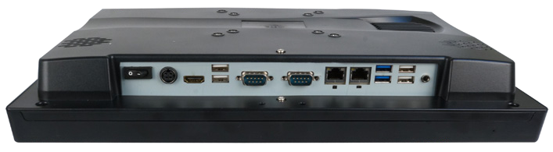9 V ~ 30 V DC Jack
2 x USB 2.0 RS-232/422/485
2 x USB 3.1 Gen 1 (5Gb/s) Line-out

AFL3-15B-H81
Fully Integrated I/O

Power Switch HDMI

RS-232

Reset

2 x USB 2.0

Digital Microphone

AT/ATX Switch

Speaker 2 x GbE LAN

RS-232

9 V ~ 30 V DC Jack

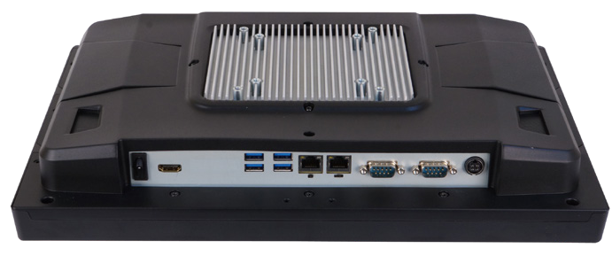AFL3-W15C-ULT3
Fully Integrated I/O

HDMI output
Reset AT/ATX Switch
RS-232/422/485
Digital Microphone

Power Switch 4 x USB 3.1 Gen 1 (5Gb/s)

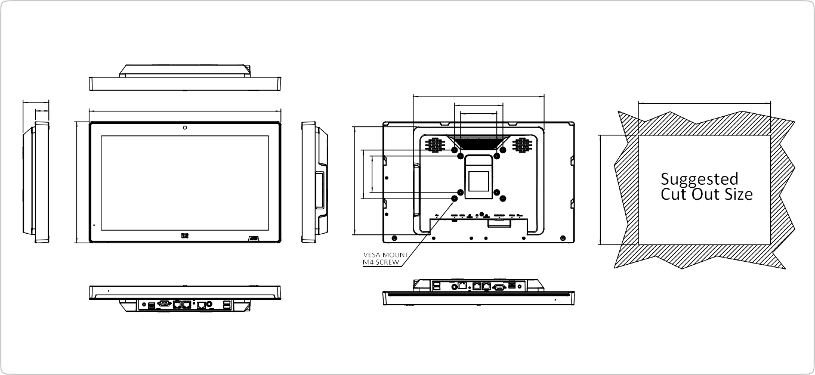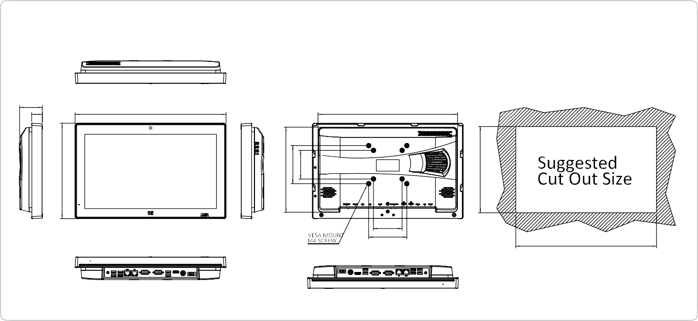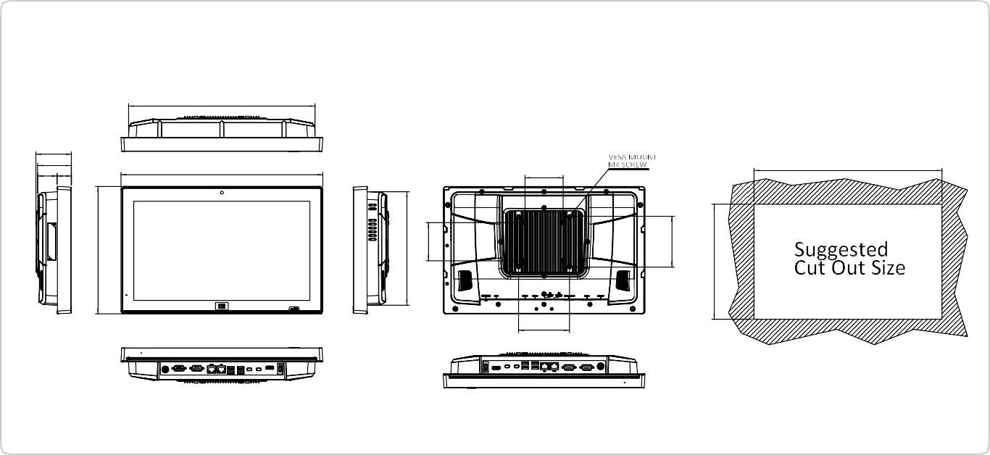
273
270
100
75
395.89
53
28
AFL3-W15A-BT Dimensions (Unit: mm)
369
75
100
366
395.89
59.40
28
AFL3-W15B-H81 Dimensions (Unit: mm)
100
369
75
395.89
69.40
66
38 28
AFL3-W15C-ULT3 Dimensions (Unit: mm)

366
250.21
250.21
250.21
222.64
75
223
100
75
223
100
75
100
226
226
226

