Intel® Celeron® J1900 (Quad Core, 2.0 GHz)
Intel® Celeron® J1900 (Quad Core, 2.0 GHz)
Intel® Core™ i5 and Celeron® ULT Processor
AFL3-12C-ULT3
AFL3-12A-BT
AFL3-W10A-BT

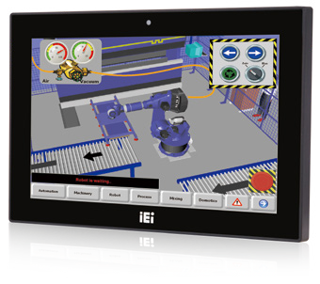Specifications
Features
- W10”~12.1” light industrial interactive panel PC
- Wide range DC input with lockable DC jack
- Selectable AT/ATX power mode
- Built-in speakers
- One mSATA slot
- IP64 compliant front panel
- IEI One Key Recovery solution alllows you to create rapid OS backup and recovery (suggested with over 4GB storage capacity)

Model |  | AFL3-W10A-BT | AFL3-12A-BT | AFL3-12C-ULT3
LCD | Size | 10.1” | 12.1” | 12.1”
 | Resolution | 1280 x 800 (16:10) | 1024 x 768 (4:3) | 1024 x 768 (4:3)
 | Brightness (cd/m²) | 350 | 500 | 500
 | Contrast Ratio | 800:1 | 700:1 | 700:1
 | LCD Color | 16.2M | 16.2M | 16.2M
 | Pixel Pitch (mm) | 0.1695 (H)×0.1695 (V) | 0.240 (H) x 0.240 (V) | 0.240 (H) x 0.240 (V)
 | Viewing Angle (H-V) | 170º / 170º | 160º / 160º | 160º / 160º
 | Backlight MTBF(hrs) | 15000 hrs | 50000 hrs | 50000 hrs
Touch | Touch Screen | Projected capacitive with USB interface (anti-UV / anti-glare coating) | 5-wire resistive with RS-232 interface (anti-glare coating)  Projected capacitive with USB interface (anti-UV / anti-glare coating) | Projected capacitive with USB interface (anti-UV / anti-glare coating)
 | Touch Controller | EETI EXC3146 | PenMount DMC9000/ EETI EXC3146 | EETI EXC3180
Motherboard | CPU | Intel® Celeron® J1900 (quad core, 2.0 GHz) | Intel® Celeron® J1900 (quad core, 2.0 GHz) | 6th Generation Intel® Core™ i5 and Celeron® on-board processor
 | RAM | One 204-pin 2 GB 1333MHz single-channel, 2GB DDR3L SO-DIMM pre-installed (system max. 8GB) | One 204-pin 2 GB 1333MHz single-channel, 2GB DDR3L SO- DIMM pre-installed (system max. 8GB) | One 260-pin 2133MHz single-channel, 4GB DDR4 SO-DIMM pre-installed (system max. 8GB)
 | Ethernet | 2 x PCIe GbE by RTL8111E controller | 2 x PCIe GbE by RTL8111E controller | 2 x PCIe GbE by Intel® i211 controller
 | Audio Codec | ALC892 | ALC892 | ALC892
Storage |  | 1 x mSATA (E-Window) | 1 x mSATA (E-Window)  1 x 2.5” SATA 3Gb/s HDD bay | 1 x mSATA (E-Window)  1 x 2.5” SATA 3Gb/s HDD bay
I/O Ports & Switch |  | 1 x RS-232 COM port (RJ-45 connector)  - x RS-232/422/485 COM port (DB-9 connector) (RI/5V/12V)  - x USB 3.1 Gen 1 (5Gb/s)  2 x USB 2.0  2 x RJ-45 for GbE LAN 1 x Power switch  1 x Audio port (line-out) 1 x Reset button  1 x AT/ATX switch  1 x 9-30V DC lockable power jack | 1 x RS-232 COM port (RJ-45 connector)  - x RS-232/422/485 COM port (DB-9 connector)(RI/5V/12V)  - x USB 3.1 Gen 1 (5Gb/s)  2 x USB 2.0  2 x RJ-45 for GbE LAN 1 x Power switch  1 x Audio port (line-out) 1 x Reset button  1 x AT/ATX switch  1 x 9-30V lockable power jack | 1 x RS-232/422/485 (DB-9)  1 x RS232 (RJ-45)  2 x GbE LAN  2 x USB 2.0  2 x USB 3.1 Gen 1 (5Gb/s)  1 x DC jack (12-30V DC)  1 x HDMI  1 x Power switch 1 x Reset button 1 x AT/ATX switch
E-Window Expansion |  | N/A | Yes, optional  (full-size mini-PCIe slot with PCIe/SATA/USB) | Yes, optional  (full-size mini-PCIe slot with PCIe/SATA/USB)
Audio |  | AMP 2W + 2W (internal speaker) | AMP 3W + 3W (internal speaker) | AMP 3W + 3W (internal speaker)
Camera and Microphone |  | 2-megapixel with low light function, digital microphone
Wireless |  | IEEE 802.11a/b/g/n/ac  half-size mini-PCIe slot (PCIe signal) |  | IEEE 802.11 a/b/g/n/ac, Bluetooth V4.1  M.2 slot A+E key 2230 slot (PCIe/USB signal)
OSD Function |  | Software OSD
Physical | Front Panel Construction | PC + ABS Plastic
 | Mounting | Panel, Wall, Stand, Arm VESA 75mm x 75mm | Panel, Wall, Rack, Stand and Arm VESA 75mm x 75mm / 100mm x 100mm | Panel, Wall, Stand and Arm VESA 75mm x 75mm / VESA 100mm x 100mm
 | Color | Black C
 | Dimensions (WxHxD) (mm) | 262 x 181 x 42 | 304 x 243 x 44 | 304 x 243 x 58
 | Cut-out Dimensions (WxH) (mm) | 236 x 149 | 243 x 205 | 272 x 223
 | Net/Gross Weight (kgs) | 1.06/2.58 | 1.92/3.95 | 3/5.03
Environment | Operating Temperature (Ambient with air flow) | -10°C~50°C | -20°C~50°C | -20°C ~ 50°C
 | Storage Temperature | -20°C~60°C | -20°C~60°C | -30°C ~ 60°C
 | Humidity | 10% to 95% (non-condensing)
 | IP Level | IP 64 compliant front panel
 | Safety&EMC | CE / FCC |  | CE , FCC , ErP 2009/125/EC
 | Thermal Solution | Fanless
Power | Power Requirement | 9 V ~ 30 V DC |  | 12 V ~ 30 V DC
 | Power Consumption | 12V@2.3A  (Intel® J1900 CPU with 2GB 1333 MHz DDR3L memory) | 12V@3.58A  (Intel® J1900 CPU with 2GB 1333 MHz DDR3L memory) | 12V@6A (Intel® Core™ i5-6300U CPU with 4GB DDR4 2133 MHz DDR4 memory)

Ordering Information

Part No. | Description
AFL3-W10A-BT-J1/PC/2G-R13 | 10.1” 350cd/m² 1280x800 fanless panel PC with Intel® Celeron® J1900 quad core 2 GHz, 802.11 a/b/g/n/ac wireless module, projected capacitive touch screen, 2GB DDR3L RAM , with AG, R13
AFL3-12A-BT-J1/PC/2G-R13 | 12.1” 500 cd/m² XGA fanless panel PC with Intel® Celeron® J1900 quad core 2 GHz, 802.11a/b/g/n/ac wireless module, projected capacitive touch screen, 2GB DDR3L RAM , with AG, R13
AFL3-12A-BT-J1/R/2G-R13 | 12.1” 500 cd/m² XGA fanless panel PC with Intel® Celeron® J1900 quad core 2 GHz, 802.11a/b/g/n/ac wireless module, resistive touch screen, 2GB DDR3L RAM , with AG, R13
AFL3-12C-ULT3-C/PC/4G-R10 | 12.1” 500cd/m² 1024 x 768 panel PC with 6th generation 14nm Intel® mobile Celeron® 3855U (15W) on-board processor (ULT), one 4GB DDR4 RAM, 802.11a/b/g/n/ac Wi-Fi module, PCAP touch, 2-megapixel camera, microphone, R10
AFL3-12C-ULT3-i5/PC/4G-R10 | 12.1” 500 cd/m² 1024 x 768 panel PC with 6th generation 14nm Intel® mobile Core™ i5-6300U (15W) on-board processor (ULT), one 4GB DDR4 RAM, 802.11a/b/g/n/ac Wi-Fi module, PCAP touch, 2-megapixel camera, microphone, R10
* AFL3-12C-ULT3-i5/R/4G-R10 | 12.1” 500 cd/m² 1024x768 Panel PC with Intel® 14nm 6th Generation Mobile Core™ i5-6300U (15W) on-board Processor (ULT), 1*4GB DDR4 RAM, 802.11a/b/g/n/ac WiFi module, resistive touch, 2-megapixel camera, microphone, R10
* AFL3-12C-ULT3-C/R/4G-R10 | 12.1” 500 cd/m² 1024x768 Panel PC with Intel® 14nm 6th Generation Mobile Celeron® 3855U (15W) on-board Processor (ULT), 1*4GB DDR4 RAM, 802.11a/b/g/n/ac WiFi module, resistive touch, 2-megapixel camera, microphone, R10
* by order MOQ 100pcs production

Options

Item | AFL3-W10A-BT | AFL3-12A-BT | AFL3-12C-ULT3
Panel Mounting Kit | AFL3PK-08A-R10
Wall Mounting Kit | AFLWK-12 | AFLWK-19B | AFLWK-19B
Rack Mounting Kit | AFL3RK-W10A-R10 | AFL3RK-12A-R10 | AFL3RK-12A-R10
Arm | ARM-11-RS/ARM-31-RS
Stand | STAND-C12-R10 | STAND-A12-RS/STAND-C12-R10/ STAND-100-RS | STAND-A12-RS/STAND-C12-R10/ STAND-100-RS
V-Stand | VSTAND-A10-R11 | VSTAND-A12-R11 | VSTAND-A12-R11
Magnetic Card Reader | AFL3P-W10MSR-U-R10
Barcode Scanner | AFL3-2D-R11
RFID Reader  **(13.56 MHz Mifare Type) for ATO assembly | AFL3-MF-RFID-KIT02-R10 | AFL3-MF-RFID-KIT02-R10** | AFL3-MF-RFID-KIT02-R10
*OS: Win 7 Embedded (64-bit) | AFL3-W07A-BT-WES7P64-R11*  (for PCAP touch) | AFL3-W07A-BT-WES7P64-R11* (for PCAP touch)  AFL3-W07A-BT-WES7E64-R11*  (for Resistive touch) | AFL3-12C-ULT3-WES7P64-R10* (for PCAP touch)  AFL3-12C-ULT3-WES7E64-R10*  (for Resistive touch)
*OS: Win 10 IOT Enterprise | AFL3-W07A-BT-W10E64-E-R10 |  | AFL3-12C-ULT3-W10E64-V-R10
**RFID is supported from AFL3-xxA-BT R11 version
*OS image with CD-ROM without storage

E-Window (for ATO assembly)
Part No. | Description | Supported Model
E-MPCIE-LAN-R10 | PCIe Mini card supports 1-port GbE with Realtek RTL8111E controller, with PMS 194C I/O bracket and 250mm cable, R10 | AFL3-12A-BT-J1/PC/2G-R12 AFL3-12A-BT-J1/R/2G-R12 AFL3-12C-ULT3-C/PC/4G-R10 AFL3-12C-ULT3-i5/PC/4G-R10
E-MPCIE-DLAN-R10 | PCIe Mini card supports 2-port GbE with Intel I211 controller, with PMS 194C I/O bracket and 250mm cable, R10
E-MPCIE-3G-R10 | PCIe Mini card supports 3G WWAN, with PMS 130C I/O bracket, 300mm RF antenna cable and GSM antenna cable, R10

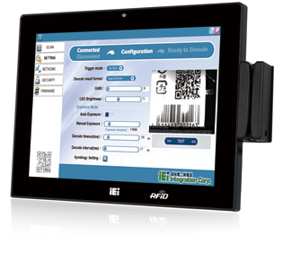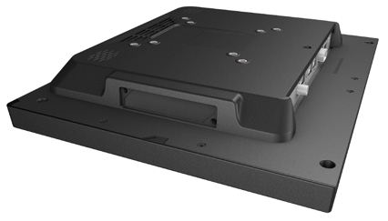
RFID
Card Reader
E-Window
(for ATO assembly)

Packing List

Item | Part No. | Q’ty | Remark
Round head machine screw | 44003-020041-RS (12A-BT) | 2 | M2*4 round head machine screw
Pan head machine screw | 44403-040061-RS | 4 | M4*6 pan head machine screw
Fix holder | 46003-009500-RS | 2
Power adapter | 63040-010036-121-RS (AFL3-W10A-BT)  63040-010060-120-RS (AFL3-12A-BT) | 1 | 36W; Vin: 90V~264V AC; Vout: 12VDC 60W; Vin: 90V~264V AC; Vout: 12VDC
RJ-45 to DB-9 COM port transfer cable | 32005-004600-100-RS | 1 | 300mm, 26AWG,  (A) D-SUB 9 male, (B) RJ-45

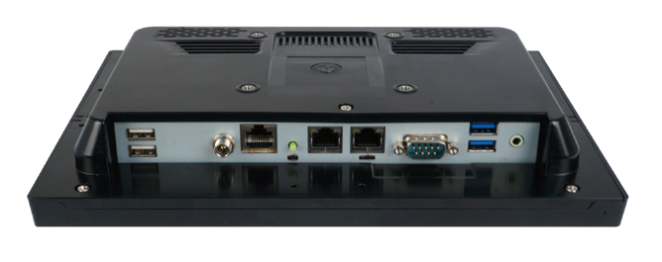Power Button
RS-232
2 x GbE LAN
2 x USB 3.1 Gen 1 (5Gb/s)
2 x USB 2.0
9 V ~ 30 V DC Jack Reset
RS-232/422/485 Line-out Digital Microphone

AFL3-W10A
Fully Integrated I/O

AT/ATX Switch

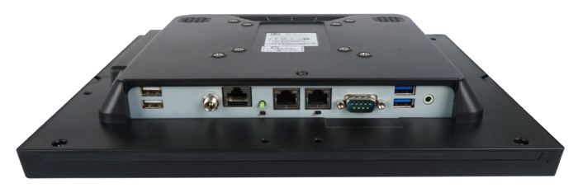Power Button

RS-232

2 x GbE LAN

2 x USB 3.1 Gen 1 (5Gb/s)

AFL3-12A
Fully Integrated I/O

2 x USB 2.0

9 V ~ 30 V DC Jack

AT/ATX Switch

Line-out

Digital Microphone

Reset
RS-232/422/485

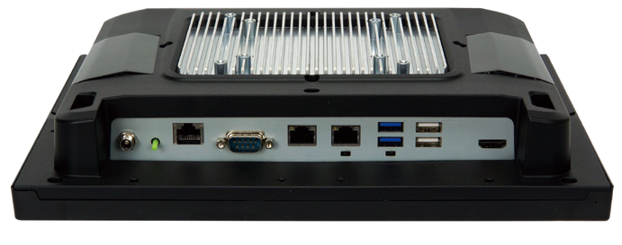Power Button
RS-232
2 x GbE LAN
2 x USB 3.1 Gen 1 (5Gb/s)
12 V ~ 30 V DC Jack
RS-232/422/485 Reset
2 x USB 2.0
Digital Microphone

AFL3-12C-ULT3
Fully Integrated I/O

AT/ATX Switch HDMI

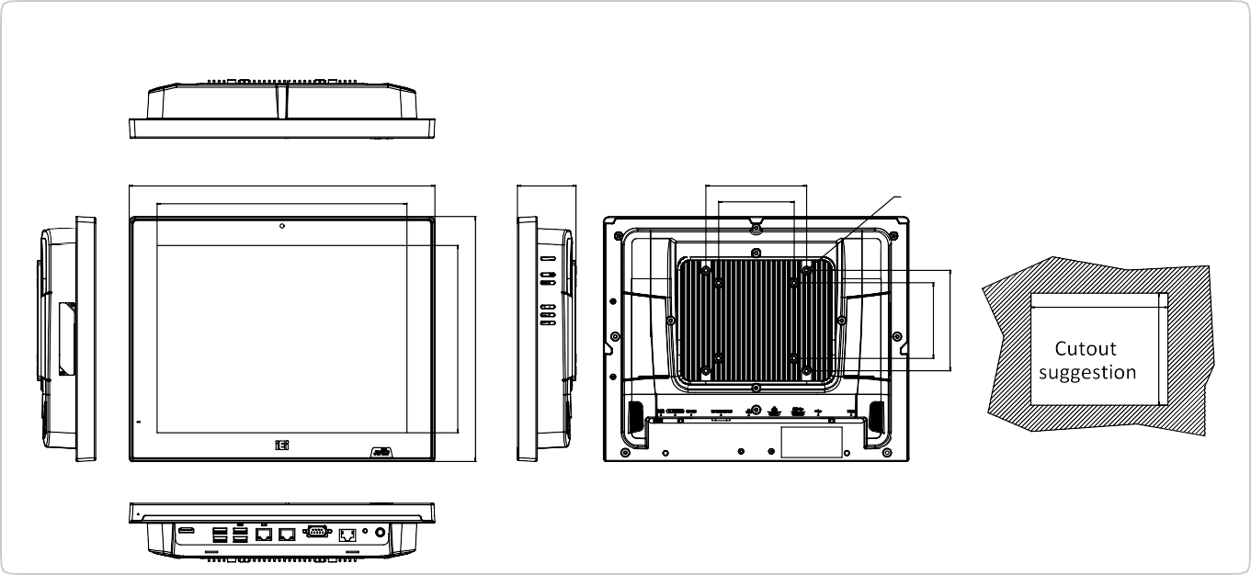
272
8XM4
100
75
58.23
303.43
248
AFL3-12C-ULT3 Dimensions (Unit: mm)
186.40
243.36
75
100
223
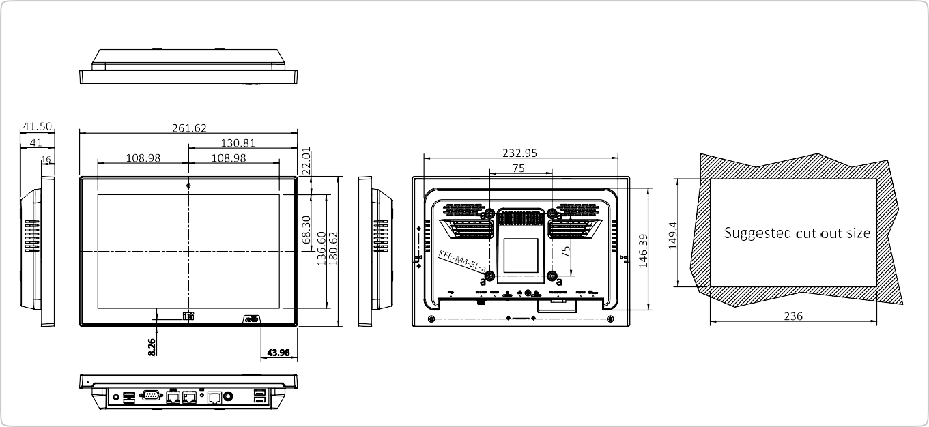
AFL3-W10A-BT Dimensions (Unit: mm)
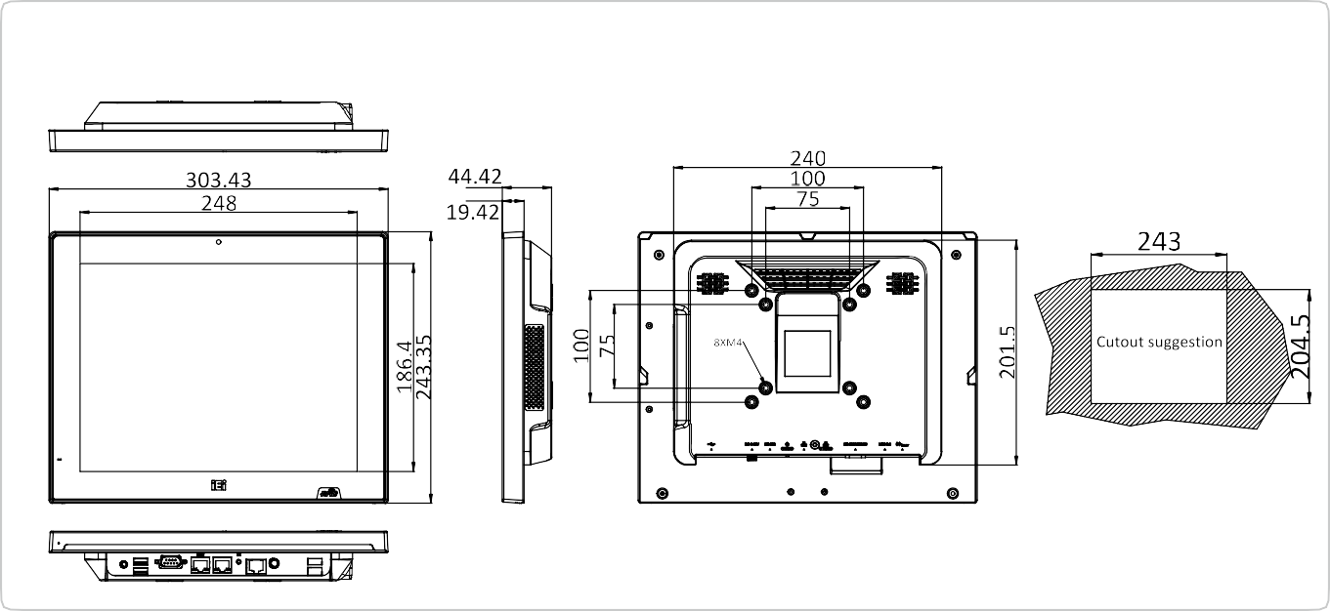
AFL3-12A-BT Dimensions (Unit: mm)

