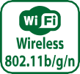
AFL2-W21A-H61
Intel® Core™ i7/i5/i3 and Pentium® Processor
IEI designed a completely new model for its new AFOLUX GEN II Panel PCs. AFL2-W21A-H61 with exclusive LED light bar function combining
Features
- Two 204-pin DDR3 SO-DIMM slot (system max. 16GB) pre-installed with 4GB (2GB x 2)
- Projected capacitive touchscreen supported
- Wi-Fi 802.11b/g/n high speed wireless
- EM or Mifare RFID reader
- Programmable colorful LED light bar
- Built-in two 3W speakers and microphone
- Auto dimming control
- Light fanless design
- Wide range 9~36 VDC input

Full HD Second Display Through HDMI Interface
Full-HD 1080p (1920x1080) reacts the resolution of panel, which is a set of high-definition video modes with 1920 of horizontal resolution and 1080 of vertical resolution. Widescreen aspect ratio of 16:9 supports perfect display sight, with brighter digital display.
1080p

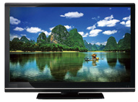1920 lines of horizontal resolution supporting a 16:9 ratio to perform perfect display sight.
HDMI

IEI Customized Expansion

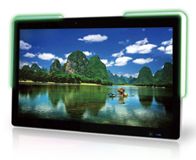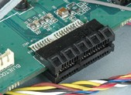Standard Connector Type Easy to Design Expansion Module
Use one system in
Video card
USB 3.0
Ethernet
Serial Port
HSUPA 3.5G DVB-T/ATSC/Hybrid
UART
The AFL2-W21A-H61 can customize the expansion board depending on user’s necessary. Customer can choose digital TV, 3G,video capturing…and so on.

Features
- Reliable board to board connection
- IEI provides ODM service which customize boards of user’s demand.

different markets!

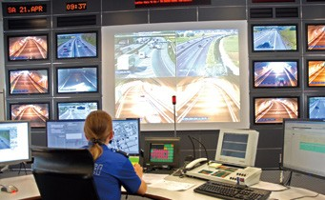
Digital TV
3G/3.75G
4-Port Video Capture
Kiosk System Mobile Broadcasting System Surveillance System

Display System
w w w . i ei w or l d .c om

Specifications

Model |  | AFL2-W21A-H61 | Other Features | EM and Mifare RFID | Optional: EM 125 KHz or Mifare 13.56 MHz card  reader
LCD  Specifications | LCD Display | W21.5″ (16:9)
 |  |  |  | LED Light Bar | Programmable R/G/B colorful LED light bar (SMBus Control)
 | Max Resolution | 1920 (W) x 1080 (H)
 | Brightness (cd/m²) | 250
 |  |  |  | Function Key | 6 x function keys:  Key1 Backlight On/Off Key2 Audio -  Key3 Audio + Key4 Brightness - Key5 Brightness+ Key6 Fn Combinations:  Fn+Key1 RFID Enable/Disable Fn+Key2 Audio Mute  Fn+Key3 Camera Enable/Disable Fn+Key5 Power ON/OFF
 | Contrast Ratio | 1000 : 1
 | LCD Color | 16.7M
 | Pixel Pitch (mm) | 0.248 mm x 0.248 mm
 | Viewing Angle (H-V) | 170° / 160°
 | Backlight MTBF (Hrs) | 30000 (LED backlight)
Touch | Touch Screen | projected capacitive type with USB interface
 | Touch Controller | EETI EXC7200 & EXC5404
System | CPU | Intel® Core™ i7/i5/i3 and Pentium® processors
 | Chipset | Intel® H61
 | RAM | Support two 204-pin DDR3 SO-DIMM slot (max. 16GB) preinstalled with 4GB (2GB x 2)
 |  |  |  | Infrared | IR receiver 38KHz
 | Storage | 1 x 2.5″ SATA 3Gb/s HDD Bay |  | Light Sensor | Ambient light sensor for panel brightness adjustment
 | Optical Drive | 1 x Slim Type DVD-ROM bay |  | TPM | Reserved by pin-header
 | Ethernet | Realtek RTL8111E PCIe GbE controller supporting ASF 2.0 | OS Support | OS Support | Windows Embedded Standard 7 Windows XP Embedded,
 | Audio Codec | Realtek ALC892 HD Audio codec | Connectivity | Wireless | IEEE 802.11b/g/n module Telec certified
 | Audio | Amplifier 3W + 3W | Physical | Construction Material | PC + ABS plastic for front cover and rear cover
 | Webcam &  Microphone | 2-megapixel camera with low light function  Digital Microphone |  | Mounting | Wall, Stand and VESA 100 mm x 100mm
 |  |  |  | Enclosure Color | Sliver + Black
 | I/O Ports | 2 x RS232 (DB9 Connector)  1 x RS422/485 COM Port (DB9 connector) 2 x GbE LAN (RJ-45 connector)  3 x USB 2.0  2 x USB 3.0  1 x HDMI  1 x VGA port (DB-15 Connector) 1 x Power switch  1 x Reset button 1 x AT/ATX switch  1 x Clear CMOS button 1 x Type K  1 x 9~36V DC jack 1 x Line out  1 x Mic
 |  |  |  | Dimension (mm) | 546.85 (W) x 345.82 (H) x 70.35 (D)
 |  |  |  | Weight (Net/Gross) | 8.27 Kg / 11.27 Kg
 |  |  | Enviornment | Operating Temperature  (with air flow) | -10°C ~ 50°C
 |  |  |  | Storage Temperature | -20°C ~ 60°C
 |  |  |  | Humidity | 10% to 90% (non-condensing)
 |  |  |  | IP Level | IP 64 compliant front panel
 |  |  |  | Safety and EMC | CE & FCC
 |  |  | Power | Power Adapter | 120W power adapter  Input: 100 V AC ~ 240 V AC, 50 / 60Hz,  Output: 19 V DC
 | Expansion Interface | 1 x PCIe Mini for Wi-Fi Module  1 x PCIe Mini reserved |  | Power Input | 9 ~ 36V DC-IN
 |  |  |  | Power Consumption | 19V@3.82A (Intel® Core™ i3-2120T processor with  4GB DDR3 memory)
 | Cooling System | Light Fanless

Ordering Information
LED Bar | Model | Description
LED Bar | AFL2-W21A-H61-i5/PC-R11 | 21.5” 250cd/m² FHD panel PC, Core i5 Dual Core 2xxxT CPU (Above 2.7GHz), TDP 35W, 4GB DDR3 (2GB x 2), 802.11b/g/n wireless module, projected capacitive touchscreen, 2M camera, microphone, R11
 | AFL2-W21A-H61-i3/PC-R11 | 21.5” 250cd/m² FHD panel PC, Core i3 Dual Core 2xxxT CPU (Above 2.5GHz), TDP 35W, 4GB DDR3 (2GB x 2), 802.11b/g/n wireless module, projected capacitive touchscreen, 2M camera, microphone, R11
 | AFL2-W21A-H61-P/PC-R11 | 21.5” 250cd/m² FHD panel PC, Pentium Dual Core G6xxT CPU (Above 2.2GHz), TDP 35W, 4GB DDR3 (2GB x 2), 802.11b/g/n wireless module, projected capacitive touchscreen, 2M camera, microphone, R11
Without LED Bar | AFL2-W21AB-H61-i5/PC-R11 | 21.5” 250cd/m² FHD panel PC, Core i5 Dual Core 2xxxT CPU (Above 2.7GHz), TDP 35W, 4GB DDR3 (2GB x 2), 802.11b/g/n wireless module, projected capacitive touchscreen, 2M camera, microphone, without LED bar, R11
 | AFL2-W21AB-H61-i3/PC-R11 | 21.5” 250cd/m² FHD panel PC, Core i3 Dual Core 2xxxT CPU (Above 2.5GHz), TDP 35W, 4GB DDR3 (2GB x 2), 802.11b/g/n wireless module, projected capacitive touchscreen, 2M camera, microphone, without LED bar, R11
 | AFL2-W21AB-H61-P/PC-R11 | 21.5” 250cd/m² FHD panel PC, Pentium Dual Core G6xxT CPU (Above 2.2GHz), TDP 35W, 4GB DDR3 (2GB x 2), 802.11b/g/n wireless module, projected capacitive touchscreen, 2M camera, microphone, without LED bar, R11

Options
Item | AFL2-W21A-H61
Panel Mount Kit | AFL2PK-W21A
Wall Mounting Kit | AFLWK-19B
Stand | STAND-A21-R10
ARM | ARM-31-RS
Slim DVD Burner Installation Kit  (Including SATA Cable) | AFL2-DVD-KIT01-R10
Magnetic Stripe Reader | AFL2P-W21AMSR-U-R10
Trusted Platform Module (TPM) | TPM-IN01-R11
EM RFID Reader | AFL2-EM-RFID-KIT01-R10
Mifare RFID Reader | AFL2-MF-RFID-KIT01-R11
OS: Windows® XP Embedded (CD-ROM) | AFL2-W21-H61-XPE-R11
OS: Windows® Embedded Standard 7  (DVD-ROM) | AFL2-W21-H61-WES7P-R11
Temperature Sensor Cable | 32133-004300-100-RS

Packing List
Item | P/N | Q'ty | Description
Utility CD | 7B000-000952-RS | 1 | drivers and user manual
One Key Recovery CD | 7B000-000781-RS | 1
Power Adapter | 63040-010120-210-RS | 1 | FSP120-AAB ; 90~264VAC input ; 120W ; 19VAC output (Meet PSE)
Power Cord | 32702-000401-100-RS | 1 | European, 1500mm
Power Transfer Cord | 32000-089400-RS | 1
Infrared Remote Controller | 7Z000-SLPCB005-RS | 1
M3 Screw Pack | 44013-030041-RS | 4 | M3 x 4 for securing HDD
M4 Screw Pack | 44033-040061-RS | 4 | M4 x 4 for VESA screw

Fully Integrated I/O

Fn

Backlight On/Off Audio -
Audio + Brightness - Brightness +

RFID Enable/Disable Audio Mute
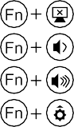
Camera Enable/Disable Power On / Off

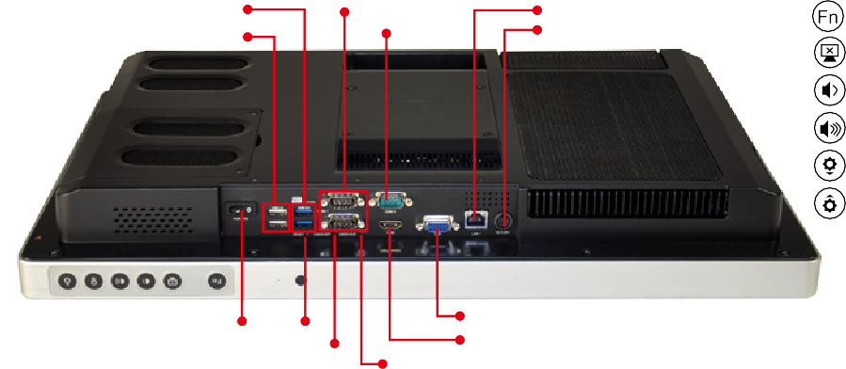
2 x USB 3.0
2 x USB 2.0
2 x RS-232
RS-422/485
LAN
9-36V DC Jack
Power Switch Reset
Clear CMOS
VGA HDMI
AT/ATX Switch

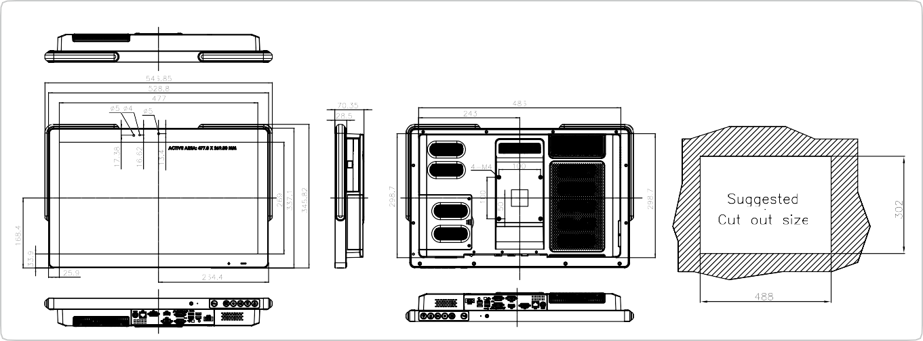

AFL2-W21A-H61
Dimensions (Unit: mm)

