Intel® Core™ i7/i5/i3 and Pentium® Processor
AFL2-17A-H61

Optional CD-ROM available

Features
- 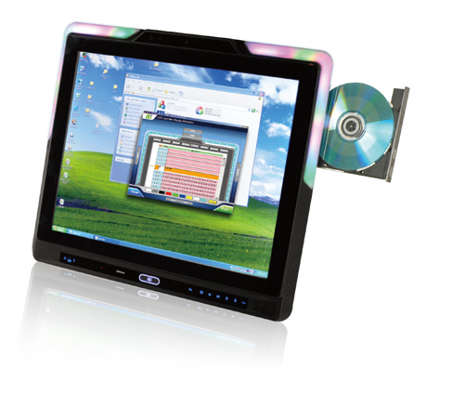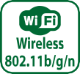Programmable colorful LED light bar
- Intel® Core™ i5/ i3 and Pentium® processor
- Two 204-pin DDR3 SO-DIMM slot (system max. 16GB) preinstalled with 4GB (2GB x 2)
- Projected capacitive touchscreen and 5-wire resistive type touchscreen supported
- Wi-Fi 802.11b/g/n
- EM or Mifare RFID reader
- Built-in 2-megapixel webcam with AF, AE and AWB capabilities
- Built-in two 2W speakers and microphone
- IP 64 compliant front panel
- Auto dimming control
- Light fanless design
- Type K thermocouple temperature sensor
- Wide range 9~36 VDC input

Specifications
Model |  | AFL2-17A-H61
LCD Specifications | Size | 17" (4:3)
 | Resolution | 1280 (W) x 1024 (H)
 | Brightness (cd/m²) | 350
 | Contrast Ratio | 1000:1
 | LCD Color | 16.7M
 | Pixel Pitch (mm) | 0.264 (H) x 0.264 (V)
 | Viewing Angle (H-V) | 170° / 160°
 | Backlight MTBF | 50,000 (LED backlight)
Touch | Touch Screen | 5-wire rsistive type with RS-232 interface / projected capacitive type with USB interface
 | Touch Controller | PenMount DMC9000 / EETI EXC7200 & EXC5404
System | CPU | 2nd/3rd Generation Intel® Core™ i7/i5/i3 and Pentium® processors
 | Chipset | Intel® H61
 | RAM | Support two 204-pin DDR3 SO-DIMM slot (max. 16GB) preinstalled with 4GB (2GB x 2)
 | Ethernet | Realtek RTL8111E PCIe GbE controller supporting ASF 2.0
 | Audio Codec | Realtek ALC892 HD Audio codec
 | HDD | 2.5" SATA 3Gb/s HDD bay
 | CD-ROM | 1 x Slim Type CD-ROM bay
 | Input / Output | 2 x RS-232 (DB-9 connector)  - x RS-422/485 (DB-9 connector)  - x GbE LAN (one on the bottom, one on the left) 2 x USB 3.0  - x USB 2.0 (two on the bottom, one on the left) 1 x Mini USB port on front panel  1 x MicroSD card slot on front panel 1 x Line out (on the left)
 | Expansion Interface | 1 x PCIe Mini slot reserved
Other Features | Audio | AMP 2W + 2W (internal speaker)
 | Camera | 2 M pixels with low light function
 | RFID Reader | EM 125 KHz or Mifare 13.56 MHz card reader (optional)
 | MSR Card Reader | MSR card reader (optional)
 | TPM | Reserved by pin-header
 | OSD Function | LCD on/off, brightness up/down, volume up/down, Hot Key
 | Ambient Light Sensor | Yes
 | Infrared Remote Controller | Yes
 | LED Light Bar | Yes
 | System Cooling | Light fanless (smart fan operates above default temperature setting)
Connectivity | Wireless | IEEE 802.11b/g/n Telec certified
Physical | Construction Front Panel | PC + ABS Plastic
 | Mounting | Panel, Wall, Rack, Stand, Arm VESA 100mm x 100mm
 | Color | Black
 | Dimensions (WxHxD)(mm) | 418 x 378 x 65
 | Weight (N/G) | 6.9 kg / 9.0 kg
Environment | Operating Temperature (°C)  (Ambient with air flow) | -20°C ~ 50°C
 | Storage Temperature (°C) | -20°C ~ 60°C
 | Humidity | 10% to 95% (non-condensing)
 | IP Level | IP 64 compliant front panel
 | Safety&EMC | CE / FCC
Power | Power Supply | 120W power adapter , Input:100 V AC ~ 240 V AC, 50 / 60Hz, Output: 19 V DC
 | Power Requirement | 9 ~ 36 VDC
 | Power Consumption | 19V@5.3A  (Intel® Core™ i3-2100T CPU with 4GB 1333 Mhz 4GB DDR3 memory)

Display System
w w w . i ei w or l d .c om

Ordering Information

LED Bar | Model | Description
LED Bar | AFL2-17A-H61-i5/R-R13 | 17" 350cd/m² SXGA panel PC, Core i5 Dual Core 2xxxT CPU (Above 2.7GHz), TDP 35W, 4GB DDR3 (2GB x 2), 802.11b/g/n wireless module, resistive touch screen, 2M camera, microphone, R13
 | AFL2-17A-H61-i5/PC-R13 | 17" 350cd/m² SXGA panel PC, Core i5 Dual Core 2xxxT CPU (Above 2.7GHz), TDP 35W, 4GB DDR3 (2GB x 2), 802.11b/g/n wireless module, projected capacitive touchscreen, 2M camera, microphone, R13
 | AFL2-17A-H61-i3/R-R13 | 17" 350cd/m² SXGA panel PC, Core i3 Dual Core 2xxxT CPU (Above 2.5GHz), TDP 35W, 4GB DDR3 (2GB x 2), 802.11b/g/n wireless module, resistive touch screen, 2M camera, microphone, R13
 | AFL2-17A-H61-i3/PC-R13 | 17" 350cd/m² SXGA panel PC, Core i3 Dual Core 2xxxT CPU (Above 2.5GHz), TDP 35W, 4GB DDR3 (2GB x 2), 802.11b/g/n wireless module, projected capacitive touchscreen, 2M camera, microphone, R13
 | AFL2-17A-H61-P/R-R13 | 17" 350cd/m² SXGA panel PC, Pentium Dual Core G6xxT CPU (Above 2.2GHz), TDP 35W, 4GB DDR3 (2GB x 2), 802.11b/g/n wireless module, resistive touch screen, 2M camera, microphone, R13
 | AFL2-17A-H61-P/PC-R13 | 17" 350cd/m² SXGA panel PC, Pentium Dual Core G6xxT CPU (Above 2.2GHz), TDP 35W, 4GB DDR3 (2GB x 2), 802.11b/g/n wireless module, projected capacitive touchscreen, 2M camera, microphone, R13
Without LED Bar | AFL2-17AB-H61-i5/R-R13 | 17" 350cd/m² SXGA panel PC, Core i5 Dual Core 2xxxT CPU (Above 2.7GHz), TDP 35W, 4GB DDR3 (2GB x 2), 802.11b/g/n wireless module, resistive touch screen, 2M camera, microphone, without LED bar, R13
 | AFL2-17AB-H61-i5/PC-R13 | 17" 350cd/m² SXGA panel PC, Core i5 Dual Core 2xxxT CPU (Above 2.7GHz), TDP 35W, 4GB DDR3 (2GB x 2), 802.11b/g/n wireless module, projected capacitive touchscreen, 2M camera, microphone, without LED bar, R13
 | AFL2-17AB-H61-i3/R-R13 | 17" 350cd/m² SXGA panel PC, Core i3 Dual Core 2xxxT CPU (Above 2.5GHz), TDP 35W, 4GB DDR3 (2GB x 2) 802.11b/g/n wireless module, resistive touch screen, 2M camera, microphone, without LED bar, R13
 | AFL2-17AB-H61-i3/PC-R13 | 17" 350cd/m² SXGA panel PC, Core i3 Dual Core 2xxxT CPU (Above 2.5GHz), TDP 35W, 4GB DDR3 (2GB x 2), 802.11b/g/n wireless module, projected capacitive touchscreen, 2M camera, microphone, without LED bar, R13
 | AFL2-17AB-H61-P/R-R13 | 17" 350cd/m² SXGA panel PC, Pentium Dual Core G6xxT CPU (Above 2.2GHz), TDP 35W, 4GB DDR3 (2GB x 2), 802.11b/g/n wireless module, resistive touch screen, 2M camera, microphone, without LED bar, R13
 | AFL2-17AB-H61-P/PC-R13 | 17" 350cd/m² SXGA panel PC, Pentium Dual Core G6xxT CPU (Above 2.2GHz), TDP 35W, 4GB DDR3 (2GB x 2), 802.11b/g/n wireless module, projected capacitive touchscreen, 2M camera, microphone, without LED bar, R13

Options
Item | AFL2-17A-H61
Panel Mounting Kit | AFL2PK-17A
Wall Mounting Kit | AFLWK-19B
Rack Mounting Kit | AFL2RK-17A
Arm | ARM-31-RS
Stand | STAND-A19-RS/STAND-A21-R10/STAND-C19-R10
Magnetic Stripe Reader | AFL2P-W19AMSR-U-R10
Slim DVD Burner | AFL2-DVD-KIT01-R10
Module (TPM) | TPM-IN01-R11
EM RFID Reader | AFL2-EM-RFID-KIT01-R10
Mifare RFID Reader | AFL2-MF-RFID-KIT01-R11
OS: Win 7 Embedded (DVD-ROM) | AFL2-17A-H61-WES7P-R13 (for Projected Capacitive Touch) AFL2-17A-H61-WES7E-R13 (for Resistive Touch)

Packing List CD-RW/DVD-RW Driver Spec.
The drive is able to write CD-R/RW disks, DVD+R/RW disks and DVD-R/RW disks
Item | P/N | Q'ty | Description
Utility CD | 7B000-000956-RS | 1 | drivers and user manual
One Key Recovery CD | 7B000-000781-RS | 1
Power Adapter | 63040-010120-210-RS | 1 | FSP120-AAB;90~264VAC input ; 120W  ;19VAC output (Meet PSE)
Power Cord | 32702-000401-100-RS | 1 | European, 1500mm
Power Transfer Cord | 32000-089400-RS | 1
Infrared Remote Controller | 7Z000-SLPCB005-RS | 1
M3 Screw Pack | 44013-030041-RS | 4 | M3 x 4 for securing HDD
M4 Screw Pack | 44033-040061-RS | 4 | M4 x 4 for VESA screw
I/O Bracket | 41013-0290C2-00-RS | 1 | I/O Bracket
Temperature Sensor Cable | 32133-004300-100-RS | 1
Pen | 43125-0002C0-00-RS | 1 | For Resistive Touch

Drive Type | Internal Slim CD-RW/DVD Combo Drive
 | Write: | Read:  DVD-ROM: 8X CD-ROM: 24X
Data Transfer | DVD+R/DVD+RW/DVD-R: 8X
Rate | DVD-RW: 6X
 | CD-R/CD-RW: 24X
Interface | SATA
Buffer Memory | 2MB

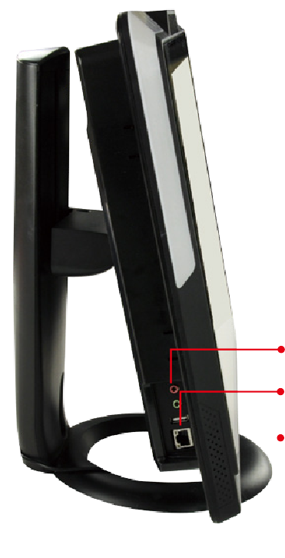Function Keys

Fn

Backlight On/Off Audio -
Audio + Brightness - Brightness +

RFID enable / disable Audio mute
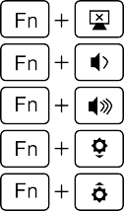
Camera enable / disable

Front side Mini USB&MicroSD enable / disable

Power on / off

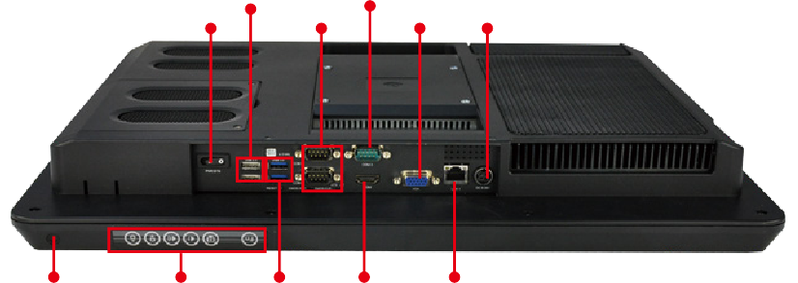
2 x USB 2.0 RS-422/485

Power Switch
2 x RS-232
VGA DC Jack

Mic, Line-out

1 x USB 2.0

1 x GbE LAN

Type K thermocouple
temperature sensor
Hot Keys 2 x USB 3.0 HDMI GbE LAN

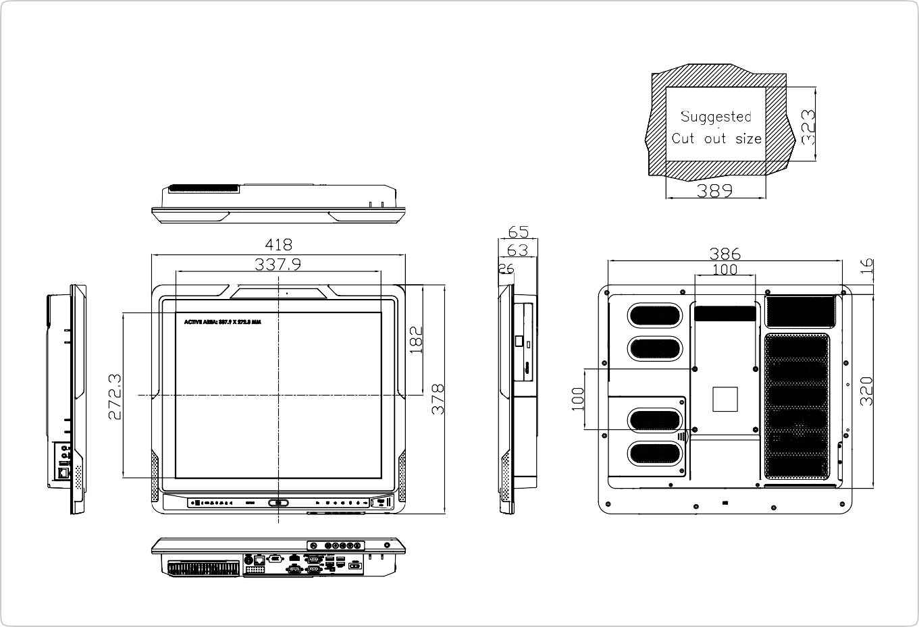

AFL2-17A-H61 Dimensions
(Unit: mm)

