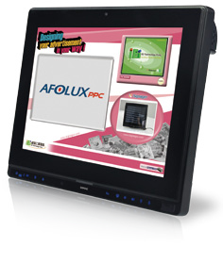
Features
- 12.1” 600nits 1024 x 768 flat-bezel LCD with LED backlight
- Supports projected capacitive touchscreen or 5-wire resistive type touchscreen
- Built-in two 3W speakers and microphone
- GbE LAN for high speed network applications
- One 204-pin DDR3 SO-DIMM slot (system max. 4GB)
- Wi-Fi 802.11b/g/n high speed wireless
- EM or Mifare RFID reader
- IP 64 compliant front panel
- Auto-dimming control
- Built-in 2 megapixels webcam with AF AE and AWB capabilities
- Wide range 9~36 VDC input
Specifications
Wireless 802.11b/g/n
EM/Mifare
Speakers Microphone Camera
Touchscreen -20ºC~45ºC IP64
Intel® Core™ i7/i5/i3 Processor
Intel® Atom™ D525 Dual Core Processor
AFL2-12A-D525
AFL2-12A-HM65

 | Model | AFL2-12A-D525 |  | AFL2-12A-HM65
LCD  Specifications | Size | 12.1"
 | Resolution | 1024 (W) x 768 (H)
 | Brightness (cd/m²) | 600
 | Contrast Ratio | 700:1
 | LCD Color | 16.2 M
 | Pixel Pitch (mm) | 0.240 (H) x 0.240 (V)
 | Viewing Angle (H-V) | 160° / 140°
 | Backlight MTBF | 50000 hrs (LED backlight)
Touch | Touch Screen | 5-wire rsistive type with RS-232 interface / projected capacitive type with USB interface
 | Touch Controller | PenMount DMC9000 / EETI EXC7200 & EXC5400
System | CPU | Intel® Atom™ D525 1.8GHz dual core processor |  | 2nd Generation Intel® Core™ i7/ i5/ i3 and Celeron® processor
 | Chipset | Intel® ICH8M |  | Intel® HM65
 | RAM | Support one 204-pin DDR3 SO-DIMM slot (Max. 4GB)
 | Ethernet | Realtek RTL8111E PCIe GbE controller supporting ASF 2.0
 | Audio Codec | Realtek ALC888 HD Audio codec
 | Storage | CF Type II socket 2.5" SATA 3Gb/s SSD bay  mSATA |  | 2.5" SATA 6Gb/s SSD bay
 | Input / Output | 1 x RS-232 (DB-9)  1 x RS-232 (RJ-45)  1 x RS-422/485  (4-pin box header)  2 x GbE LAN (RJ-45)  4 x USB 2.0  1 x Mini USB 2.0 port on front panel 1 x Audio jack (line-out) | 1 x VGA port (DB-15)  1 x MicroSD card slot on front panel 1 x Power switch  1 x AT/ATX switch 1 x Reset button  1 x Clear CMOS button 1 x DC input jack | 1 x RS-232 (DB-9)  1 x RS-232 (RJ-45)  - x RS-422/485 (4-pin box header) 2 x GbE LAN (RJ-45)  - x USB 2.0  2 x USB 3.0  1 x Mini USB 2.0 port on front panel 1 x Audio jack (line-out) | 1 x HDMI port  1 x MicroSD card slot on front panel 1 x Power switch  1 x AT/ATX switch 1 x Reset button  1 x Clear CMOS button 1 x DC input jack
Other Features | Audio | AMP 3W + 3W (internal speaker)
 | Camera | 2 M pixels with low light function
 | RFID Reader | EM 125 KHz or Mifare 13.56 MHz card reader (optional)
 | MSR Card Reader | MSR card reader (optional)
 | OSD Function | LCD on/off, brightness up/down, volume up/down, Hot Key
 | Ambient Light Sensor | Yes
 | Infrared Remote Controller | Yes
 | System Cooling | Fanless |  | Smart fan
Connectivity | Wireless | IEEE 802.11b/g/n module Telec certified
Physical | Construction Front Panel | PC + ABS Plastic
 | Mounting | Panel, Wall, Rack, Stand and Arm VESA 100 mm x 100 mm
 | Color | Black
 | Dimensions (WxHxD)(mm) | 310 x 265 x 52.6
 | Weight (N/G) | 3.2 kg / 5.5 kg |  | 3.8 kg / 6.1 kg
Environment | Operating Temperature (°C)  (Ambient with air flow) | -20°C ~ 50°C |  | -20°C ~ 50°C with SSD
 | Storage Temperature (°C) | -20°C ~ 60°C |  | -20°C ~ 60°C
 | Humidity | 10% to 95% (non-condensing)
 | IP Level | IP 64 compliant front panel
 | Safety&EMC | CE / FCC
Power | Power Supply | 65W power adapter  Input: 100VAC~240VAC, 50/60 Hz  Output: 19VDC |  | 90W power adapter  Input: 100VAC~240VAC, 50/60Hz  Output: 19VDC
 | Power Requirement | 9 ~ 36 VDC
 | Power Consumption | 19V@2.2A  (Intel® Atom™ D525 CPU with 800MHz 2GB DDR3 memory ) |  | 19V@2.68A  (Intel® Core™ i5-2510E processor with 4GB DDR3 memory)

w w w . i ei w or l d .c om

Ordering Information

- AFL2-12A-D525
Part No. |  | Description
Resistive Touch Panel Screen | AFL2-12A-D525/R/2G-R14 | 12.1” 600cd/m² XGA fanless panel PC with Intel® Atom™ D525 dual core 1.8GHz, 802.11b/g/n wireless module, resistive touch screen, 2M camera, microphone, 2 GB DDR3 RAM, Dual GbE LAN, R14
Projective Capacitive Touch Screen | AFL2-12A-D525/PC/2G-R14 | 12.1” 600cd/m² XGA fanless panel PC with Intel® Atom™ D525 dual core 1.8GHz, 802.11b/g/n wireless module, projected capacitive touchscreen, 2M camera, microphone, 2 GB DDR3 RAM, Dual GbE LAN, R14

- AFL2-12A-HM65
Part No. |  | Description
Resistive Touch Screen | AFL2-12A-HM65/R-R14 | 12.1" 600cd/m² XGA panel PC, 802.11b/g/n wireless module, resistive touch screen, 2M camera, microphone, dual GbE LAN, R14
Projective Capacitive Touch Screen | AFL2-12A-HM65/PC-R14 | 12.1" 600cd/m² XGA panel PC, 802.11b/g/n wireless module, projected capacitive touchscreen, 2M camera, microphone, dual GbE LAN, R14
CPU Selection | CPU-MB-i7-2640M | 2nd Generation Intel® Core™ i7 Processor [Mobile], PPGA-988, dual core 2.8GHz, 35W, iAMT
 | CPU-MB-i5-2510E | 2nd Generation Intel® Core™ i5 Processor [Mobile], PPGA-988, dual core 2.5GHz, 35W, iAMT
 | CPU-MB-i3-2310M | 2nd Generation Intel® Core™ i3 Processor [Mobile], PPGA-988, dual core 2.1GHz, 35W
 | CPU-MB-CM-B810 | Intel® Celeron® Mobile Processor, PPGA-988, dual core 1.6GHz, 35 W
 | CPU-MB-CM-B710 | Intel® Celeron® Mobile Processor, PPGA-988, single core 1.6GHz, 35 W
Memory Selection | DDR3-SO-1333-1GB | SO-DIMM DDR3 1333MHz 1GB
 | DDR3-SO-1333-2GB | SO-DIMM DDR3 1333MHz 2GB
 | DDR3-SO-1333-4GB | SO-DIMM DDR3 1333MHz 4GB

Options

Item | AFL2-12A-D525 | AFL2-12A-HM65
Panel Mounting Kit | AFLPK-15
Wall Mounting Kit | AFLWK-19B
Rack Mounting Kit | AFL2RK-12
Arm | ARM-11-RS
Stand | STAND-A12-RS/STAND-A19-RS/STAND-A21-R10/STAND-C12-R10
V-Stand | VSTAND-A12-R11
Magnetic Stripe Reader Kit | AFL2P-12AMSR-U-R10
EM RFID Reader | AFL2-EM-RFID-KIT01-R10
Mifare RFID Reader | AFL2-MF-RFID-KIT01-R11
OS: Win XPE (2GB CF Card) | AFL2CF-12-D525-XPE-2G-R14 | AFL2-12A-HM65-XPE-R14*
OS: Win XPE (4GB CF Card) | AFL2CF-12-D525-XPE-4G-R14 | AFL2-12A-HM65-XPE-R14*
OS: Win 7 Embedded (4GB CF Card) | AFL2CF-12-D525-WES7P-4G-R14 (for Projected Capacitive Touch) AFL2CF-12-D525-WES7E-4G-R14 (for Resistive Touch) | AFL2-12A-HM65-WES7P-R14*  (for Projected Capacitive Touch)  AFL2-12A-HM65-WES7E-R14* (for Resistive Touch)

Packing List
*OS image with CD-ROM or DVD-ROM

Display System
Item | P/N | Q'ty | Description
Utility CD |  | 1 | Drivers and user manual
One Key Recovery CD |  | 1
Power Adapter | 63040-010065-200-RS (for AFL2-12A-D525)  63040-010090-120-RS (for AFL2-12A-HM65) | 1 | 65W ;19VDC output (Meet PSE) 90W ;19VDC output
Power Cord | 32702-000401-100-RS | 1 | 1500 mm, European Standard
Power Transfer Cord | 32702-000300-100-RS | 1
M3 Screw Pack | 44013-030041-RS | 4 | M3*4 for securing HDD
M4 Screw Pack | 44403-040061-RS | 4 | M4*4 VESA screw
Touch Pen | 43125-0002C0-00-RS | 1
RJ-45 to DB-9 COM Port Cable | 32005-000200-200-RS | 1
IR Remote Controller | 7Z000-SLPCB005-RS | 1
RS-422 Cable | 32205-002400-100-RS | 1
Pen | 43125-0002C0-00-RS | 1 | For Resistive Touch

AFL2-12A-D525
Fully Integrated I/O
AFL2-12A-HM65 Fully
Integrated I/O

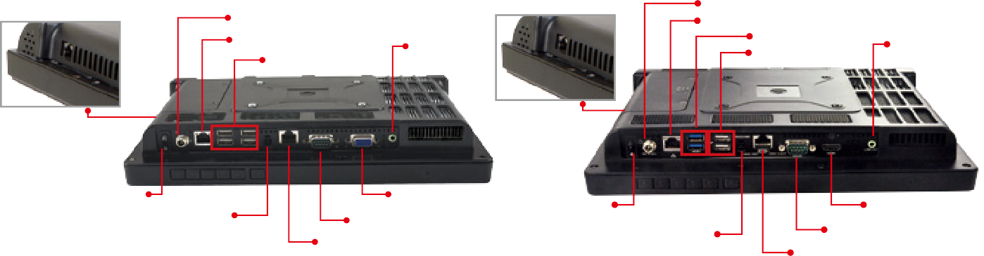
DC Jack
DC Jack
LAN
LAN
Line-out
2 x USB 3.0
2 x USB 2.0
Line-out
4 x USB 2.0
LAN Port
LAN Port
Power Switch
VGA RS-232
RS-232
Power Switch
HDMI
RS-422/485
RS-422/485
RS-232

RS-232

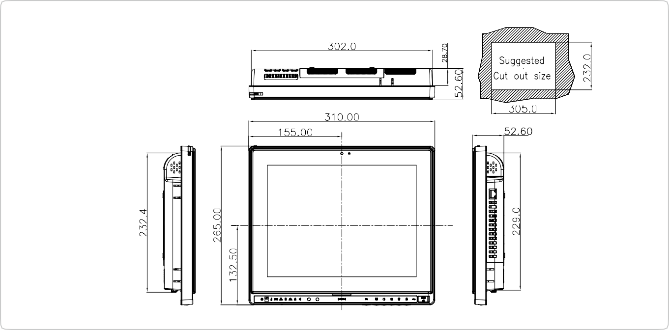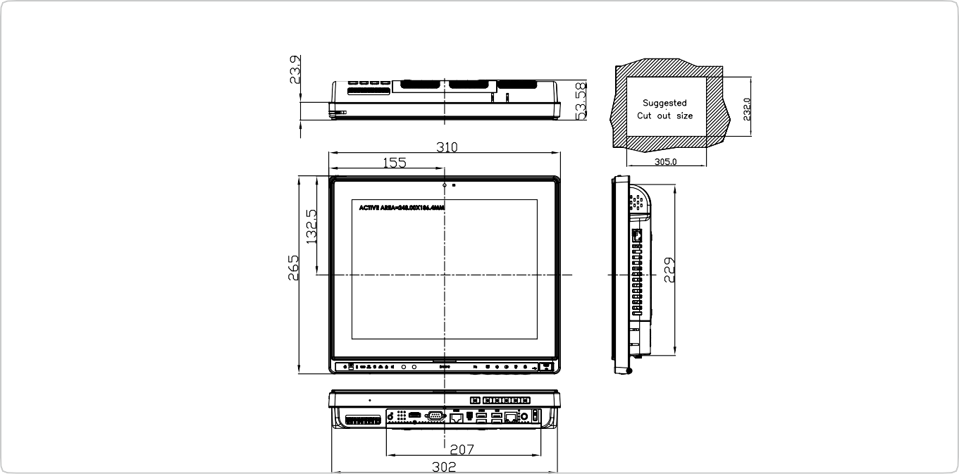
AFL2-12A-D525 Dimensions
(Unit: mm)
AFL2-12A-HM65 Dimensions
(Unit: mm)

