Display System
w w w . i ei w or l d .c om
Intel® Atom™ N2800 Dual Core Processor
AFL2-10A-N28

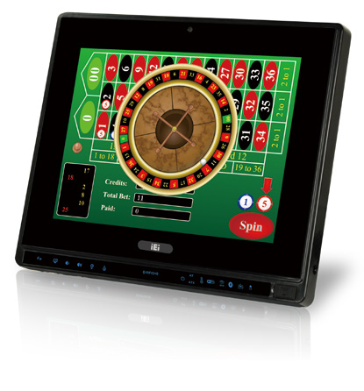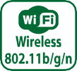Features
- Flat-bezel LCD with LED backlight
- Intel® Atom™ N2800 dual core 1.86 GHz processor
- One 1066 MHz 204-pin DDR3 SO-DIMM slot (system max. 4GB)
pre-installed with 2GB
- 5-wire resistive type touch screen supported
- Wi-Fi 802.11b/g/n high speed wireless
- EM or Mifare RFID reader
- Built-in 2M pixels webcam with AF, AE and AWB capabilities
- Built-in two 1.5W speakers and microphone
- IP 64 compliant front panel

Specifications

Model |  | AFL2-10A-N28
LCD  Specifications | Size | 10.4”
 | Resolution | 800 (W) x 600 (H)
 | Brightness (cd/m²) | 400 cd/m²
 | Contrast Ratio | 700:1
 | LCD Color | 262K/16.2M
 | Pixel Pitch (mm) | 0.264 (H) x 0.264 (V)
 | Viewing Angle (H-V) | 160°(H) / 140°(V)
 | Backlight MTBF | 30000 hrs (LED backlight)
Touch | Touch Screen | 5-wire rsistive type with RS-232 interface
 | Touch Controller | PenMount DMC9000
System | CPU | Intel® Atom™ N2800 dual core 1.86 GHz CPU
 | Chipset | Intel® NM10
 | RAM | Support one 1066MHz 204-pin DDR3 SO-DIMM slot (max. 4GB)
 | Ethernet | Realtek RTL8111E PCIe GbE controller supporting ASF 2.0
 | Audio Codec | Realtek ALC892 HD Audio codec
 | HDD | 2.5” SATA 2.0 HDD bay
 | Input / Output | 1 x Mini USB 2.0 port on front panel 1 x MicroSD card slot on front panel 1 x Power switch  1 x AT/ATX switch 1 x Reset button  1 x Clear CMOS button 1 x DC input jack
Other Features | Audio | AMP 1.5 W + 1.5 W
 | Camera and Microphone | 2M pixels with low light function, digital microphone
 | RFID Reader | EM 125 KHz or Mifare 13.56 MHz card reader (optional)
 | MSR Card Reader | MSR card reader (optional)
 | OSD Function | LCD on/off, brightness up/down, volume up/down, hotkey
 | System Cooling | Fanless
Connectivity | Wireless | IEEE 802.11b/g/n Telec certified
Physical | Construction Front Panel | PC + ABS plastic front frame
 | Mounting | Wall, Rack, Stand, RACK Mounting and Arm VESA 75mm x 75mm
 | Color | Black
 | Dimensions (WxHxD) (mm) | 282.5 x 242.7 x 51
 | Weight (N/G) | 2.98 kg / 4.5 kg
Environment | Operating Temperature (°C) (Ambient with air flow) | -20°C ~ 45°C
 | Storage Temperature (°C) | -20°C ~ 60°C
 | Humidity | 10% to 95% (non-condensing)
 | IP Level | IP 64 compliant front panel
 | Safety&EMC | CE / FCC
Power | Power Supply | 60W power adapter, Input: 90VAC~264VAC, 50/60 Hz, Output: 12VDC
 | Power Requirement | 9 ~ 36 VDC
 | Power Consumption | 12V@2.75A (Intel® Atom™ N2800 CPU with 2GB DDR3 memory )

w w w . i ei w or l d .c om

Ordering Information
Part Number | Description
AFL2-10A-N28/R/2G-R11 | 10.4" 400cd/m² SVGA fanless panel PC with Intel® Atom™ cedarview N2800 dual core 1.86GHz, 802.11b/g/n wireless module, resistive touch screen, 2M camera, microphone, 2GB DDR3 RAM, R11

Options

Item | AFL2-10A-N28
Panel Mounting Kit | AFL2PK-10A
Wall Mounting Kit | AFLWK-12
Rack Mounting Kit | AFL2RK-10A
Stand | STAND-C12-R10/STAND-A21-R10
V-stand | VSTAND-A10-R11
Magnetic Stripe Reader | AFL2P-12AMSR-U-R10
EM RFID Reader | AFL2-EM-RFID-KIT01-R10
Mifare RFID Reader | AFL2-MF-RFID-KIT01-R11
OS: Win XPE (CD-ROM) | AFL2-W10A-CV-XPE-R11
OS: Win 7 Embedded (DVD-ROM) | AFL2-W10A-CV-WES7E-R11 (for Resistive Touch)

Fully Integrated I/O
Packing List

Item | P/N | Q'ty | Description
Utility CD |  | 1 | drivers and user manual
One Key Recovery CD |  | 1
Power adapter | 63040-010060-130-RS | 1 | (Meet PSE)
Power cord | 32702-000200-100-RS | 1 | European standard,  1830mm
Power transfer cord | 32702-000300-100-RS | 1

RJ-45 for RS-232 LAN

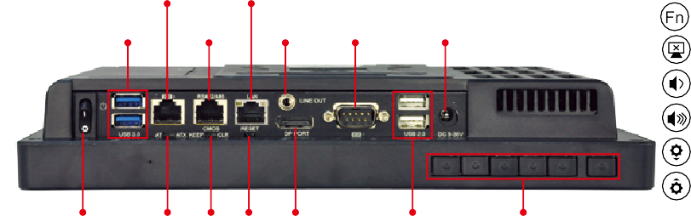Fn
RJ-45 for
2 x USB 3.0 RS-422/485 Line-out RS-232
9-36V DC Jack

Backlight On/Off Audio -
Audio + Brightness - Brightness +

RFID Enable/Disable Audio Mute
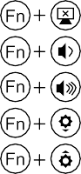
Camera Enable/Disable

Front Side USB Enable/Disable Power On / Off

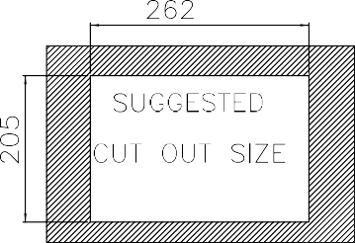
Power Switch AT/ATX CMOS Reset Display Port
2 x USB 2.0
Function Keys

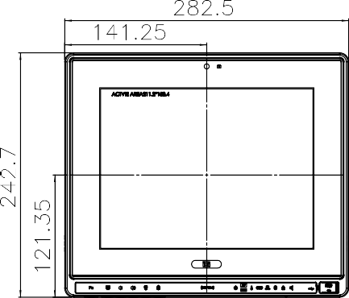
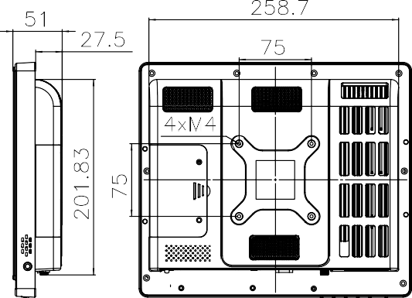
Display System

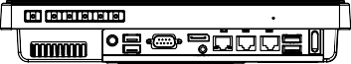

AFL2-10A Dimensions
(Unit: mm)

